**Name: Keerthana P**

**Roll No:12**

**Batch:RMCA(B)**

**Date:24/03/2022**

**NETWORKING & SYSTEM ADMINISTRATION LAB**

**Experiment No: 3**

**Aim**

Familiarization of Linux commands.

**Procedure**

1. **$pwd:** This command is used to print working directory starting from the root.

**Output:**



1. **$mkdir:** This command is used to make new directory.

**Output:**



1. **$man:** This command is used to display the user manual of any command that we can run on the terminal.

**Output:**



**4. $ls -t :** It is used to list files or directories and sort by last modified date in

descending order(biggest to smallest).

**Output:**



**5 .$ls -l:** This command is used to list the contents of directory in table format with

columns.

**Output:**

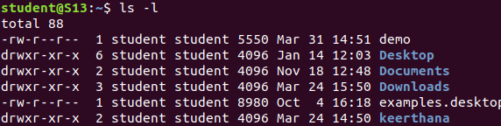

**6. $ls -al:** This command is used to list files or directories in a table format with

extra information with including hidden files or directories.

**Output:**

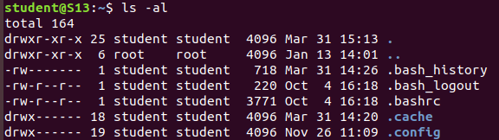

**7. $ls -a:** This command is used to list files or directories including hidden files

or directories.

**Output:**

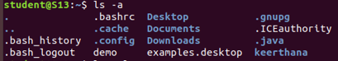

**7. $ls -r:** This command is used to display the contents of subdirectories.

**Output:**



**8. $ls:** It is used to list the contents of current working directory.

**Output:**

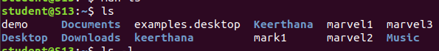

**9. $cd:** This command is used to change current working directory in linux.

**Output:**



**10. $cd ..:** This command is used to move to parent directory of current directory.

**Output:**



**11. $cd -:** This command is used to change to previous directory.

**Output:**



**12. $cat filename.**type: It is used to display contents on the file.

**Output:**

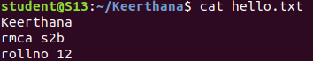

**13.** **$cat >filename.**type: Its is used to create filename and contents can be added on the

terminal itself.

**Output:**

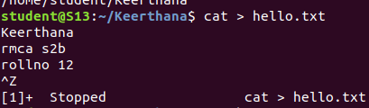

**14. $cat >>filename.**type: It is used to append content to existing file.

**Output:**

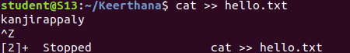

1. **$cat filename.**type > **filename2**.type: This command is used to copy contents of one file to another file.

**Output:**

