**Name: Keerthana P**

**Roll No:12**

**Batch:RMCA(B)**

**Date:31/03/2022**

**NETWORKING & SYSTEM ADMINISTRATION LAB**

**Experiment No.: 5**

**Aim**

Familiarization of Linux commands.

**Procedure**

**1.$cut -d ‘ ‘ –(f1/f2) filename.txt :** This command is used to display a particular column

on behalf of space delimiter.

**Output:**

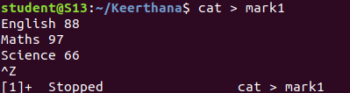

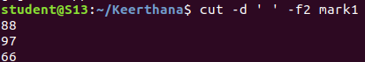

**2. $cut -b (number) filename.txt :** This command is used to display the particular

column.

**Output:**

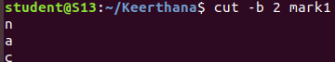

**3. $cut –complement -c (number) filename.txt:** This command is used to display all columns except the column specified in the column.

**Output:**

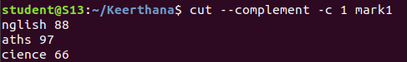

**4. $paste filename1.txt filename2.txt:** it is used to append contents of two files in

column order.

**Output:**

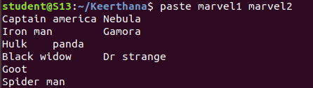

**5. $paste filename1.txt filename2.txt > filename3.txt:** It is used to append content of

two files in column order and paste into another file.

**Output:**

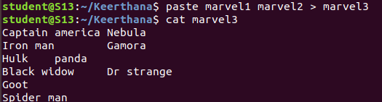

**6. $paste -d ‘-’ filename1.txt filename2.txt:** It is used to append contents of two files in

column order seperated by hyphen delimiter.

**Output:**

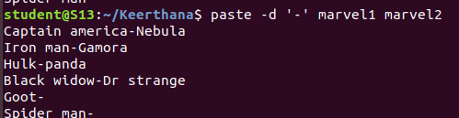

**7. $paste -d ‘--’ filename1.txt filename2.txt fielname3.txt:** This command is used to

seperate contents of 3 file with hyphen delimiterin column order

**Output:**

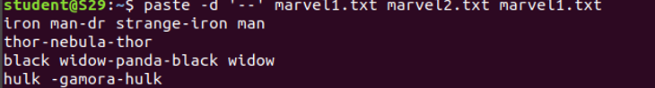

**8. $ paste -s filename1.txt filename2.txt:** This command is used append contents in two

files in row order.

**Output:**

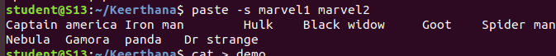

**9. $ more filename1.txt:** This command is used to view the text files in the

command prompt, displaying one screen at a time in case the file is large.

**Output:**

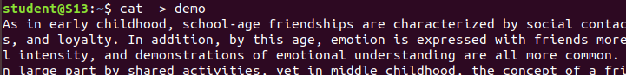



**10. $more -s filename.txt:** This command is used to squeeze multiple blank lines into

one single blank line.

**Output:**

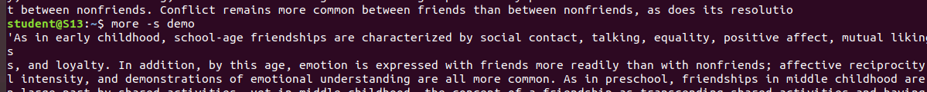

**11. $more +number filename.txt:**This command helps to specify from where you want

to start displaying the text content.

**Output**:

