**Name: Keerthana P**

**Roll No:12**

**Batch:RMCA(B)**

**Date:25/04/2022**

**NETWORKING & SYSTEM ADMINISTRATION LAB**

**Experiment No.: 8**

**Aim**

Familirization of linux commands

**Procedure**

1. **$useradd:** This command is used to add user accounts to your

system.

**Output:**

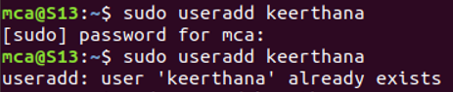

1. **$.password:** This command is used to change the user account passwords.

**Output:**

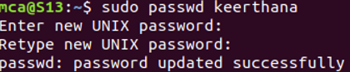

1. **$groupadd:**This command is used to create a new user group.

**Output:**

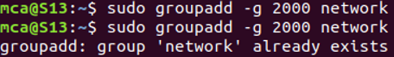

1. **$usermod:** This command or modify user is a command in Linux that is used to change the properties of a user in Linux through the command line.

**Output:**



1. **$compgen:**This is a bash built-in command which is used to list all the commands that could be executed in the Linux system.

**Output:**

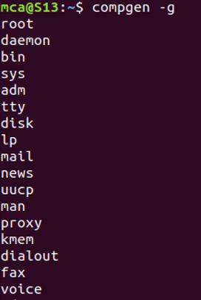

1. **$userdel:**This command in Linux system is used to delete a user account and related files.

**Output:**

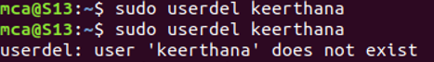

1. **$groupdel:** This command is used to delete a existing group. It will delete all entry that refers to the group, modifies the system account files, and it is handled by superuser or root user

**Output:**

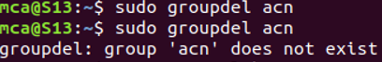

1. **$chmod:**This command is used to change the access mode of a file.  
   The name is an abbreviation of change mode.

**Output:**

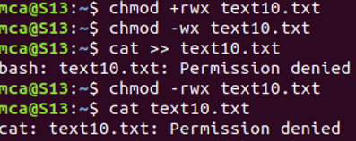

1. **$chown:** Thiscommand is used to change the file Owner or group. Whenever you want to change ownership you can use chown command.

**Output:**

