**Name: Keerthana P**

**Roll No: 12**

**Batch: RMCA B**

**Date:05/05/2022**

**NETWORKING & SYSTEM ADMINISTRATION LAB**

**Experiment No.: 8**

1.Write a shell script to print the basic details.

#!/bin/bash

echo "Enter your name"

read name

echo "Enter your age"

read age

echo "Enter your location"

read location

echo "Enter your batch"

read batch

echo "Enter your gender"

read gender

echo "Basic details"

echo "***************"

echo "Name:"$name

echo "Age:"$age

echo "Location:"$location

echo "Batch:"$batch

echo "Gender:"$gender

**OUTPUT**

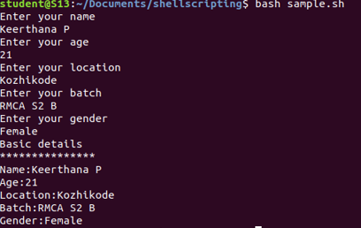

2. Write a shell script to find the sum of two numbers.

PROCEDURE

#!/bin/bash

echo "Enter first number"

read num1

echo "Enter second number"

read num2

sum=$(($num1+$num2))

echo "sum of" $num1 "and" $num2 "is": $sum

if [ $sum -ge 0 ]

then

echo "greater than zero"

else

echo "less than zero"

fi

**OUTPUT**

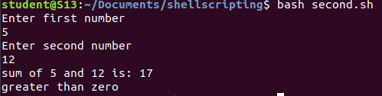

3. Write a shell script to find the largest of two numbers.

PROCEDURE

#!/bin/bash

echo "Enter first number"

read num1

echo "Enter second number"

read num2

if [ $num1 -gt $num2 ]

then

echo $num1 "is greater"

else

echo $num2 "is greater"

fi

**OUTPUT**

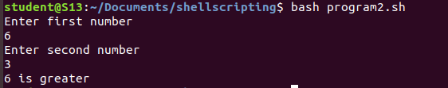

4. Write a shell script to find the largest of three numbers.

PROCEDURE

#!/bin/bash

echo "Enter first number"

read num1

echo "Enter second number"

read num2

echo "Enter third number"

read num3

if [ $num1 -gt $num2 ] && [ $num1 -gt $num3 ]

then

echo $num1 "is greater"

elif [ $num2 -gt $num1 ] && [ $num2 -gt $num3 ]

then

echo $num2 "is greater"

else

echo $num3 "is greater"

fi

**OUTPUT**

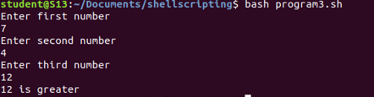

5. Write a shell script to find odd and even numbers.

PROCEDURE

#!/bin/bash

echo "Enter the number"

read num

n=$(( num % 2))

if [ $n -eq 0 ]

then

echo $num "is even"

else

echo $num "is odd"

fi

**OUTPUT**

