**Android Lab Cycle 2**

1. Design a Login Form with username and password using LinearLayout and toast valid credentials

**activity_main.xml**

<?xml version="1.0" encoding="utf-8"?>  
<LinearLayout xmlns:android="http://schemas.android.com/apk/res/android"  
 xmlns:tools="http://schemas.android.com/tools"  
 android:layout_width="match_parent"  
 android:layout_height="match_parent"  
 xmlns:card_view="http://schemas.android.com/apk/res-auto"  
 tools:context=".MainActivity"  
 android:gravity="center"  
 android:orientation="vertical"  
  
 >  
  
 <androidx.cardview.widget.CardView  
 android:layout_width="match_parent"  
 android:layout_height="wrap_content"  
 android:layout_margin="70dp"  
 android:background="#fff"  
  
  
 card_view:cardCornerRadius="10dp"  
 android:layout_gravity="center"  
 card_view:cardElevation="8dp">  
  
 <LinearLayout  
 android:layout_width="match_parent"  
 android:layout_height="wrap_content"  
 android:orientation="vertical"  
 android:layout_gravity="center"  
 android:padding="24dp">  
  
 <TextView  
 android:layout_width="match_parent"  
 android:layout_height="wrap_content"  
 android:layout_gravity="center_horizontal"  
 android:text="LOGIN"  
  
 android:textAlignment="center"  
 android:textSize="36sp" />  
  
 <TextView  
 android:layout_width="wrap_content"  
 android:layout_height="wrap_content"  
 android:hint="Username"  
  
 android:textSize="22sp" />  
  
 <EditText  
 android:id="@+id/activity_main_usernameEditText"  
 android:layout_width="match_parent"  
 android:layout_height="wrap_content"  
 android:inputType="text" />  
  
 <TextView  
 android:layout_width="wrap_content"  
 android:layout_height="wrap_content"  
 android:hint="Password"  
  
 android:textSize="22sp" />  
  
 <EditText  
 android:id="@+id/activity_main_passwordEditText"  
 android:layout_width="match_parent"  
 android:layout_height="wrap_content"  
 android:inputType="textPassword" />  
  
 <Button  
 android:id="@+id/activity_main_loginButton"  
 android:layout_width="match_parent"  
 android:layout_height="wrap_content"  
 android:text="Login"  
 android:textSize="22sp" />  
  
 </LinearLayout>  
  
 </androidx.cardview.widget.CardView>  
  
</LinearLayout>

**Main_Activity.java**

package com.example.loginlab2;  
  
import androidx.appcompat.app.AppCompatActivity;  
  
import android.os.Bundle;  
import android.view.View;  
import android.widget.Button;  
import android.widget.EditText;  
import android.widget.Toast;  
  
public class MainActivity extends AppCompatActivity {  
 private EditText usernameEditText;  
 private EditText passwordEditText;  
 private Button loginButton;  
 @Override  
 protected void onCreate(Bundle savedInstanceState) {  
 super.onCreate(savedInstanceState);  
 setContentView(R.layout.*activity_main*);  
 usernameEditText = findViewById(R.id.*activity_main_usernameEditText*);  
 passwordEditText = findViewById(R.id.*activity_main_passwordEditText*);  
 loginButton = findViewById(R.id.*activity_main_loginButton*);  
  
 loginButton.setOnClickListener(new View.OnClickListener() {  
 @Override  
 public void onClick(View v) {  
 if (usernameEditText.getText().length() > 0 && passwordEditText.getText().length() > 0) {  
 String toastMessage = "Username: " + usernameEditText.getText().toString() + ", Password: " + passwordEditText.getText().toString();  
 Toast.*makeText*(getApplicationContext(), toastMessage, Toast.*LENGTH_SHORT*).show();  
 } else {  
 String toastMessage = "Username or Password are not populated";  
 Toast.*makeText*(getApplicationContext(), toastMessage, Toast.*LENGTH_SHORT*).show();  
 }  
 }  
 });  
 }  
}

**OUTPUT**

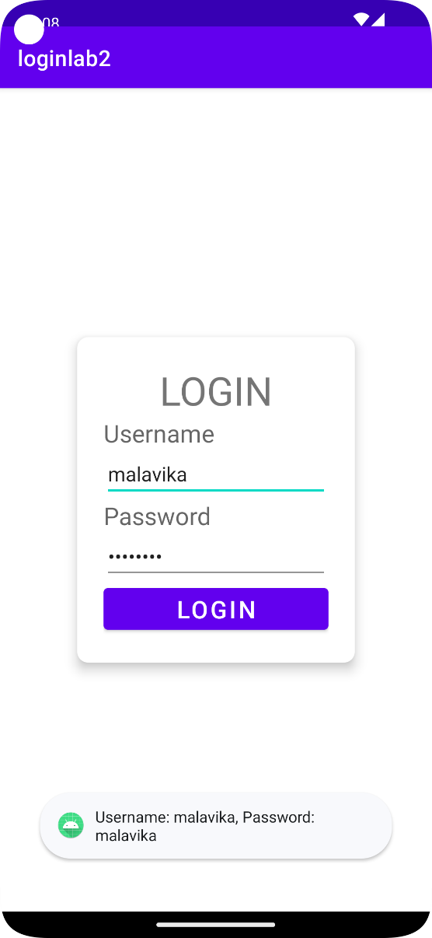

1. Create an application to design a Visiting Card. The Visiting card should have a company logo at the top right corner. The company name should be displayed in Capital letters, aligned to the centre. Information like the name of the employee, job title, phone number, address, email, fax and the website address is to be displayed. Insert a horizontal line between the job title and the phone number.

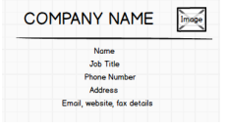

1. Develop an Android application using controls like Button, TextView, EditText for designing a calculator having basic functionality like Addition, Subtraction, Multiplication, and Division.

