Student Performance & Education Analytics Dashboard
Prepared By: Keerthana Ramesh
Course: PGA-38
Date: 07-08-2026

Project Objective
- Develop an interactive Power BI dashboard to analyze student demographics, academic performance, attendance, and dropout risk.

Dataset Overview
- 2,000 students across 5 courses.
- Fields include Age, Gender, Attendance, Hours Studied, Final Score, Scholarship, Fee Payment and Dropout Risk.
- Tool: Microsoft Power BI.

Data Preparation (Power Query)
- Verified data types.
- Created Age Group.
- Validated data.
- Prepared data model.

DAX Measures
- Total Students
- Total Courses
- Average Age
- Average Attendance
- Average Overall Score
- Students At Risk
- High Risk %

Dashboard Screenshots
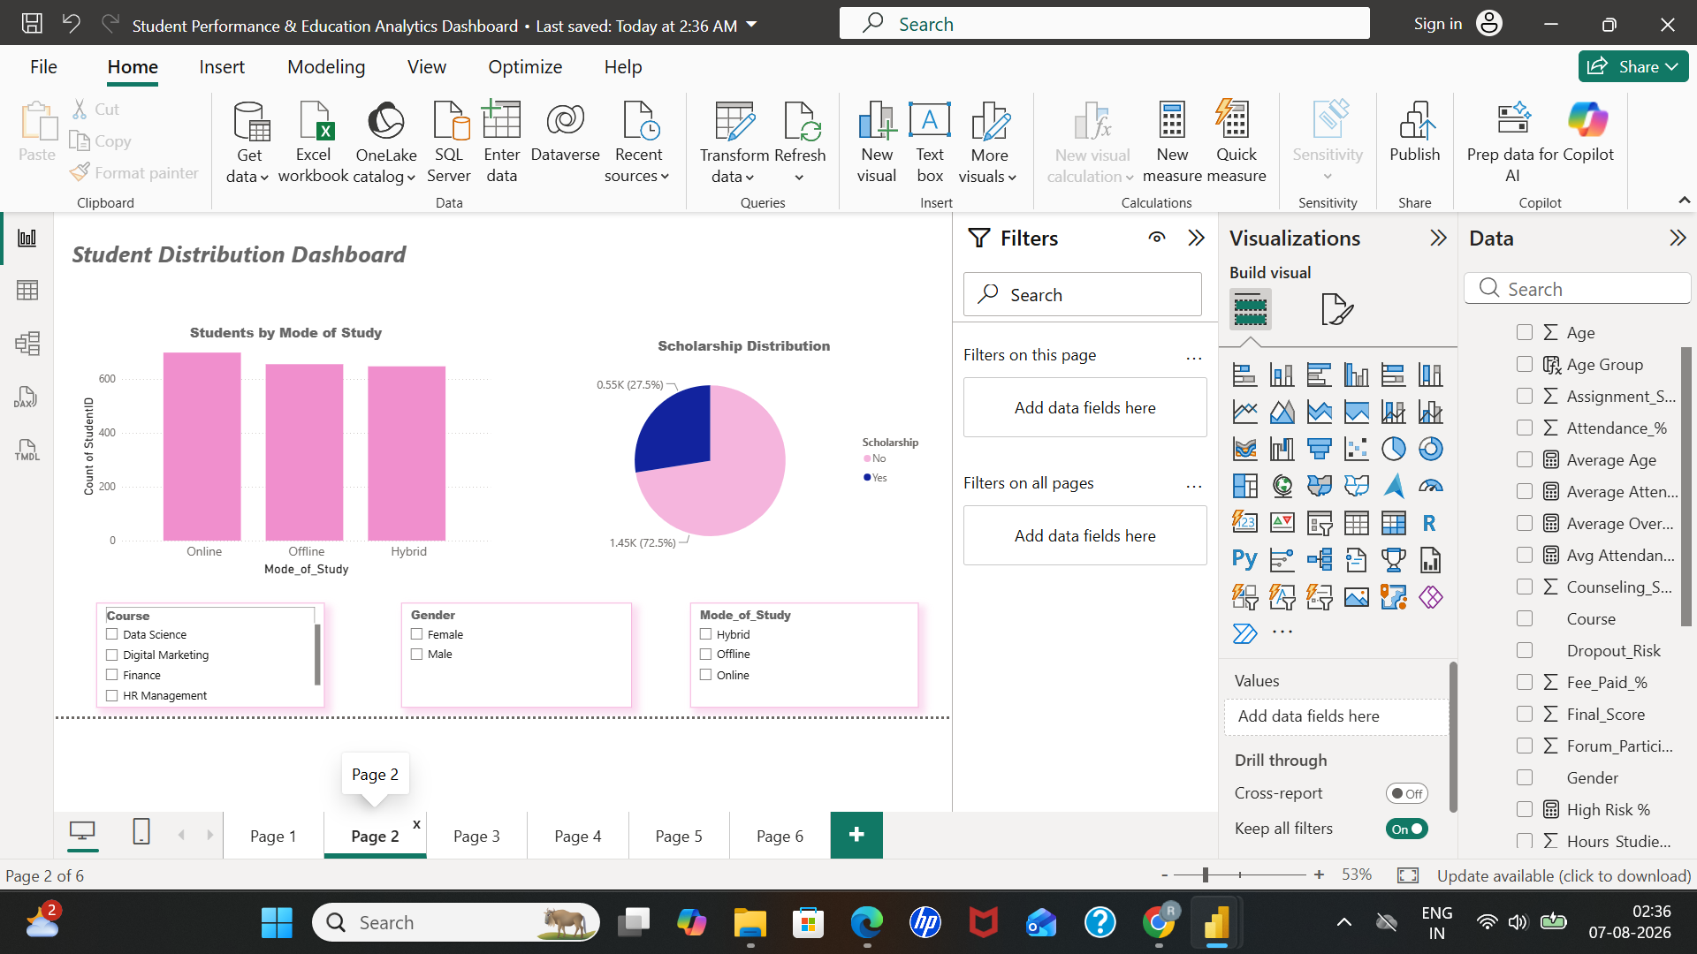 | 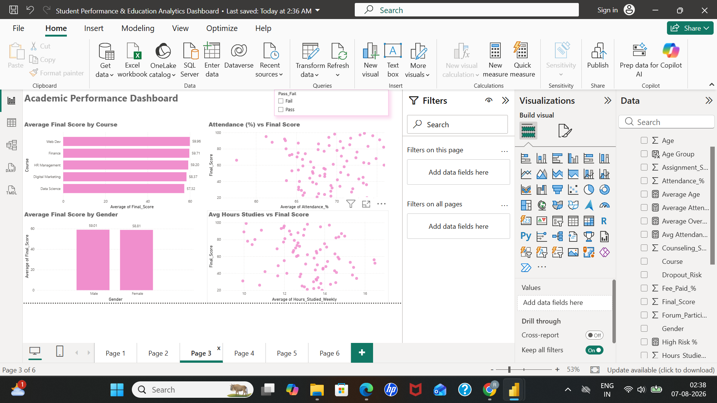
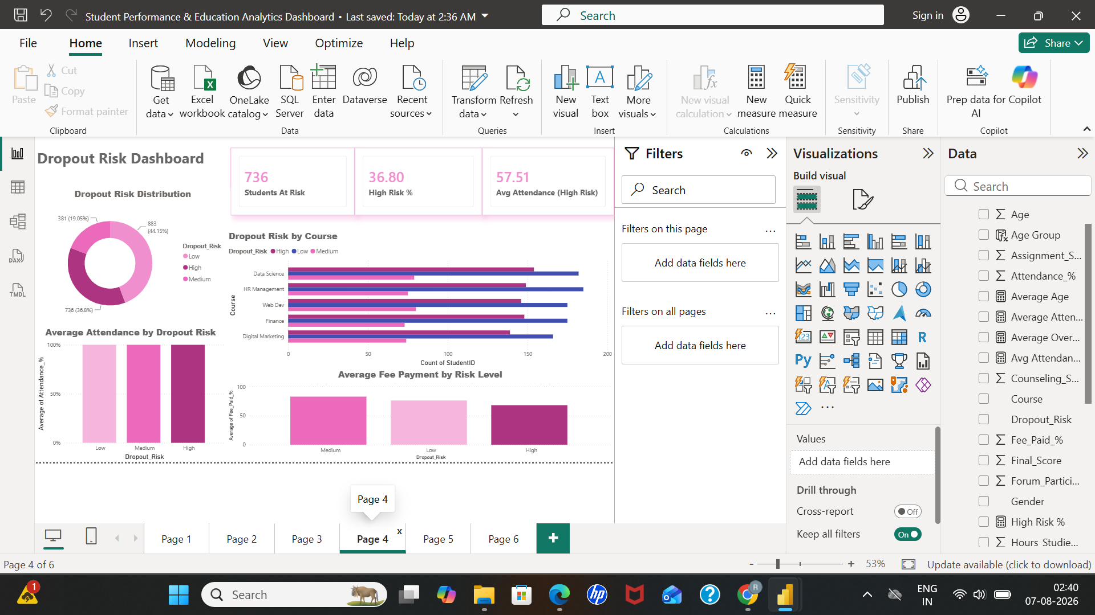 | 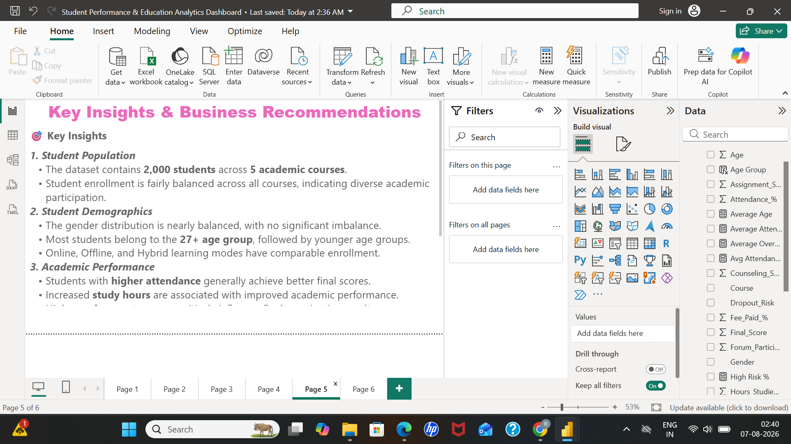

Key Insights
- Balanced enrollment across courses.
- Attendance and study hours positively influence performance.
- 736 students are at risk; 36.8% are High Risk.
- Dashboard supports early intervention.

Business Recommendations
- Improve attendance.
- Support low-performing students.
- Monitor at-risk students.
- Use dashboard for decision making.

Conclusion
The dashboard enables institutions to monitor student performance and make data-driven academic decisions.

Project Reference
Dataset: https://www.kaggle.com/datasets

