**LAB 4:**

**Program:** Implement Annealing Technique to Solve N-Queen’s Problem

**Code:**

import numpy as np

import random

import math

def create_initial_state(n):

return np.random.permutation(n)

def fitness(state):

attacks = 0

n = len(state)

for i in range(n):

for j in range(i + 1, n):

if state[i] == state[j] or abs(state[i] - state[j]) == abs(i - j):

attacks += 1

return (n * (n - 1)) // 2 - attacks

def get_neighbors(state):

neighbors = []

n = len(state)

for i in range(n):

for j in range(i + 1, n):

new_state = state.copy()

new_state[i], new_state[j] = new_state[j], new_state[i]

neighbors.append(new_state)

return neighbors

def probability(delta_fitness, temperature):

if delta_fitness > 0:

return 1.0

return math.exp(delta_fitness / temperature)

def print_grid(state):

n = len(state)

grid = np.full((n, n), '.')

for i in range(n):

grid[i, state[i]] = 'Q'

print("\n".join(" ".join(row) for row in grid))

print("\n")

def simulated_annealing(n, initial_temp, cooling_rate, max_iters):

current_state = create_initial_state(n)

current_fitness = fitness(current_state)

best_state = current_state.copy()

best_fitness = current_fitness

temperature = initial_temp

state_space_steps = [current_state.copy()]

for iteration in range(max_iters):

neighbors = get_neighbors(current_state)

new_state = random.choice(neighbors)

new_fitness = fitness(new_state)

delta_fitness = new_fitness - current_fitness

if delta_fitness > 0 or random.uniform(0, 1) < probability(delta_fitness, temperature):

current_state = new_state

current_fitness = new_fitness

if current_fitness > best_fitness:

best_state = current_state.copy()

best_fitness = current_fitness

state_space_steps.append(current_state.copy())

temperature *= cooling_rate

if best_fitness == (n * (n - 1)) // 2:

break

return best_state, best_fitness, state_space_steps

N = 8

initial_temperature = 10

cooling_rate = 0.95

max_iterations = 100

best_position, best_objective, steps = simulated_annealing(N, initial_temperature, cooling_rate, max_iterations)

print('The best position found is:', best_position)

print('The number of non-attacking pairs of queens is:', best_objective)

print("Grid representation of the best position:")

print_grid(best_position)

print("State space steps:")

for idx, step in enumerate(steps):

print(f"Step {idx}:")

print_grid(step)

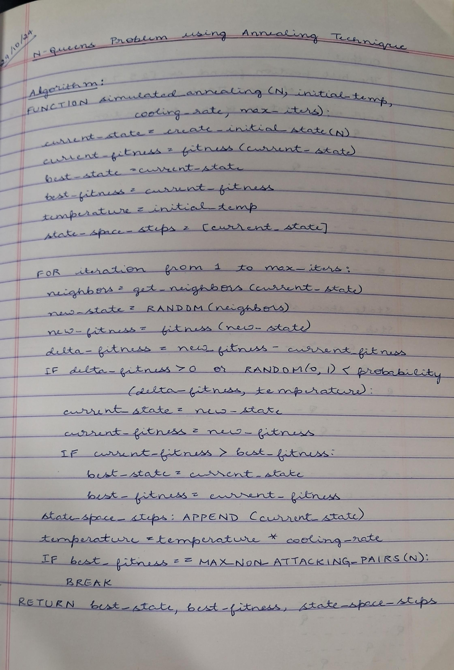**Algorithm:**

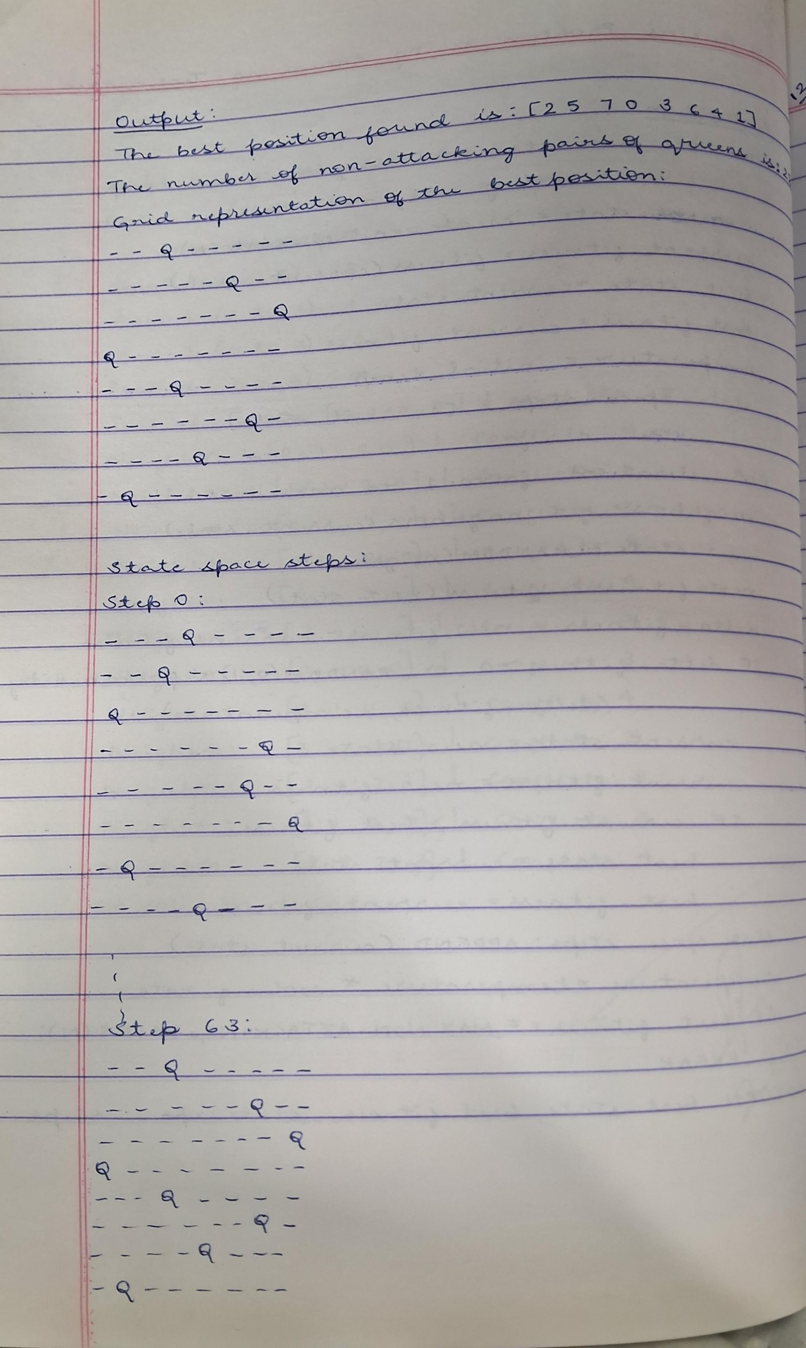

**Output:**

