**LAB 6:**

**Program:** Implement Prepositional Logic

**Code:**

def PL_TRUE(model, sentence):

sentence = sentence.replace("A", str(model["A"])).replace("B", str(model["B"])).replace("C", str(model["C"]))

sentence = sentence.replace("and", "and").replace("or", "or").replace("not", "not")

return eval(sentence)

def truth_table_entaiment(KB, query, variables):

all_assignments = []

for i in range(2 ** len(variables)):

assignment = {}

for j, var in enumerate(variables):

assignment[var] = (i >> j) & 1

all_assignments.append(assignment)

for assignment in all_assignments:

kb_true = PL_TRUE(assignment, KB)

query_true = PL_TRUE(assignment, query)

if kb_true and not query_true:

return False

return True

KB = "(A or C) and (B or not C)"

query = "A or B"

variables = ['A', 'B', 'C']

result = truth_table_entaiment(KB, query, variables)

print("Does KB entail the query?", result)

**Algorithm:**

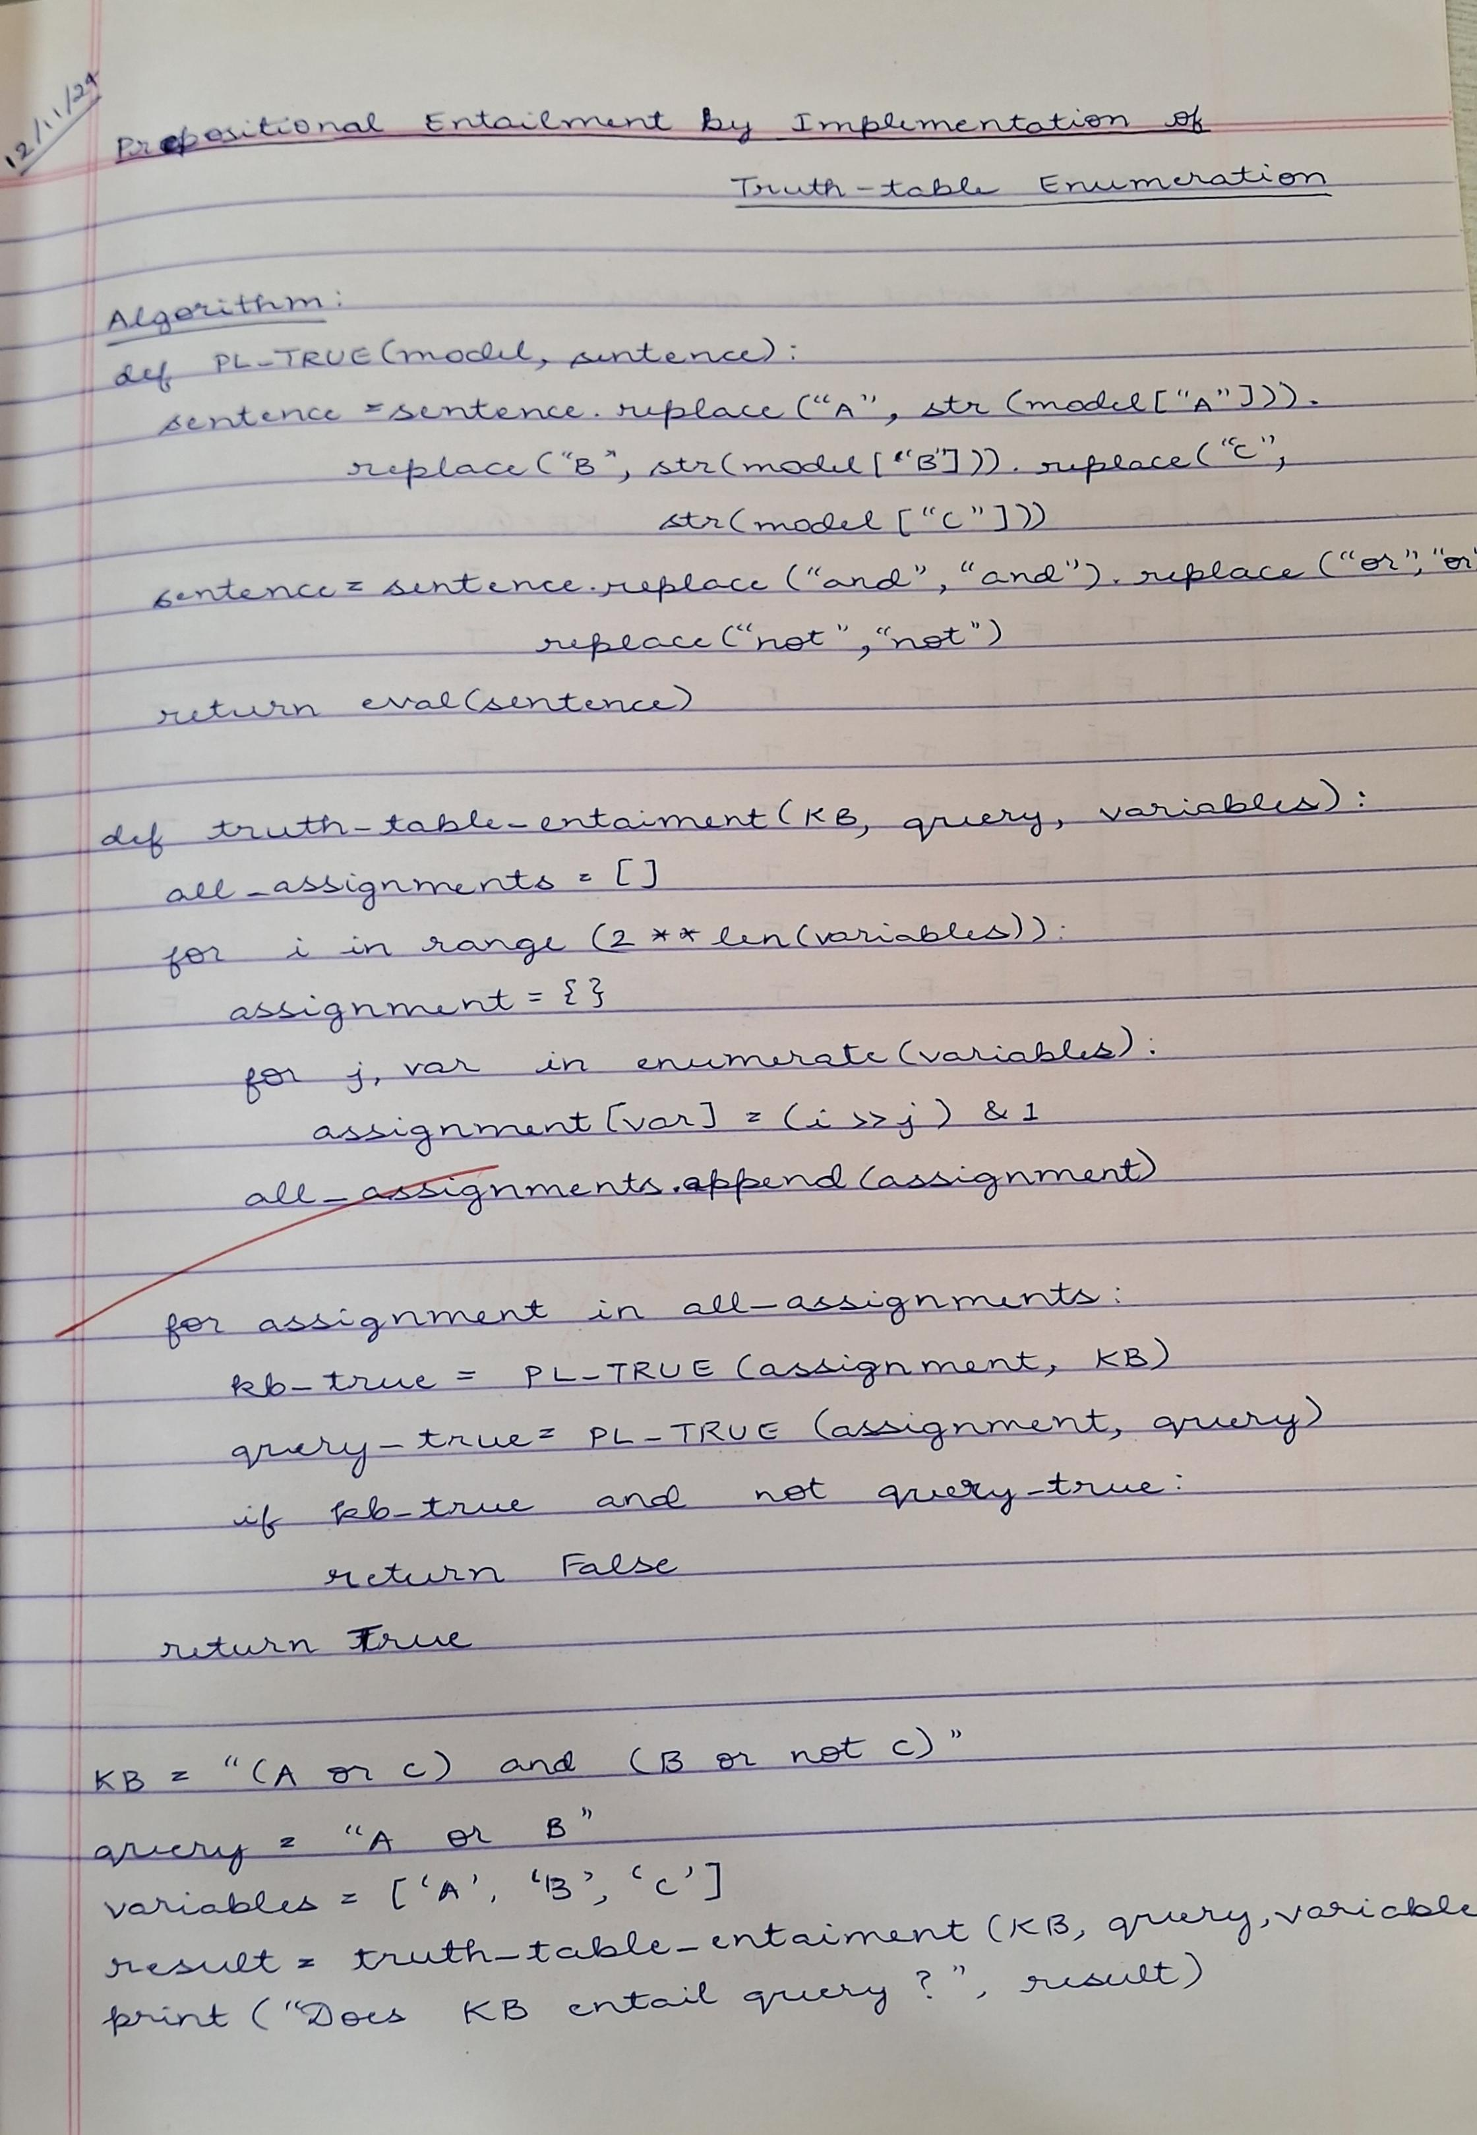

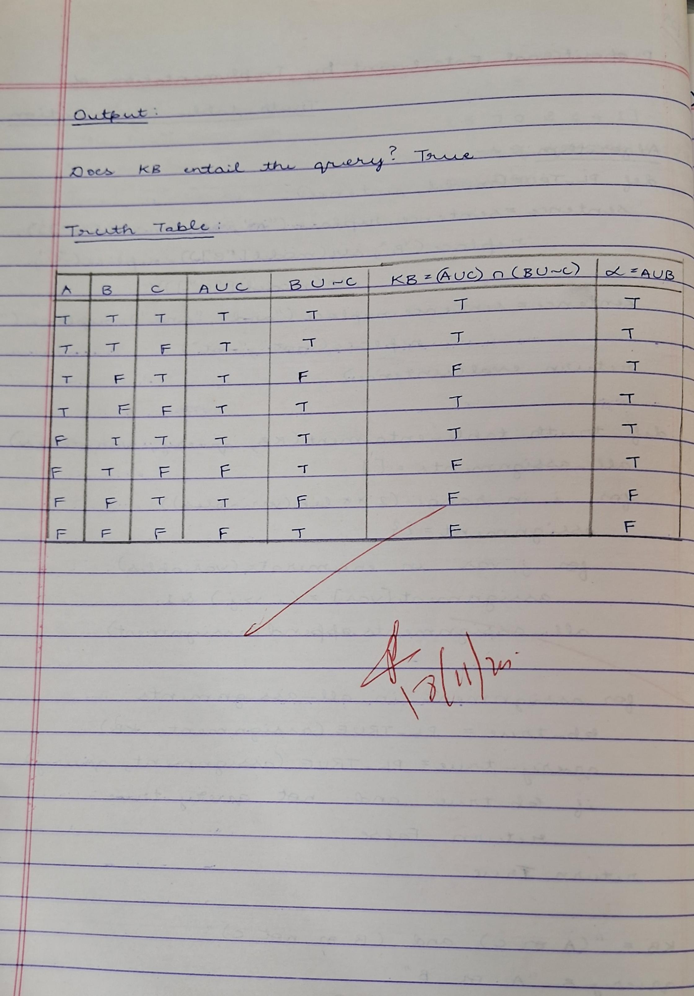

**Output:**

