**LAB 9:**

**Program:** Create knowledge base consisting of FOL statements and prove given query using resoltuion.

**Code:**

def resolve_clause(c1, c2):

    resolvent = set(c1)

    for literal in c2:

        if f"¬{literal}" in resolvent:

            resolvent.remove(f"¬{literal}")

            return resolvent

    return None

def resolution(kb, query):

    negated_query = {f"¬{literal}" for literal in query}

    kb = kb.copy()

    kb.append(frozenset(negated_query))

    clauses = [frozenset(clause) for clause in kb]

    while True:

        new_clauses = set()

        for i in range(len(clauses)):

            for j in range(i + 1, len(clauses)):

                resolvent = resolve_clause(clauses[i], clauses[j])

                if resolvent:

                    new_clauses.add(frozenset(resolvent))

        if frozenset() in new_clauses:

            return "Yes"

        if new_clauses.issubset(clauses):

            return "No"

        clauses.extend(new_clauses)

kb = [

    {"Food(Banana)", "Enjoys(Ravi, Banana)"},

    {"Food(Pizza)", "Enjoys(Ravi, Pizza)"},

    {"Eats(Sam, Idli)", "Alive(Sam)", "Food(Idli)"},

    {"Eats(Sam, f)", "Alive(Sam)", "Food(f)"},

    {"Eats(Sam, f)", "Eats(Bill, f)"},

]

query = {"Enjoys(Ravi, Idli)"}

result = resolution(kb, query)

print("Result:", result)

**Output:**



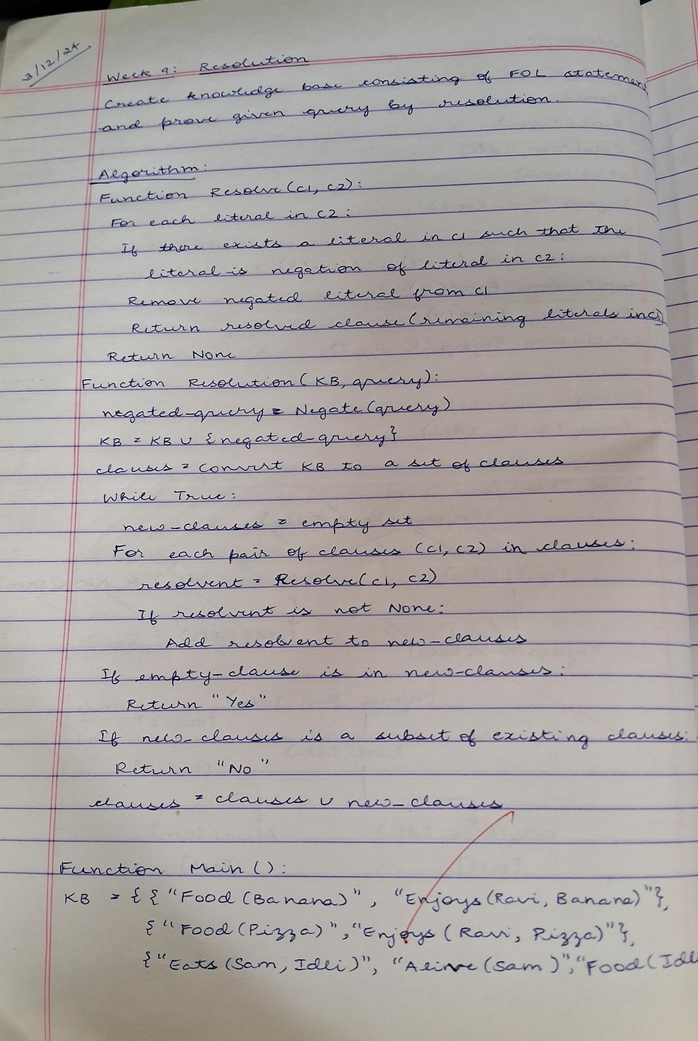**Algorithm:**

