**LAB 4:**

**Program:** A* Algorithm with Misplaced Tiles Heuristic

**Code:**

import heapq

class PuzzleState:

    def __init__(self, board, zero_pos, moves=0):

        self.board = board

        self.zero_pos = zero_pos

        self.moves = moves

        self.heuristic = self.calculate_misplaced_tiles()

    def calculate_misplaced_tiles(self):

        goal_state = [[1, 2,3], [8, 0, 4], [7, 6, 5]]

        return sum(1 for i in range(3) for j in range(3) if self.board[i][j] != goal_state[i][j])

    def get_neighbors(self):

        neighbors = []

        x, y = self.zero_pos

        directions = [(-1, 0), (1, 0), (0, -1), (0, 1)]

        for dx, dy in directions:

            new_x, new_y = x + dx, y + dy

            if 0 <= new_x < 3 and 0 <= new_y < 3:

                new_board = [row[:] for row in self.board]

                new_board[x][y], new_board[new_x][new_y] = new_board[new_x][new_y], new_board[x][y]

                neighbors.append((new_board, (new_x, new_y)))

        return neighbors

    def __lt__(self, other):

        return (self.moves + self.heuristic) < (other.moves + other.heuristic)

    def __repr__(self):

        return f"{self.board} (Moves: {self.moves}, Heuristic: {self.heuristic})"

def a_star(initial_board):

    initial_zero_pos = next((i, j) for i in range(3) for j in range(3) if initial_board[i][j] == 0)

    initial_state = PuzzleState(initial_board, initial_zero_pos)

    priority_queue = []

    heapq.heappush(priority_queue, initial_state)

    visited = set()

    while priority_queue:

        current_state = heapq.heappop(priority_queue)

        print(f"Exploring State: {current_state}")

        if current_state.heuristic == 0:

            print(f"Reached goal in {current_state.moves} moves.")

            return

        visited.add(tuple(map(tuple, current_state.board)))

        for neighbor_board, neighbor_zero_pos in current_state.get_neighbors():

            neighbor_state = PuzzleState(neighbor_board, neighbor_zero_pos, current_state.moves + 1)

            if tuple(map(tuple, neighbor_board)) not in visited:

                heapq.heappush(priority_queue, neighbor_state)

    print("No solution found.")

if __name__ == "__main__":

    initial_board = [

        [2, 8, 3],

        [1, 6, 4],

        [0, 7, 5]

    ]

a_star(initial_board)

**Algorithm:**

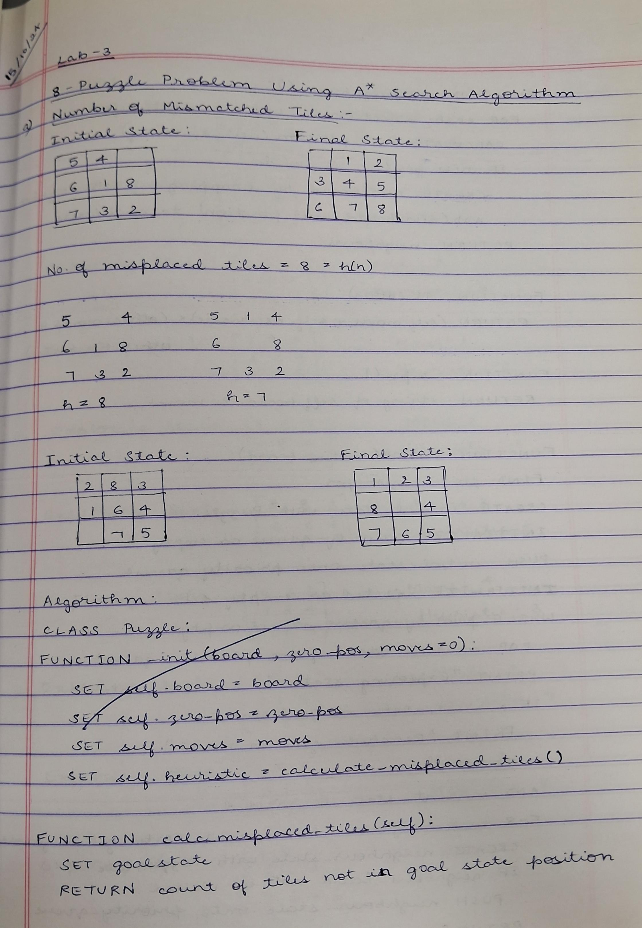

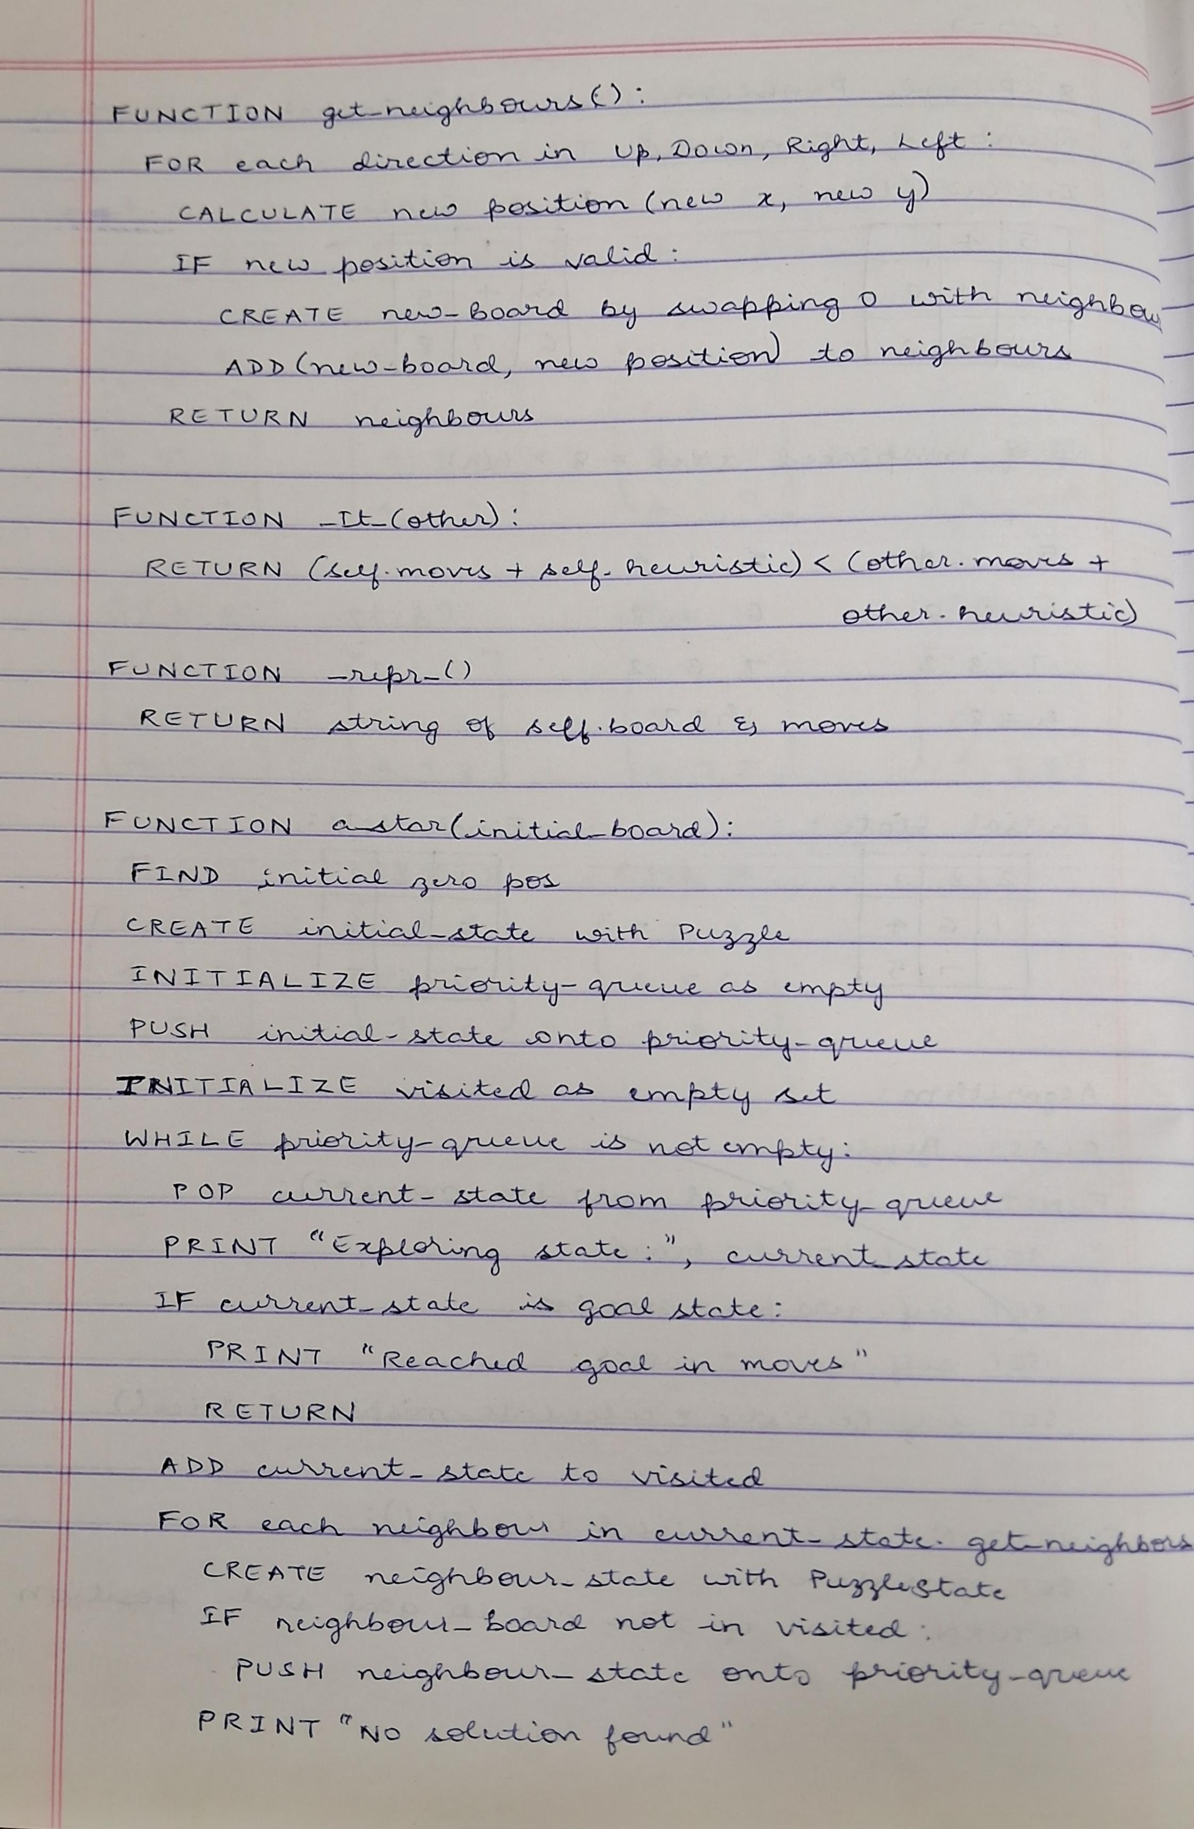

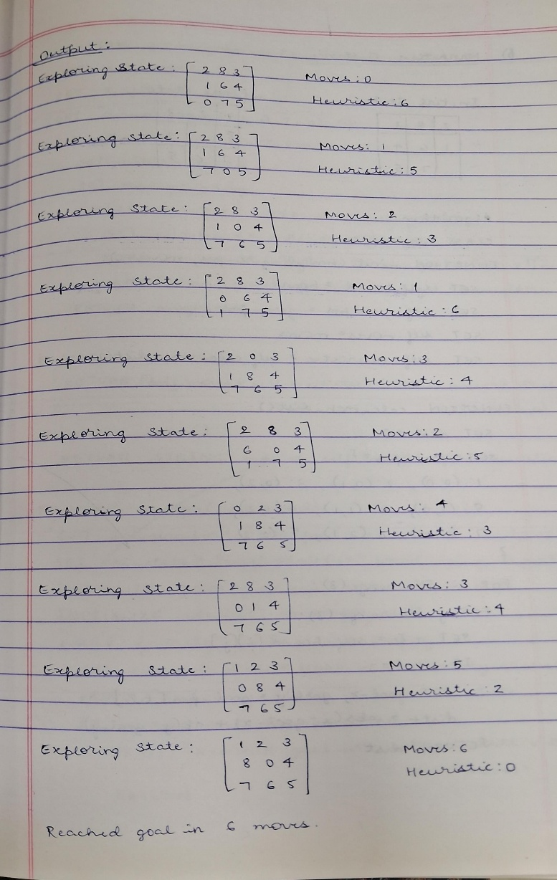

**Output:**

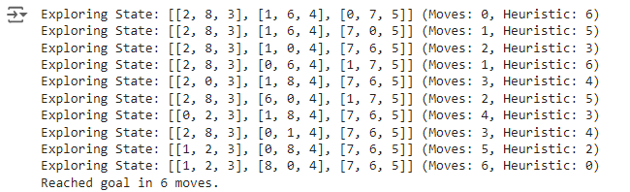

### Program: A* Search in 8-Puzzle using Manhattan

**Code:**

import heapq

class PuzzleState:

    def __init__(self, board, zero_pos, moves=0):

        self.board = board

        self.zero_pos = zero_pos

        self.moves = moves

        self.heuristic = self.calculate_manhattan_distance()

    def calculate_manhattan_distance(self):

        distance = 0

        goal_positions = {

            1: (0, 0), 2: (0, 1), 3: (0, 2),

            8: (1, 0), 0: (1, 1), 4: (1, 2),

            7: (2, 0), 6: (2, 1), 5: (2, 2)

        }

        for i in range(3):

            for j in range(3):

                tile = self.board[i][j]

                if tile != 0:

                    goal_x, goal_y = goal_positions[tile]

                    distance += abs(i - goal_x) + abs(j - goal_y)

        return distance

    def get_neighbors(self):

        neighbors = []

        x, y = self.zero_pos

        directions = [(-1, 0), (1, 0), (0, -1), (0, 1)]

        for dx, dy in directions:

            new_x, new_y = x + dx, y + dy

            if 0 <= new_x < 3 and 0 <= new_y < 3:

                new_board = [row[:] for row in self.board]

                new_board[x][y], new_board[new_x][new_y] = new_board[new_x][new_y], new_board[x][y]

                neighbors.append((new_board, (new_x, new_y)))

        return neighbors

    def __lt__(self, other):

        return (self.moves + self.heuristic) < (other.moves + other.heuristic)

    def __repr__(self):

        return f"{self.board} (Moves: {self.moves}, Heuristic: {self.heuristic})"

def a_star(initial_board):

    initial_zero_pos = next((i, j) for i in range(3) for j in range(3) if initial_board[i][j] == 0)

    initial_state = PuzzleState(initial_board, initial_zero_pos)

    priority_queue = []

    heapq.heappush(priority_queue, initial_state)

    visited = set()

    while priority_queue:

        current_state = heapq.heappop(priority_queue)

        print(f"Exploring State: {current_state}")

        if current_state.heuristic == 0:

            print(f"Reached goal in {current_state.moves} moves.")

            return

        visited.add(tuple(map(tuple, current_state.board)))

        for neighbor_board, neighbor_zero_pos in current_state.get_neighbors():

            neighbor_state = PuzzleState(neighbor_board, neighbor_zero_pos, current_state.moves + 1)

            if tuple(map(tuple, neighbor_board)) not in visited:

                heapq.heappush(priority_queue, neighbor_state)

    print("No solution found.")

if __name__ == "__main__":

    initial_board = [

        [2, 8, 3],

        [1, 6, 4],

        [0, 7, 5]

    ]

    a_star(initial_board)

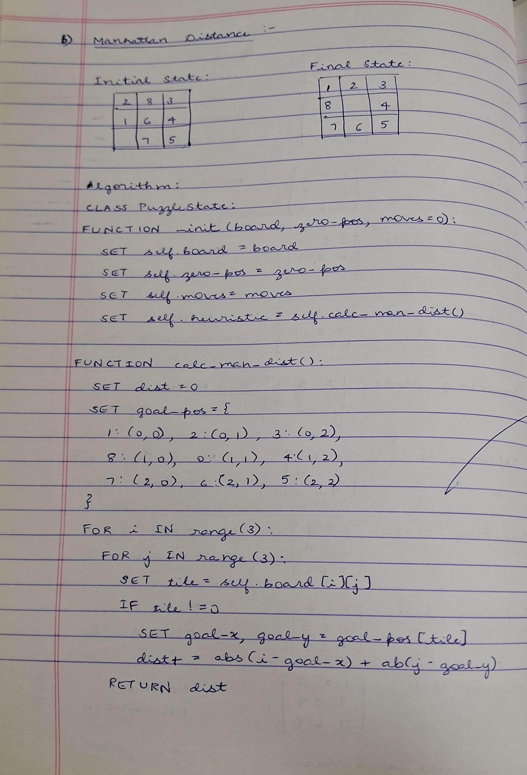**Algorithm:**

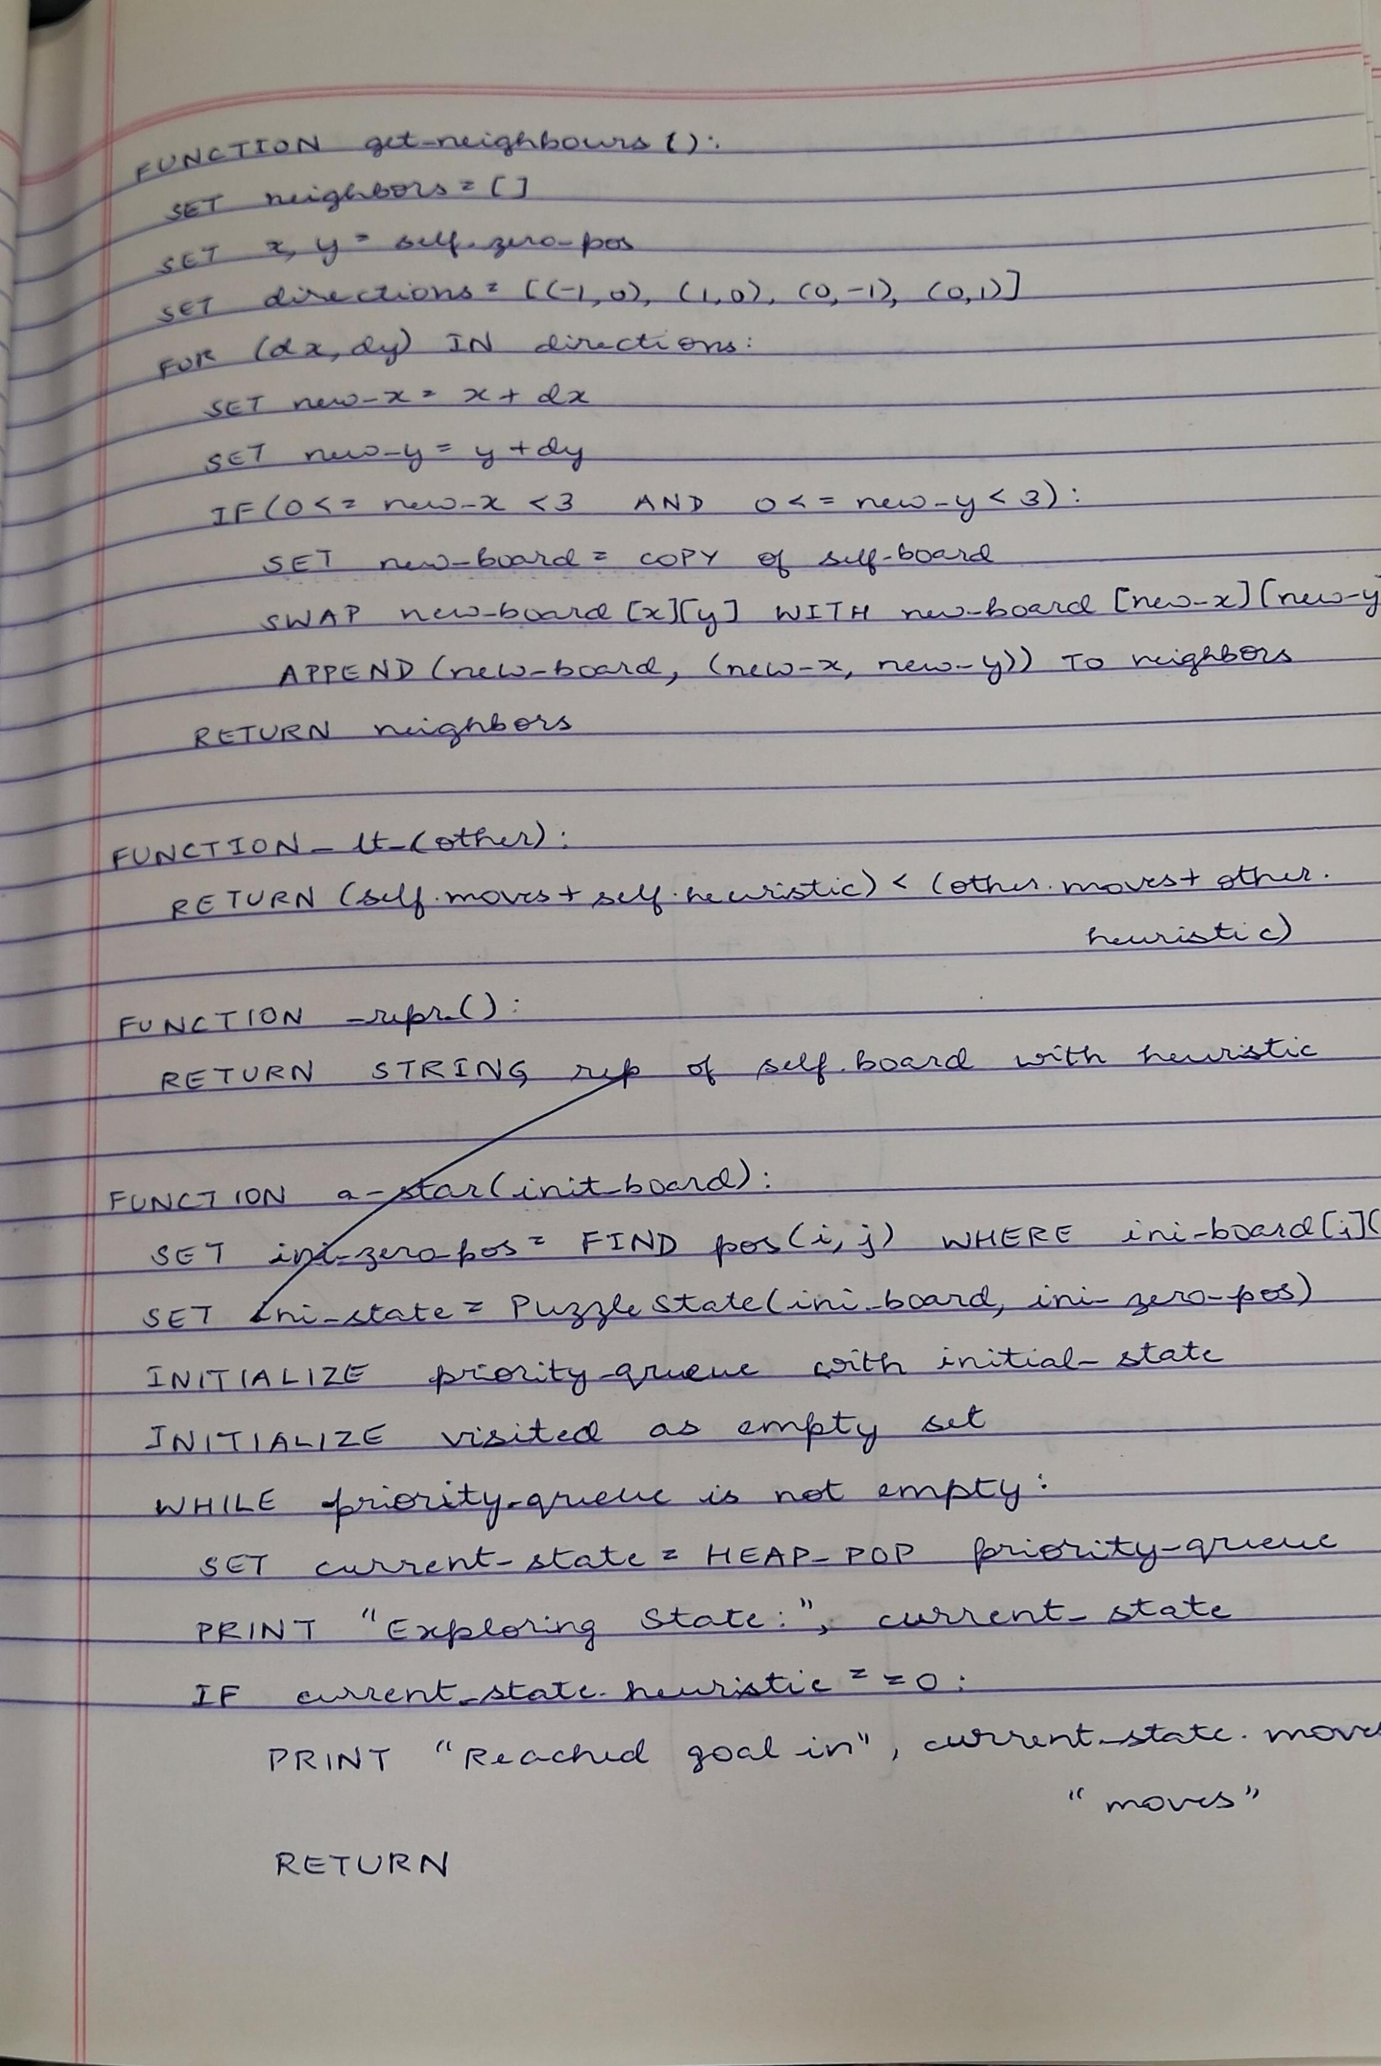

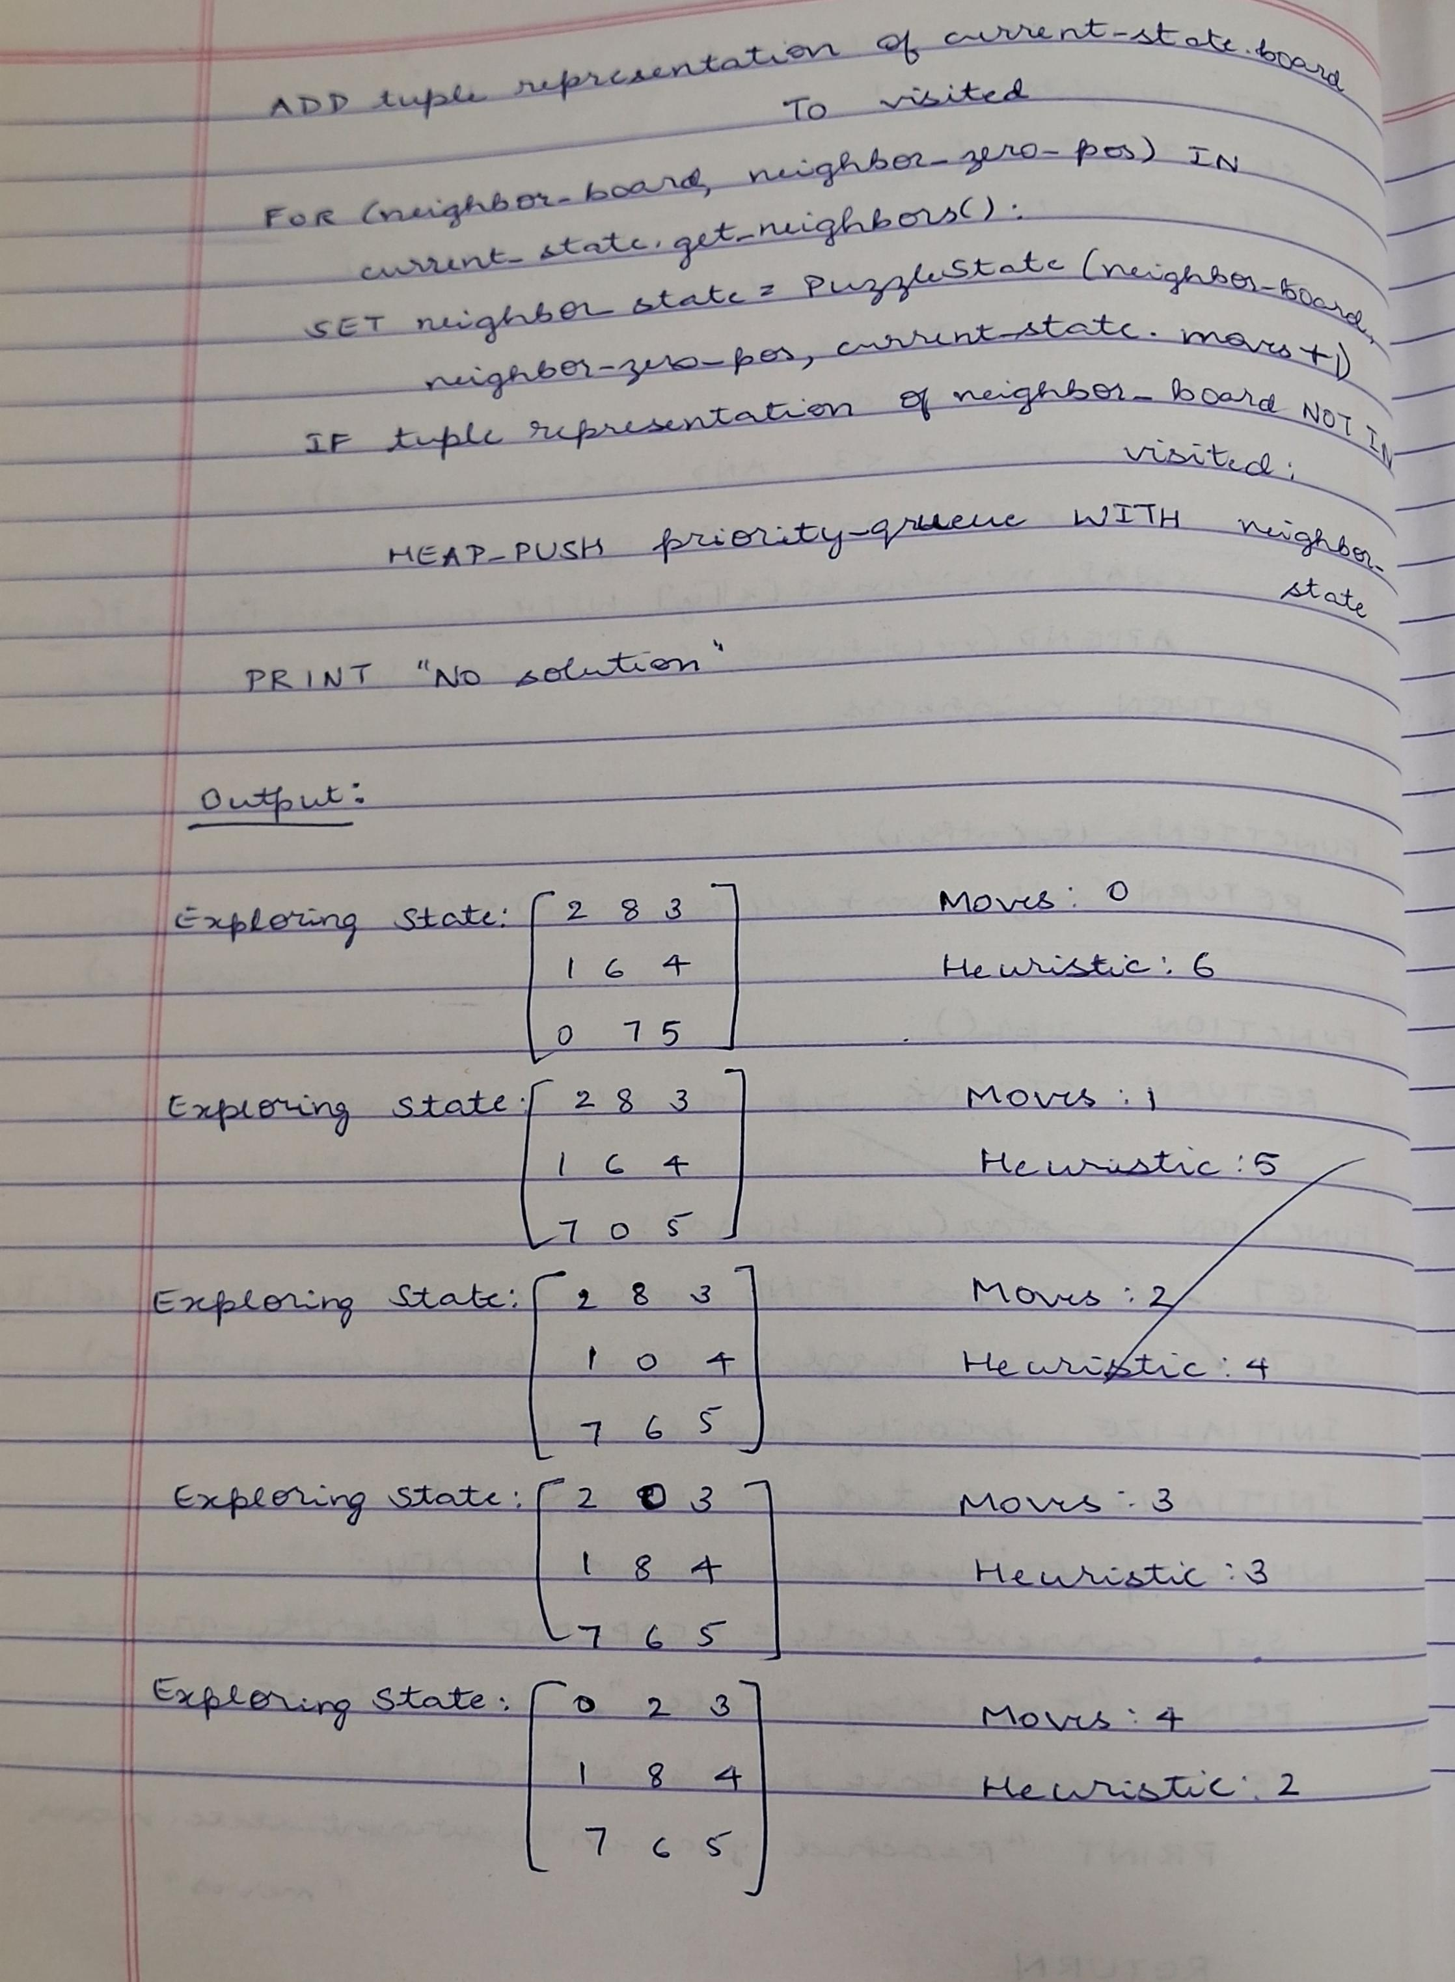

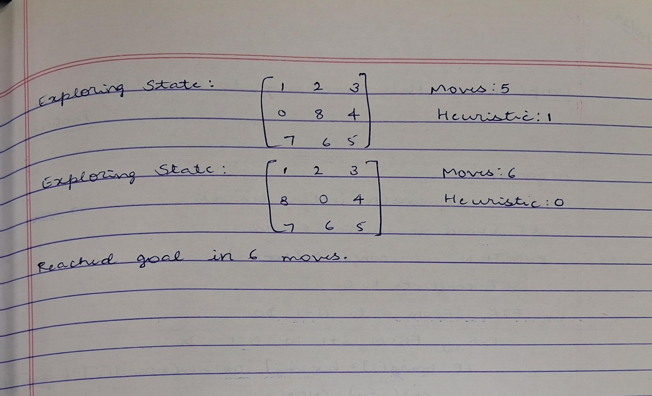

**Output:**

