**LAB 4:**

**Program:** Implement Hill Climbing to Solve N-Queen’s Problem

**Code:**

import random

class NQueens:

def __init__(self, n, initial_board=None):

self.n = n

self.board = initial_board if initial_board is not None else self.initialize_board()

def initialize_board(self):

# Place one queen in each row randomly

return [random.randint(0, self.n - 1) for _ in range(self.n)]

def calculate_conflicts(self, board):

conflicts = 0

for i in range(self.n):

for j in range(i + 1, self.n):

# Check for conflicts between queens

if board[i] == board[j] or abs(board[i] - board[j]) == abs(i - j):

conflicts += 1

return conflicts

def get_neighbors(self, board):

neighbors = []

for row in range(self.n):

for col in range(self.n):

if col != board[row]:

# Create a new board configuration by moving the queen

new_board = board[:]

new_board[row] = col

neighbors.append(new_board)

return neighbors

def hill_climbing(self):

current_board = self.board

current_conflicts = self.calculate_conflicts(current_board)

print(f"Initial State: {current_board} | Conflicts: {current_conflicts}")

while current_conflicts > 0:

neighbors = self.get_neighbors(current_board)

next_board = None

next_conflicts = float('inf')

for neighbor in neighbors:

conflicts = self.calculate_conflicts(neighbor)

print(f"Neighbor: {neighbor} | Conflicts: {conflicts}")

# Choose the neighbor with the smallest number of conflicts

# If there's a tie, choose the one with the smallest column number

if conflicts < next_conflicts or (conflicts == next_conflicts and self.choose_smaller(neighbor, next_board)):

next_board = neighbor

next_conflicts = conflicts

if next_conflicts >= current_conflicts:

# No better neighbors found

return None

print(f"Moving to: {next_board} | Conflicts: {next_conflicts}")

current_board = next_board

current_conflicts = next_conflicts

return current_board

def choose_smaller(self, new_board, current_board):

if current_board is None:

return True

for i in range(self.n):

if new_board[i] != current_board[i]:

return new_board[i] < current_board[i]

return False

def print_board(self, board):

for row in range(self.n):

line = ['Q' if board[i] == row else '.' for i in range(self.n)]

print(' '.join(line))

print()

if __name__ == "__main__":

n = int(input("Enter the size of the board (N): "))

initial_board = []

print("Enter the initial positions of the queens (0-indexed, one number per row):")

for i in range(n):

while True:

try:

pos = int(input(f"Row {i} (0 to {n-1}): "))

if 0 <= pos < n:

initial_board.append(pos)

break

else:

print(f"Invalid position! Please enter a value between 0 and {n-1}.")

except ValueError:

print("Invalid input! Please enter an integer.")

solver = NQueens(n, initial_board)

solution = solver.hill_climbing()

if solution:

print("\nSolution found:")

solver.print_board(solution)

else:

print("No solution found.")

**Algorithm:**

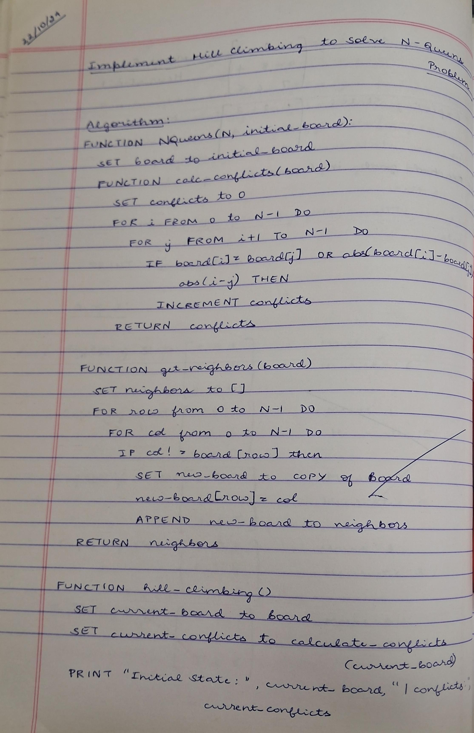

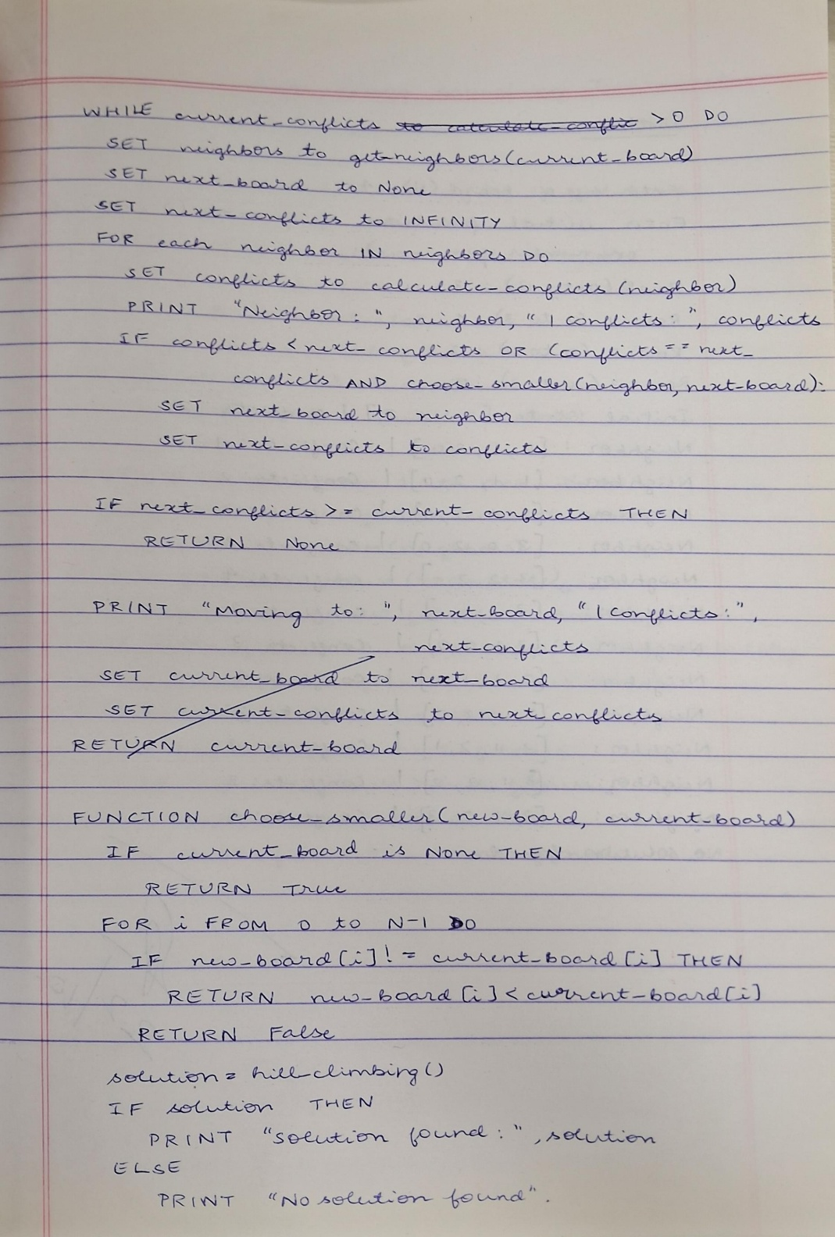

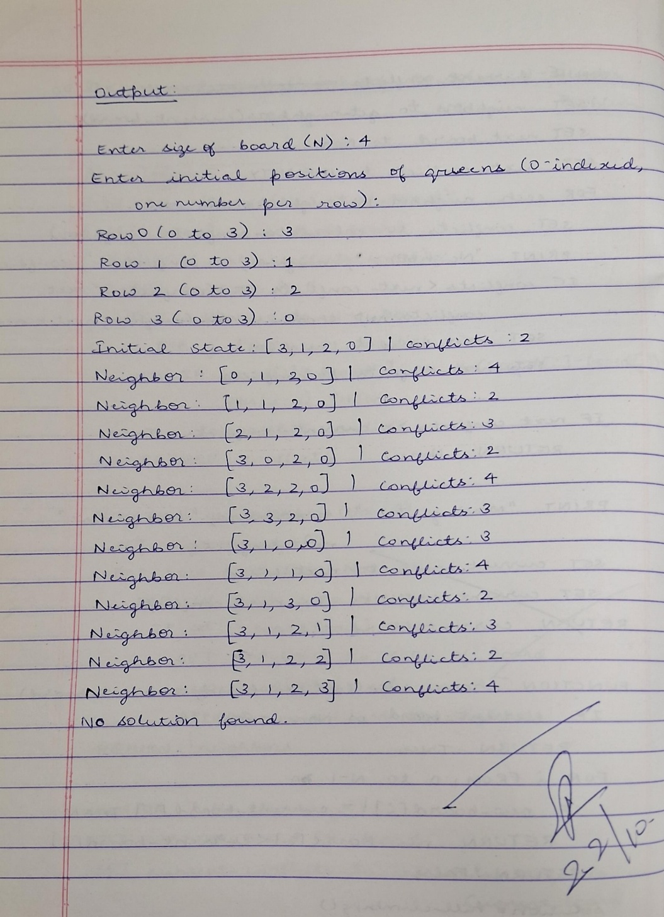

**Output:**

