DAY 2
LLM, TRANSFORMERS, PROMPTING, FINE-TUNING & RAG
SEQUENCE MODELLING AND ATTENTION
1. What is sequence modelling? Sequence modelling means working with data where the order of information matters. Examples are sentences, speech, stock values, weather readings and time-series data. The model uses earlier information to understand or predict later information.
Interview way: In a normal table, changing row order may not matter. In a sentence, changing word order can completely change the meaning.
- Text: I am going to college → word order matters.
- Speech: audio arrives over time.
- Time series: today's value is related to previous values.
- Traditional sequence models: RNN, LSTM and GRU.
- Modern language models: Transformers.
2. What is an attention mechanism? Attention is a way for a model to decide which parts of the input are important for the current prediction. Instead of treating every word equally, it gives more importance to relevant words.
Interview way: Example: In the sentence 'The student put the book on the table because it was heavy', attention helps the model connect 'it' with the relevant earlier information.
Query, Key and Value
- Query (Q) → what information am I looking for?
- Key (K) → what information does each token represent?
- Value (V) → the actual information passed forward.
- Attention score → measures how relevant a key is to a query.
- The values are combined using the attention weights.

TRANSFORMERS
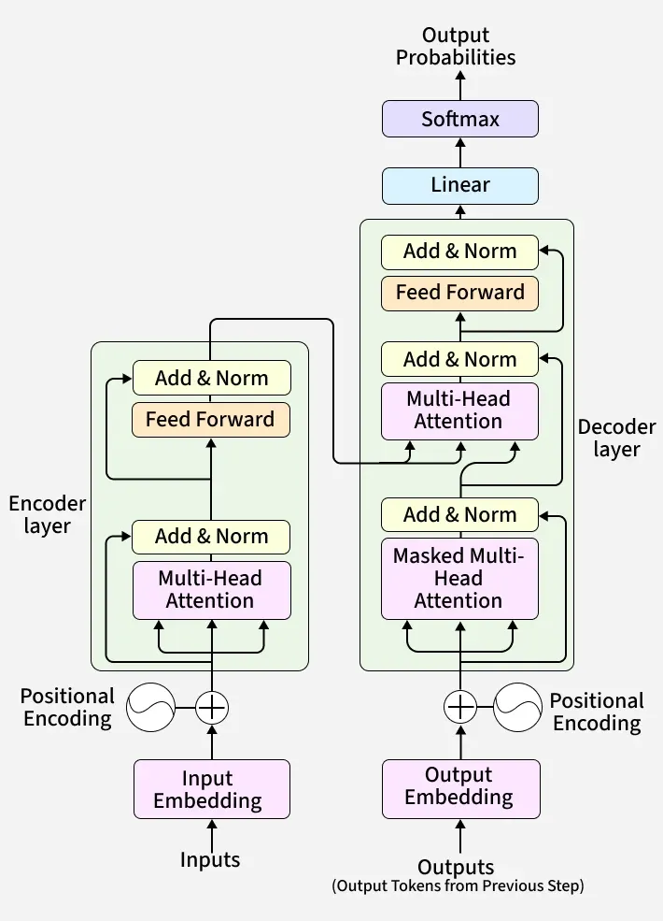
What is a Transformer? A Transformer is a neural-network architecture designed to process sequences using attention. It became very important in NLP because it can connect words that are far apart and can process many tokens in parallel during training.
Interview way: GPT, BERT, T5 and many modern LLMs are based on Transformer ideas.
How a Transformer works – simple flow
- 1. Input text is split into tokens.
- 2. Tokens are converted into numerical embeddings.
- 3. Positional information is added so the model knows token order.
- 4. Self-attention checks relationships between tokens.
- 5. Multi-head attention lets the model look at different relationships at the same time.
- 6. Feed-forward layers further transform the information.
- 7. Residual connections and layer normalization help stable training.
- 8. The final layers produce scores/probabilities for the required output.
The main Transformer concepts
Tokenization Converts text into tokens that the model can process. A token may be a whole word, part of a word or punctuation.
Interview way: The model does not directly process raw English sentences; it processes token IDs and their numerical representations.
Embedding Converts each token into a vector of numbers. Similar meanings can have related representations.
Interview way: Think of an embedding as turning a word into a location in a high-dimensional mathematical space.
Positional information Attention by itself does not naturally tell the model the order of tokens, so positional information is added to the token representations.
Interview way: The difference between 'dog bites man' and 'man bites dog' shows why order matters.
Self-Attention Each token looks at other tokens in the same sequence and calculates how relevant they are. This lets the model capture relationships between words.
Interview way: For the word 'bank', surrounding words such as 'river' or 'money' can help determine its meaning.
Multi-Head Attention Instead of using only one attention pattern, the model uses multiple attention heads. Different heads can learn different relationships.
Interview way: One head may focus on grammar, another on nearby words, and another on long-distance relationships.
Feed-Forward Network After attention, each token representation passes through a small neural network that learns additional transformations.
Interview way: Attention decides what information to look at; the feed-forward layer further processes that information.
Residual Connection The original input of a layer is added back to the layer's output. This helps information and gradients move through deep networks.
Interview way: Residual connections are one reason very deep Transformers can be trained more reliably.
Layer Normalization Normalizes activations within the model to make training more stable.
Interview way: It helps keep values in a useful range during deep-network training.
Attention Formula – Simple Version
Scaled Dot-Product Attention Attention(Q,K,V) = softmax(QKᵀ / √dₖ)V. Q is Query, K is Key, V is Value and dₖ is the key-vector dimension.
Interview way: The formula can be understood as: calculate similarity → scale it → convert scores to probabilities → use those probabilities to combine the values.
Small Formula Problem
Example Suppose a query has similarity scores with three keys: [2, 1, 0]. After softmax, the largest score receives the largest weight. The exact values depend on the softmax calculation, but the important idea is that the model gives more weight to the more relevant token.
Interview way: You do not need to manually calculate large attention matrices in a basic interview. Understand the steps and meaning of Q, K, V.
Why divide by √dₖ? When the key dimension becomes large, dot products can become large. Dividing by √dₖ keeps the values at a more useful scale before softmax.
Interview way: This helps avoid extremely sharp or unstable softmax values.
TEMPERATURE, TOP-K AND TOP-P
What is Temperature? Temperature controls how random or confident the next-token probability distribution is during generation. Lower temperature makes output more focused and predictable. Higher temperature makes it more varied and creative.
Interview way: Typical API ranges depend on the model/provider. A common practical range is around 0 to 2, but there is no universal Transformer rule that every model must follow.
- Temperature near 0 → more deterministic/focused output.
- Temperature around 0.7 → moderate variety.
- Temperature around 1 → close to the original probability distribution.
- Higher values → more randomness and risk of poor/inconsistent output.
- Very high temperature → output can become noisy.
Top-K Top-K limits token selection to the K most probable next tokens. For example, K=5 means the model chooses from the five highest-probability candidates.
Interview way: There is no universal fixed maximum K across all systems. The valid range depends on the model/API; usually K is an integer greater than or equal to 1.
Top-P (Nucleus Sampling) Top-P selects the smallest set of tokens whose combined probability reaches P. For example, if P=0.9, the model considers enough high-probability tokens to cover about 90% of the probability mass.
Interview way: P is normally between 0 and 1. Smaller P gives more focused output; larger P gives more variety.
Temperature vs Top-K vs Top-P
Setting | What it controls | Lower value | Higher value
Temperature | Randomness | Focused / predictable | More varied / random
Top-K | Number of candidate tokens | Fewer candidates | More candidates
Top-P | Probability mass considered | More focused | More candidates / variety
Important limitation Temperature, Top-K and Top-P affect generation, not the knowledge stored inside the model. They cannot reliably fix factual errors or hallucinations.
Interview way: These are decoding/generation controls, not training methods.
GPT AND BERT
What is GPT? GPT stands for Generative Pre-trained Transformer. GPT models are decoder-style Transformers designed mainly to predict the next token and generate text.
Interview way: GPT is useful for chat, writing, summarization, coding and generation tasks.
GPT process
- Text → tokens
- Tokens → embeddings + positional information
- Transformer decoder blocks → self-attention + feed-forward processing
- Model predicts the next token
- The predicted token is added to the sequence
- The process repeats until the response is complete
What is BERT? BERT stands for Bidirectional Encoder Representations from Transformers. It uses the Transformer encoder and learns representations by looking at both left and right context.
Interview way: BERT is mainly used for understanding text rather than open-ended text generation.
BERT process
- Text → tokens
- Tokens → embeddings + positional information
- Encoder layers process the full context
- Self-attention connects each token with other tokens
- The output representations can be used for classification, question answering, similarity and other NLP tasks.
GPT vs BERT
Feature | GPT | BERT
Main architecture | Decoder-style Transformer | Encoder-style Transformer
Main purpose | Generation | Understanding / representation
Context | Autoregressive next-token prediction | Bidirectional context
Examples of use | Chat, writing, coding | Classification, NER, similarity
Main pretraining idea | Predict next token | Masked language modelling
Simple example If the input is 'The cat is sitting on the ___', GPT predicts a likely next token such as 'mat'. BERT can read the context on both sides of a masked word and predict the missing word.
Interview way: Remember: GPT is mainly generation-oriented; BERT is mainly understanding-oriented.
HOW TO TRAIN AN LLM
How do we train an LLM? Training a modern LLM is a large pipeline involving data, compute, architecture, an objective, optimization, evaluation and finally inference/deployment. It is much more than simply calling an API.
1. Data
- Collect large amounts of text/data from appropriate sources.
- Clean duplicate, corrupted and low-quality content.
- Filter unsafe or unwanted data where required.
- Tokenize the data.
- Split into training, validation and test/evaluation sets.
2. Architecture
- Choose the model architecture, commonly Transformer-based.
- Decide number of layers, hidden dimension, attention heads and context length.
- Initialize model parameters.
3. Compute
- Training requires substantial GPU/accelerator compute, memory and storage.
- Large models may use distributed training across many machines.
- Training cost increases with model size, dataset size and training steps.
4. Objective
Next-token prediction For a causal language model, the objective is to predict the next token from previous tokens. Example: 'I drink ___' → model learns to predict a likely next token such as 'water'.
Interview way: The model calculates loss between its predicted probability and the correct next token, then updates its weights using backpropagation and an optimizer.
5. Evaluation
- Perplexity can be used for language-model evaluation.
- Task-specific accuracy/F1/ROUGE/BLEU or other metrics may be used depending on the task.
- Human evaluation is important for helpfulness, quality and safety.
- Test for hallucination, bias, robustness and harmful behavior where relevant.
6. Post-training / response behavior
- A pretrained model may be further trained or aligned to follow instructions.
- Instruction tuning teaches the model to respond to user requests.
- Preference/alignment methods can improve helpfulness and behavior.
- At inference time, the model generates a response token by token.
Training vs Inference
 | Training | Inference
Purpose | Learn/update parameters | Generate predictions/responses
Weights | Updated | Usually fixed
Compute | Very high for large LLMs | Lower per request, but still can be expensive
Data | Training data | User prompt + available context
Output | Improved model | Tokens / response
CAPABILITIES, TASKS AND LIMITATIONS
What is capability in an LLM? Capability means what the model is able to do. Examples include understanding language, generating text, summarizing, translating, coding, extracting information and reasoning.
Interview way: Capability is the model's ability; a task is the specific job we ask it to perform.
What is a task? A task is a specific problem given to the model, such as 'summarize this paragraph', 'classify this email' or 'write Python code'.
Interview way: One capability can support many tasks.
Limitations of LLMs
- Hallucination → can produce false information.
- Knowledge limitations → may not know recent events without updated information.
- Bias → training data can contain unwanted biases.
- Reasoning limitations → can make mistakes on complex multi-step problems.
- Context limitations → models have a finite context window.
- Cost → large models can be expensive to train and run.
- Latency → larger models can take longer to respond.
- Security/privacy risks → sensitive information needs careful handling.
- Prompt sensitivity → small changes in instructions can sometimes change output.
What is knowledge cutoff? Knowledge cutoff is the point in time after which the model's training knowledge may not include new information. The exact cutoff depends on the model and training process.
Interview way: A model with an old cutoff may not know a recent event unless it is given updated information through tools, search, RAG or another current data source.

PROMPTING
What is prompting? Prompting means giving instructions or context to an AI model so that it produces the desired output.
Interview way: A good prompt clearly tells the model the task, relevant context, constraints and expected output.
Common prompting types
- Zero-shot prompting → ask the task directly without examples.
- One-shot prompting → provide one example.
- Few-shot prompting → provide a few examples.
- Role prompting → give the model a role, such as 'Act as an ML interviewer'.
- Instruction prompting → clearly specify what the model should do.
- Chain-of-thought style prompting → encourage careful reasoning, while not requiring the model to reveal private internal reasoning.
- Structured prompting → specify an output format such as JSON, table or bullet list.
- Context-based prompting → provide relevant information the model should use.
Simple prompt example
Weak prompt: Tell me about ML.
Better prompt: Explain supervised learning in simple language. Give one real-world example, one formula, two advantages and two limitations. Keep it interview-friendly.
FINE-TUNING
What is Fine-Tuning? Fine-tuning means taking an already pretrained model and training it further on a smaller, task-specific dataset so that it becomes better suited to a particular task, style or domain.
Interview way: You normally fine-tune because the base model already knows general language patterns; you want to specialize it.
How fine-tuning works
- Start with a pretrained model.
- Prepare a high-quality task/domain dataset.
- Format examples as input → expected output.
- Train the model further on those examples.
- Evaluate on data the model did not train on.
- Deploy the specialized model if performance is good.
Types of Fine-Tuning
- Full fine-tuning → update most/all model parameters. Powerful but expensive.
- Parameter-Efficient Fine-Tuning (PEFT) → update only a small number of additional parameters or selected parts.
- LoRA → learns low-rank updates while keeping the base model mostly frozen.
- QLoRA → combines quantization with LoRA to reduce memory requirements.
- Instruction tuning → trains on instruction/response examples so the model follows user instructions better.
- Domain fine-tuning → adapts a model to a domain such as legal, finance or medicine, using suitable data and safeguards.
Why do fine-tuning? To make a general model better at a specific task, domain, output style or instruction-following behavior.
Interview way: Example: a general model can be fine-tuned on a company's approved support conversations to produce responses in the company's desired format and style.
Limitations of Fine-Tuning
- Needs a good training dataset.
- Training costs compute and time.
- Bad or biased data can make the model worse.
- Can overfit if the dataset is small or training is excessive.
- Updating the model requires another training cycle.
- A fine-tuned model can still hallucinate.
- Fine-tuning is not always the best way to add frequently changing facts.
Fine-Tuning vs RAG
 | Fine-Tuning | RAG
Main goal | Change model behavior/skill/style | Give model external, relevant information
Knowledge update | Requires more training | Update the knowledge source
Cost | Training compute required | Retrieval + inference cost
Best for | Style, format, specialized behavior | Current/private/domain information
Can hallucinate? | Yes | Yes, but good retrieval/grounding can reduce factual errors
Trade-off and Computational Cost
- Larger models generally need more memory and compute.
- More training data and more training steps increase training cost.
- Full fine-tuning updates many parameters, so it needs more memory and storage.
- PEFT/LoRA reduces the number of trainable parameters and is usually cheaper.
- Quantization can reduce memory and inference cost, with a possible quality trade-off.
- A smaller specialized model may be cheaper and faster but may lose some general capability.
RAG
What is RAG? RAG means Retrieval-Augmented Generation. Instead of asking the LLM to answer only from what it learned during training, we first retrieve relevant information from an external knowledge source and give that information to the model as context.
Interview way: Simple flow: User question → retrieve relevant documents → add them to prompt → LLM generates answer.
Why was RAG introduced?
- To use private/company-specific documents.
- To provide more current information without retraining the whole model.
- To ground answers in retrieved source material.
- To reduce some hallucination and factual-error problems.
- To keep the knowledge source easier to update.
Basic RAG Pipeline
- 1. Collect documents.
- 2. Clean and split documents into chunks.
- 3. Convert chunks into embeddings.
- 4. Store embeddings in a vector database/index.
- 5. User asks a question.
- 6. Convert the question into an embedding.
- 7. Retrieve similar/relevant chunks.
- 8. Put retrieved context into the LLM prompt.
- 9. LLM generates the answer using the context.
Types of RAG
- Naive/Basic RAG → simple retrieve-then-generate pipeline.
- Hybrid RAG → combines keyword search with vector/semantic search.
- Graph RAG → uses a knowledge graph to retrieve relationships and entities.
- Multi-query RAG → creates multiple search queries to improve retrieval.
- Agentic RAG → an agent decides what to retrieve and may perform multiple retrieval/tool steps.
- Hierarchical RAG → retrieves information at different levels, such as document summaries and detailed chunks.
Vector Search Searches using embeddings to find semantically similar content rather than relying only on exact words.
Interview way: Example: a query saying 'How can I get my money back?' can retrieve a document titled 'Refund Policy' even if the exact words are different.
Hybrid Search Combines semantic/vector search with keyword-based search. This is useful because exact terms such as product IDs, names and error codes can matter as much as meaning.
Interview way: Hybrid RAG is often more robust than using only one retrieval method.
Simple RAG Example
Question: What is our college's attendance requirement?
Without RAG: The LLM may guess or say it does not know.
With RAG: The system retrieves the college attendance policy, gives the relevant section to the LLM, and the LLM answers using that context.
RAG Limitations
- If retrieval returns the wrong documents, the final answer can still be wrong.
- Poor chunking can lose important context.
- Embedding quality affects retrieval.
- Large retrieved context can increase token cost and latency.
- The LLM can still ignore or misunderstand the retrieved information.
- A good RAG system needs evaluation of both retrieval quality and answer quality.

FINAL DAY 2 – QUICK INTERVIEW REVISION
- Sequence modelling → learning from ordered data.
- Attention → focuses on relevant parts of the input.
- Transformer → attention-based architecture for sequence processing.
- Q → what am I looking for?
- K → what does each token offer?
- V → information that gets combined.
- Self-attention → tokens attend to other tokens in the same sequence.
- Multi-head attention → several attention patterns learned in parallel.
- Temperature → controls generation randomness.
- Top-K → limits sampling to K likely tokens.
- Top-P → samples from the smallest set reaching probability P.
- GPT → decoder-style Transformer, mainly generation.
- BERT → encoder-style Transformer, mainly understanding.
- LLM training → data + architecture + compute + objective + optimization + evaluation.
- Capability → what the model can do.
- Task → the specific job given to the model.
- Knowledge cutoff → latest point represented by the model's training knowledge.
- Prompting → giving instructions/context to get the desired output.
- Fine-tuning → further training a pretrained model for specialization.
- LoRA/PEFT → cheaper ways to specialize by training fewer parameters.
- RAG → retrieve external information and give it to the LLM before generation.
- Hybrid RAG → keyword + semantic/vector retrieval.
- Graph RAG → retrieval using graph relationships.
- Fine-tuning changes model behavior; RAG supplies external knowledge.

