DAY 4 – AGENTIC WORKFLOWS, HANDOFFS & SYSTEM ARCHITECTUR
Real-Life Workflow: Student Help Desk
1. How I understand the flow: A student starts with one request, but the request may move through different departments.
Student → Help Desk → Admin → Placement → Mess (The actual path depends on the request.)
2. Agent idea: Each department can be treated as an agent or service. The system decides whether the same agent continues, a sub-agent helps, or control is handed to another agent.
2. Delivery Partner Example
3. Simple example: Customer places an order → Restaurant prepares it → Delivery Partner picks it up → Customer receives it.
4. Agentic idea: Different agents own different stages. When the task changes owner, control can be handed off.
3. Sub-Agent vs Handoff Agent
5. Sub-agent: A sub-agent works under a parent agent. The parent gives it a small task, gets the result back, and keeps control.
6. Handoff agent: A handoff transfers the conversation/task to another agent. The new agent takes control of the next part.
Point | Sub-agent | Handoff agent
Control | Parent keeps control | New agent takes control
Use | Small specialist task | Different owner/department
Example | Help Desk → FAQ sub-agent → result to Help Desk | Help Desk → Placement Agent → Placement Agent continues
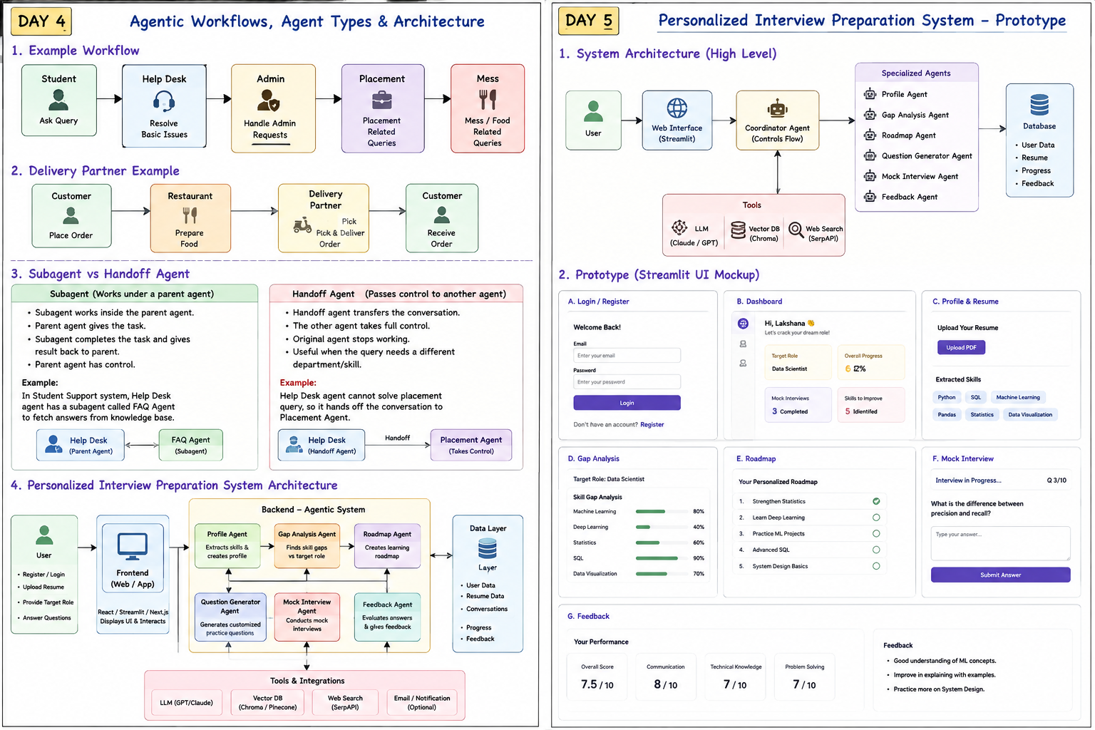
4. Personalized Interview Preparation System – My Idea
7. Goal: I want one system that reads my profile/resume, understands the target role, finds my skill gaps, creates a roadmap, asks questions, conducts mock interviews and gives feedback.
User → Frontend → Coordinator Agent → Specialist Agents → Tools/Data
5. Specialist Agents
- Profile Agent → extracts skills and experience from resume.
- Skill Gap Agent → compares current skills with target role.
- Roadmap Agent → creates a learning plan.
- Question Generator Agent → creates role-based questions.
- Mock Interview Agent → conducts the interview.
- Feedback Agent → checks answers and suggests improvements.
6. Architecture in Simple Words
8. Frontend: Login, resume upload, target role, dashboard, roadmap and mock interview pages.
9. Coordinator: Acts like the manager. It decides which specialist should work next.
10. Tools: LLM API, resume parser, vector database, web/search API and database.
11. Data: User profile, resume, skills, questions, progress and feedback.
7. Day 4 Build Plan
- Create the system flow and agent roles.
- Define state: user profile, target role, current task, results and progress.
- Define tools and what each tool is allowed to do.
- Decide where sub-agents are useful and where handoff is needed.
- Keep the first version simple: one coordinator + specialist agents.
8. Interview Answer
12. If asked to explain my architecture: I designed a coordinator-based interview preparation system. The coordinator receives the user's goal and routes work to profile, skill-gap, roadmap, question, mock-interview and feedback agents. Tools and memory provide external information and continuity, while guardrails and evaluation improve reliability.

