DAY 5 – PERSONALIZED INTERVIEW PREPARATION SYSTEM: PROTOTYPE
What I am building
1. Project: A simple AI interview preparation system that takes a resume and target role, then gives personalized skill-gap analysis, a roadmap, questions, mock interviews and feedback.
2. Prototype Flow
Login → Resume Upload → Basic Questions → Target Role → Profile → Skill Gap → Roadmap → Mock Interview → Feedback
3. Prototype Pages
- Login/Register → simple user entry.
- Profile & Resume → upload PDF and show extracted skills.
- Dashboard → target role, progress and completed interviews.
- Skill Gap → current skill vs required skill.
- Roadmap → ordered learning steps.
- Mock Interview → one question at a time.
- Feedback → score, strengths and areas to improve.
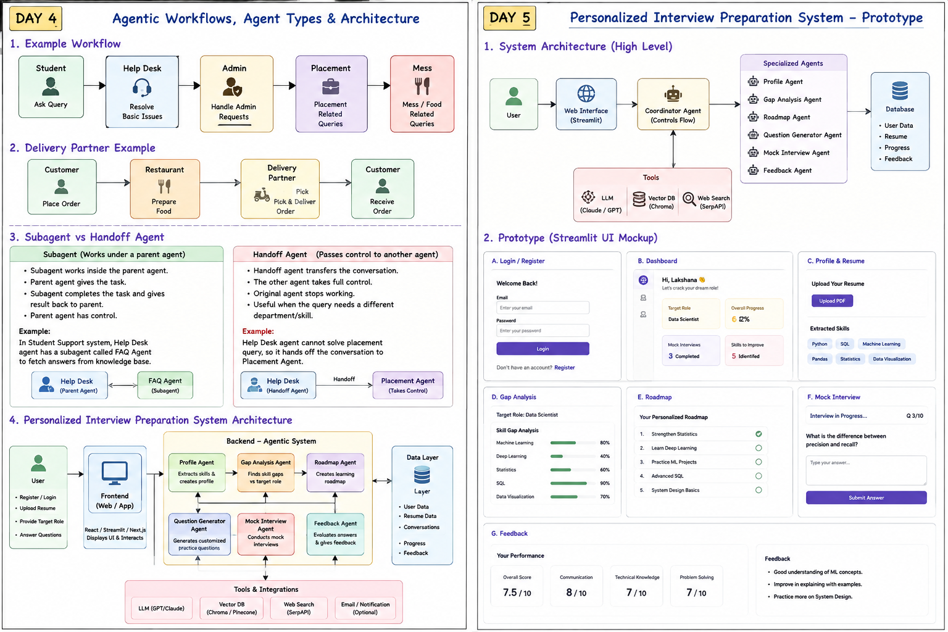
4. Simple Backend Logic
2. Step 1: Read the uploaded resume.
3. Step 2: Extract important details such as skills, education and projects.
4. Step 3: Ask for the target role.
5. Step 4: Coordinator sends the profile to the Skill Gap Agent.
6. Step 5: Skill Gap Agent finds missing skills.
7. Step 6: Roadmap Agent creates a learning plan.
8. Step 7: Question Generator creates questions based on the target role and gaps.
9. Step 8: Mock Interview Agent asks questions and receives answers.
10. Step 9: Feedback Agent evaluates the answer and gives suggestions.
5. State I Would Keep
user_id | resume_text | skills | target_role | skill_gaps | roadmap | current_question | answers | score | feedback
6. Prototype Tools
- Frontend → Streamlit.
- LLM → Groq or another selected LLM API.
- Embeddings/knowledge → Hugging Face or an embedding model.
- Vector DB → Chroma for a simple prototype.
- Search → SerpAPI if current web information is required.
- Storage → simple JSON/SQLite first; upgrade later if needed.
7. Very Simple Agent Logic
Coordinator → Profile Agent → Skill Gap Agent → Roadmap Agent → Question Agent → Mock Interview → Feedback
If a specialist cannot solve the task, the coordinator can retry, use another tool, or hand off to the appropriate specialist.
8. Prototype Success Criteria
- Resume is uploaded successfully.
- Skills are extracted and displayed.
- Target role is captured.
- Skill gaps are personalized.
- Roadmap matches the gaps.
- Questions match the target role.
- Mock interview stores answers.
- Feedback is understandable and useful.
9. Day 5 Interview Answer
11. If asked 'How did you build it?': I built a coordinator-based multi-agent prototype. The user uploads a resume and selects a target role. The coordinator sends the profile to specialist agents for skill-gap analysis, roadmap generation, question generation, mock interview and feedback. I kept the first prototype simple with Streamlit, an LLM API, a vector store and basic state so I can test the complete workflow before adding production features.
10. What I Would Add Later
- Login with proper authentication.
- Persistent user database.
- Better resume parsing.
- Role-specific question bank.
- Evaluation metrics for each agent.
- Human review for important actions.
- Deployment and monitoring.

