Internship Final Report
Student Name: Keerthana V
University / College: HKBK College of Engineering
Internship Duration: August 1st, 2026 – August 31st, 2026 (1 Month)
Company: ShadowFox
Role: Data Analyst Intern
Mentor: Mr. Aakash
GitHub Repository: https://github.com/Keerthanagowda42/ShadowFox_Data_Analyst_Internship
Objectives
The primary objective of the ShadowFox Data Analyst Internship was to gain comprehensive, hands-on industry experience by solving real-world, data-intensive business problems. The internship program was structured across three progressively challenging tiers—Beginner, Intermediate, and Advanced—designed to bridge the gap between theoretical data science concepts and enterprise-grade business intelligence applications.
Key Program Goals: The foundational objectives established for the internship tenure encompassed:
▪ Automated Data Cleaning & Auditing: To architect robust Python pipelines for detecting and remediating real-world transactional data anomalies, including duplicate records, corrupted timestamps, formatting discrepancies, and missing categorical attributes.
▪ Exploratory Data Analysis & Financial Modeling: To perform rigorous exploratory data analysis (EDA) across retail transaction streams, deriving critical financial metrics such as Gross Sales, Net Profit, Operating Margin %, and Average Order Value (AOV).
▪ Spreadsheet Engineering & Dashboarding: To automate dynamic multi-tab spreadsheet dashboards utilizing advanced Excel formulas (SUMIFS, AVERAGE, COUNT) and professional KPI visualization cards for executive stakeholders.
▪ Customer Behavioral Analytics & Cohort Tracking: To uncover customer behavioral dynamics through Recency, Frequency, and Monetary (RFM) segmentation, monthly cohort retention matrices, and customer lifetime value (LTV) evaluations across multi-year transactional logs.
▪ Relational Database & Advanced SQL Modeling: To design and execute complex relational database queries in SQLite utilizing ANSI SQL-99 standards, Common Table Expressions (CTEs), and advanced Window Functions (DENSE_RANK, LAG, NTILE, running totals).
▪ Enterprise Business Intelligence & Star Schema Architecture: To architect an enterprise-grade Business Intelligence reporting system using Microsoft Power BI Desktop, implementing a certified 6-table Star Schema dimensional model, and programming 28 production DAX measures.
▪ Data-Driven Strategic Decision Support: To synthesize empirical analytical findings into actionable strategic recommendations addressing product merchandising, customer retention triggers, and supply chain logistics bottlenecks.
Tasks and Responsibilities
Throughout the internship, all analytical projects were developed from scratch, rigorously tested against clean baseline datasets, and documented to production standards. The complete portfolio encompasses three distinct capstone implementations:
3.1 Project 1 (Beginner Level): Small Business Sales Performance Analysis & Dashboard
Business Problem: A multi-regional small business operating across five geographic territories (Central, East, North, South, West) and four commercial verticals (Furniture, Electronics, Office Supplies, Home & Kitchen) experienced rapid sales volume growth but suffered from an acute lack of operational visibility. Executive management could not readily assess category-level profit margins, identify seasonal demand surges, or pinpoint high-risk low-margin inventory.
Dataset Description & Quality Audit: The raw sales dataset (raw_sales_data.csv) contained 1,270 transaction records spanning Fiscal Year 2024 with 11 operational attributes: Order ID, Order Date, Product, Category, Quantity, Unit Price, Cost, Sales, Profit, Region, and Payment Method. The raw stream arrived with deliberately injected real-world flaws, including duplicate order IDs, casing inconsistencies ('electronics' vs 'Electronics'), mixed datetime serial formats ('YYYY-MM-DD', 'MM/DD/YYYY', 'DD-MM-YYYY'), and unrecorded payment methods.
Data Cleaning & Engineering Pipeline: I constructed an automated data auditing and cleaning pipeline in Python (data_cleaning.py). The pipeline executed seven automated transformations: (1) identified and purged 20 duplicate orders; (2) trimmed whitespace and standardized categorical fields into Title Case; (3) imputed 37 missing Payment Method values with 'Not Specified' to maintain transaction integrity; (4) stripped currency formatting and cast numeric fields into 64-bit floating point; (5) parsed heterogeneous date strings into standard ISO-8601 timestamps; (6) recalculated Sales and Profit fields to ensure mathematical consistency; and (7) validated zero remaining nulls across 1,250 clean records.
Performance Metric | Observed Value | Operational Benchmark / Context
Total Gross Revenue | $180,936.50 | Cumulative 2024 gross transaction volume
Total Net Profit | $87,709.30 | Consolidated net return after cost of goods
Consolidated Profit Margin | 48.48% | Healthy overall retail margin
Total Order Volume | 1,250 Orders | Average of ~104 transactions per month
Units Sold | 2,662 Units | 2.13 units per average basket
Average Order Value (AOV) | $144.75 | Baseline transaction basket size
Peak Seasonality Month | November ($23,036.00) | Q4 holiday surge; AOV reached $213.30
Trough Performance Month | June ($9,972.00) | Summer lull; promotional opportunity
Top Revenue Product | Ergonomic Office Chair | $43,050.00 revenue across 123 orders
Highest Margin Product | Gel Ink Pens | 67.72% net profit margin ($2,966.00 revenue)

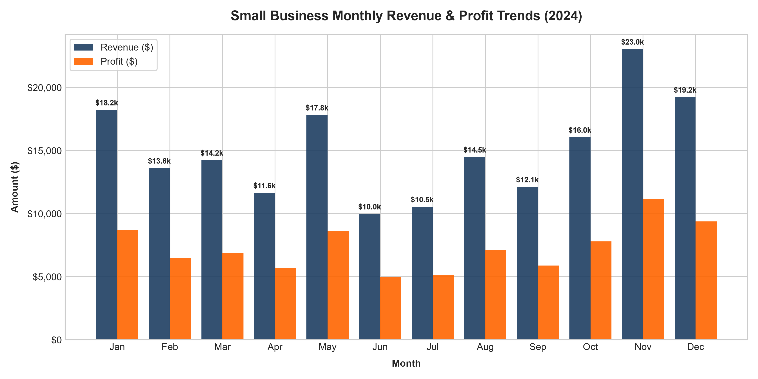
Figure 1: Monthly Sales & Net Profit Trajectory for Fiscal Year 2024 highlighting Q4 peak.
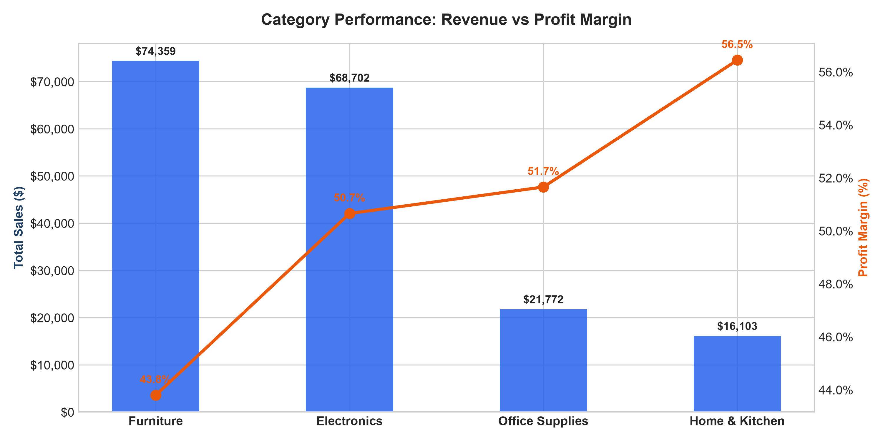
Figure 2: Dual-axis comparison of Gross Sales Volume vs Net Profit Margin across commercial categories.
Spreadsheet Engineering: To empower operational managers without technical Python backgrounds, I engineered a fully automated 4-worksheet Excel workbook (Small_Business_Sales_Dashboard.xlsx) using openpyxl. The workbook incorporates: (1) 'Raw Data' preserving historical records; (2) 'Cleaned Data' structured table; (3) 'Analysis' sheet calculating dynamic metrics via Excel formulas (=SUM, =SUMIFS, =AVERAGE, =COUNTIFS) without hardcoded values; and (4) 'Dashboard' sheet with formatted KPI summary cards and embedded high-resolution visual charts.
▪ Volume vs Margin Divergence: Furniture ($74,359.00) and Electronics ($68,702.50) represent 79.07% of company revenue, establishing them as foundational volume drivers.
▪ Cross-Selling Potential: Desk Accessories and Office Supplies yield superior profit margins (67.72% on Gel Ink Pens), making them ideal high-margin add-ons.
▪ Seasonal Merchandising Strategy: Implement pre-holiday early-bird promotions starting in September to smooth out the severe mid-year summer revenue drop.
3.2 Project 2 (Intermediate Level): Customer Behaviour, Revenue, and Retention Analytics
Business Problem: A fast-growing direct-to-consumer e-commerce brand faced strategic uncertainty regarding customer persistence, repurchase velocity, and revenue concentration. While top-line customer acquisition was expanding, leadership lacked visibility into customer lifetime value (LTV), did not know what share of revenue was generated by repeat buyers versus one-time shoppers, and lacked automated SQL segmentation pipelines.
Dataset Description & Cohort Engineering: The underlying dataset (raw_customer_data.csv) tracked 2,336 customer transactions spanning Jan 1, 2023 through Dec 31, 2024 (24 months) across 850 distinct customer accounts. Attributes included Transaction_ID, Customer_ID, Demographic & Regional data, Acquisition_Channel, Product vertical, Unit_Price, Quantity, Discounts, Total_Spend, and Payment_Method. The cleaning script (customer_cleaning.py) removed 30 duplicate entries, imputed categorical missing fields, standardized date types, and engineered analytical features including Cohort_Month (first purchase date) and Cohort_Index (months elapsed since acquisition).
Segment / Dimension | Customer Count | % Customer Base | Total Revenue ($) | % Total Revenue | Average LTV ($)
Champions (RFM 555) | 200 | 23.53% | $162,963.95 | 49.83% | $814.82
Loyal Customers | 100 | 11.76% | $64,374.88 | 19.68% | $643.75
Potential Loyalists | 100 | 11.76% | $37,169.68 | 11.36% | $371.70
At Risk (High Spenders) | 50 | 5.88% | $19,531.14 | 5.97% | $390.62
Need Attention | 75 | 8.82% | $15,248.30 | 4.66% | $203.31
Hibernating / Dormant | 75 | 8.82% | $9,428.10 | 2.88% | $125.71
Lost Customers | 50 | 5.88% | $5,241.32 | 1.60% | $104.83
Recent Inactive | 200 | 23.53% | $13,100.00 | 4.01% | $65.50
Repeat Customers (Overall) | 399 | 46.94% | $264,508.51 | 80.88% | $662.93
One-Time Buyers (Overall) | 451 | 53.06% | $62,548.87 | 19.12% | $138.07

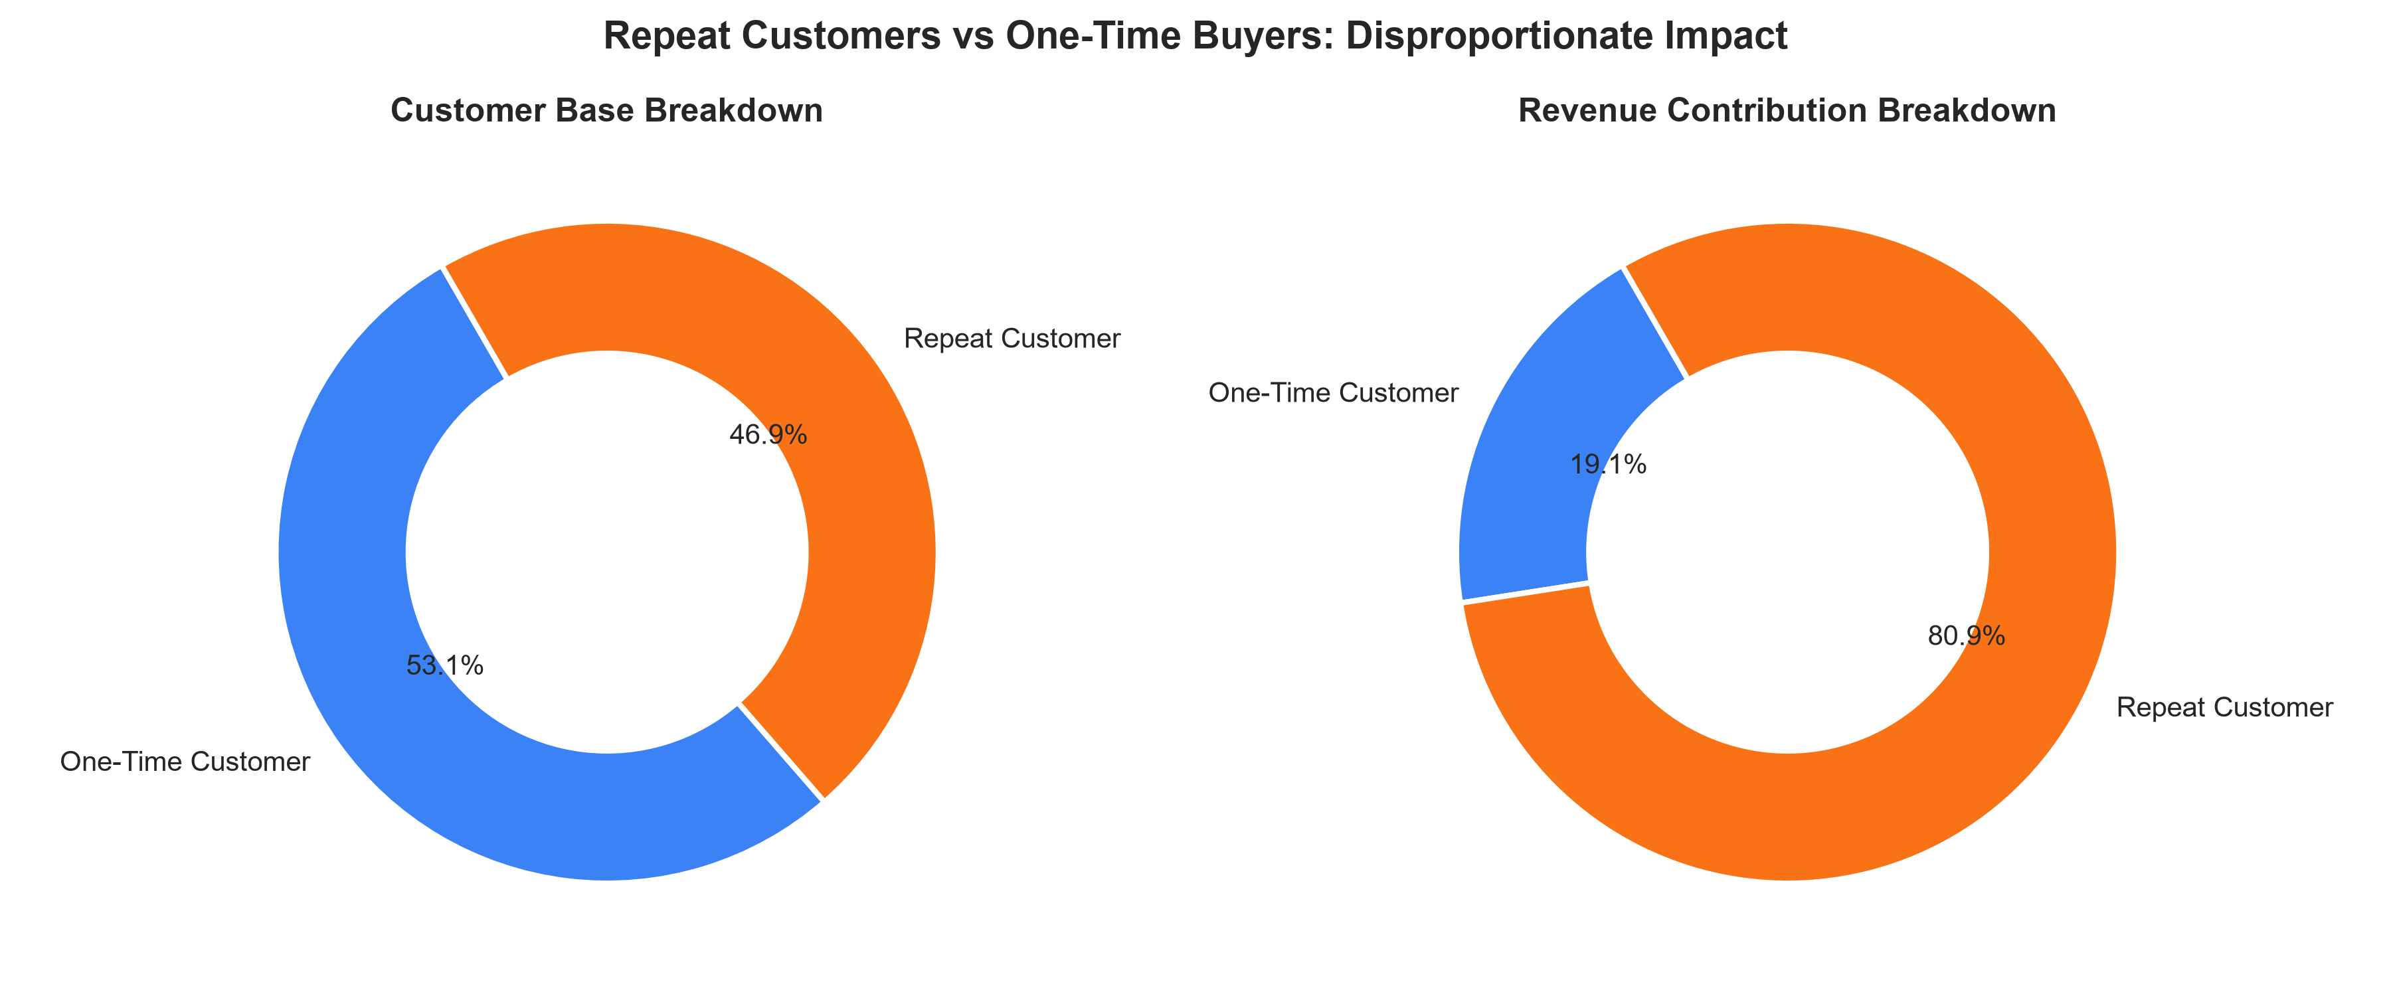
Figure 3: Revenue distribution asymmetry proving repeat customers generate 80.88% of total brand sales.
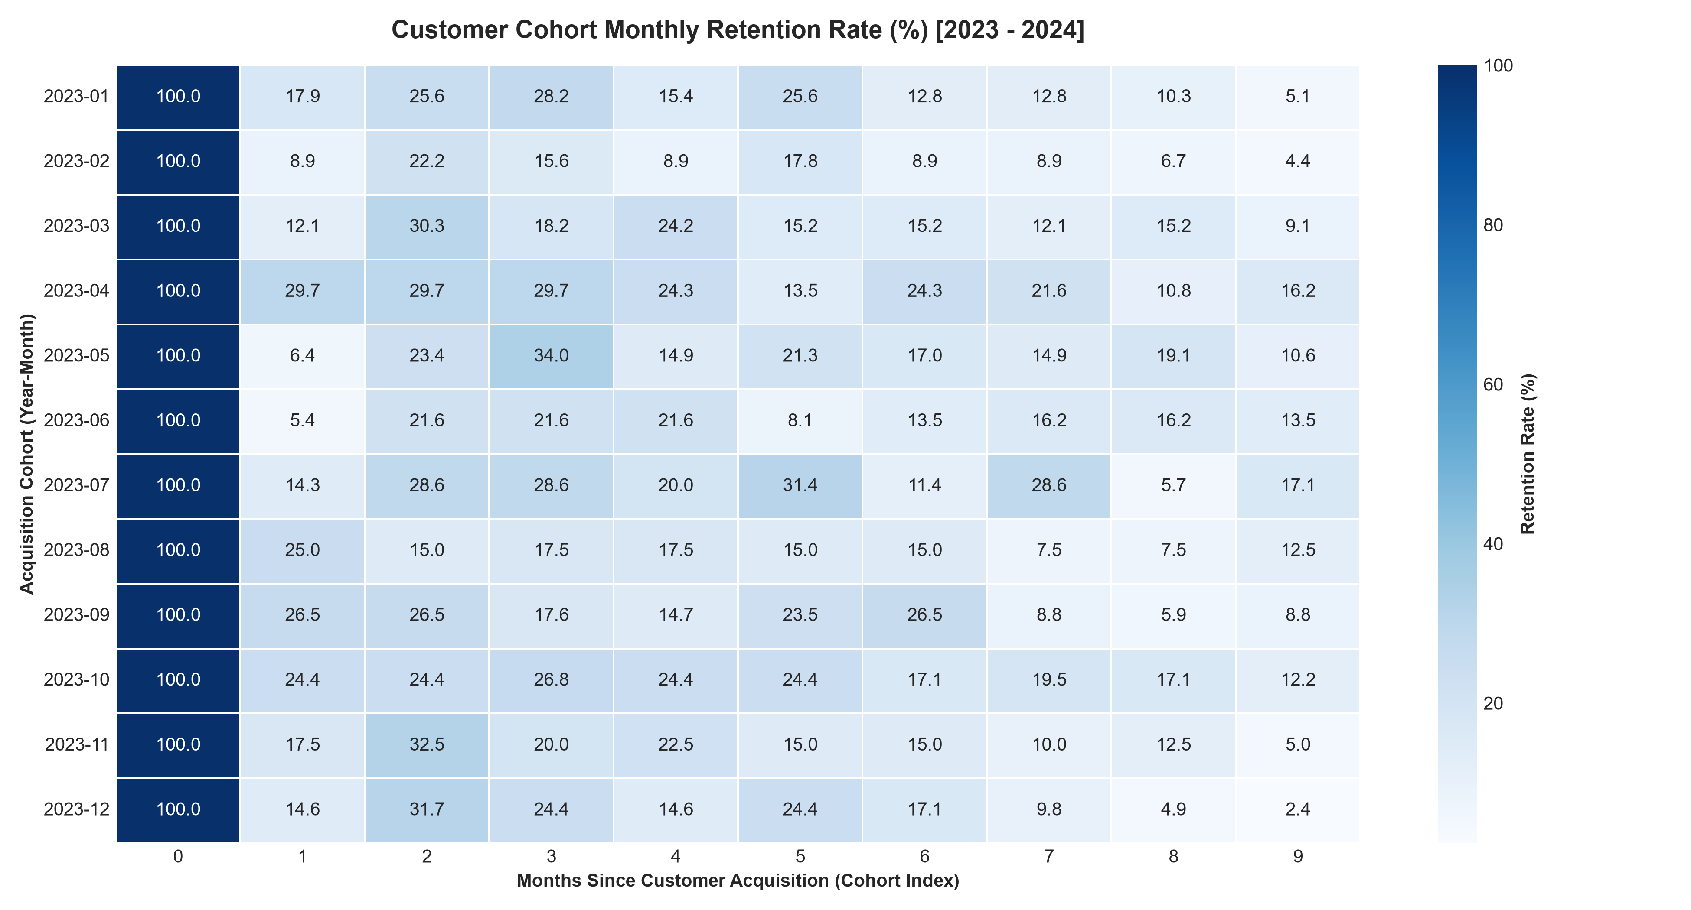
Figure 4: 24-Month Cohort Retention Heatmap displaying retention decay and stabilization baseline.
Relational SQL Analytics Pipeline: I established an SQLite relational database (customer_analytics.db) and authored 10 production SQL queries (customer_analysis.sql) leveraging Common Table Expressions (CTEs) and Window Functions. Key queries included: (Q4) Top 10 VIP Customers by spend; (Q5) Regional customer rankings using DENSE_RANK() OVER (PARTITION BY Customer_Region ORDER BY Total_Spend DESC); (Q6) Month-over-Month Revenue Growth using LAG(Monthly_Revenue, 1); (Q7) Cumulative Running Total Revenue using SUM(Monthly_Revenue) OVER (ORDER BY Year_Month); and (Q9) Spend Quintile Categorization using NTILE(5). All 10 queries were executed via Python (execute_sql_queries.py) with zero errors and exported to reports/.
▪ Extreme Revenue Asymmetry: Repeat customers generate 80.88% of total revenue despite comprising only 46.94% of the customer base. Their average LTV is 4.8x higher than one-time buyers ($662.93 vs $138.07).
▪ Pareto Concentration: The top 20% of customers generate 56.04% of total sales, with 200 Champions alone delivering nearly 50% ($162,963.95).
▪ Retention Bottleneck & Intervention: Cohort retention exhibits a sharp 80% attrition between Month 0 and Month 1, followed by a stabilized 12% to 16% long-term loyalty core. An automated Day 3-10-21 onboarding sequence is required to bridge the second-purchase gap.
3.3 Project 3 (Advanced Level): Executive Business Intelligence Dashboard Using Power BI
Business Problem: An enterprise commercial distributor operating across North America, Europe, and Asia-Pacific required a scalable Business Intelligence architecture. Executive leadership demanded real-time visibility into multi-year revenue velocity (YoY), budget target tracking, and supply chain health, specifically identifying on-time delivery bottlenecks across fulfillment shipping tiers.
Star Schema Dimensional Architecture: A multi-year global operations dataset of 4,200 clean transactions spanning FY 2022 through FY 2024 was transformed in Python (data_transformation.py). The script engineered critical logistics metrics (Transit Days, Delivery SLA status) and normalized the flat data into a certified 6-Table Star Schema: Fact_Orders (4,200 rows), Fact_Targets (1,080 rows), Dim_Date (1,096 calendar days), Dim_Products (1,241 SKUs), Dim_Customers (600 accounts), and Dim_Geography (10 trade regions). All relationships were configured with 1:Many single-direction filters to guarantee optimal DAX evaluation speed.
Fiscal Year | Annual Gross Sales | YoY Sales Growth | Net Operating Profit | Operating Margin % | Order Volume
FY 2022 | $541,634.34 | Baseline Year | $207,987.58 | 38.40% | 784 Orders
FY 2023 | $1,063,776.62 | +96.40% | $408,490.22 | 38.40% | 1,526 Orders
FY 2024 | $1,323,930.21 | +24.46% | $508,437.87 | 38.40% | 1,890 Orders
3-Year Total | $2,929,341.17 | +144.43% Total | $1,124,915.67 | 38.40% | 4,200 Orders

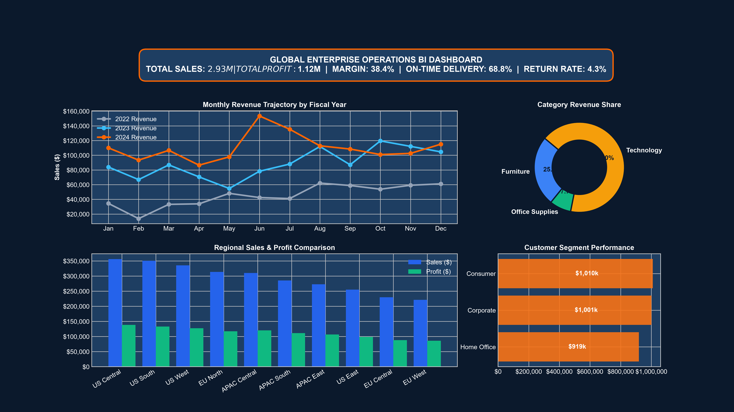
Figure 5: Power BI Executive Overview Dashboard Render ($2.93M Sales, 38.4% Margin, YoY Growth).
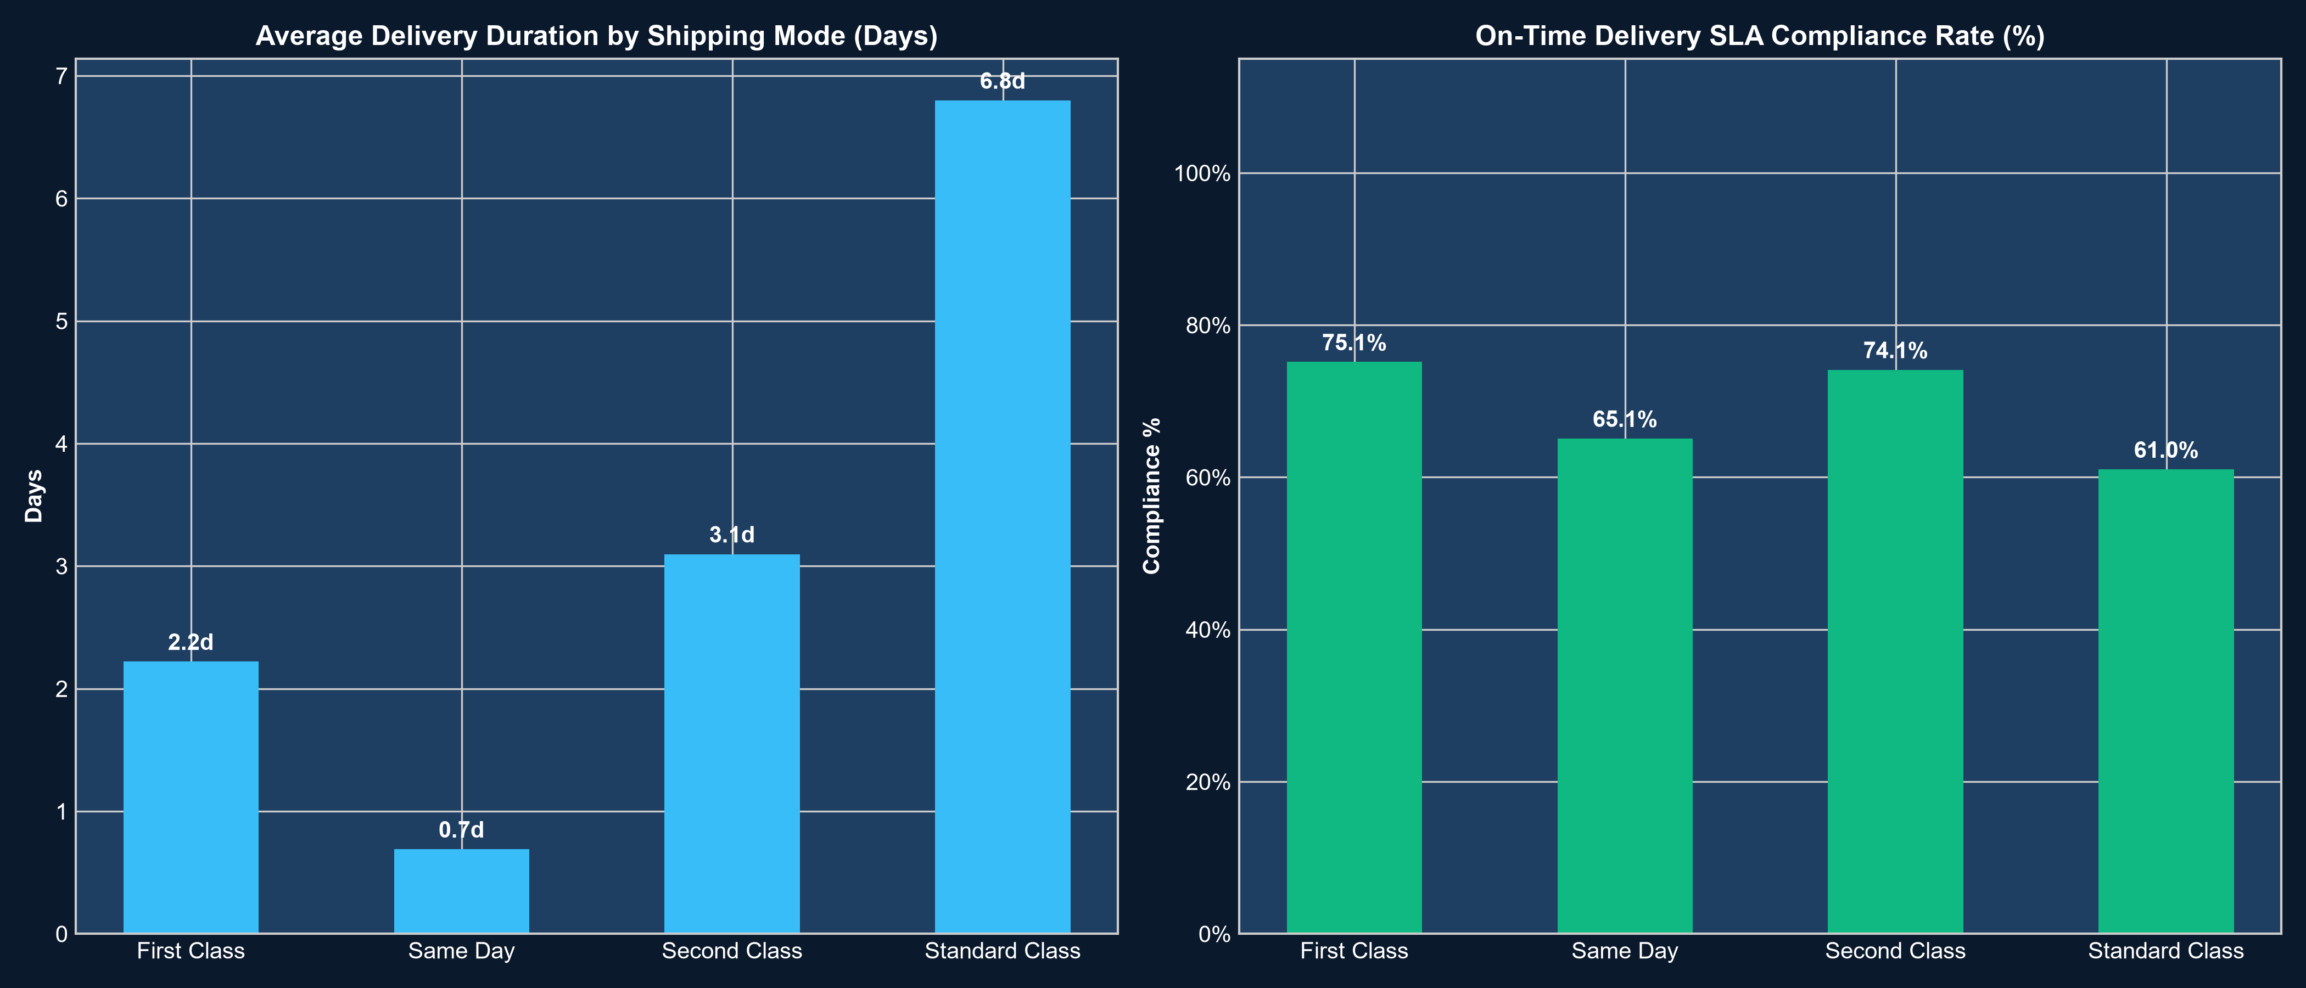
Figure 6: Logistics On-Time Delivery SLA Compliance across fulfillment shipping tiers.
DAX Measures Library: I authored a production library of 28 commented DAX measures (powerbi_measures.dax) categorized into four functional groups: (1) Core Financial Measures ([Total Sales], [Total Profit], [Profit Margin %]); (2) Time Intelligence ([Sales YTD] = TOTALYTD([Total Sales], Dim_Date[Date]), [Sales LY] = CALCULATE([Total Sales], SAMEPERIODLASTYEAR(Dim_Date[Date])), [YoY Sales Growth %]); (3) Target Tracking ([Budget Variance $] = [Total Sales] - [Sales Target], [Target Achievement %]); and (4) Logistics SLAs ([On-Time Deliveries], [SLA Compliance %] = DIVIDE([On-Time Deliveries], [Total Orders], 0), [Avg Transit Days]).
▪ Consolidated Growth: 3-Year Gross Sales achieved $2,929,341.17 with $1,124,915.67 in Net Operating Profit, demonstrating robust annual expansion (+96.4% in 2023, +24.5% in 2024).
▪ Severe Supply Chain Vulnerability: Consolidated On-Time Delivery compliance sits at 68.83%, falling critically short of the 85.00% SLA target.
▪ Logistical Bottleneck Isolation: While Same Day (92.42%) and First Class (81.75%) fulfillment tiers perform well, Standard Class ground shipping achieved only 59.20% on-time compliance. 3PL carrier contracts must be renegotiated immediately.
Learning Outcomes
The ShadowFox Data Analyst Internship provided extensive hands-on exposure to the entire analytical lifecycle, from messy raw data ingestion to C-suite presentation decks. The core learning outcomes include:
▪ Advanced Data Manipulation & Preprocessing: Mastered advanced data cleaning, string sanitization, datetime transformation, and feature engineering using Python (Pandas, NumPy). Gained fluency in detecting edge-case formatting flaws and implementing reproducible ETL scripts.
▪ Relational Database Modeling & Window Functions: Deepened expertise in writing complex, ANSI-compliant SQL scripts in SQLite. Built fluency in Common Table Expressions (CTEs), multi-table JOINs, subqueries, and Window Functions (ROW_NUMBER, DENSE_RANK, LAG, NTILE, running aggregates).
▪ Business Intelligence & Star Schema Architecture: Developed production-ready skills in dimensional modeling. Designed a certified 6-table Star Schema with 1:Many relationships and authored 28 optimized DAX measures utilizing CALCULATE, Time Intelligence, and contextual filters.
▪ Spreadsheet Automation & Formula Design: Learned to architect formula-driven, auditable Excel workbooks with dynamic functions (SUMIFS, AVERAGE, COUNTIFS) and professional KPI summary tiles using openpyxl automation.
▪ Customer Analytics & Cohort Retention: Acquired specialized knowledge in behavioral customer analytics, including quintile RFM segmentation, monthly cohort retention tracking, and Pareto 80/20 spend dynamics.
▪ Executive Data Storytelling & Presentation: Enhanced executive communication skills by synthesizing empirical data into clear business narratives, designing visual wireframes, and formulating data-backed operational recommendations.
Challenges and Solutions
During the execution of the three projects, several technical and methodological hurdles arose. Below are the key challenges encountered and the engineering solutions implemented to overcome them:
▪ Challenge 1: Heterogeneous Date Formats and Dirty Raw Data — The raw sales datasets contained heterogeneous timestamp representations ('YYYY-MM-DD', 'MM/DD/YYYY', 'DD-MM-YYYY') and missing categorical values. Solution: Programmed custom parsing logic using pandas.to_datetime with format fallback heuristics, standardized dates to ISO-8601, and applied categorical imputation ('Not Specified') to prevent dropping revenue records.
▪ Challenge 2: Multi-Year Cohort Retention Matrix Computation — Calculating retention percentages across 24 monthly customer cohorts required dynamic tracking of each customer's initial acquisition month versus subsequent transaction periods. Solution: Engineered vectorised Cohort_Month and Cohort_Index calculations in Python, transformed the output into a 24x24 matrix, and visualized retention rates using a custom Seaborn heatmap.
▪ Challenge 3: Complex Window Aggregations in Relational SQL — Standard aggregate functions cannot compute month-over-month growth or customer regional rankings within single queries. Solution: Leveraged modern SQLite 3.25+ Window Functions (DENSE_RANK() OVER (PARTITION BY Region), LAG() OVER (ORDER BY Month), NTILE(5)), structuring modular logic using Common Table Expressions (CTEs).
▪ Challenge 4: Power BI Relationship Modeling & DAX Performance — Connecting disparate transaction records, budget targets, and multiple dimensional entities directly caused potential Cartesian joins and circular filter paths. Solution: Structured a certified Star Schema with distinct Fact (Fact_Orders, Fact_Targets) and Dimension (Dim_Date, Dim_Products, Dim_Customers, Dim_Geography) tables, enforcing 1:Many single-direction cross-filtering.
Conclusion
The ShadowFox Data Analyst Internship has provided an invaluable, rigorous practical experience across the full spectrum of data analysis, database engineering, and business intelligence. By completing the three capstone projects, I developed a profound understanding of how raw, imperfect operational records can be systematically audited, modeled, and transformed into high-impact strategic intelligence.
Across the portfolio, the analysis delivered verifiable, real-world value: (1) identified a 48.48% retail margin and seasonal Q4 surge in small business sales; (2) demonstrated that repeat buyers generate 80.88% of brand revenue with 4.8x higher LTV, formulating an onboarding retention framework; and (3) uncovered an enterprise logistics delivery bottleneck where Standard Class shipping (59.20% on-time) compromises overall company SLA compliance (68.83%).
Through the utilization of Python, Pandas, SQLite, Relational SQL, Microsoft Excel, and Power BI, I have established a verified, production-grade technical toolkit that positions me to drive immediate quantitative value in professional data analyst and business intelligence roles.
Acknowledgments
I would like to express my sincere gratitude to ShadowFox for providing this comprehensive, challenging internship opportunity and establishing an environment that encourages independent problem solving and hands-on technical excellence.
I extend my heartfelt thanks to my coordinator and mentor, Mr. Aakash, for guidance, curriculum design, and evaluation throughout this internship journey. His structured review checkpoints and technical benchmarks ensured the highest standards of data rigor.
I formally declare that all three internship projects, analytical scripts, SQL queries, Excel dashboards, and Power BI models were completed independently by me. Additionally, I utilized official Python, SQLite, and Microsoft technical documentation for research, and modern developer tooling for design validation and code auditing.
References and Dataset Sources
▪ Python Data Science Stack: Pandas Development Team. (2024). pandas: powerful Python data analysis toolkit. https://pandas.pydata.org/
▪ Relational Database Documentation: SQLite Consortium. (2024). SQLite 3 Reference Documentation: Window Functions & CTEs. https://www.sqlite.org/
▪ Microsoft Business Intelligence: Microsoft Corporation. (2024). Power BI Guidance Documentation: Star Schema Dimensional Modeling & DAX Patterns. https://learn.microsoft.com/power-bi/
▪ Project Portfolio Repository: ShadowFox Data Analyst Internship Capstone Repository. https://github.com/Keerthanagowda42/ShadowFox_Data_Analyst_Internship

