**CHATBOT USING PYTHON**

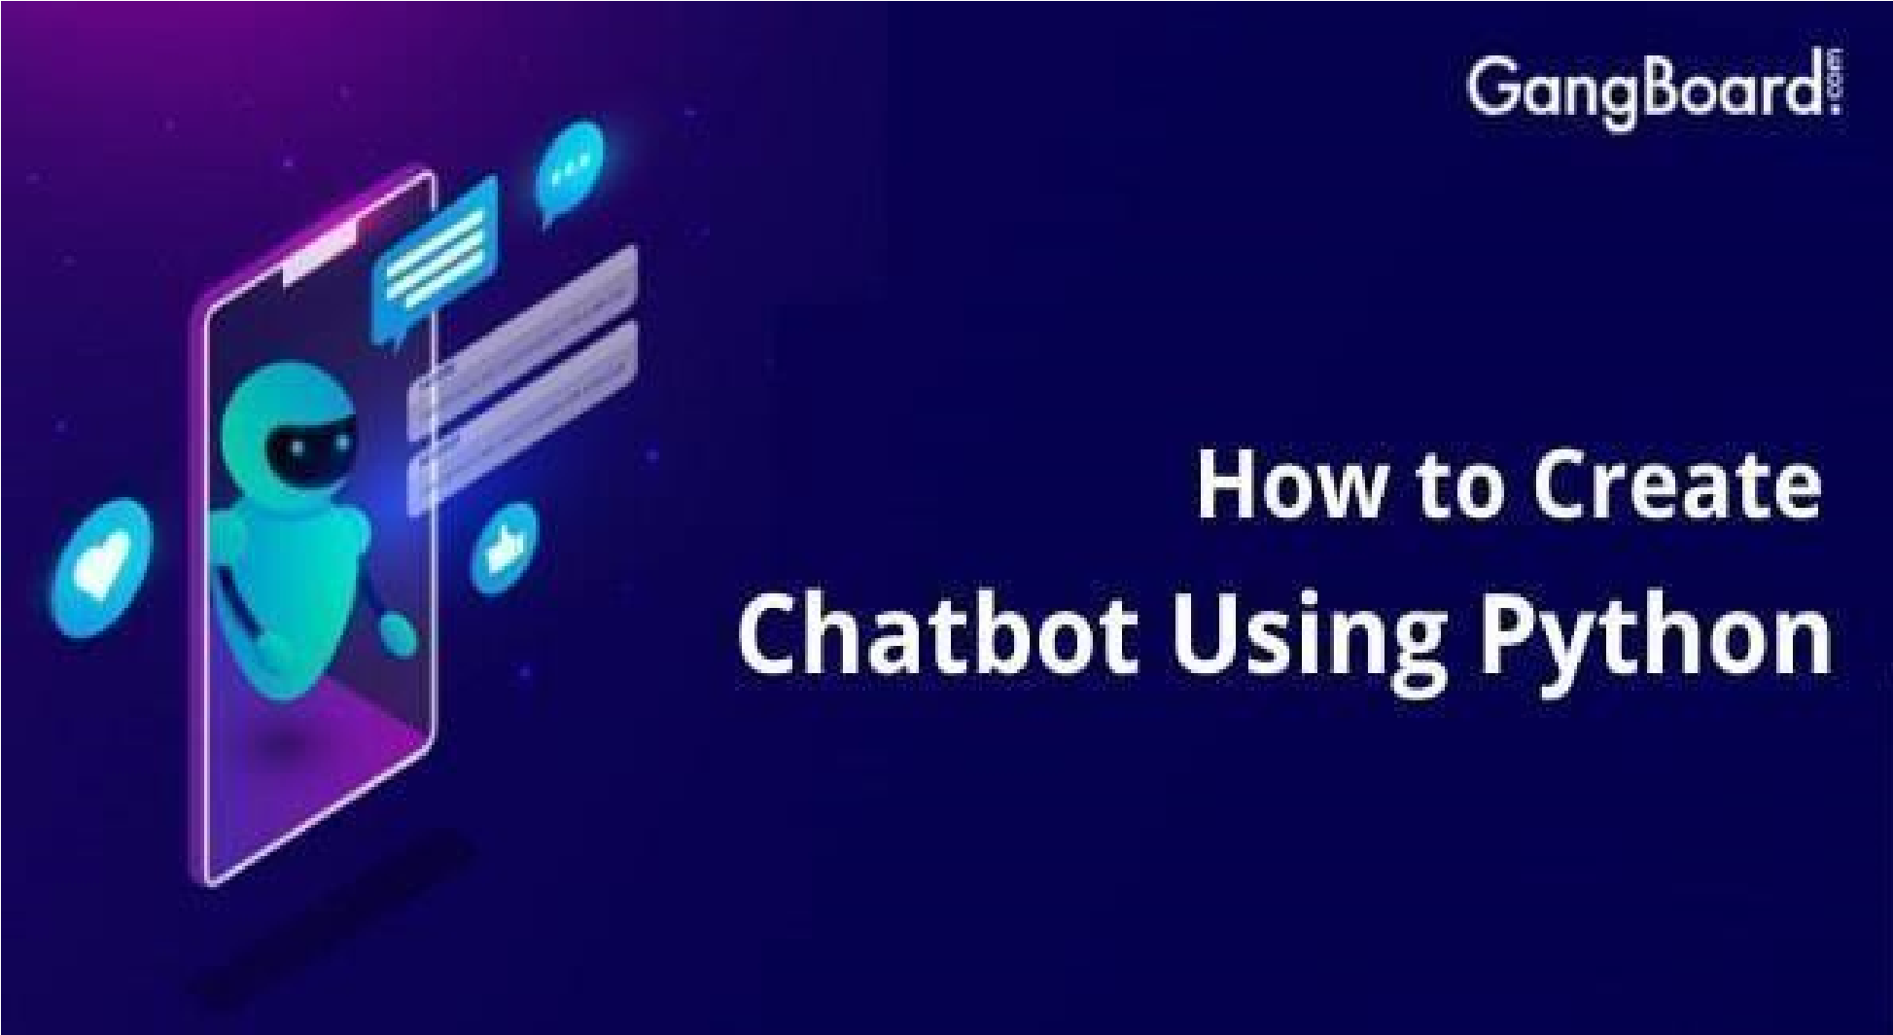

Name:KEERTHANA KUMARI. V

Reg.No: 513521106013

Department: ECE

Year: III

NM ID: au51352106013

# EMail:keerthanakumari424@gmail.com

**PROBLEM STATEMENT:**

Develop a chatbot using Python that can effectively engage with users, provide helpful information, and perform tasks or answer questions across various domains. The chatbot should be able to understand natural language input and provide appropriate responses, ensuring a smooth and userfriendly conversational experience.

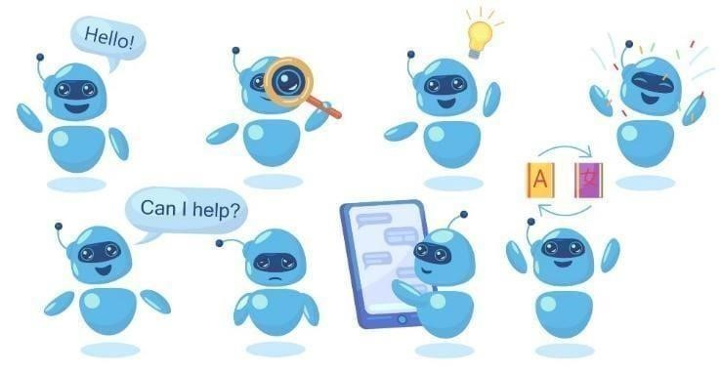

**PROJECT OVERVIEW:**

1. Natural Language Understanding: Implement natural language processing (NLP) techniques to enable the chatbot to understand and interpret user input effectively. This includes intent recognition, entity extraction, and context awareness.

1. Multi-Domain Support: Design the chatbot to handle a wide range of user queries across different domains, such as customer support, general knowledge, e-commerce, and more.

1. Personalization: Incorporate features that allow the chatbot to remember user preferences and maintain context throughout the conversation, providing a personalized user experience.

1. Task Automation: Enable the chatbot to perform tasks or actions on behalf of users, including making recommendations, scheduling appointments, or processing orders.

1. Integration: Integrate the chatbot with external data sources, APIs, or databases to fetch real-time information or execute specific actions. This may involve accessing weather data, retrieving product details, or connecting to booking systems.

**THE TEAM MEMBERS:**

* 1. Durga Devi. A
  2. Keerthana Kumari. V
  3. Sandhiya. E
  4. Sneka. K

**DESIGN THINKING**

Design thinking is a human-centered approach to problem-solving and innovation. When designing a chatbot using Python, applying design thinking principles can help create a user-centric and effective conversational AI system.

Here's a design thinking process tailored for developing a chatbot using Python:

1. Empathize: Understand User Needs
2. Define: Clearly Define the Problem
3. Ideate: Brainstorm Solutions
4. Prototype: Build a Minimum Viable Product (MVP)
5. Test: Gather Feedback
6. Implement: Develop the Chatbot
7. Deploy: Make the Chatbot Accessible
8. Gather Feedback: Continuous Improvement
9. Iterate: Continuous Development
10. Scale: Handle Growth
11. Monitor: Maintain and Monitor

By following this design thinking process, you can develop a chatbot using Python that not only meets user needs but also evolves over time to provide an increasingly valuable conversational experience. The iterative nature of design thinking ensures that the chatbot remains relevant and effective in a dynamic environment.

**PROBLEM DEFINTION**:

Chatbots in customer support comes with interpreting the messages and understanding the user intention. Programming flexible algorithms for interpreting the intention of the message is a top priority upon making a chatbot.

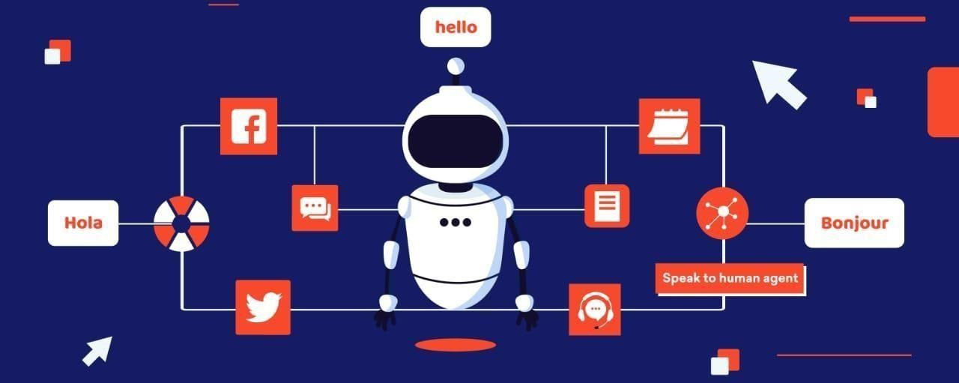

# Empathize: Understand User Needs

User Research: Begin by conducting in-depth user research to understand the needs, pain points, and preferences of your target audience. Gather feedback through surveys, interviews, and user observations.

User Personas: Create user personas to represent different user segments, each with unique characteristics and requirements for the chatbot.

# Define: Clearly Define the Problem

Problem Statement: Based on the insights gained during the empathize phase, define a clear problem statement that the chatbot will address.

Consider what specific tasks or issues the chatbot will help users with.

# Ideate: Brainstorm Solutions

Cross-Functional Team: Assemble a cross-functional team that includes developers, designers, NLP specialists, and domain experts to brainstorm creative solutions.

# Prototype: Build a Minimum Viable Product (MVP)

Develop MVP: Create a basic version of the chatbot using Python. Focus on core functionalities that address the defined problem. Use Python libraries or frameworks suitable for chatbot development.

# Test: Gather Feedback

Usability Testing: Conduct usability testing with real users to gather feedback on the chatbot's functionality, user interface, and overall user experience.

# Implement: Develop the Chatbot

Programming: Develop the chatbot using Python and relevant libraries or frameworks. Implement natural language understanding (NLU) and natural language generation (NLG) components for effective communication.

# Deploy: Make the Chatbot Accessible

Hosting: Deploy the chatbot to a hosting environment that ensures availability and scalability. Consider cloud-based hosting solutions.

# Gather Feedback: Continuous Improvement

User Feedback: Encourage users to provide feedback on their interactions with the chatbot. Implement feedback mechanisms within the chatbot.

# Iterate: Continuous Development

Iterative Development: Use an iterative development approach to make regular updates and enhancements to the chatbot based on user feedback, changing requirements, and emerging technologies.

# Scale: Handle Growth

Scalability: Ensure that the chatbot can handle increased usage as its user base grows. Optimize performance and resource utilization.

Security: Implement robust security measures to protect user data and ensure safe interactions.

# Monitor: Maintain and Monitor

Ongoing Maintenance: Continuously monitor and maintain the chatbot to address any issues, bugs, or performance bottlenecks.

**POSSIBLE FUTURE WORK:**

There are several exciting and potentially transformative directions for future work on chatbots using Python or other bot development platforms. Here are some possible future avenues for chatbot development and research:

* Multilingual and Cross-Cultural Chatbots: Create chatbots that can understand and respond to users in multiple languages and adapt to cultural nuances. This will make chatbots more inclusive and globally accessible.

* Voice-Enabled Chatbots: Extend chatbot capabilities to support voice interactions, enabling users to have natural conversations without typing. Integrating speech recognition and synthesis technologies will be essential.

These future directions for chatbot development and research hold the potential to significantly enhance the capabilities, usability, and impact of chatbots in various domains and applications. Chatbot developers and researchers can explore these areas to stay at the forefront of conversational AI innovation.



# GPT-3

•

The Generative Pre-Trained Transformer (GPT) is an innovation in the Natural Language Processing (NLP) space developed by OpenAI. These models are known to be the most advanced of its kind and can even be dangerous in the wrong hands. It is an unsupervised generative model which means that it takes an input such as a sentence and tries to generate an appropriate response, and the data used for its training is not labelled.

•

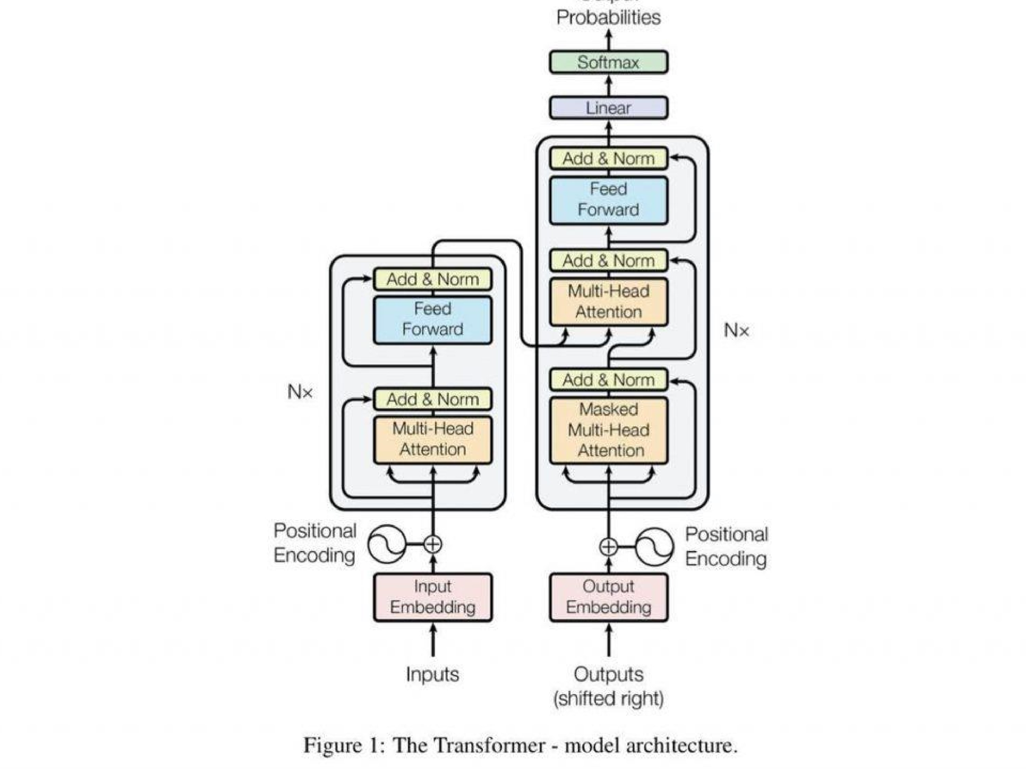

## GPT 3 Chatbot: A Magic Tool to Supersede Human Workforce

• The AI platform has grabbed gazillions of eyeballs, with people trying out the new label worldwide. Not only this, but the innovation has successfully entered the list of tech companies loved by the tech giant Microsoft. The news suggests that the company is all set to invest billions of dollars in the OpenAI GPT 3 chatbot.

**The Difference Between ChatGPT and GPT-3**

people thought Google would always be the go-to

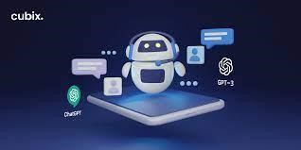source for all kinds of info. It was never capable of delivering everything. However, it was perhaps the only source that incrementally improved, eventually emerging with a fabulous array of tools and resources for individuals and businesses to benefit from. All that Google achieved now seems like a proverbial stoneage in the face of the OpenAI algorithm and its different models. ChatGPT, for example, is an unprecedented worry for a robust entity

## GPT-3 and innovation in natural language processing (NLP)

• The [**OpenAI**](https://openai.com/)laboratory, based in California, launched this year a new model of artificial intelligence language called GPT-3, or **Generative Pre-trained Transformer**. The new generation of the program is nothing more than a predictor of texts that performs a simple action – that of autocomplete -, but represents an important technical advance for the NLP area.

# LIMITATIONS OF GPT-3 CHATBOTS

## • 1. Natural language processing

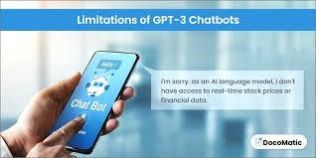• GPT-3 chatbots do not understand human-like conversational text or words. Instead, generating a correct answer like humans becomes difficult. It sometimes provides irrelevant output code or answers due to a pre-trained model. The output that it gives lacks the perfect understanding of the words. However, due to the language model used, the chatbot is restricted from answering questions correctly.

## • 2. Uncertainty of input leads to ambiguity

• Chatbot is not similar to Google search engine, where you can throw any questions to get accurate answers. To generate text from the chatbot exactly the way you want is only possible if the language you use is certain. Be specific with the questions and language you use, as the chatbot will struggle with complex questions resulting in response errors.

•

## Natural Language Processing

* [**Human natural**](https://cic.unb.br/~jhcf/MyBooks/ic/3.ProgramacaoBasica/AspectosTeoricos/MaquinasLinguagens/LinguagensNaturais/linguagensnaturais.html)language, by definition, is any means of communication developed by humans and without premeditation. For example, languages, which are made up of signs specific to the language of a location, require people to know how to “decode” the signs of a language in order to understand them.
* **Human-machine communication exists through the ability to process natural language**, that is, the computer needs inputs – data and parameters – to process certain information, understand it, and eventually bring a coherent response.