Instructions

- Download and install anaconda3 from given link(ignore step 1,3 if you already done )
- link : https://www.filehorse.com/download-anaconda-64/download/

- At the stage given in the image below check both checkboxes

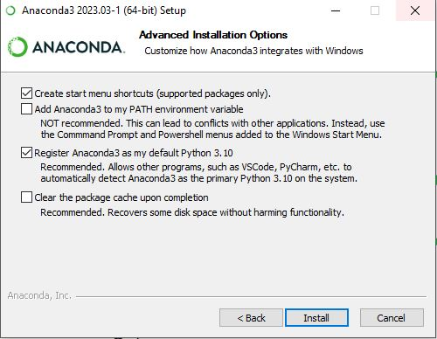

- Extract “updated_bts.Rar” file in a folder
- Extract myenv.rar file to location C->users->user(it may be vary based on your system)->anaconda3->envs
- Open anaconda prompt
- In prompt(cd) Navigate to ‘bts’ folder
- Run command : conda activate myenv
- Run command : python manage.py runserver
- Copy & paste url to browser

