**What is OAuth?**

OAuth is an open-standard authorization protocol or framework that provides applications the ability for “secure designated access.” For example, you can tell Facebook that it’s OK for ESPN.com to access your profile or post updates to your timeline without having to give ESPN your Facebook password. This minimizes risk in a major way: In the event ESPN suffers a breach, your Facebook password remains safe.

OAuth doesn’t share password data but instead uses authorization tokens to prove an identity between consumers and service providers. OAuth is an authentication protocol that allows you to approve one application interacting with another on your behalf without giving away your password.

**OAuth 1 & OAuth 2**

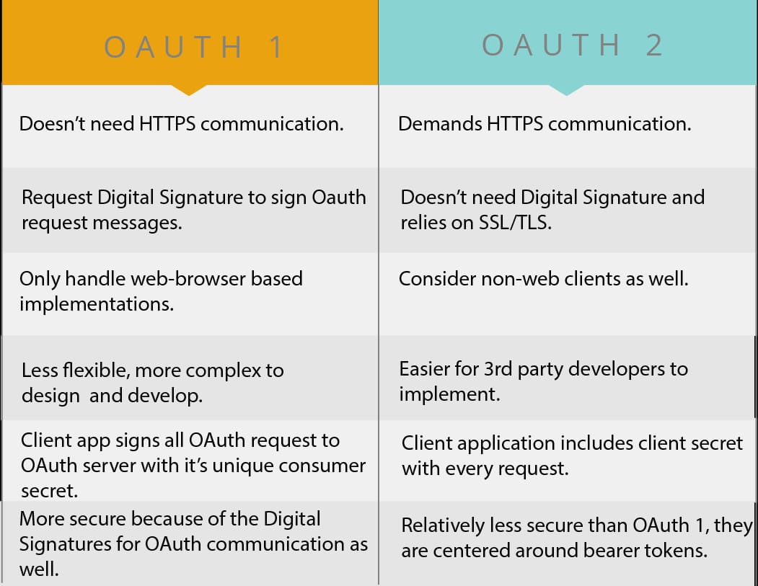

* OAuth2.0 Authorization with Postman.

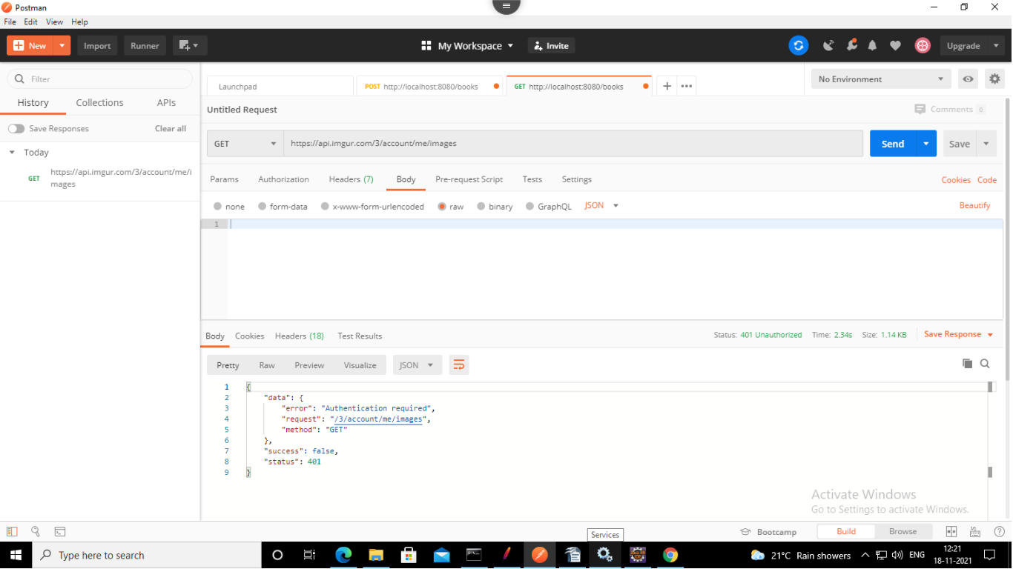

* Creating access Token using OAuth2.0 authorization with Postman

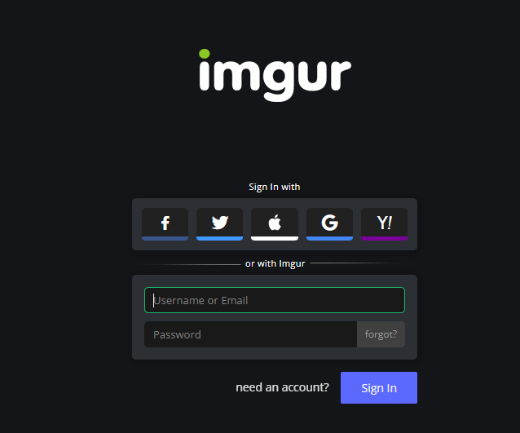

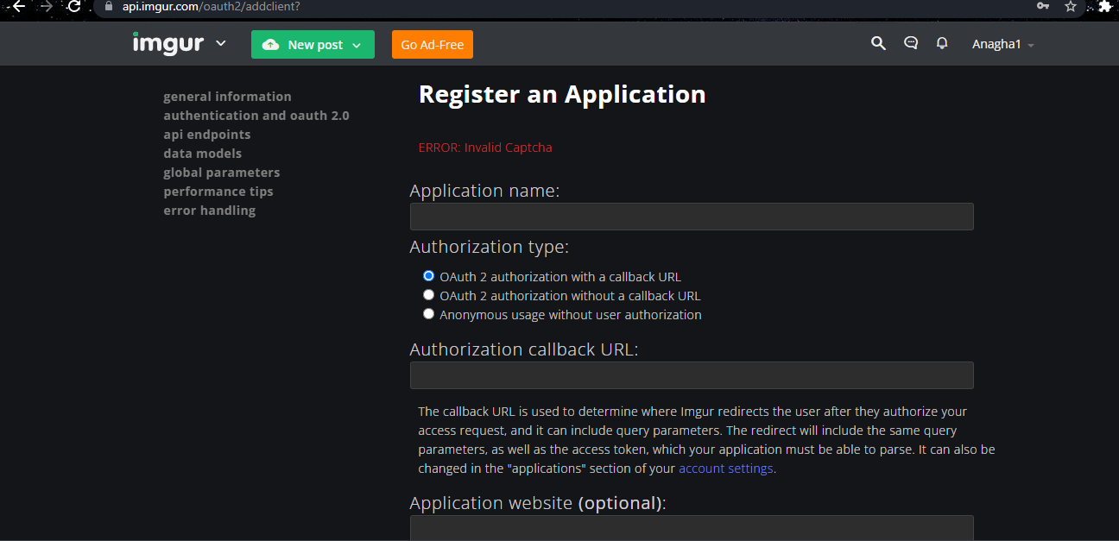

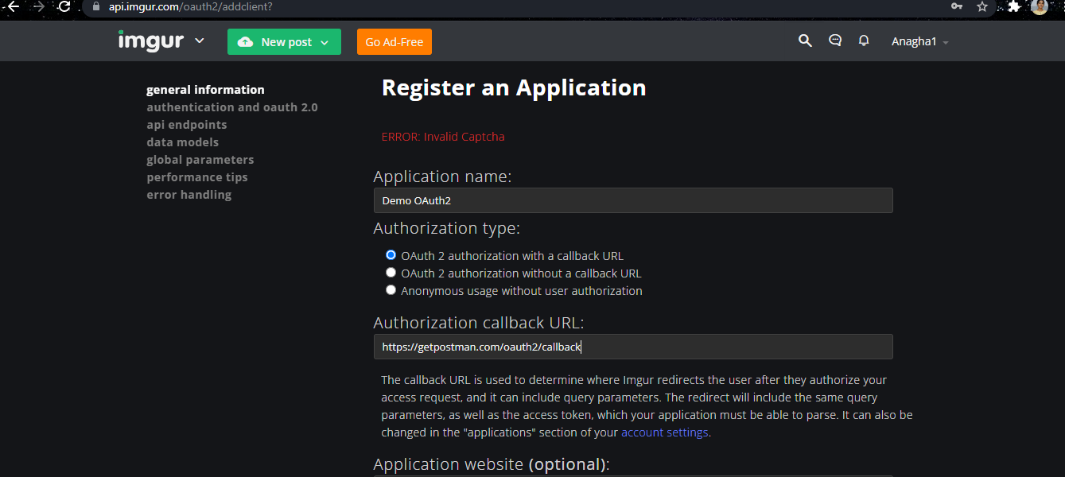

* After submitting this. We receive client id & client secret code

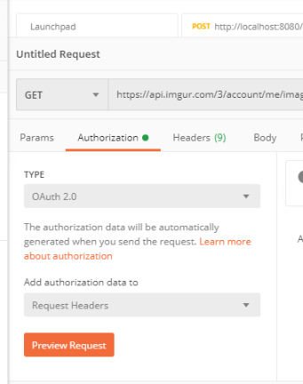

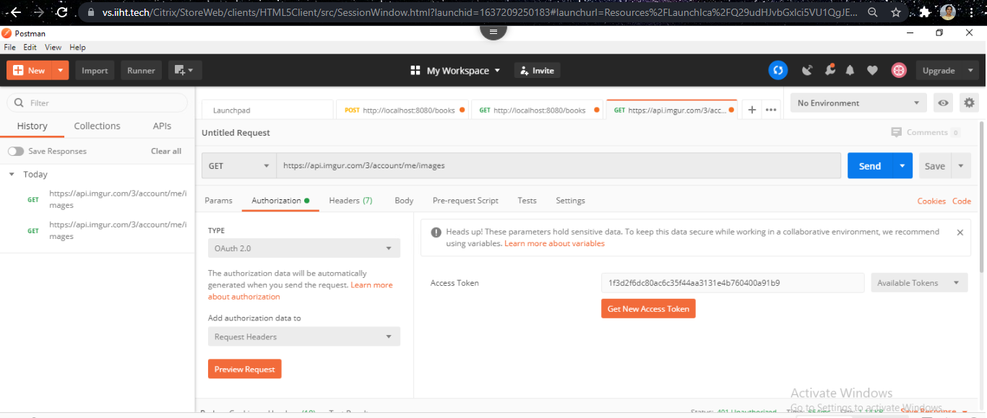

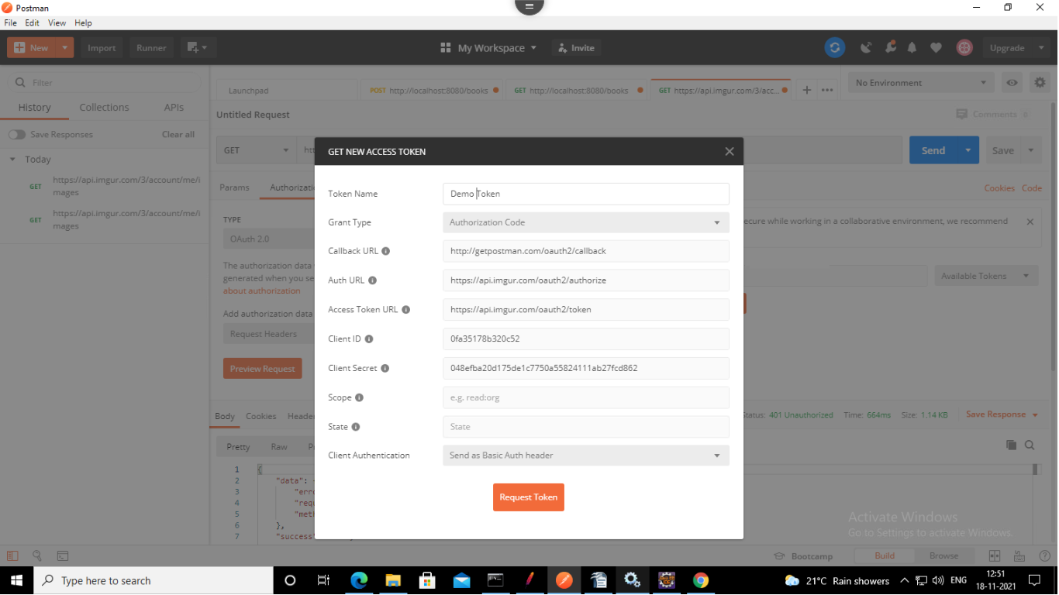

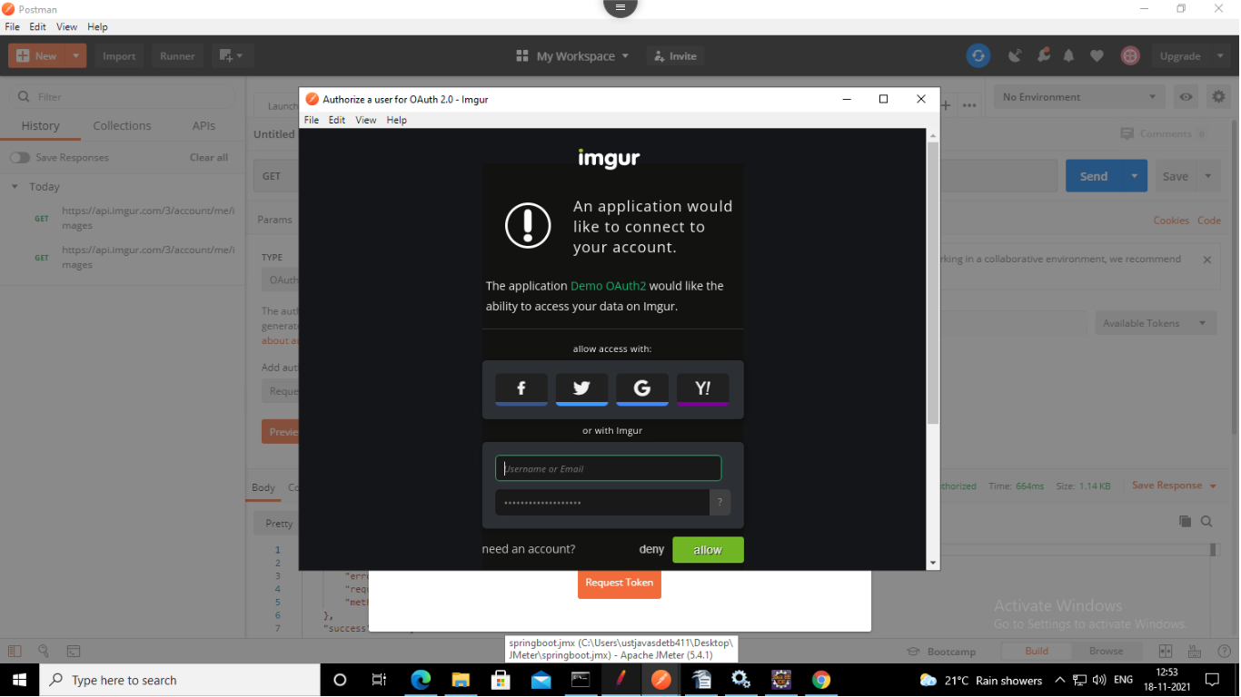

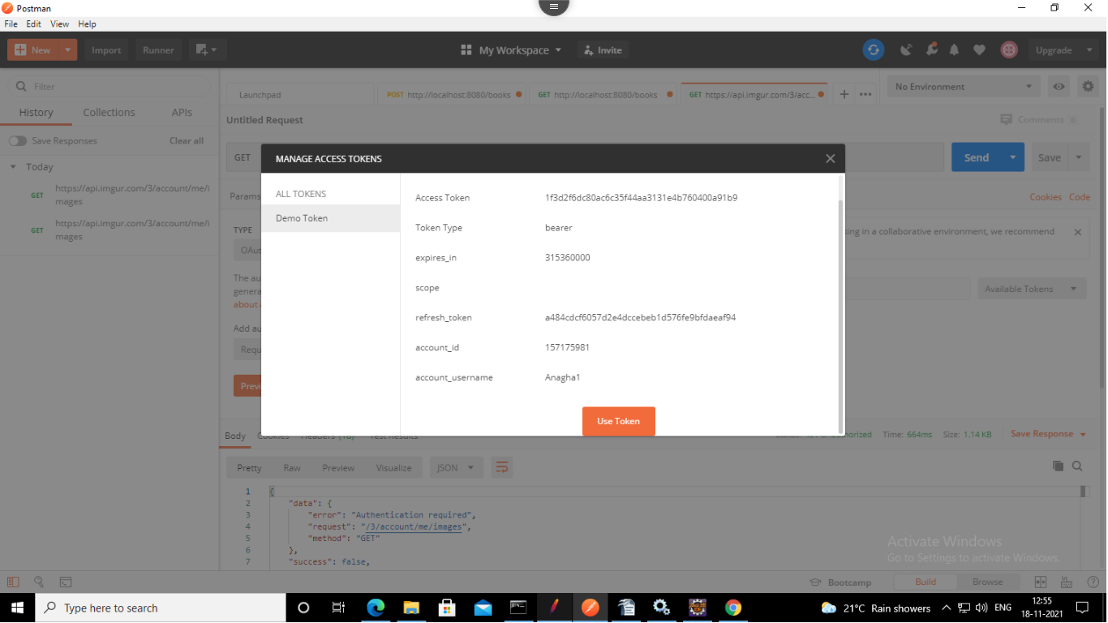

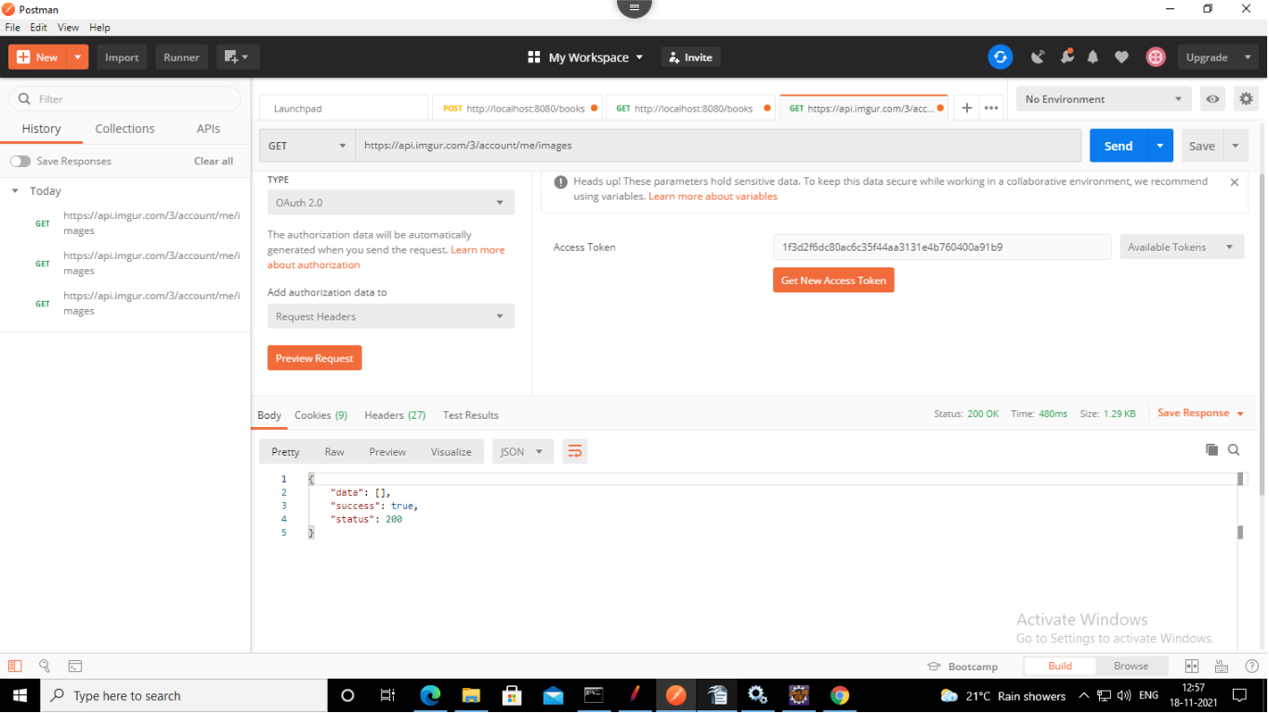

This is how access token is generated. Thus, we can access our account using 3rd party app.