1. Create an array of 10 elements and print them using the for each loop.
2. Take the number input from the console and add all the positive numbers. (not to consider the negative number if entered)
3. Create a labeled break and write a simple logic and execute the program.
4. Do the addition of around 10 even numbers, but use the continue statement in the logic.

**ANSWERS**

3)

public class Main

{

public static void main(String[] args) {

first:

//the for loop is labelled as first

for(int i=1;i<5;i++){

//the for loop is labelled as second

second:

for(int j=1;j<3;j++){

System.out.println("i="+i+";j="+j);

}

}

}

}

Output:

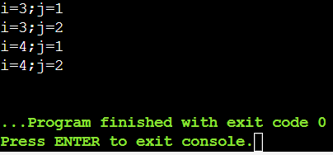

1)

public class Main

{

public static void main(String[] args) {

int[] arr={10,2,8,7,3,14,17,9,20,-7};

System.out.println("Enter the elements:");

for(int number:arr){

System.out.println(number);

}

}

}

Output:

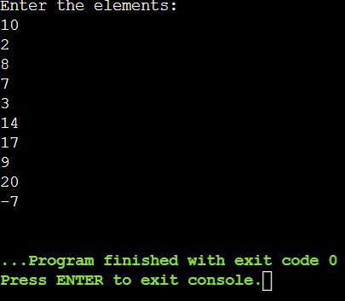

2)

import java.util.Scanner;

public class Main

{

public static void main(String[] args) {

int sum=0,value;

Scanner sc=new Scanner(System.in);

System.out.println("Enter the limit of number:");

int n=sc.nextInt();

System.out.println("Enter the numbers:");

for(int i=0;i<n;i++){

value=sc.nextInt();

if(value>0){

sum+=value;

}

}

System.out.println("Sum:"+sum);

sc.close();

}

}

Output:

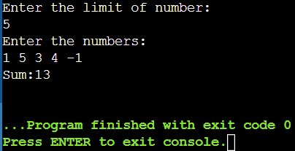

4)

import java.util.Scanner;

public class Main

{

public static void main(String[] args) {

int sum=0, i=0, num,n;

Scanner sc=new Scanner(System.in);

System.out.println("Enter the limit of number:");

n=sc.nextInt();

for(i=1;i<=(2*n);i++){

if(i%2==0)

sum=sum+i;

else

continue;

}

System.out.println("The Sum of first "+n+"even numbers are"+sum);

}}

Output:

