A
MINOR PROJECT REPORT
On
CHATBOT
Submitted in partial fulfillment of the requirements for the award of the degree of
BACHELOR OF TECHNOLOGY
In
COMPUTER SCIENCE AND ENGINEERING (DATA SCIENCE)
Submitted by
B.KEERTHI (22UP1A6710)

Under the Guidance of
Dr. P. ESWARAIAH
Assistant Professor

DEPARTMENT OF COMPUTER SCIENCE AND ENGINEERING (DATA SCIENCE)

VIGNAN’S INSTITUTE OF MANAGEMENT AND TECHNOLOGY FOR WOMEN


Accredited to NBA (CSE & ECE) and NAAC A+
(Affiliated to Jawaharlal Nehru Technological University Hyderabad) Kondapur (Village), Ghatkesar (Mandal), Medchal (Dist.), Telangana Pincode-501301
2022-2026

DEPARTMENT OF COMPUTER SCIENCE AND ENGINEERING
(DATA SCIENCE)

CERTIFICATE

This is to certify that project work entitled “CHATBOT” submitted by B.KEERTHI(22UP1A6710) in the partial fulfillment of the requirements for the award of the degree of Bachelor of Technology in COMPUTER SCIENCE AND ENGINEERING (DATA SCIENCE), VIGNAN’S INSTITUTE OF MANAGEMENT AND TECHNOLOGY FOR WOMEN is a record of bonafide work carried by them under my guidance and supervision. The results embodied in this project report have not been submitted to any other University or institute for the award of any degree.

PROJECT GUIDE THE HEAD OF DEPARTMENT
DR.P.ESHWARAIH Dr M.VISHNU VARDHANA RAO Assistant Professor Department of DS

(External Examiner)

DEPARTMENT OF COMPUTER SCIENCE AND ENGINEERING
(DATA SCIENCE)

DECLARATION

We hereby declare that project entitled “CHATBOT” is bonafide work duly completed by us. It does not contain any part of the project or that is submitted by any other candidate to this or another institute of the university. All such materials that have been obtained from other sources have been duly acknowledged.

B. KEERTHI (22UP1A6710)

ACKOWLEDGEMENT

We would like to express sincere gratitude to Dr. G. APPARAO NAIDU, Principal, Vignan’s Institute of Management and Technology for Women for his timely suggestions which helped us to complete the project in time.

We would also like to thank our sir Dr M.VISHNU VARDHANA RAO, Head of the Department and Associate Professor, Data Science, for providing us with constant encouragement and resources which helped us to complete the project in time.

We would also like to thank our sir DR.P. ESHWARAIH , Assistant Professor, Internal Guide, Data Science, for providing us with constant encouragement and resources which helped us to complete the project in time with her valuable suggestions throughout the project. We are indebted to her for the opportunity given to work under his guidance. Our sincere thanks to all the teaching and non-teaching staff of Department of Information Technology for their support throughout our project work.

B. KEERTHI (22UP1A6710)

ABSTRACT

The rapid growth of e-commerce has transformed the way people shop, interact with brands, and make purchase decisions. In modern online platforms, customers expect quick responses, personalized suggestions, and round-the-clock support. Traditional customer service systems, such as email support or human-operated live chat, often fail to meet these expectations due to delays, limited availability, and operational costs. To overcome these limitations, e-commerce chatbots have emerged as an efficient and scalable solution for enhancing customer engagement. This project presents the design and implementation of an advanced e-commerce chatbot capable of assisting users throughout their shopping journey.

The proposed chatbot leverages natural language processing (NLP), machine learning, and rule-based logic to understand user queries and provide automated responses. It helps customers browse products, compare features, track orders, answer FAQs, and receive personalized recommendations. The chatbot is integrated into an e-commerce platform to serve as a virtual shopping assistant. Instead of navigating through multiple pages, customers can easily ask the chatbot about product availability, price ranges, specifications, or discounts. This conversational approach makes the shopping experience faster and more intuitive.

The primary goal of the chatbot is to minimize customer effort and provide a seamless, human-like interaction experience. By automating customer support tasks, businesses can significantly reduce labor costs and increase user engagement. The system also analyzes user behavior and chat patterns to deliver personalized product suggestions, improving conversion rates. Machine learning models can further enhance accuracy by learning from user interactions and continuously improving conversation quality.

INDEX

S.NO CHAPTER PAGENO
1 Introduction 1
1.1 Evolution 2-3
2 Literature Survey 4-5
3 Existing system 6-7
4 Proposed system 8-9
5 Architecture 10-12
6 Data flow diagram 13-15
7 Software requirments 16-18
8 Hardware requirments 19-20
9 Implementation 21
9.1 Program 22-27
10 Conclusion 28

1. Introduction
The introduction of digital technologies has revolutionized the way consumers interact with businesses. E-commerce, in particular, has experienced exponential growth, enabling users to shop from anywhere, anytime, without visiting physical stores. As online traffic increases, businesses face challenges in providing consistent, real-time customer support. Consumers expect instant responses, personalized product suggestions, and quick problem resolution. Meeting these expectations requires tools that can operate continuously, accurately, and efficiently.
This is where chatbots play a transformative role. A chatbot is an automated conversational agent designed to simulate human-like interaction. It can understand natural language inputs and respond in a structured, meaningful manner. In e-commerce platforms, chatbots act as virtual assistants that help users browse products, answer questions, provide recommendations, track orders, and resolve queries. They eliminate the need for waiting times and ensure immediate support.
The introduction of this project discusses the motivation behind developing an e-commerce chatbot. Traditional customer service models depend heavily on human agents, which increases cost and limits availability. In contrast, chatbots provide a scalable, low-cost, and user-friendly solution that enhances the shopping experience. They also allow businesses to capture valuable customer insights by analyzing conversation data.
The introduction further explains how advancements in natural language processing and machine learning have significantly improved chatbot capabilities. Earlier chatbots operated on rule-based responses and predefined options. Modern chatbots, however, can understand user intent, detect keywords, learn from interactions, and generate human-like replies. They support multiple languages, emojis, and voice commands, making them more interactive and user-centric.
This section highlights the objectives of the e-commerce chatbot project, such as improving customer support, automating tasks, reducing operational costs, boosting sales, and strengthening user engagement. It also introduces the architecture of the system, the technologies used, and the expected outcomes of implementing such a solution.

1.1 EVOLUTION OF CHATBOTS
Chatbots have significantly evolved over the past few decades, paralleling advancements in artificial intelligence, natural language processing (NLP), and human-computer interaction. Initially, chatbots were simple, rule-based programs that could only respond to specific inputs. Today, they are sophisticated conversational agents capable of understanding intent, context, and user preferences. Understanding this evolution helps us design effective e-commerce chatbots that enhance customer experience, improve engagement, and reduce operational costs.
1. Early Chatbots: Rule-Based Systems
The first generation of chatbots, developed in the 1960s, was rule-based. ELIZA, created by Joseph Weizenbaum in 1966, is one of the earliest examples. ELIZA used pattern matching and substitution methodology to simulate conversation, giving users the illusion of understanding. Rule-based chatbots operate on a set of predefined “if-else” rules, which means they respond only to questions or commands that match
2. Keyword-Based Chatbots
The next step in evolution was keyword-based chatbots. These chatbots scan user inputs for specific keywords and phrases and then provide predefined responses associated with those keywords. This method added some flexibility compared to pure rule-based chatbots, as it could handle multiple variations of user input containing target keywords.
3. NLP and Machine Learning-Based Chatbots
The most significant leap in chatbot evolution came with the integration of Natural Language Processing (NLP) and Machine Learning (ML). These chatbots are capable of understanding the user’s intent, context, and sentiment. NLP allows chatbots to parse human language, identify entities, and detect the meaning behind a sentence. Machine learning algorithms enable chatbots to learn from past interactions, improve responses, and adapt to user preferences.
4. Intelligent Conversational Agents
The latest generation of chatbots incorporates deep learning, neural networks, sentiment analysis, and contextual reasoning. These chatbots can interact almost as naturally as humans, understand complex sentences, detect emotions, and provide multi-modal support (text, voice, and image recognition)..
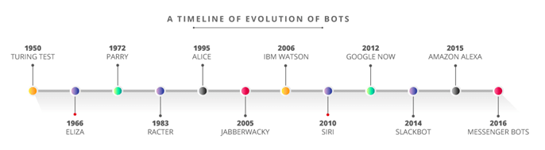

2.LITERATURE SURVEY
The development of chatbots, particularly in the e-commerce domain, has been a major area of research in recent years. Chatbots are designed to simulate human conversation, providing instant assistance to users in online shopping, customer support, and decision-making. A literature survey helps understand the current state of technology, challenges, and potential areas of improvement. This survey explores various studies on e-commerce chatbots, focusing on their design, implementation, performance, and impact on user experience.
1. Early Studies on Rule-Based Chatbots
The earliest research on chatbots focused on rule-based systems. ELIZA (1966) and PARRY (1972) were pioneers in this field. ELIZA could simulate a conversation by matching patterns and replying with predefined scripts, while PARRY, designed to emulate a patient with paranoia, used more complex conditional responses. Studies highlighted that rule-based chatbots are easy to implement but cannot handle complex or ambiguous queries. In the e-commerce context, rule-based chatbots were initially used for answering FAQs, such as store timings, return policies, and shipping details. These studies emphasize that rule-based chatbots, though limited, formed the foundation for automated customer service.
2. Keyword-Based Chatbots in E-Commerce
With the growth of online retail, keyword-based chatbots emerged as the next step. These chatbots scan user input for specific words or phrases and trigger predefined responses. Research by Adamopoulou & Moussiades (2020) highlights that keyword-based chatbots improved customer experience compared to rule-based systems. For instance, users searching for “laptop under 50,000” could receive filtered product suggestions based on
3. AI and Machine Learning-Based Chatbots
A significant shift occurred with the integration of Artificial Intelligence (AI) and Machine Learning (ML). NLP techniques allowed chatbots to understand user intent, detect entities, and maintain context across multiple conversational turns. Research by Shawar & Atwell (2007) indicated that machine learning algorithms, such as decision trees, Naïve Bayes, and Support Vector Machines, enhanced the accuracy of chatbot responses.
4. Deep Learning and Neural Network Chatbots
The latest research focuses on deep learning and neural networks to build intelligent conversational agents. Studies have implemented LSTM (Long Short-Term Memory) networks, GRU (Gated Recurrent Units), and Transformers for chatbots. For example, research by Serban et al. (2017) showed that neural conversational models could understand complex sentences and maintain long-term context better than previous models.
5. Chatbot Integration with E-Commerce Platforms
Studies show that chatbot integration with platforms like Shopify, WooCommerce, and Magento improves user engagement and conversion rates. For instance, a study by McLean & Osei-Frimpong (2019) found that users interacting with chatbots were more likely to complete purchases, especially when chatbots provided recommendations or guided them through checkout.
6. User Experience and Satisfaction Studies
User-centric studies emphasize the importance of conversational design, interface simplicity, and response accuracy. Research indicates that chatbot success in e-commerce depends on:
- Speed of response.
- Relevance of recommendations.
- Ability to handle multi-intent queries.
- Friendly and natural conversational style.

3.EXISTING SYSTEM
In the current digital marketplace, many e-commerce platforms still rely on traditional customer support systems to assist users, answer queries, and guide them through their shopping journey. Although technology has advanced, the majority of small and medium-sized online businesses continue to use outdated or semi-automated support systems that struggle to match the growing expectations of modern consumers. The existing system generally includes manual customer service methods such as email support, phone calls, basic live chat, static FAQ pages, and limited search tools. While these methods are functional, they often fail to provide real-time, personalized, and interactive assistance. This section discusses the existing system in detail, highlighting how it operates, its benefits, and its limitations.

1. Email-Based Customer Support
Email is one of the oldest and most widely used support channels in e-commerce. When customers face issues related to product availability, delivery status, returns, refunds, or payment failures, they usually contact support via email.
2. Phone Call-Based Support
Many e-commerce platforms rely on customer service helplines. Users can call support to ask about product details, payment issues, or refunds.

3. Live Chat with Human Agents
Some modern e-commerce sites offer live chat where human operators answer queries in real-time. Although faster than email, this method still depends heavily on human availability.
- Limited to business hours in many cases.
- Cannot handle repetitive queries efficiently.

4. Static FAQ Pages
Most e-commerce websites provide a list of frequently asked questions (FAQs) addressing common issues such as return policies, refund times, shipping methods, payment modes, and general product inquiries.

5. Basic Search Tools
Existing systems also include keyword-based search bars that help users find products. However, these search tools have significant limitations.
6. Mobile Apps with Limited Automation
Many e-commerce apps offer push notifications, order updates, and static product recommendations. These features help users but are not conversational or adaptive.
Current Limitations:
- Recommendations are generic, not personalized.
- Apps cannot answer questions directly.
- Only specific actions are automated (tracking, reminders).

7. Social Media Messaging Support
Some businesses use WhatsApp, Instagram, or Facebook Messenger for customer support. Usually, this is managed manually or with basic automated replies.
Limitations:
- Automated responses are very basic (e.g., “Hello! How can we help?”).
- Human agents still have to respond manually.
- Cannot assist with product search, comparison, or order management.

4. PROPOSED SYSTEM
The proposed system introduces an AI-powered e-commerce chatbot designed to overcome the challenges and limitations of the existing customer support system. Unlike traditional support channels that depend heavily on human intervention, the proposed chatbot system uses Artificial Intelligence (AI), Natural Language Processing (NLP), Machine Learning (ML), and automated workflows to provide real-time, personalized, and interactive customer assistance. The main objective is to create a smart conversational agent that enhances user experience, reduces operational costs, improves customer engagement, and boosts conversions for online businesses.
1. Overview of the Proposed System
The proposed system introduces a chatbot that acts as a virtual shopping assistant. It can:
- Respond to user queries instantly
- Suggest products based on user preferences
- Assist with order tracking and status
- Handle payment and refund-related questions
- Manage complaints and returns
- Provide personalized recommendations
By integrating AI technologies, the chatbot can understand user intent, recognize entities, learn from past interactions, and adapt responses accordingly. This makes the system more intelligent, scalable, and efficient compared to existing manual systems.
2. Features of the Proposed E-commerce Chatbot
a) Natural Language Understanding (NLU)
The chatbot can understand user queries written in natural language. Whether the customer types “Show me red shoes under 1000” or “I want cheap red sneakers,” the chatbot can identify intent and extract important details such as color, product type, and price range.
b) Personalized Product Recommendations
Using ML algorithms, the system analyzes user behavior, past purchases, browsing history, and preferences to recommend suitable products. This enhances user engagement and increases the chances of purchase.
c) 24/7 Automated Customer Support
The chatbot is available all the time, unlike human agents. Customers can get instant responses at any hour of the day, improving customer satisfaction and accessibility.
d) Multilingual Support
The system can be extended to support multiple languages, allowing businesses to serve a wider audience.
e) Order Tracking and Status Update
Users can simply type, “Where is my order?” and the chatbot fetches real-time tracking information from the order database.
f) Complaint Handling and Feedback Collection
Customers can register complaints regarding damaged products, late delivery, or payment issues. The bot automatically logs complaints and provides immediate guidance.
g) Seamless Integration with E-commerce Platforms
The chatbot can be integrated with websites, mobile apps, WhatsApp, Messenger, and other communication channels.
h) Cart Management
The chatbot can help users add products to their cart, remove items, compare products, and proceed to checkout smoothly.

5.ARCHITECTURE
In a typical e-commerce environment, the chatbot must manage multiple tasks simultaneously such as handling customer questions, supporting product searches, tracking orders, and guiding users throughout their shopping journey. To achieve this, the architecture must be modular, scalable, secure, and capable of integrating with the existing e-commerce platform.
1. User Interface Layer
The User Interface (UI) Layer is the front-end component where users interact with the chatbot. This interface can exist on multiple platforms such as a website, mobile app, WhatsApp, Facebook Messenger, or other social media platforms.
2. Input Processing Layer
Once the user sends a message, it enters the Input Processing Layer. This layer prepares the user’s raw text or voice input for further analysis. Important tasks that occur here include:
- Tokenization – Breaking the sentence into meaningful units.
- Stop-word removal – Eliminating unnecessary words such as “the”, “is”, “at”.
- Stemming or Lemmatization – Converting words to their base form (e.g., “running” → “run”).
- Speech-to-text (if voice input is used).

3. Natural Language Processing (NLP) Layer
This is the heart of the chatbot architecture. The NLP Layer interprets the user’s query and identifies what they actually mean. It typically involves two sub-components:
a. Natural Language Understanding (NLU)
b. Natural Language Generation (NLG)
4. Database Layer
A chatbot cannot function without access to accurate, real-time data. The Database Layer stores all essential information including:
- Product catalog (name, price, specifications, availability).
- User profiles (past orders, preferences).
- Order history and tracking details.

5. Integration Layer (API Layer)
The Integration Layer connects the chatbot with external systems through Application Programming Interfaces (APIs). This includes:
- Payment gateways (Razorpay, PayPal).
- Shipment tracking systems (BlueDart, FedEx).
- Inventory management software.
- CRM tools for customer support.
- Recommendation engines (AI models).

6. Machine Learning and Training Layer
To keep the chatbot improving over time, a dedicated layer handles ML training and updates. This layer observes chat patterns, collects feedback, and improves understanding accuracy. Key processes include:
- Training on new user queries.
- Updating intent and entity models.
- Improving product recommendation accuracy.
8. Response Generation Layer
After the decision is made, the system generates a final response using:
- Templates (for greetings, confirmations).
- Dynamic data insertion (product names, prices).
- NLG-generated natural sentences.
- Multimedia elements (images, carousels, buttons).
7. Logging and Monitoring Layer
This layer monitors the chatbot’s performance and records:
- Conversation logs.
- Errors or failed queries.
- User behavior patterns.
- Performance analytics.
8. Security Layer
Security is extremely important in e-commerce because financial transactions and personal data are involved. The chatbot architecture implements security through:
- End-to-end encryption.
- Secure authentication (OAuth, JWT).
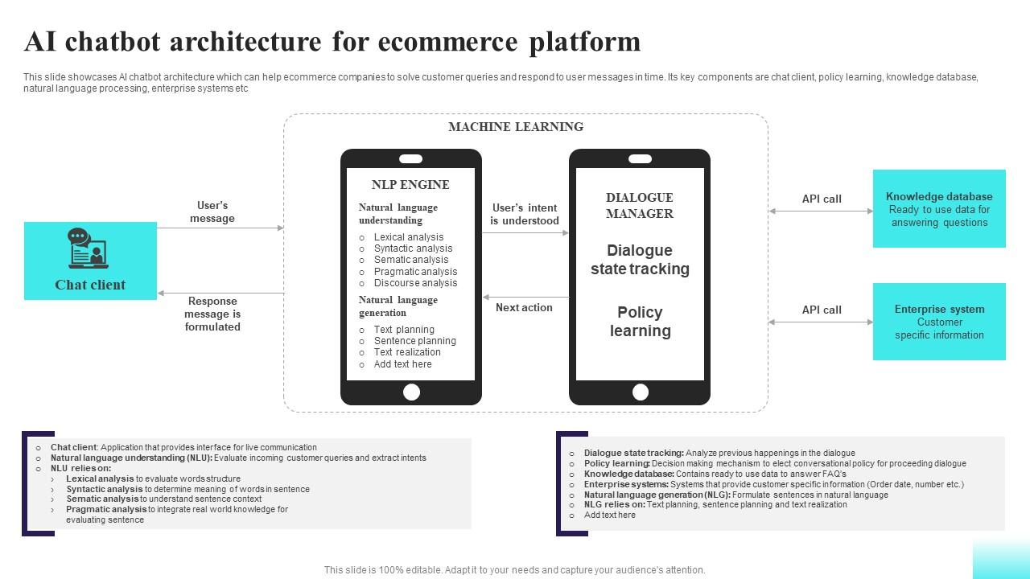

6.DATA FLOW DIAGRAM
A Data Flow Diagram (DFD) illustrates how information moves through the e-commerce chatbot system. It helps explain the flow of user messages, the processing of those messages, and how data travels between different components such as NLP engines, product databases, order systems, and APIs. A well-designed DFD ensures clarity in understanding how the chatbot interacts with both users and backend systems to deliver intelligent responses.
The DFD can be explained at two major levels:
- Level 0 (Context Diagram) – High-level system overview
- Level 1 (Detailed Data Flow) – Internal components and detailed interactions
1. DFD Level 0 – Context Diagram
In the Context Diagram, the entire e-commerce chatbot is represented as a single system. The focus is on external entities and major data flows, not internal working.
External Entities
- User – the customer interacting with the chatbot
- E-commerce Database – stores products, orders, user profiles
- Payment Gateway – handles payment-related queries
- Shipping/Tracking System – provides delivery status
- Admin/Support Team – monitors logs and manages responses
Main Flows
- User sends queries → Chatbot
- Chatbot fetches data → Databases, APIs
- Processed output → User

2. DFD Level 1 – Detailed Data Flow
At Level 1, we break the chatbot into its internal modules. This gives a clearer picture of how data moves within the system.
Main Components:
- User Interface Module
- Input Preprocessing Unit
- NLP Engine (NLU + NLG)
- Intent Classification & Entity Extraction
- Business Logic Module
- Database Management System
- API Integration Layer
- Response Generation Unit
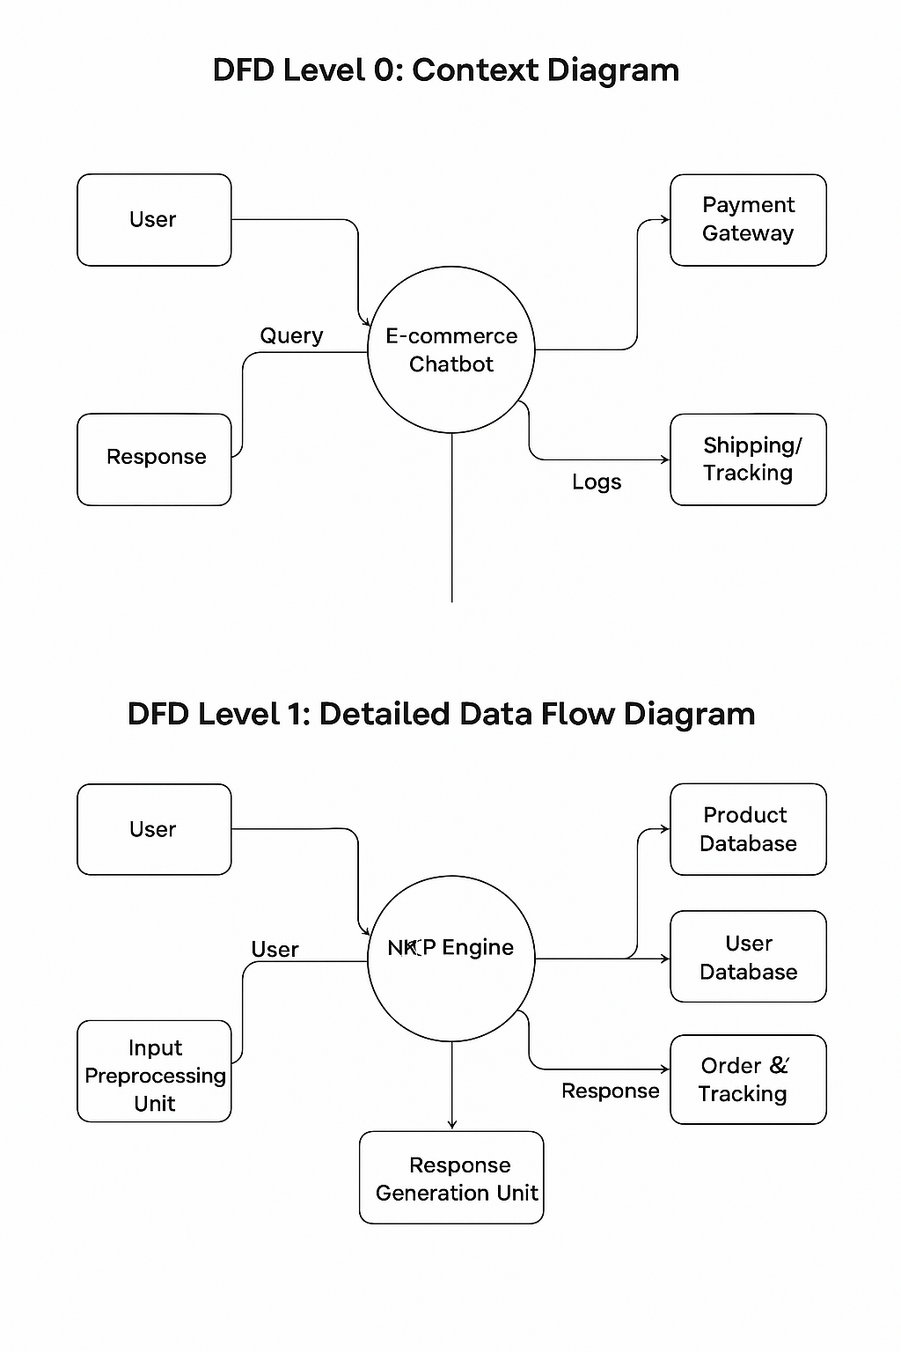
7. SOFTWARE REQUIEMENT
The software requirements of an e-commerce chatbot define the various tools, platforms, frameworks, and technologies needed to build, deploy, and maintain the system. These requirements ensure that the chatbot runs smoothly, communicates intelligently with users, integrates with the e-commerce platform, and provides reliable performance under real-time conditions.
1. Operating System
The chatbot system can run on any modern operating system that supports Python, Node.js, or cloud deployment platforms. Examples:
- Windows 10/11
- Linux (Ubuntu preferred for servers)
- macOS (for development purposes)
2. Programming Languages
To build an intelligent, flexible, and scalable chatbot:
- Python (recommended) – for NLP, ML, backend logic
- JavaScript / Node.js – for real-time chat, web integration
- HTML, CSS – for embedding chatbot on websites
- Java or Kotlin – for Android app integration (optional)
Python is the most popular because it supports frameworks like TensorFlow, PyTorch, Rasa, NLTK, and spaCy.
3. NLP & AI Frameworks
These frameworks allow the chatbot to understand human language, classify intents, extract entities, and generate intelligent responses.
- Rasa (open-source chatbot framework)
- Dialogflow by Google
- Microsoft Bot Framework
- NLTK (Natural Language Toolkit)
- spaCy
- TensorFlow / PyTorch (for ML models)
For academic projects, Rasa or Dialogflow is the best choice due to easy integration and smart conversation handling.
4. Web Framework / Backend Server
A backend server is required to handle API calls, connect to databases, and process user queries.
Common options include:
- Flask (Python) – simple API-based backend
- Django (Python) – full-featured web framework
- Node.js (Express.js) – fast and scalable JS backend
The backend manages user sessions, authentication, product search, order tracking, and bot responses.
5. Database Software
Databases store information such as products, prices, user details, orders, chats, and logs.
Options include:
- MySQL / MariaDB – relational database
- PostgreSQL – robust relational DB
- MongoDB – NoSQL DB for flexible storage
- Firebase Firestore – cloud-based, real-time DB
For e-commerce systems, MySQL or MongoDB is commonly used.
6. API Integration Tools
APIs help connect the chatbot with external systems.
- Payment Gateway APIs (Razorpay, PayPal)
- Shipping APIs (Delhivery, FedEx)
- SMS/Email APIs (Twilio, Mailgun)
- WhatsApp API (Meta Business API)
These APIs allow users to track orders, make payments, and receive notifications.
7. IDEs and Code Editors
To write and test code effectively:
- Visual Studio Code (VS Code)
- PyCharm
- Jupyter Notebook
- Android Studio (optional for mobile integration)
8. Cloud Hosting Platforms
To deploy the chatbot:
- AWS EC2 / AWS Lambda
- Google Cloud Platform (GCP)
- Microsoft Azure
- Heroku (for student projects)
- Render / Vercel (for frontend hosting)
Cloud hosting ensures high availability, auto-scaling, and secure performance.

9. Browser Compatibility
The chatbot interface must run on:
- Google Chrome
- Firefox
- Safari
- Microsoft Edge
Responsive design ensures that the chatbot runs across desktops and mobiles.

8.HARDWARE REQUIREMENT
Hardware requirements describe the physical devices needed for developing, testing, and deploying the chatbot. These are divided into:
- Development Hardware
- Server/Deployment Hardware
- User-End Hardware
1. Development Hardware
This is the system used by developers to build and test the chatbot.
Minimum Requirements
- Processor: Intel i3 or AMD equivalent
- RAM: 4 GB
- Storage: 100 GB HDD
- Graphics: Integrated GPU
- Internet: 5–10 Mbps
Recommended Requirements
- Processor: Intel i5/i7 or AMD Ryzen 5/7
- RAM: 8–16 GB (for NLP model training)
- Storage: 256+ GB SSD
- Graphics: NVIDIA GPU (optional, for ML training)
- Internet: 20+ Mbps high-speed internet
2. Server Hardware (if deployed on-premise)
Most chatbot systems run on cloud servers, but if deployed locally, the server must be strong enough to handle real-time traffic.
Recommended Server Configuration
- Processor: Multi-core Intel Xeon / Ryzen 7
- RAM: 16–32 GB
- Storage: 1 TB SSD
- Bandwidth: High-speed network connection
- GPU: Optional (for deep learning)
Servers must be able to handle:
- Large volumes of user queries
- Fast database operations
- API calls
- Real-time NLP processing
3. Client/User-End Hardware
For end-users accessing the chatbot:
No special hardware is required.
They can use:
- Smartphone (Android/iOS)
- Laptop / Desktop
- Tablet
- Any device with a browser and internet
The chatbot runs on the frontend (website, app, WhatsApp, Messenger), so minimal hardware is needed.
4. Network and Connectivity Requirements
A stable internet connection is essential for:
- API calls
- Database queries
- Cloud hosting communication
- Real-time chat updates
Requirements:
- Minimum: 5 Mbps
- Recommended: 20+ Mbps
9.IMPLEMENTATION
The implementation of the E-commerce chatbot system involves integrating a conversational interface into an online shopping platform to enhance user support, product discovery, and order management. The chatbot is built using a combination of Python (Flask/Django) for backend logic, HTML/CSS/JavaScript for the frontend interface, and a database such as MySQL or Firebase for storing product data, user information, and chat history. The development begins with creating the chatbot model, where user input is processed through tokenization, encoding, and intent classification. Natural Language Processing (NLP) techniques help the system understand queries related to product search, order tracking, returns, recommendations, and payment FAQs.
Once a query is detected, the backend retrieves relevant data from the database and constructs a personalized response. The chatbot also includes a feedback module that improves the accuracy of future predictions. Admin access is provided to update product information, FAQs, and system responses. The frontend integrates a user-friendly chat window that enables customers to interact in real-time. The chatbot is embedded into the e-commerce website, ensuring seamless communication without page reloads. This implementation allows the platform to assist customers 24×7, reduce service load, provide instant answers, and improve overall shopping experience.

9.1 PROGRAM
from flask import Flask, request
import json
app = Flask(__name__)
product_data = {
"shoes": ["Nike Running Shoes", "Adidas Sports Shoes", "Puma Casual Shoes"],
"mobiles": ["iPhone 14", "Samsung Galaxy S23", "Redmi Note 12"],
"laptops": ["HP Pavilion", "Dell Inspiron", "MacBook Air"]
}
faq_data = {
"payment": "We support UPI, Netbanking, Debit/Credit Cards & Cash on Delivery.",
"refund": "Refunds take 5–7 working days to process.",
"delivery": "Delivery usually takes 2–5 working days.",
"return": "You can return the product within 7 days of delivery."
}
def chatbot_response(user_query):
query = user_query.lower()

# Product search logic
for category in product_data:
if category in query:
return f"Available {category}:\n" + ", ".join(product_data[category])
# Order tracking
if "track" in query or "order" in query:
return "Please share your Order ID to track your shipment."
# FAQ answers
for key in faq_data:
if key in query:
return faq_data[key]

# Default fallback
return "Sorry, I didn't understand. Please try asking about products, order tracking, or FAQs."
html_page = """
<html>
<head>
<title>E-commerce Chatbot</title>
<style>
body { font-family: Arial; background: #f2f2f2; }
#chatbox { width: 400px; height: 500px; background: #fff;
padding: 10px; margin: auto; border-radius: 8px; margin-top: 40px; }
#messages { height: 430px; overflow-y: auto; border-bottom: 1px solid #ccc; padding-bottom: 10px; }
.user { color: #0000cc; margin: 8px; font-size: 15px; }
.bot { color: #008000; margin: 8px; font-size: 15px; }
input { width: 78%; padding: 8px; border-radius: 5px; border: 1px solid #ccc; }
button { padding: 8px 12px; border-radius: 5px; background: #008CBA; color: white; border: none; }
</style>
</head>
<body>
<h2 align="center">💬 E-commerce Chatbot</h2>
<div id="chatbox">
<div id="messages"></div>
<br>
<input type="text" id="user_input" placeholder="Type your message...">
<button onclick="sendMessage()">Send</button>
</div>
<script>
function sendMessage() {
let userMsg = document.getElementById("user_input").value;
if (userMsg.trim() === "") return;

let messageBox = document.getElementById("messages");
messageBox.innerHTML += "<div class='user'><b>You:</b> " + userMsg + "</div>";

fetch("/chat", {
method: "POST",
headers: { "Content-Type": "application/x-www-form-urlencoded" },
body: "msg=" + userMsg
})
.then(res => res.text())
.then(botReply => {
messageBox.innerHTML += "<div class='bot'><b>Bot:</b> " + botReply + "</div>";
messageBox.scrollTop = messageBox.scrollHeight;
});

document.getElementById("user_input").value = "";
}
</script>

</body>
</html>
"""
# ROUTES
# -------------------------------
@app.route("/")
def index():
return html_page

@app.route("/chat", methods=["POST"])
def chat():
user_text = request.form["msg"]
bot_reply = chatbot_response(user_text)
return bot_reply
if __name__ == "__main__":
app.run(debug=True)

OUTPUT
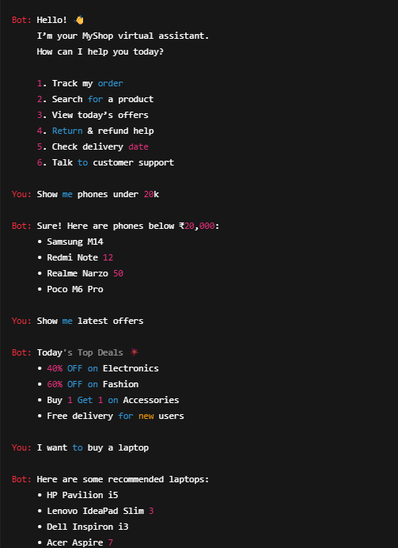

10.CONCLUSION

The development of an e-commerce chatbot marks a significant advancement in improving the overall online shopping experience. Traditional e-commerce systems often struggle to provide instant responses, personalized guidance, and continuous support. By integrating a chatbot into an e-commerce platform, users can interact with the system in a natural, conversational manner, making the website more engaging and customer-friendly.
The chatbot enhances the platform by automating product search, order tracking, return requests, and customer support. It reduces the workload on human support teams by answering repetitive queries instantly. With features such as intelligent product recommendations, real-time assistance, and 24/7 availability, the chatbot ensures a smooth and efficient shopping journey for every user. The use of natural language processing (NLP) enables the system to understand user intent, making communication more personalized and human-like.
The proposed system significantly improves upon the existing manual approach by offering faster responses, reducing operational costs, and increasing customer satisfaction. It also streamlines business processes by providing valuable insights based on user interactions and preferences. Overall, the integration of an e-commerce chatbot creates a smart, interactive, and user-centric environment that benefits both customers and online retailers.

