Predicting NYC Yellow Taxi Fares: Data Preprocessing and Initial Model Development

Harsha Sanka, Keerthi Maheswari Mallampaty, Sri Navya Pajjuru

University of Cumberlands
PhDAI: 733 M21 Python Application for Data Analytics in AI
Dr Najam Hassan
November, 2026
Predicting NYC Yellow Taxi Fares: Data Preprocessing and Initial Model Development
Introduction and Problem Framing
Taxi fares can already be estimated by the meter and by fare apps, so our project is a learning exercise with a clear question: how well can a model learn the fare of a New York City yellow taxi trip from simple trip details, and for which trips is it less accurate? The answer helps a booking service or city analyst judge when an estimate can be trusted. The inputs are trip distance, trip time, hour of day, and a weekend flag.
We framed the task as regression, predicting the fare in dollars, using the official yellow taxi trip records for September 2026 published by the New York City Taxi and Limousine Commission (NYC TLC, 2026). The main metric is the mean absolute error (MAE), the average gap in dollars between predicted and actual fare, supported by R² (the share of fare differences the model explains). Guessing the training-set average fare for every trip is the baseline to beat.
Dataset Exploration and Preprocessing
Data Overview
The file contains 3,876,044 trips. Each row records pick-up and drop-off time, distance, passenger count, fare, tip, tolls, and total. The target is the fare. We used pandas (McKinney, 2010) and NumPy (Harris et al., 2020) for data handling, Matplotlib (Hunter, 2007) and seaborn (Waskom, 2021) for visualization, and scikit-learn (Pedregosa et al., 2011) for modeling.
Cleaning
The raw data contain impossible values, including a pick-up dated 2009, a trip of 232,645 miles, and fares from −$1,800 to $9,999.70. We removed trips using four rules: pick-up outside September 2026 (22 trips), distance outside 0.1 to 100 miles (178,826), duration outside 1 to 180 minutes (50,717), and fare below $3 or above $500 (13,440). In total, 6.3% of trips were removed, leaving 3,633,039. For speed, we modeled a random sample of 100,000 trips.
Figure 1
Fare Distribution and Fare by Trip Distance
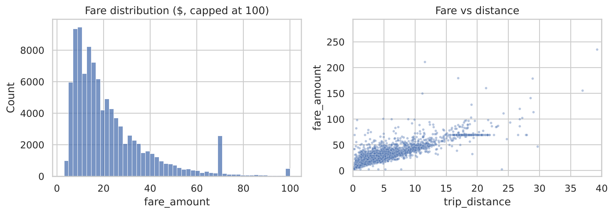
Note. Fare is capped at $100 in the histogram. The scatterplot shows a random 5,000 trips.
Exploration
Fares are right-skewed (M = $22.99, Mdn = $17.21). Distance has the strongest relationship with fare (r = .88), followed by trip time (r = .82), and fare rises roughly linearly with distance (Figure 1).
Transformation
The inputs were distance, trip minutes, hour of day, and a weekend flag. We excluded tip, tolls, and total because they include or follow the fare, which would leak the answer to the model. We split the sample into 80,000 training and 20,000 test trips (random seed 42) and placed scaling inside a scikit-learn pipeline so it learned only from training data.
Initial Model Development
We built models from simple to detailed: a linear regression on distance only, a linear regression on all four inputs, and a random forest, which combines many decision trees. The forest was tuned with grid search over tree depth (5, 10, or unlimited) and minimum leaf size (1 or 5) using 3-fold cross-validation on 20,000 training trips, then refit on all training trips. Every model was evaluated on the 20,000 held-out trips. Table 1 shows the results.
Table 1
Test Set Performance of Fare Prediction Models
Model | MAE ($) | R²
Guess the average fare | 12.93 | .000
Linear regression, distance only | 5.28 | .787
Linear regression, all four inputs | 3.52 | .839
Random forest | 3.45 | .838
Random forest (tuned) | 3.18 | .855
Note. N = 20,000 test trips. MAE = mean absolute error. The tuned forest used a maximum depth of 10 and a minimum leaf size of 5.
Guessing the average fare was off by $12.93. Distance alone reduced the error to $5.28, with each extra mile adding about $3.64 to the fare. Adding trip time, hour, and weekend reduced it to $3.52, and the random forest reached $3.45. The tuned forest performed best (MAE = $3.18, R² = .855), so tuning gave a modest gain over the default forest (Figure 2).
Figure 2
Predicted Versus Actual Fare for the Tuned Random Forest
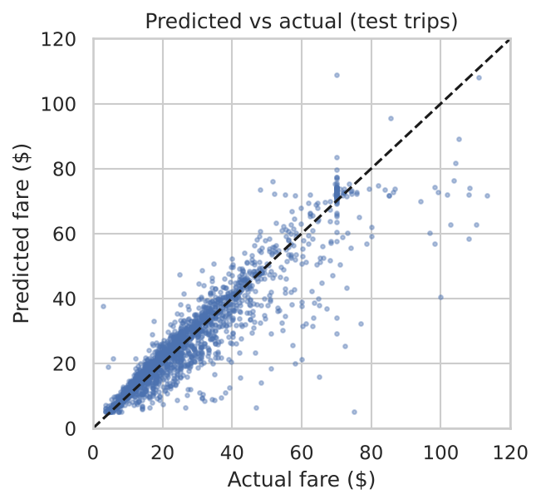
Note. Random sample of 3,000 test trips. The dashed line shows perfect prediction.
Errors were not equal across trips. In dollars, error grew with trip length, from $1.64 for trips under 2 miles to $7.47 for trips over 10 miles, although in every length group the error was about 12% to 16% of the average fare. Night trips (10 p.m. to 5 a.m.) had a mean error of $4.51, compared with $2.24 in the evening rush (4 to 8 p.m.). Trip time is only known after a ride, so a real upfront quote would need distance or a predicted time. Estimates should never be used to refuse rides or to price riders differently by area, and pick-up and drop-off locations are sensitive and require privacy protection. The study covers one month and a 100,000-trip sample. We kept the inputs deliberately simple; an earlier version that also used airport, rate code, and request-source columns reached an error of about $2.34, so more detail helps. Next steps are adding those columns, predicting trip time before the ride, and testing other months.
Team Collaboration Process
We worked in a shared Google Colab notebook and kept our code, report, and slides in a GitHub repository, using branches and pull requests reviewed by a teammate. We worked on problem framing and the report, led exploration and visualization, built the preprocessing pipeline, and trained and evaluated the models.

References
New York City Taxi and Limousine Commission. (2026). TLC trip record data: Yellow taxi trip records, September 2026 [Data set]. https://www.nyc.gov/site/tlc/about/tlc-trip-record-data.page

