A PROJECT REPORT ON

QR CODE GENERATOR

Submitted to
JAWAHARLAL NEHRU TECHNOLOGICAL UNIVERSITY, KAKINADA
For Partial Fulfilment of Award of the Degree of

BACHELOR OF TECHNOLOGY

Submitted By

V. Tarun | 19X41A05B8
MD. Feroz | 19X41A0591
B. Ravi Chandu | 19X41A0570
N. Sai Ram | 19X41A0592

Under the esteemed guidance of
P. Beersheba
Associate Professor, Department of CSE



DEPARTMENT OF COMPUTER SCIENCE AND ENGINEERING

S.R.K INSTITUTE OF TECHNOLOGY
(AFFILIATED TO JNTU, KAKINADA)
Enikepadu, Vijayawada – 521108.

April 20

S.R.K INSTITUTE OF TECHNOLOGY
ENIKEPADU, VIJAYAWADA.
DEPARTMENT OF COMPUTER SCIENCE AND ENGINEERING

CERTIFICATE

This is to certify that this project report entitled “QR CODE GENERATOR” is the bonafide work of V. Tarun (19X41A05B8), MD. Feroz (19X41A0591), B. Ravi Chandu (19X41A0570), N. Sai Ram (19X41A0592) in partial fulfillment of the requirements for the award of the graduate degree in BACHELOR OF TECHNOLOGY during the academic year 2022-2023. This Work has carried out under our supervision and guidance.

(P. Beersheba) (Dr. B. Asha Latha)
Signature of the Guide Signature of the HOD

Signature of the
External Examiner

DECLARATION
We V. Tarun, MD. Feroz Sai, B. Ravi Chandu, N. Sai Ram hereby declare that the project report entitled “QR CODE GENERATOR” is an original work done in the Department of Computer Science & Engineering, SRK Institute of Technology, Enikepadu, Vijayawada, during the academic year 2022-2023, in partial fulfillment for the award of the Degree of Bachelor of Technology in Computer Science & Engineering. We assure you that this project is not submitted to any other College or University.

PROJECT ASSOCIATES

V. Tarun (19X41A05B5)

MD. Feroz (19X41A05A0)

B. Ravi Chandu (19X41A0599)
N. Sai Ram (19X41A0573)

ACKNOWLEDGEMENT
Firstly, we would like to convey our heart full thanks to the Almighty for the blessings on us to carry out this project work without any disruption.
We are extremely thankful to P. Beersheba, our guide throughout the project. We also thank her for most independence and freedom throughout the given to us during various phases of the project.
We are also thankful for our project coordinator Dr. K. Chaitanya, for their valuable guidance which helped us to bring this project successfully.
We are very much grateful to Dr. B. Asha Latha. H.O.D of C.S.E Department, for her valuable guidance which helped us to bring out this project successfully. Her wise approach made us learn the minute details of the subject. Her matured and patient guidance paved away for completing our project with a sense of satisfaction and pleasure.
We are greatly thankful to our principal Dr. M. Ekambaram Naidu for his kind support and facilities provided at our campus which helped us to bring out this project successfully.
Finally, we would like to convey our heart full thanks to our Technical Staff, for their guidance and support in every step of this project. We convey our sincere thanks to all the faculty and friends who directly or indirectly helped us with the successful completion of this project.

V. Tarun (19X41A05B8)

MD. Feroz (19X41A0591)

B. Ravi Chandu (19X41A0570)
N. Sai Ram (19X41A0592)

CONTENTS
TITLE Page. No
List of Figures i
List of Tables ii
Abstract iii
Chapter 1: INTRODUCTION 1
  - : Overview 1
  - : About The Project 1
  - : purpose 1
  - : Scope 1
Chapter 2: LITERATURE SURVEY 2
Chapter 3: SYSTEM ANALYSIS 7
  - : Existing System 7
    - : Disadvantage of Existing System 7
  - : Proposed System 7
    - : Advantages of Proposed System 8
  - : Feasibility study 8
    - : Economic Feasibility 9
    - : Operational Feasibility 9
    - : Technical Feasibility 9
Chapter 4: SYSTEM SPECIFICATIONS 11
  - : Hardware Requirement 11
  - : Software Requirement 11
Chapter 5: SYSTEM DESIGN 12
  - : UML Diagram 12
5.5.1: Class Diagram 13
5.5.2: Use Case Diagram 13
5.5.3: Sequence Diagram 15
5.5.4: Collaboration Diagram 16
Chapter 6: SYSTEM IMPLEMENTATON 18
6.1: Sample Code 18
6.2: System Tests 59
6.3: Types of Tests 59
6.3.1: Unit testing 59
6.3.2: Integrational Testing 59
6.3.3: Function Testing 60
6.3.4: System Testing 60
6.3.5: White Box Testing 60
6.3.6: Black Box Testing 61
6.3.7: Acceptance Testing 61
6.3.8: Testing Results 61
6.4: Testing Methodologies 61
6.4.1: Unit Testing 61
6.4.2: Integration Testing 62
6.4.3: Use Acceptance Testing 63
6.4.4: Output Testing 63
6.4.5: Validation Testing 63
Chapter 7: SCREEN SHOTS 64
Chapter 8: CONCLUSION 70
REFERENCES 71

LIST OF FIGURES
Figure No. Name of the Figure Page No.
5.5.1 Representation of Use Case Diagram 15
5.5.2.1 Representation of Class Diagram 16
5.5.2.2 Representation of Class Diagram 16
5.5.2.3 Representation of Class Diagram 17
5.5.3 Representation of Sequence Diagram 18
5.5.4 Representation of Collaboration Diagram 19

ABSTRACT

The proposed project is a system that keeps a track of employees' attendance using QR Codes. This is an interesting concept set forth to automate the traditional attendance system of taking signature by using authentication technique. The traditional system requires a register maintained for manually signing the attendance by the employees which is time consuming. Hence this proposed project eliminates the need of maintaining attendance sheet.
The proposed system uses QR Code for authenticating employees with a unique QR Code that represents their unique id. Every employee is provided with a card that contains the QR Code. They just must scan their cards using QR Code reader and the system notes down their attendance as per date and time. System then stores all the employees' attendance records and generates a brief report for admin as required in excel sheet. And this application allows the Admin to search about a particular employee attendance details in excel sheet. Such kind of application is very useful in organizations or corporations for taking daily attendance.

Chapter 1
INTRODUCTION

1.1 Overview

This project is designed to take down employees’ attendance using Qr code. It generates an overall report in excel sheet for admin as required in excel sheet and even allows him to search for particular employee’s attendance.

1.2 ABOUT THE PROJECT

In this application we uses QR Code for authenticating employees with a unique QR Code that represents their unique id. Every employee is provided with a card that contains the QR Code. They just must scan their cards using QR Code reader and the system notes down their attendance as per date and time. System then stores all the employees' attendance records and generates a brief reports for admin as required in excel sheet. And this application allows the Admin to search about a particular employee attendance details in excel sheet. Such kind of application is very useful in organizations or corporations for taking daily attendance.

1.3 Purpose:

Main purpose of this application is system notes down employee attendance as per date and time using their unique QR Code id card ..And this application allows the Admin to search about a particular employee attendance details in excel sheet.

1.4 Scope:

The Employee Attendance System using QR Code project is widely used for note employee attendance details. It can even be used in industries, commercial businesses, corporations and organizations for taking down employees' attendance.

Chapter 2

LITERATURE REVIEW

1. In 1994, Denso Wave. Masahiro Hara, who took the lead in the development, spoke about its secret history, and Atsushi Tano, who is engaged in the system solution business, offering services/systems utilizing QR Code, spoke about the future vision.
In the case of barcodes, information can be coded only in the transverse direction (one dimension), while in the case of 2D codes, information can be coded in both the transverse and longitudinal directions (two dimensions). The development team led by Masahiro Hara began to develop a new 2D code system with only two members. The most challenging problem for the development team was how to make 2D codes read as fast as possible; it is more difficult for scanners to recognize the location of a 2D code than that of a barcode. One day, Hara hit on the idea of adding, to the code, information that indicates its location, which might solve this problem.
Based on this idea, a position detection pattern, located at three corners of each code, was created. He expected that by incorporating this pattern into a 2D code, a scanner could accurately recognize the code and thereby read it at high speed. However, developing the shape of the position detection pattern was extremely difficult because when a similarly shaped figure was near the code, the pattern could not be recognized accurately. To prevent false recognition, the position detection pattern had to have a unique shape. The development team members began an exhaustive survey of the ratio of white to black areas in pictures and characters printed on leaflets, magazines, corrugated cartons and other documents after reducing them to patterns with black and white areas. They continued to study numerous printed matter day and night, and at last identified the ratio that least appeared on the printed matter. It was 1:1:3: 1:1.In this way, the widths of the black and white areas in the position detection pattern were determined and scanners became able to detect the code regardless of the scanning angle by finding this unique ratio. After a year and a half from the start of the development project, because of much trial and error, the QR Code system, capable of storing approximately 7,000 figures with the additional capability to code Kanji characters, was successfully developed. This code can store a large quantity of information and at the same time can be read at more than 10 times the speed of other codes.

2. Raghavendra 2014, To assess the effect of three types of acids (sulfuric, nitric, and hydrochloric) in QR codes included in conventional complete dentures.
Production and incorporation of the QR code in complete dentures In general, the techniques reported in the literature regarding the incorporation of the QR code into complete dentures involve inclusion of patient information in a QR code generator production and impression of the QR code on paper cutting of the code and waterproofing using laminated paper or similar materials production of a recess in the denture with compatible dimensions with the code and in flat regions like the palate in the maxillary denture and the external lingual flange in the mandibular denture positioning of the code in the denture and coverage with the use of self-curing acrylic resin removal of excess, finishing and polishing download the QR code reading app on smartphone or other compatible devices and code reading-test5,10,11. Some variations were observed with respect to the way of obtaining the code. Rajendran et al. (2010)10, Dineshshankar et al. (2015)11 and Basavanna et al. (2016)5 reported the use of the software QR 2 Kaywa-Code Generator (Kaywa AG, Zurique, Suíça) and Sudheendra et al. (2012)6 reported the use of the software Barcode Generator. In a different way, Jain et al. (2015)12 suggested the use of the website www.the-qrcode-generator.com as an alternative to obtain the QR code without the need to install software. In addition, different QR code decoding apps have also been described among studies. The mobile app I-nigma (v3.10.02, 3GVision, Yehuda) was used in the studies of Rajendran et al. (2010)1Dineshshankar et al. (2015)11 and Basavanna et al. (2016)5. Other studies did not describe which specific app was used and there was only a mention that a QR code decoder obtained free of charge in the app stores was employed.

3. Pablo Franco & Francisco Garcia 2019, Evaluation for QR Codes in Environmental Museums.
The continued use of digital devices, such as smartphones and tablets, has substantially changed the way we communicate and acquire knowledge. Museums are a key element in our society and a source of culture. Updating the method of transmission of museum culture is needed, so technologies related to the Internet have been integrated into the exposed elements. One of the most widespread methods among innovation trends in museums is the use of Quick Response (QR) codes for the transmission of additional information to the exposed elements. The case of the Alborania Museum, being a museum of environmental education, has live animals in veterinary treatment, so the information on the available animals is constantly changing. Establishing posters would have an environmental impact that is against the museum's ethics, so QRs are the best way to present dynamic content with low environmental impact. This article proposes an evaluation of an educational innovation project in the Alborania Museum of Malaga through the Contribution Analysis, in order to verify the value of QR codes as an improvement in the transmission of environmental education. The results show a very good acceptance and usability in this museistic context. The conclusions of this study are relevant to the optimization of environmental museum information.

4. Hawazen Alamoudi, College of Business, Marketing Department, King Abdulaziz University, Rabigh, Saudi Arabia 2018
The COVID-19 has influenced customers' purchasing behaviour, especially the acceptability of mobile payments based on quick response (QR) codes. Sustainability is key for retail to thrive. In this context, customer acceptance of QR code–enabled m-payments needs further improvement. This study examines the critical antecedents affecting QR code–enabled m-payments acceptance intention, with the aim of determining why customers must accept QR codes. The Mobile Technology Acceptance Model was modified, as we examined ease of use, usefulness, transaction convenience, transaction speed, attitudes, optimism, and personal innovativeness to investigate customers’ adoption of mobile shopping in grocery stores using questionnaire survey data of 351 respondents. Most constructs in the model influence shoppers’ intentions for accepting QR code–enabled m-payments. Consumers are more likely to use mobile shopping channels if the system is simple and easy to use. A validated model would be an invaluable guide for researchers during the creation and improvement of QR code–enabled m-payments studies.

5. Poovannan 2016, An In vitro evaluation of the reliability of QR code denture labeling technique
This study included 160 specimens of heat-cured acrylic blocks (1.8 cm × 1.8 cm) and these were divided into 4 groups (40 samples per group). QR Codes were incorporated in the samples using clear acrylic sheet and they were assessed for reliability under various depths, acid, heat, and fracture. Data were analyzed using Chi-square test, test of proportion. The QR Code inclusion technique was reliable under various depths of acrylic sheet, acid (sulfuric acid 99%, hydrochloric acid 40%) and heat (up to 370°C). Results were variable with fracture of QR Code labeled acrylic blocks. Thin the limitations of the study, by analyzing the results, it was clearly indicated that the QR Code technique was reliable under various depths of acrylic sheet, acid, and heat (370°C). Effectiveness varied in fracture and depended on the level of distortion. This study thus suggests that QR Code is an effective and simpler denture labeling method.

6. Nikita Bhoskar 2022, A Survey on Secrete Communication through QR Code Steganography for Military Application.
The quick response code (QR) has become most popular barcode because of its larger data capacity and increased damage resistance. Barcode scanners can easily extract information hidden in the QR code when scanning data forms. However, some confidential data stored directly in QR codes are not secure in real world QR apps. To propose an approach to visual secret sharing scheme to encode a secret QR code into distinct shares. In assessment with other techniques, the shares in proposed scheme are valid QR codes that may be decoded with some unique that means of a trendy QR code reader, so that escaping increases suspicious attackers. strategy for (k, n) get to structures by using the (k, k) sharing occurrence on each k-member subset dependent on specific an existing sharing technique is subjected to loss of security. On this premise, consider the relationship. In addition, the secret message is recovered with the aid of XOR-ing the qualified shares. This operation which can effortlessly be achieved the use of smartphones or different QR scanning gadgets. Contribution work is working on optimal partitioning methods and compare original message with shared message using hashing techniques. Keywords: Hashing, partitioning algorithm, error correction capacity, high security, Quick Response code, visual secret sharing scheme

Chapter 3

SYSTEM ANALYSIS

EXISTING SYSTEM

In existing system have seen over the years that the process of manual attendance has been carried out across almost all educational institutions. The process is not only time consuming but also sometimes inefficient resulting in the false marking of attendance. Today, we need not maintain pen and paper-based attendance registers.

3.1.1 DISADVANTAGES OF EXISTING SYSTEM

- More more power
- Time consuming
- Consumes large volume of paper work.
- Needs manual calculations
- No direct role for the higher officles
- Damage of machines due to lack of attention

  - PROPOSED SYSTEM
“Why an Automated Employee Attendance System using QR Code?”
- ◻Almost 60% of today’s attendance information is still paper based.
- ◻30% of all office time is spent finding documents.
- ◻The average time to manage a single document is 12 minutes,
9 minutes to re-file and 3 minutes to process.
Hence the requirement is to develop a system that minimizes all these overheads .
The basis for the project is to develop an employee attendance using QR Code id cards. This helps admin to maintain attendance information.

3.2.1 ADVANTAGES OF PROPOSED SYSTEM

- Employees will be more regular as the system notes down the time along with the attendance.
- Since now no attendance sheet signature is required, so no other person can make an attendance on behalf of others as QR Code are unique for every employee.
- No need to maintain attendance sheet as the attendance are electronically stored in database.
- The system helps the admin to easily find out latecomers.
- Admin can easily get attendance history of a particular employee.
- It saves time, cost, efforts and organization resources.

3.3 FEASIBILITY STUDY
Preliminary investigation examines project feasibility, the likelihood the system will be useful to the organization. The main objective of the feasibility study is to test the Technical, Operational and Economical feasibility for adding new modules and debugging old running system. All system is feasible if they are unlimited resources and infinite time. There are aspects in the feasibility study portion of the preliminary investigation:

- Economical Feasibility
- Operational Feasibility
- Technical Feasibility

3.3.1 Economic Feasibility
A system can be developed technically and that will be used if installed must still be a good investment for the organization. In the economical feasibility, the development cost in creating the system is evaluated against the ultimate benefit derived from the new systems.
Financial benefits must equal or exceed the costs. The system is economically feasible. It does not require any addition hardware or software. Since the interface for this system is developed using the existing resources and technologies available at NIC, there is nominal expenditure and economical feasibility for certain.

3.3.2 OPERATIONAL FEASIBILITY
Proposed projects are beneficial only if they can be turned out into information system. That will meet the organization’s operating requirements. Operational feasibility aspects of the project are to be taken as an important part of the project implementation. Some of the important issues raised are to test the operational feasibility of a project includes the following: -
- Is there sufficient support for the management from the users?
- Will the system be used and work properly if it is being developed and implemented?
- Will there be any resistance from the user that will undermine the possible application benefits?

This system is targeted to be in accordance with the above-mentioned issues. Beforehand, the management issues and user requirements have been taken into consideration. So, there is no question of resistance from the users that can undermine the possible application benefits. The well-planned design would ensure the optimal utilization of the computer resources and would help in the improvement of performance status.
3.3.2 Technical Feasibility
The technical issue usually raised during the feasibility stage of the investigation includes the following:
- Does the necessary technology exist to do what is suggested?
- Do the proposed equipment’s have the technical capacity to hold the data required to use the new system?
- Will the proposed system provide adequate response to inquiries, regardless of the number or location of users?
- Can the system be upgraded if developed?
- Are there technical guarantees of accuracy, reliability, ease of access and data security?
Earlier no system existed to cater to the needs of ‘Secure Infrastructure Implementation System’. The current system developed is technically feasible. It is a web-based user interface for audit workflow at NIC-CSD. Thus, it provides an easy access to the users. The database’s purpose is to create, establish and maintain a workflow among various entities in order to facilitate all concerned users in their various capacities or roles. Permission to the users would be granted based on the roles specified. Therefore, it provides the technical guarantee of accuracy, reliability and security. The software and hard requirements for the development of this project are not many and are already available in-house at NIC or are available as free as open source. The work for the project is done with the current equipment and existing software technology. Necessary bandwidth exists for providing fast feedback to the users irrespective of the number of users using the system.

Chapter 4
SYSTEM SPECIFICATIONS

  - HARDWARE REQUIREMENTS

- System : Pentium IV 2.4GHz.
- Hard Disk : 40 GB.
- Floppy Drive : 1.44 Mb.
- Monitor : 15’ VGA Colour.
- Mouse : Optical Mouse.
- Ram : 4 GB.

  - SOFTWARE REQUIREMENTS

- Operating system : Windows XP/7.
- Coding Language : JAVA.
- Data Base : MYSQL.
- Translator : NetBeans.

Chapter 5
SYSTEM DISIGN

5.1 UML DIAGRAMS
UML stands for Unified Modeling Language. UML is a standardized general-purpose modeling language in the field of object-oriented software engineering. The standard is managed, and was created by, the Object Management Group.
The goal is for UML to become a common language for creating models of object-oriented computer software. In its current form UML is comprised of two major components: a Meta-model and a notation. In the future, some form of method or process may also be added to; or associated with, UML.
The Unified Modeling Language is a standard language for specifying, Visualization, Constructing and documenting the artifacts of software system, as well as for business modeling and other non-software systems.
The UML represents a collection of best engineering practices that have proven successful in the modeling of large and complex systems.
The UML is a very important part of developing objects-oriented software and the software development process. The UML uses mostly graphical notations to express the design of software projects.

GOALS
The Primary goals in the design of the UML are as follows:

- Provide users a ready-to-use, expressive visual modeling Language so that they can develop and exchange meaningful models.
- Provide extendibility and specialization mechanisms to extend the core concepts.
- Be independent of particular programming languages and development process.
- Provide a formal basis for understanding the modeling language.
- Encourage the growth of OO tools market.
- Support higher level development concepts such as collaborations, frameworks, patterns and components.
- Integrate best practices.

5.5.1 USE CASE DIAGRAM
A use case diagram in the Unified Modelling Language (UML) is a type of behavioural diagram defined by and created from a Use-case analysis. Its purpose is to present a graphical overview of the functionality provided by a system in terms of actors, their goals (represented as use cases), and any dependencies between those use cases. The main purpose of a use case diagram is to show what system functions are performed for which actor. Roles of the actors in the system can be depicted.

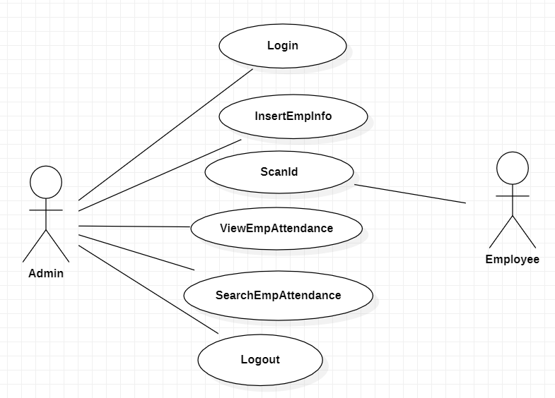
FIG:5.5.1Representation of Use Case Diagram

5.5.2 CLASS DIAGRAM
In software engineering, a class diagram in the Unified Modelling Language (UML) is a type of static structure diagram that describes the structure of a system by showing the system's classes, their attributes, operations (or methods), and the relationships among the classes. It explains which class contains information.

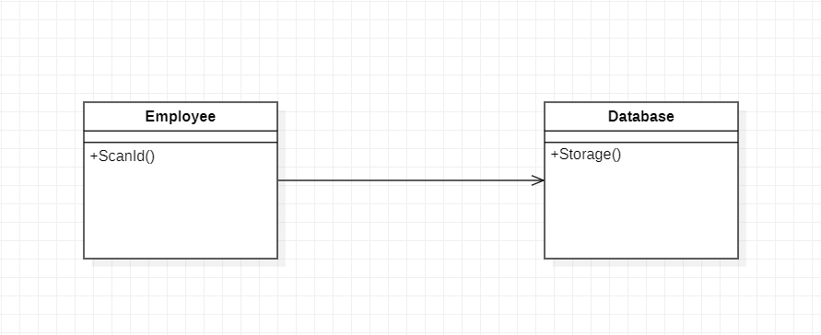
FIG:5.5.2.1 Representation of Class Diagram

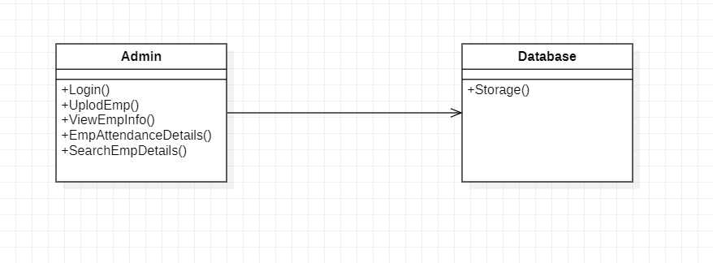
FIG:5.5.2.2 Representation of Class Diagram

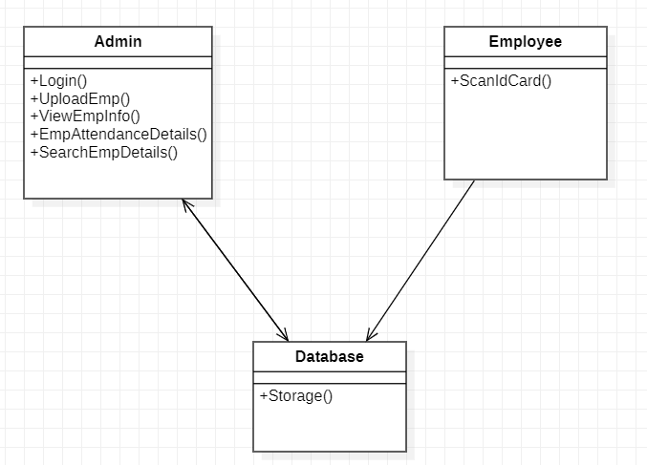

FIG:5.5.2.3 Representation of Class Diagram

5.5.3 SEQUENCE DIAGRAM
A sequence diagram in Unified Modelling Language (UML) is a kind of interaction diagram that shows how processes operate with one another and in what order. It is a construct of a Message Sequence Chart. Sequence diagrams are sometimes called event diagrams, event scenarios, and timing diagrams.

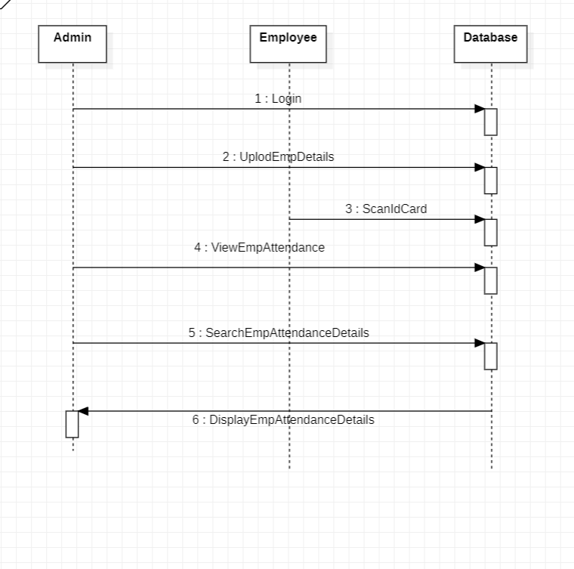

FIG:5.5.3 Representation of Sequence Diagram

5.5.4 COLLABORATION DIAGRAM
The collaboration diagram is used to show the relationship between the objects in a system. Both the sequence and the collaboration diagrams represent the same information but differently. Instead of showing the flow of messages, it depicts the architecture of the object residing in the system as it is based on object-oriented programming. An object consists of several features.
Multiple objects present in the system are connected to each other. The collaboration diagram, which is also known as a communication diagram, is used to portray the object's architecture in the system.

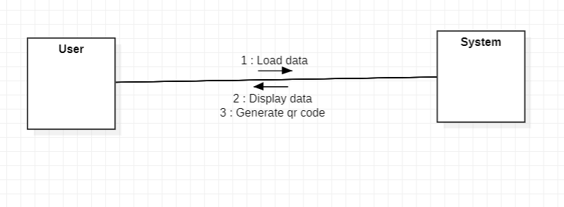

FIG:5.5.4 Representation of Collaboration Diagram

Chapter 6
SYSTEM IMPLEMENTATON

6.1 SAMPLE CODE
Source: [
<?xml version="1.0" encoding="UTF-8" ?>

<Form version="1.3" maxVersion="1.8" type="org.netbeans.modules.form.forminfo.JFrameFormInfo">
<Properties>
<Property name="defaultCloseOperation" type="int" value="3"/>
</Properties>
<SyntheticProperties>
<SyntheticProperty name="formSizePolicy" type="int" value="0"/>
<SyntheticProperty name="generateSize" type="boolean" value="false"/>
<SyntheticProperty name="generateCenter" type="boolean" value="true"/>
</SyntheticProperties>
<AuxValues>
<AuxValue name="FormSettings_autoResourcing" type="java.lang.Integer" value="0"/>
<AuxValue name="FormSettings_autoSetComponentName" type="java.lang.Boolean" value="false"/>
<AuxValue name="FormSettings_generateFQN" type="java.lang.Boolean" value="true"/>
<AuxValue name="FormSettings_generateMnemonicsCode" type="java.lang.Boolean" value="false"/>
<AuxValue name="FormSettings_i18nAutoMode" type="java.lang.Boolean" value="false"/>
<AuxValue name="FormSettings_layoutCodeTarget" type="java.lang.Integer" value="1"/>
<AuxValue name="FormSettings_listenerGenerationStyle" type="java.lang.Integer" value="0"/>
<AuxValue name="FormSettings_variablesLocal" type="java.lang.Boolean" value="false"/>
<AuxValue name="FormSettings_variablesModifier" type="java.lang.Integer" value="2"/>
</AuxValues>

<Layout>
<DimensionLayout dim="0">
<Group type="103" groupAlignment="0" attributes="0">
<Group type="102" alignment="0" attributes="0">
<Component id="jPanel1" min="-2" pref="347" max="-2" attributes="0"/>
<EmptySpace max="32767" attributes="0"/>
<Component id="jPanel2" min="-2" pref="468" max="-2" attributes="0"/>
<EmptySpace min="-2" pref="0" max="-2" attributes="0"/>
</Group>
</Group>
</DimensionLayout>
<DimensionLayout dim="1">
<Group type="103" groupAlignment="0" attributes="0">
<Component id="jPanel1" alignment="0" max="32767" attributes="0"/>
<Component id="jPanel2" alignment="1" max="32767" attributes="0"/>
</Group>
</DimensionLayout>
</Layout>
<SubComponents>
<Container class="javax.swing.JPanel" name="jPanel1">

<Layout class="org.netbeans.modules.form.compat2.layouts.DesignAbsoluteLayout">
<Property name="useNullLayout" type="boolean" value="false"/>
</Layout>
<SubComponents>
<Component class="javax.swing.JLabel" name="jLabel1">
<Properties>
<Property name="font" type="java.awt.Font" editor="org.netbeans.beaninfo.editors.FontEditor">
<Font name="Tahoma" size="18" style="1"/>
</Property>
<Property name="foreground" type="java.awt.Color" editor="org.netbeans.beaninfo.editors.ColorEditor">
<Color blue="33" green="33" red="0" type="rgb"/>
</Property>
<Property name="text" type="java.lang.String" value="New Employee Registration"/>
</Properties>
<Constraints>
<Constraint layoutClass="org.netbeans.modules.form.compat2.layouts.DesignAbsoluteLayout" value="org.netbeans.modules.form.compat2.layouts.DesignAbsoluteLayout$AbsoluteConstraintsDescription">
<AbsoluteConstraints x="55" y="20" width="258" height="34"/>
</Constraint>
</Constraints>
</Component>
<Component class="javax.swing.JLabel" name="jLabel2">
<Properties>
<Property name="font" type="java.awt.Font" editor="org.netbeans.beaninfo.editors.FontEditor">
<Font name="Tahoma" size="11" style="1"/>
</Property>
<Property name="foreground" type="java.awt.Color" editor="org.netbeans.beaninfo.editors.ColorEditor">
<Color blue="33" green="33" red="0" type="rgb"/>
</Property>
<Property name="text" type="java.lang.String" value="EMP ID"/>
</Properties>
<Constraints>
<Constraint layoutClass="org.netbeans.modules.form.compat2.layouts.DesignAbsoluteLayout" value="org.netbeans.modules.form.compat2.layouts.DesignAbsoluteLayout$AbsoluteConstraintsDescription">
<AbsoluteConstraints x="74" y="75" width="-1" height="-1"/>
</Constraint>
</Constraints>
</Component>
<Component class="javax.swing.JLabel" name="jLabel3">
<Properties>
<Property name="font" type="java.awt.Font" editor="org.netbeans.beaninfo.editors.FontEditor">
<Font name="Tahoma" size="11" style="1"/>
</Property>
<Property name="foreground" type="java.awt.Color" editor="org.netbeans.beaninfo.editors.ColorEditor">
<Color blue="33" green="33" red="0" type="rgb"/>
</Property>
<Property name="text" type="java.lang.String" value="NAME"/>
</Properties>
<Constraints>
<Constraint layoutClass="org.netbeans.modules.form.compat2.layouts.DesignAbsoluteLayout" value="org.netbeans.modules.form.compat2.layouts.DesignAbsoluteLayout$AbsoluteConstraintsDescription">
<AbsoluteConstraints x="82" y="119" width="-1" height="-1"/>
</Constraint>
</Constraints>
</Component>
<Component class="javax.swing.JLabel" name="jLabel4">
<Properties>
<Property name="font" type="java.awt.Font" editor="org.netbeans.beaninfo.editors.FontEditor">
<Font name="Tahoma" size="11" style="1"/>
</Property>
<Property name="foreground" type="java.awt.Color" editor="org.netbeans.beaninfo.editors.ColorEditor">
<Color blue="33" green="33" red="0" type="rgb"/>
</Property>
<Property name="text" type="java.lang.String" value="SURNAME"/>
</Properties>
<Constraints>
<Constraint layoutClass="org.netbeans.modules.form.compat2.layouts.DesignAbsoluteLayout" value="org.netbeans.modules.form.compat2.layouts.DesignAbsoluteLayout$AbsoluteConstraintsDescription">
<AbsoluteConstraints x="59" y="160" width="-1" height="-1"/>
</Constraint>
</Constraints>
</Component>
<Component class="javax.swing.JLabel" name="jLabel5">
<Properties>
<Property name="font" type="java.awt.Font" editor="org.netbeans.beaninfo.editors.FontEditor">
<Font name="Tahoma" size="11" style="1"/>
</Property>
<Property name="foreground" type="java.awt.Color" editor="org.netbeans.beaninfo.editors.ColorEditor">
<Color blue="33" green="33" red="0" type="rgb"/>
</Property>
<Property name="text" type="java.lang.String" value="EMAIL"/>
</Properties>
<Constraints>
<Constraint layoutClass="org.netbeans.modules.form.compat2.layouts.DesignAbsoluteLayout" value="org.netbeans.modules.form.compat2.layouts.DesignAbsoluteLayout$AbsoluteConstraintsDescription">
<AbsoluteConstraints x="78" y="198" width="-1" height="-1"/>
</Constraint>
</Constraints>
</Component>
<Component class="javax.swing.JLabel" name="jLabel6">
<Properties>
<Property name="font" type="java.awt.Font" editor="org.netbeans.beaninfo.editors.FontEditor">
<Font name="Tahoma" size="11" style="1"/>
</Property>
<Property name="foreground" type="java.awt.Color" editor="org.netbeans.beaninfo.editors.ColorEditor">
<Color blue="33" green="33" red="0" type="rgb"/>
</Property>
<Property name="text" type="java.lang.String" value="PHONE "/>
</Properties>
<Constraints>
<Constraint layoutClass="org.netbeans.modules.form.compat2.layouts.DesignAbsoluteLayout" value="org.netbeans.modules.form.compat2.layouts.DesignAbsoluteLayout$AbsoluteConstraintsDescription">
<AbsoluteConstraints x="74" y="236" width="-1" height="-1"/>
</Constraint>
</Constraints>
</Component>
<Component class="javax.swing.JLabel" name="jLabel7">
<Properties>
<Property name="font" type="java.awt.Font" editor="org.netbeans.beaninfo.editors.FontEditor">
<Font name="Tahoma" size="11" style="1"/>
</Property>
<Property name="foreground" type="java.awt.Color" editor="org.netbeans.beaninfo.editors.ColorEditor">
<Color blue="33" green="33" red="0" type="rgb"/>
</Property>
<Property name="text" type="java.lang.String" value="ADDRESS"/>
</Properties>
<Constraints>
<Constraint layoutClass="org.netbeans.modules.form.compat2.layouts.DesignAbsoluteLayout" value="org.netbeans.modules.form.compat2.layouts.DesignAbsoluteLayout$AbsoluteConstraintsDescription">
<AbsoluteConstraints x="61" y="304" width="-1" height="-1"/>
</Constraint>
</Constraints>
</Component>
<Component class="javax.swing.JLabel" name="jLabel8">
<Properties>
<Property name="font" type="java.awt.Font" editor="org.netbeans.beaninfo.editors.FontEditor">
<Font name="Tahoma" size="11" style="1"/>
</Property>
<Property name="foreground" type="java.awt.Color" editor="org.netbeans.beaninfo.editors.ColorEditor">
<Color blue="33" green="33" red="0" type="rgb"/>
</Property>
<Property name="text" type="java.lang.String" value="DESIGNATION "/>
</Properties>
<Constraints>
<Constraint layoutClass="org.netbeans.modules.form.compat2.layouts.DesignAbsoluteLayout" value="org.netbeans.modules.form.compat2.layouts.DesignAbsoluteLayout$AbsoluteConstraintsDescription">
<AbsoluteConstraints x="34" y="384" width="-1" height="-1"/>
</Constraint>
</Constraints>
</Component>
<Component class="javax.swing.JTextField" name="T1">
<Constraints>
<Constraint layoutClass="org.netbeans.modules.form.compat2.layouts.DesignAbsoluteLayout" value="org.netbeans.modules.form.compat2.layouts.DesignAbsoluteLayout$AbsoluteConstraintsDescription">
<AbsoluteConstraints x="139" y="72" width="124" height="-1"/>
</Constraint>
</Constraints>
</Component>
<Component class="javax.swing.JTextField" name="T2">
<Constraints>
<Constraint layoutClass="org.netbeans.modules.form.compat2.layouts.DesignAbsoluteLayout" value="org.netbeans.modules.form.compat2.layouts.DesignAbsoluteLayout$AbsoluteConstraintsDescription">
<AbsoluteConstraints x="139" y="116" width="124" height="-1"/>
</Constraint>
</Constraints>
</Component>
<Component class="javax.swing.JTextField" name="T3">
<Constraints>
<Constraint layoutClass="org.netbeans.modules.form.compat2.layouts.DesignAbsoluteLayout" value="org.netbeans.modules.form.compat2.layouts.DesignAbsoluteLayout$AbsoluteConstraintsDescription">
<AbsoluteConstraints x="139" y="157" width="124" height="-1"/>
</Constraint>
</Constraints>
</Component>
<Component class="javax.swing.JTextField" name="T4">
<Events>
<EventHandler event="actionPerformed" listener="java.awt.event.ActionListener" parameters="java.awt.event.ActionEvent" handler="T4ActionPerformed"/>
</Events>
<Constraints>
<Constraint layoutClass="org.netbeans.modules.form.compat2.layouts.DesignAbsoluteLayout" value="org.netbeans.modules.form.compat2.layouts.DesignAbsoluteLayout$AbsoluteConstraintsDescription">
<AbsoluteConstraints x="139" y="195" width="124" height="-1"/>
</Constraint>
</Constraints>
</Component>
<Component class="javax.swing.JTextField" name="T5">
<Constraints>
<Constraint layoutClass="org.netbeans.modules.form.compat2.layouts.DesignAbsoluteLayout" value="org.netbeans.modules.form.compat2.layouts.DesignAbsoluteLayout$AbsoluteConstraintsDescription">
<AbsoluteConstraints x="139" y="233" width="124" height="-1"/>
</Constraint>
</Constraints>
</Component>
<Component class="javax.swing.JTextField" name="T6">
<Constraints>
<Constraint layoutClass="org.netbeans.modules.form.compat2.layouts.DesignAbsoluteLayout" value="org.netbeans.modules.form.compat2.layouts.DesignAbsoluteLayout$AbsoluteConstraintsDescription">
<AbsoluteConstraints x="139" y="381" width="124" height="-1"/>
</Constraint>
</Constraints>
</Component>
<Container class="javax.swing.JScrollPane" name="jScrollPane1">
<AuxValues>
<AuxValue name="autoScrollPane" type="java.lang.Boolean" value="true"/>
</AuxValues>
<Constraints>
<Constraint layoutClass="org.netbeans.modules.form.compat2.layouts.DesignAbsoluteLayout" value="org.netbeans.modules.form.compat2.layouts.DesignAbsoluteLayout$AbsoluteConstraintsDescription">
<AbsoluteConstraints x="139" y="271" width="124" height="84"/>
</Constraint>
</Constraints>

<Layout class="org.netbeans.modules.form.compat2.layouts.support.JScrollPaneSupportLayout"/>
<SubComponents>
<Component class="javax.swing.JTextArea" name="TA1">
<Properties>
<Property name="columns" type="int" value="20"/>
<Property name="rows" type="int" value="5"/>
</Properties>
</Component>
</SubComponents>
</Container>
<Component class="javax.swing.JButton" name="jButton1">
<Properties>
<Property name="font" type="java.awt.Font" editor="org.netbeans.beaninfo.editors.FontEditor">
<Font name="Tahoma" size="12" style="1"/>
</Property>
<Property name="foreground" type="java.awt.Color" editor="org.netbeans.beaninfo.editors.ColorEditor">
<Color blue="0" green="cc" red="33" type="rgb"/>
</Property>
<Property name="text" type="java.lang.String" value="Submit"/>
</Properties>
<Events>
<EventHandler event="actionPerformed" listener="java.awt.event.ActionListener" parameters="java.awt.event.ActionEvent" handler="jButton1ActionPerformed"/>
</Events>
<Constraints>
<Constraint layoutClass="org.netbeans.modules.form.compat2.layouts.DesignAbsoluteLayout" value="org.netbeans.modules.form.compat2.layouts.DesignAbsoluteLayout$AbsoluteConstraintsDescription">
<AbsoluteConstraints x="130" y="430" width="-1" height="38"/>
</Constraint>
</Constraints>
</Component>
<Component class="javax.swing.JButton" name="jButton2">
<Properties>
<Property name="font" type="java.awt.Font" editor="org.netbeans.beaninfo.editors.FontEditor">
<Font name="Tahoma" size="12" style="1"/>
</Property>
<Property name="foreground" type="java.awt.Color" editor="org.netbeans.beaninfo.editors.ColorEditor">
<Color blue="33" green="0" red="cc" type="rgb"/>
</Property>
<Property name="text" type="java.lang.String" value="Clear"/>
</Properties>
<Events>
<EventHandler event="actionPerformed" listener="java.awt.event.ActionListener" parameters="java.awt.event.ActionEvent" handler="jButton2ActionPerformed"/>
</Events>
<Constraints>
<Constraint layoutClass="org.netbeans.modules.form.compat2.layouts.DesignAbsoluteLayout" value="org.netbeans.modules.form.compat2.layouts.DesignAbsoluteLayout$AbsoluteConstraintsDescription">
<AbsoluteConstraints x="220" y="430" width="-1" height="38"/>
</Constraint>
</Constraints>
</Component>
<Component class="javax.swing.JLabel" name="L9">
<Properties>
<Property name="font" type="java.awt.Font" editor="org.netbeans.beaninfo.editors.FontEditor">
<Font name="Tahoma" size="14" style="1"/>
</Property>
<Property name="foreground" type="java.awt.Color" editor="org.netbeans.beaninfo.editors.ColorEditor">
<Color blue="0" green="0" red="ff" type="rgb"/>
</Property>
</Properties>
<Constraints>
<Constraint layoutClass="org.netbeans.modules.form.compat2.layouts.DesignAbsoluteLayout" value="org.netbeans.modules.form.compat2.layouts.DesignAbsoluteLayout$AbsoluteConstraintsDescription">
<AbsoluteConstraints x="0" y="476" width="337" height="28"/>
</Constraint>
</Constraints>
</Component>
<Component class="javax.swing.JLabel" name="L10">
<Properties>
<Property name="font" type="java.awt.Font" editor="org.netbeans.beaninfo.editors.FontEditor">
<Font name="Tahoma" size="14" style="1"/>
</Property>
<Property name="foreground" type="java.awt.Color" editor="org.netbeans.beaninfo.editors.ColorEditor">
<Color blue="0" green="99" red="0" type="rgb"/>
</Property>
</Properties>
<Constraints>
<Constraint layoutClass="org.netbeans.modules.form.compat2.layouts.DesignAbsoluteLayout" value="org.netbeans.modules.form.compat2.layouts.DesignAbsoluteLayout$AbsoluteConstraintsDescription">
<AbsoluteConstraints x="10" y="510" width="307" height="27"/>
</Constraint>
</Constraints>
</Component>
<Component class="javax.swing.JLabel" name="jLabel11">
<Properties>
<Property name="icon" type="javax.swing.Icon" editor="org.netbeans.modules.form.editors2.IconEditor">
<Image iconType="2" name="C:\Users\java4\Documents\NetBeansProjects\Employee_Attendance_System\img\bg.jpg"/>
</Property>
</Properties>
<Constraints>
<Constraint layoutClass="org.netbeans.modules.form.compat2.layouts.DesignAbsoluteLayout" value="org.netbeans.modules.form.compat2.layouts.DesignAbsoluteLayout$AbsoluteConstraintsDescription">
<AbsoluteConstraints x="0" y="0" width="350" height="580"/>
</Constraint>
</Constraints>
</Component>
</SubComponents>
</Container>
<Container class="javax.swing.JPanel" name="jPanel2">

<Layout class="org.netbeans.modules.form.compat2.layouts.DesignAbsoluteLayout">
<Property name="useNullLayout" type="boolean" value="false"/>
</Layout>
<SubComponents>
<Component class="javax.swing.JTextField" name="T7">
<Constraints>
<Constraint layoutClass="org.netbeans.modules.form.compat2.layouts.DesignAbsoluteLayout" value="org.netbeans.modules.form.compat2.layouts.DesignAbsoluteLayout$AbsoluteConstraintsDescription">
<AbsoluteConstraints x="180" y="320" width="90" height="-1"/>
</Constraint>
</Constraints>
</Component>
<Component class="javax.swing.JButton" name="jButton3">
<Properties>
<Property name="font" type="java.awt.Font" editor="org.netbeans.beaninfo.editors.FontEditor">
<Font name="Tahoma" size="12" style="1"/>
</Property>
<Property name="foreground" type="java.awt.Color" editor="org.netbeans.beaninfo.editors.ColorEditor">
<Color blue="33" green="cc" red="0" type="rgb"/>
</Property>
<Property name="text" type="java.lang.String" value="Search"/>
</Properties>
<Events>
<EventHandler event="actionPerformed" listener="java.awt.event.ActionListener" parameters="java.awt.event.ActionEvent" handler="jButton3ActionPerformed"/>
</Events>
<Constraints>
<Constraint layoutClass="org.netbeans.modules.form.compat2.layouts.DesignAbsoluteLayout" value="org.netbeans.modules.form.compat2.layouts.DesignAbsoluteLayout$AbsoluteConstraintsDescription">
<AbsoluteConstraints x="280" y="320" width="-1" height="-1"/>
</Constraint>
</Constraints>
</Component>
<Component class="javax.swing.JLabel" name="jLabel10">
<Properties>
<Property name="font" type="java.awt.Font" editor="org.netbeans.beaninfo.editors.FontEditor">
<Font name="Tahoma" size="11" style="1"/>
</Property>
<Property name="foreground" type="java.awt.Color" editor="org.netbeans.beaninfo.editors.ColorEditor">
<Color blue="33" green="33" red="0" type="rgb"/>
</Property>
<Property name="text" type="java.lang.String" value="EMP ID"/>
</Properties>
<Constraints>
<Constraint layoutClass="org.netbeans.modules.form.compat2.layouts.DesignAbsoluteLayout" value="org.netbeans.modules.form.compat2.layouts.DesignAbsoluteLayout$AbsoluteConstraintsDescription">
<AbsoluteConstraints x="200" y="300" width="-1" height="-1"/>
</Constraint>
</Constraints>
</Component>
<Component class="javax.swing.JLabel" name="jLabel9">
<Properties>
<Property name="icon" type="javax.swing.Icon" editor="org.netbeans.modules.form.editors2.IconEditor">
<Image iconType="2" name="C:\Users\java4\Documents\NetBeansProjects\Employee_Attendance_System\img\vv.png"/>
</Property>
</Properties>
<Constraints>
<Constraint layoutClass="org.netbeans.modules.form.compat2.layouts.DesignAbsoluteLayout" value="org.netbeans.modules.form.compat2.layouts.DesignAbsoluteLayout$AbsoluteConstraintsDescription">
<AbsoluteConstraints x="110" y="30" width="220" height="250"/>
</Constraint>
</Constraints>
</Component>
<Container class="javax.swing.JScrollPane" name="jScrollPane2">
<AuxValues>
<AuxValue name="autoScrollPane" type="java.lang.Boolean" value="true"/>
</AuxValues>
<Constraints>
<Constraint layoutClass="org.netbeans.modules.form.compat2.layouts.DesignAbsoluteLayout" value="org.netbeans.modules.form.compat2.layouts.DesignAbsoluteLayout$AbsoluteConstraintsDescription">
<AbsoluteConstraints x="10" y="360" width="440" height="200"/>
</Constraint>
</Constraints>

<Layout class="org.netbeans.modules.form.compat2.layouts.support.JScrollPaneSupportLayout"/>
<SubComponents>
<Component class="javax.swing.JTable" name="jTable1">
<Properties>
<Property name="model" type="javax.swing.table.TableModel" editor="org.netbeans.modules.form.editors2.TableModelEditor">
<Table columnCount="4" rowCount="4">
<Column editable="true" title="Title 1" type="java.lang.Object"/>
<Column editable="true" title="Title 2" type="java.lang.Object"/>
<Column editable="true" title="Title 3" type="java.lang.Object"/>
<Column editable="true" title="Title 4" type="java.lang.Object"/>
</Table>
</Property>
</Properties>
</Component>
</SubComponents>
</Container>
<Component class="javax.swing.JButton" name="jButton4">
<Properties>
<Property name="font" type="java.awt.Font" editor="org.netbeans.beaninfo.editors.FontEditor">
<Font name="Tahoma" size="12" style="1"/>
</Property>
<Property name="foreground" type="java.awt.Color" editor="org.netbeans.beaninfo.editors.ColorEditor">
<Color blue="0" green="33" red="33" type="rgb"/>
</Property>
<Property name="text" type="java.lang.String" value="Get Attendance"/>
</Properties>
<Events>
<EventHandler event="actionPerformed" listener="java.awt.event.ActionListener" parameters="java.awt.event.ActionEvent" handler="jButton4ActionPerformed"/>
</Events>
<Constraints>
<Constraint layoutClass="org.netbeans.modules.form.compat2.layouts.DesignAbsoluteLayout" value="org.netbeans.modules.form.compat2.layouts.DesignAbsoluteLayout$AbsoluteConstraintsDescription">
<AbsoluteConstraints x="20" y="110" width="-1" height="-1"/>
</Constraint>
</Constraints>
</Component>
<Component class="javax.swing.JLabel" name="L12">
<Properties>
<Property name="font" type="java.awt.Font" editor="org.netbeans.beaninfo.editors.FontEditor">
<Font name="Tahoma" size="11" style="1"/>
</Property>
<Property name="foreground" type="java.awt.Color" editor="org.netbeans.beaninfo.editors.ColorEditor">
<Color blue="33" green="0" red="ff" type="rgb"/>
</Property>
</Properties>
<Constraints>
<Constraint layoutClass="org.netbeans.modules.form.compat2.layouts.DesignAbsoluteLayout" value="org.netbeans.modules.form.compat2.layouts.DesignAbsoluteLayout$AbsoluteConstraintsDescription">
<AbsoluteConstraints x="10" y="320" width="160" height="20"/>
</Constraint>
</Constraints>
</Component>
<Component class="javax.swing.JButton" name="jButton5">
<Properties>
<Property name="font" type="java.awt.Font" editor="org.netbeans.beaninfo.editors.FontEditor">
<Font name="Tahoma" size="12" style="1"/>
</Property>
<Property name="foreground" type="java.awt.Color" editor="org.netbeans.beaninfo.editors.ColorEditor">
<Color blue="0" green="33" red="ff" type="rgb"/>
</Property>
<Property name="text" type="java.lang.String" value="Logout"/>
</Properties>
<Events>
<EventHandler event="actionPerformed" listener="java.awt.event.ActionListener" parameters="java.awt.event.ActionEvent" handler="jButton5ActionPerformed"/>
</Events>
<Constraints>
<Constraint layoutClass="org.netbeans.modules.form.compat2.layouts.DesignAbsoluteLayout" value="org.netbeans.modules.form.compat2.layouts.DesignAbsoluteLayout$AbsoluteConstraintsDescription">
<AbsoluteConstraints x="380" y="20" width="-1" height="40"/>
</Constraint>
</Constraints>
</Component>
<Component class="javax.swing.JLabel" name="jLabel13">
<Properties>
<Property name="icon" type="javax.swing.Icon" editor="org.netbeans.modules.form.editors2.IconEditor">
<Image iconType="3" name="/employee_attendance_system/bg.jpg"/>
</Property>
</Properties>
<Constraints>
<Constraint layoutClass="org.netbeans.modules.form.compat2.layouts.DesignAbsoluteLayout" value="org.netbeans.modules.form.compat2.layouts.DesignAbsoluteLayout$AbsoluteConstraintsDescription">
<AbsoluteConstraints x="0" y="0" width="470" height="580"/>
</Constraint>
</Constraints>
</Component>
</SubComponents>
</Container>
</SubComponents>
</Form>
]
Outputs: []
Source:[
<?xml version="1.0" encoding="UTF-8" ?>

<Form version="1.3" maxVersion="1.8" type="org.netbeans.modules.form.forminfo.JFrameFormInfo">
<Properties>
<Property name="defaultCloseOperation" type="int" value="3"/>
</Properties>
<SyntheticProperties>
<SyntheticProperty name="formSizePolicy" type="int" value="0"/>
<SyntheticProperty name="generateSize" type="boolean" value="false"/>
<SyntheticProperty name="generateCenter" type="boolean" value="true"/>
</SyntheticProperties>
<AuxValues>
<AuxValue name="FormSettings_autoResourcing" type="java.lang.Integer" value="0"/>
<AuxValue name="FormSettings_autoSetComponentName" type="java.lang.Boolean" value="false"/>
<AuxValue name="FormSettings_generateFQN" type="java.lang.Boolean" value="true"/>
<AuxValue name="FormSettings_generateMnemonicsCode" type="java.lang.Boolean" value="false"/>
<AuxValue name="FormSettings_i18nAutoMode" type="java.lang.Boolean" value="false"/>
<AuxValue name="FormSettings_layoutCodeTarget" type="java.lang.Integer" value="1"/>
<AuxValue name="FormSettings_listenerGenerationStyle" type="java.lang.Integer" value="0"/>
<AuxValue name="FormSettings_variablesLocal" type="java.lang.Boolean" value="false"/>
<AuxValue name="FormSettings_variablesModifier" type="java.lang.Integer" value="2"/>
</AuxValues>

<Layout>
<DimensionLayout dim="0">
<Group type="103" groupAlignment="0" attributes="0">
<Component id="jPanel1" alignment="0" max="32767" attributes="0"/>
</Group>
</DimensionLayout>
<DimensionLayout dim="1">
<Group type="103" groupAlignment="0" attributes="0">
<Component id="jPanel1" alignment="1" max="32767" attributes="0"/>
</Group>
</DimensionLayout>
</Layout>
<SubComponents>
<Container class="javax.swing.JPanel" name="jPanel1">

<Layout class="org.netbeans.modules.form.compat2.layouts.DesignAbsoluteLayout">
<Property name="useNullLayout" type="boolean" value="false"/>
</Layout>
<SubComponents>
<Component class="javax.swing.JLabel" name="jLabel1">
<Properties>
<Property name="font" type="java.awt.Font" editor="org.netbeans.beaninfo.editors.FontEditor">
<Font name="Tahoma" size="18" style="1"/>
</Property>
<Property name="foreground" type="java.awt.Color" editor="org.netbeans.beaninfo.editors.ColorEditor">
<Color blue="33" green="33" red="0" type="rgb"/>
</Property>
<Property name="text" type="java.lang.String" value="Employee Attendance"/>
</Properties>
<Constraints>
<Constraint layoutClass="org.netbeans.modules.form.compat2.layouts.DesignAbsoluteLayout" value="org.netbeans.modules.form.compat2.layouts.DesignAbsoluteLayout$AbsoluteConstraintsDescription">
<AbsoluteConstraints x="70" y="70" width="200" height="29"/>
</Constraint>
</Constraints>
</Component>
<Component class="javax.swing.JTextField" name="jTextField1">
<Constraints>
<Constraint layoutClass="org.netbeans.modules.form.compat2.layouts.DesignAbsoluteLayout" value="org.netbeans.modules.form.compat2.layouts.DesignAbsoluteLayout$AbsoluteConstraintsDescription">
<AbsoluteConstraints x="60" y="130" width="214" height="-1"/>
</Constraint>
</Constraints>
</Component>
<Component class="javax.swing.JButton" name="Submit">
<Properties>
<Property name="font" type="java.awt.Font" editor="org.netbeans.beaninfo.editors.FontEditor">
<Font name="Tahoma" size="14" style="1"/>
</Property>
<Property name="foreground" type="java.awt.Color" editor="org.netbeans.beaninfo.editors.ColorEditor">
<Color blue="33" green="99" red="0" type="rgb"/>
</Property>
<Property name="text" type="java.lang.String" value="Select"/>
</Properties>
<Events>
<EventHandler event="actionPerformed" listener="java.awt.event.ActionListener" parameters="java.awt.event.ActionEvent" handler="SubmitActionPerformed"/>
</Events>
<Constraints>
<Constraint layoutClass="org.netbeans.modules.form.compat2.layouts.DesignAbsoluteLayout" value="org.netbeans.modules.form.compat2.layouts.DesignAbsoluteLayout$AbsoluteConstraintsDescription">
<AbsoluteConstraints x="290" y="130" width="-1" height="-1"/>
</Constraint>
</Constraints>
</Component>
<Component class="javax.swing.JButton" name="enter">
<Properties>
<Property name="font" type="java.awt.Font" editor="org.netbeans.beaninfo.editors.FontEditor">
<Font name="Tahoma" size="14" style="1"/>
</Property>
<Property name="foreground" type="java.awt.Color" editor="org.netbeans.beaninfo.editors.ColorEditor">
<Color blue="33" green="99" red="0" type="rgb"/>
</Property>
<Property name="text" type="java.lang.String" value="Submit"/>
</Properties>
<Events>
<EventHandler event="actionPerformed" listener="java.awt.event.ActionListener" parameters="java.awt.event.ActionEvent" handler="enterActionPerformed"/>
</Events>
<Constraints>
<Constraint layoutClass="org.netbeans.modules.form.compat2.layouts.DesignAbsoluteLayout" value="org.netbeans.modules.form.compat2.layouts.DesignAbsoluteLayout$AbsoluteConstraintsDescription">
<AbsoluteConstraints x="80" y="170" width="-1" height="-1"/>
</Constraint>
</Constraints>
</Component>
<Component class="javax.swing.JButton" name="jButton3">
<Properties>
<Property name="font" type="java.awt.Font" editor="org.netbeans.beaninfo.editors.FontEditor">
<Font name="Tahoma" size="14" style="1"/>
</Property>
<Property name="foreground" type="java.awt.Color" editor="org.netbeans.beaninfo.editors.ColorEditor">
<Color blue="33" green="99" red="0" type="rgb"/>
</Property>
<Property name="text" type="java.lang.String" value="Logout"/>
</Properties>
<Events>
<EventHandler event="actionPerformed" listener="java.awt.event.ActionListener" parameters="java.awt.event.ActionEvent" handler="jButton3ActionPerformed"/>
</Events>
<Constraints>
<Constraint layoutClass="org.netbeans.modules.form.compat2.layouts.DesignAbsoluteLayout" value="org.netbeans.modules.form.compat2.layouts.DesignAbsoluteLayout$AbsoluteConstraintsDescription">
<AbsoluteConstraints x="190" y="170" width="-1" height="-1"/>
</Constraint>
</Constraints>
</Component>
<Component class="javax.swing.JLabel" name="jLabel2">
<Properties>
<Property name="icon" type="javax.swing.Icon" editor="org.netbeans.modules.form.editors2.IconEditor">
<Image iconType="2" name="C:\Users\java4\Desktop\blue_abstract_background_310971.jpg"/>
</Property>
</Properties>
<Constraints>
<Constraint layoutClass="org.netbeans.modules.form.compat2.layouts.DesignAbsoluteLayout" value="org.netbeans.modules.form.compat2.layouts.DesignAbsoluteLayout$AbsoluteConstraintsDescription">
<AbsoluteConstraints x="0" y="0" width="420" height="300"/>
</Constraint>
</Constraints>
</Component>
</SubComponents>
</Container>
</SubComponents>
</Form>
]
Outputs: []
Source: [
<?xml version="1.0" encoding="UTF-8" ?>

<Form version="1.3" maxVersion="1.8" type="org.netbeans.modules.form.forminfo.JFrameFormInfo">
<Properties>
<Property name="defaultCloseOperation" type="int" value="3"/>
</Properties>
<SyntheticProperties>
<SyntheticProperty name="formSizePolicy" type="int" value="0"/>
<SyntheticProperty name="generateSize" type="boolean" value="false"/>
<SyntheticProperty name="generateCenter" type="boolean" value="true"/>
</SyntheticProperties>
<AuxValues>
<AuxValue name="FormSettings_autoResourcing" type="java.lang.Integer" value="0"/>
<AuxValue name="FormSettings_autoSetComponentName" type="java.lang.Boolean" value="false"/>
<AuxValue name="FormSettings_generateFQN" type="java.lang.Boolean" value="true"/>
<AuxValue name="FormSettings_generateMnemonicsCode" type="java.lang.Boolean" value="false"/>
<AuxValue name="FormSettings_i18nAutoMode" type="java.lang.Boolean" value="false"/>
<AuxValue name="FormSettings_layoutCodeTarget" type="java.lang.Integer" value="1"/>
<AuxValue name="FormSettings_listenerGenerationStyle" type="java.lang.Integer" value="0"/>
<AuxValue name="FormSettings_variablesLocal" type="java.lang.Boolean" value="false"/>
<AuxValue name="FormSettings_variablesModifier" type="java.lang.Integer" value="2"/>
</AuxValues>

<Layout>
<DimensionLayout dim="0">
<Group type="103" groupAlignment="0" attributes="0">
<Group type="102" alignment="0" attributes="0">
<EmptySpace max="-2" attributes="0"/>
<Component id="jPanel1" max="32767" attributes="0"/>
<EmptySpace max="-2" attributes="0"/>
</Group>
</Group>
</DimensionLayout>
<DimensionLayout dim="1">
<Group type="103" groupAlignment="0" attributes="0">
<Component id="jPanel1" alignment="0" max="32767" attributes="0"/>
</Group>
</DimensionLayout>
</Layout>
<SubComponents>
<Container class="javax.swing.JPanel" name="jPanel1">

<Layout class="org.netbeans.modules.form.compat2.layouts.DesignAbsoluteLayout">
<Property name="useNullLayout" type="boolean" value="false"/>
</Layout>
<SubComponents>
<Component class="javax.swing.JLabel" name="jLabel1">
<Properties>
<Property name="font" type="java.awt.Font" editor="org.netbeans.beaninfo.editors.FontEditor">
<Font name="Monotype Corsiva" size="24" style="1"/>
</Property>
<Property name="foreground" type="java.awt.Color" editor="org.netbeans.beaninfo.editors.ColorEditor">
<Color blue="33" green="33" red="0" type="rgb"/>
</Property>
<Property name="text" type="java.lang.String" value="Admin Login"/>
</Properties>
<Constraints>
<Constraint layoutClass="org.netbeans.modules.form.compat2.layouts.DesignAbsoluteLayout" value="org.netbeans.modules.form.compat2.layouts.DesignAbsoluteLayout$AbsoluteConstraintsDescription">
<AbsoluteConstraints x="126" y="45" width="150" height="44"/>
</Constraint>
</Constraints>
</Component>
<Component class="javax.swing.JLabel" name="jLabel2">
<Properties>
<Property name="font" type="java.awt.Font" editor="org.netbeans.beaninfo.editors.FontEditor">
<Font name="Tahoma" size="14" style="1"/>
</Property>
<Property name="foreground" type="java.awt.Color" editor="org.netbeans.beaninfo.editors.ColorEditor">
<Color blue="0" green="33" red="33" type="rgb"/>
</Property>
<Property name="text" type="java.lang.String" value="Admin ID"/>
</Properties>
<Constraints>
<Constraint layoutClass="org.netbeans.modules.form.compat2.layouts.DesignAbsoluteLayout" value="org.netbeans.modules.form.compat2.layouts.DesignAbsoluteLayout$AbsoluteConstraintsDescription">
<AbsoluteConstraints x="91" y="112" width="-1" height="-1"/>
</Constraint>
</Constraints>
</Component>
<Component class="javax.swing.JLabel" name="jLabel3">
<Properties>
<Property name="font" type="java.awt.Font" editor="org.netbeans.beaninfo.editors.FontEditor">
<Font name="Tahoma" size="14" style="1"/>
</Property>
<Property name="foreground" type="java.awt.Color" editor="org.netbeans.beaninfo.editors.ColorEditor">
<Color blue="0" green="33" red="33" type="rgb"/>
</Property>
<Property name="text" type="java.lang.String" value="Password"/>
</Properties>
<Constraints>
<Constraint layoutClass="org.netbeans.modules.form.compat2.layouts.DesignAbsoluteLayout" value="org.netbeans.modules.form.compat2.layouts.DesignAbsoluteLayout$AbsoluteConstraintsDescription">
<AbsoluteConstraints x="91" y="150" width="-1" height="-1"/>
</Constraint>
</Constraints>
</Component>
<Component class="javax.swing.JTextField" name="name">
<Constraints>
<Constraint layoutClass="org.netbeans.modules.form.compat2.layouts.DesignAbsoluteLayout" value="org.netbeans.modules.form.compat2.layouts.DesignAbsoluteLayout$AbsoluteConstraintsDescription">
<AbsoluteConstraints x="182" y="112" width="121" height="-1"/>
</Constraint>
</Constraints>
</Component>
<Component class="javax.swing.JPasswordField" name="pass">
<Constraints>
<Constraint layoutClass="org.netbeans.modules.form.compat2.layouts.DesignAbsoluteLayout" value="org.netbeans.modules.form.compat2.layouts.DesignAbsoluteLayout$AbsoluteConstraintsDescription">
<AbsoluteConstraints x="182" y="150" width="121" height="-1"/>
</Constraint>
</Constraints>
</Component>
<Component class="javax.swing.JButton" name="jButton1">
<Properties>
<Property name="font" type="java.awt.Font" editor="org.netbeans.beaninfo.editors.FontEditor">
<Font name="Tahoma" size="14" style="3"/>
</Property>
<Property name="foreground" type="java.awt.Color" editor="org.netbeans.beaninfo.editors.ColorEditor">
<Color blue="33" green="cc" red="0" type="rgb"/>
</Property>
<Property name="text" type="java.lang.String" value="Login"/>
</Properties>
<Events>
<EventHandler event="actionPerformed" listener="java.awt.event.ActionListener" parameters="java.awt.event.ActionEvent" handler="jButton1ActionPerformed"/>
</Events>
<Constraints>
<Constraint layoutClass="org.netbeans.modules.form.compat2.layouts.DesignAbsoluteLayout" value="org.netbeans.modules.form.compat2.layouts.DesignAbsoluteLayout$AbsoluteConstraintsDescription">
<AbsoluteConstraints x="192" y="188" width="-1" height="-1"/>
</Constraint>
</Constraints>
</Component>
<Component class="javax.swing.JButton" name="jButton2">
<Properties>
<Property name="font" type="java.awt.Font" editor="org.netbeans.beaninfo.editors.FontEditor">
<Font name="Tahoma" size="14" style="3"/>
</Property>
<Property name="foreground" type="java.awt.Color" editor="org.netbeans.beaninfo.editors.ColorEditor">
<Color blue="33" green="cc" red="0" type="rgb"/>
</Property>
<Property name="text" type="java.lang.String" value="Employee"/>
</Properties>
<Events>
<EventHandler event="actionPerformed" listener="java.awt.event.ActionListener" parameters="java.awt.event.ActionEvent" handler="jButton2ActionPerformed"/>
</Events>
<Constraints>
<Constraint layoutClass="org.netbeans.modules.form.compat2.layouts.DesignAbsoluteLayout" value="org.netbeans.modules.form.compat2.layouts.DesignAbsoluteLayout$AbsoluteConstraintsDescription">
<AbsoluteConstraints x="293" y="242" width="-1" height="-1"/>
</Constraint>
</Constraints>
</Component>
<Component class="javax.swing.JLabel" name="jLabel4">
<Constraints>
<Constraint layoutClass="org.netbeans.modules.form.compat2.layouts.DesignAbsoluteLayout" value="org.netbeans.modules.form.compat2.layouts.DesignAbsoluteLayout$AbsoluteConstraintsDescription">
<AbsoluteConstraints x="0" y="0" width="520" height="320"/>
</Constraint>
</Constraints>
</Component>
</SubComponents>
</Container>
</SubComponents>
</Form>
]
Outputs: []
Source: [
import java.io.FileNotFoundException;
import java.io.FileOutputStream;
import java.io.IOException;
import java.sql.Connection;
import java.sql.DriverManager;
import java.sql.ResultSet;
import java.sql.SQLException;
import java.sql.Statement;
import java.util.logging.Level;
import java.util.logging.Logger;
import org.apache.poi.hssf.usermodel.HSSFRow;
import org.apache.poi.hssf.usermodel.HSSFSheet;
import org.apache.poi.hssf.usermodel.HSSFWorkbook;
import org.apache.poi.ss.usermodel.*;

public class Plexada2 {

public void GetExcel() {
try {
Class.forName("com.mysql.jdbc.Driver");
Connection con = DriverManager.getConnection("jdbc:mysql://localhost:3306/attendance", "root", "root");
Statement st = con.createStatement();
ResultSet rs = st.executeQuery("Select * from attend");
HSSFWorkbook workbook = new HSSFWorkbook();
HSSFSheet sheet = workbook.createSheet("lawix10");
HSSFRow rowhead = sheet.createRow((short) 0);
rowhead.createCell((short) 0).setCellValue("EMP ID");
rowhead.createCell((short) 1).setCellValue("NAME");
rowhead.createCell((short) 2).setCellValue("MOBILE NO");
rowhead.createCell((short) 3).setCellValue("DATE");
rowhead.createCell((short) 4).setCellValue("TIME");
int i = 1;
while (rs.next()) {
HSSFRow row = sheet.createRow((short) i);
row.createCell((short) 0).setCellValue(rs.getString("eid"));
row.createCell((short) 1).setCellValue(rs.getString("name"));
row.createCell((short) 2).setCellValue(rs.getString("mail"));
row.createCell((short) 3).setCellValue(rs.getString("indate"));
row.createCell((short) 4).setCellValue(rs.getString("time"));
i++;
}
String yemi = "D:\\Report.xls";
FileOutputStream fileOut = new FileOutputStream(yemi);
workbook.write(fileOut);
fileOut.close();
} catch (ClassNotFoundException e1) {
e1.printStackTrace();
} catch (SQLException e1) {
e1.printStackTrace();
} catch (FileNotFoundException e1) {
e1.printStackTrace();
} catch (IOException e1) {
e1.printStackTrace();
}
}
}
]
Outputs: []
Source: [
package employee_attendance_system;

import java.awt.Color;
import java.awt.Graphics2D;
import java.awt.image.BufferedImage;
import java.io.File;
import java.io.IOException;
import java.util.EnumMap;
import java.util.Map;
import javax.imageio.ImageIO;
import com.google.zxing.BarcodeFormat;
import com.google.zxing.EncodeHintType;
import com.google.zxing.WriterException;
import com.google.zxing.common.BitMatrix;
import com.google.zxing.qrcode.QRCodeWriter;
import com.google.zxing.qrcode.decoder.ErrorCorrectionLevel;

/**
*
* @author java4
*/

public class QR_codeGen {

public void QR_code(String details, String name){
String myCodeText = details;
String filePath = "D:\\'"+name+"'.png";
int size = 250;
String fileType = "png";
File myFile = new File(filePath);
try {

Map<EncodeHintType, Object> hintMap = new EnumMap<EncodeHintType, Object>(EncodeHintType.class);
hintMap.put(EncodeHintType.CHARACTER_SET, "UTF-8");

// Now with zxing version 3.2.1 you could change border size (white border size to just 1)
hintMap.put(EncodeHintType.MARGIN, 1); /* default = 4 */
hintMap.put(EncodeHintType.ERROR_CORRECTION, ErrorCorrectionLevel.L);

QRCodeWriter qrCodeWriter = new QRCodeWriter();
BitMatrix byteMatrix = qrCodeWriter.encode(myCodeText, BarcodeFormat.QR_CODE, size,
size, hintMap);
int CrunchifyWidth = byteMatrix.getWidth();
BufferedImage image = new BufferedImage(CrunchifyWidth, CrunchifyWidth,
BufferedImage.TYPE_INT_RGB);
image.createGraphics();

Graphics2D graphics = (Graphics2D) image.getGraphics();
graphics.setColor(Color.WHITE);
graphics.fillRect(0, 0, CrunchifyWidth, CrunchifyWidth);
graphics.setColor(Color.BLACK);

for (int i = 0; i < CrunchifyWidth; i++) {
for (int j = 0; j < CrunchifyWidth; j++) {
if (byteMatrix.get(i, j)) {
graphics.fillRect(i, j, 1, 1);
}
}
}
ImageIO.write(image, fileType, myFile);
} catch (WriterException e) {
e.printStackTrace();
} catch (IOException e) {
e.printStackTrace();
}
System.out.println("\n\nYou have successfully created QR Code.");
}
}
]
Outputs: []
Source: [
import java.io.FileInputStream;
import java.io.FileNotFoundException;
import java.io.IOException;
import java.util.HashMap;
import java.util.Map;
import javax.imageio.ImageIO;
import com.google.zxing.BinaryBitmap;
import com.google.zxing.EncodeHintType;
import com.google.zxing.MultiFormatReader;
import com.google.zxing.NotFoundException;
import com.google.zxing.Result;
import com.google.zxing.WriterException;
import com.google.zxing.client.j2se.BufferedImageLuminanceSource;
import com.google.zxing.common.HybridBinarizer;
import com.google.zxing.qrcode.decoder.ErrorCorrectionLevel;

public class QRCodeExtract {
public static String getvall;

public void QRCodeReader(String path) throws WriterException, IOException,
NotFoundException {
String filePath = path;
String charset = "UTF-8"; // or "ISO-8859-1"
Map hintMap = new HashMap();
hintMap.put(EncodeHintType.ERROR_CORRECTION, ErrorCorrectionLevel.L);

getvall = readQRCode(filePath, charset, hintMap);
System.out.println("Data read from QR Code >>>--->>: "+getvall);
}

public static String readQRCode(String filePath, String charset, Map hintMap)
throws FileNotFoundException, IOException, NotFoundException {
BinaryBitmap binaryBitmap = new BinaryBitmap(new HybridBinarizer(
new BufferedImageLuminanceSource(
ImageIO.read(new FileInputStream(filePath)))));
Result qrCodeResult = new MultiFormatReader().decode(binaryBitmap,
hintMap);
return qrCodeResult.getText();
}
}
]
Outputs: []
Source: [
<?xml version="1.0" encoding="UTF-8" ?>

<Form version="1.3" maxVersion="1.8" type="org.netbeans.modules.form.forminfo.JFrameFormInfo">
<Properties>
<Property name="defaultCloseOperation" type="int" value="3"/>
</Properties>
<SyntheticProperties>
<SyntheticProperty name="formSizePolicy" type="int" value="0"/>
<SyntheticProperty name="generateSize" type="boolean" value="false"/>
<SyntheticProperty name="generateCenter" type="boolean" value="true"/>
</SyntheticProperties>
<AuxValues>
<AuxValue name="FormSettings_autoResourcing" type="java.lang.Integer" value="0"/>
<AuxValue name="FormSettings_autoSetComponentName" type="java.lang.Boolean" value="false"/>
<AuxValue name="FormSettings_generateFQN" type="java.lang.Boolean" value="true"/>
<AuxValue name="FormSettings_generateMnemonicsCode" type="java.lang.Boolean" value="false"/>
<AuxValue name="FormSettings_i18nAutoMode" type="java.lang.Boolean" value="false"/>
<AuxValue name="FormSettings_layoutCodeTarget" type="java.lang.Integer" value="1"/>
<AuxValue name="FormSettings_listenerGenerationStyle" type="java.lang.Integer" value="0"/>
<AuxValue name="FormSettings_variablesLocal" type="java.lang.Boolean" value="false"/>
<AuxValue name="FormSettings_variablesModifier" type="java.lang.Integer" value="2"/>
</AuxValues>

<Layout>
<DimensionLayout dim="0">
<Group type="103" groupAlignment="0" attributes="0">
<Component id="jPanel1" alignment="1" max="32767" attributes="0"/>
</Group>
</DimensionLayout>
<DimensionLayout dim="1">
<Group type="103" groupAlignment="0" attributes="0">
<Component id="jPanel1" alignment="0" max="32767" attributes="0"/>
</Group>
</DimensionLayout>
</Layout>
<SubComponents>
<Container class="javax.swing.JPanel" name="jPanel1">

<Layout class="org.netbeans.modules.form.compat2.layouts.DesignAbsoluteLayout">
<Property name="useNullLayout" type="boolean" value="false"/>
</Layout>
<SubComponents>
<Component class="javax.swing.JLabel" name="jLabel1">
<Properties>
<Property name="font" type="java.awt.Font" editor="org.netbeans.beaninfo.editors.FontEditor">
<Font name="Cambria Math" size="14" style="1"/>
</Property>
<Property name="foreground" type="java.awt.Color" editor="org.netbeans.beaninfo.editors.ColorEditor">
<Color blue="33" green="33" red="0" type="rgb"/>
</Property>
<Property name="text" type="java.lang.String" value="Welcome to the Employee Attendance Details"/>
</Properties>
<Constraints>
<Constraint layoutClass="org.netbeans.modules.form.compat2.layouts.DesignAbsoluteLayout" value="org.netbeans.modules.form.compat2.layouts.DesignAbsoluteLayout$AbsoluteConstraintsDescription">
<AbsoluteConstraints x="30" y="30" width="321" height="34"/>
</Constraint>
</Constraints>
</Component>
<Component class="javax.swing.JLabel" name="jLabel2">
<Properties>
<Property name="icon" type="javax.swing.Icon" editor="org.netbeans.modules.form.editors2.IconEditor">
<Image iconType="2" name="C:\Users\java4\Documents\NetBeansProjects\Employee_Attendance_System\img\admin1.png"/>
</Property>
</Properties>
<Constraints>
<Constraint layoutClass="org.netbeans.modules.form.compat2.layouts.DesignAbsoluteLayout" value="org.netbeans.modules.form.compat2.layouts.DesignAbsoluteLayout$AbsoluteConstraintsDescription">
<AbsoluteConstraints x="90" y="90" width="176" height="140"/>
</Constraint>
</Constraints>
</Component>
<Component class="javax.swing.JButton" name="jButton1">
<Properties>
<Property name="font" type="java.awt.Font" editor="org.netbeans.beaninfo.editors.FontEditor">
<Font name="Tahoma" size="14" style="1"/>
</Property>
<Property name="foreground" type="java.awt.Color" editor="org.netbeans.beaninfo.editors.ColorEditor">
<Color blue="66" green="cc" red="0" type="rgb"/>
</Property>
<Property name="text" type="java.lang.String" value="Enter"/>
</Properties>
<Events>
<EventHandler event="actionPerformed" listener="java.awt.event.ActionListener" parameters="java.awt.event.ActionEvent" handler="jButton1ActionPerformed"/>
</Events>
<Constraints>
<Constraint layoutClass="org.netbeans.modules.form.compat2.layouts.DesignAbsoluteLayout" value="org.netbeans.modules.form.compat2.layouts.DesignAbsoluteLayout$AbsoluteConstraintsDescription">
<AbsoluteConstraints x="270" y="250" width="-1" height="31"/>
</Constraint>
</Constraints>
</Component>
<Component class="javax.swing.JLabel" name="jLabel3">
<Properties>
<Property name="icon" type="javax.swing.Icon" editor="org.netbeans.modules.form.editors2.IconEditor">
<Image iconType="3" name="/employee_attendance_system/bg.jpg"/>
</Property>
</Properties>
<Constraints>
<Constraint layoutClass="org.netbeans.modules.form.compat2.layouts.DesignAbsoluteLayout" value="org.netbeans.modules.form.compat2.layouts.DesignAbsoluteLayout$AbsoluteConstraintsDescription">
<AbsoluteConstraints x="0" y="0" width="420" height="320"/>
</Constraint>
</Constraints>
</Component>
</SubComponents>
</Container>
</SubComponents>
</Form>
]

6.2 SYSTEM TESTING
The purpose of testing is to discover errors. Testing is the process of trying to discover every conceivable fault or weakness in a work product. It provides a way to check the functionality of components, sub-assemblies, assemblies and/or a finished product It is the process of exercising software with the intent of ensuring that the Software system meets its requirements and user expectations and does not fail in an unacceptable manner. There are various types of tests. Each test type addresses a specific testing requirement.

6.3 TYPES OF TESETING
6.3.1 UNIT TESTING
Unit testing involves the design of test cases that validate that the internal program logic is functioning properly, and that program inputs produce valid outputs. All decision branches and internal code flow should be validated. It is the testing of individual software units of the application .it is done after the completion of an individual unit before integration. This is a structural testing, that relies on knowledge of its construction and is invasive. Unit tests perform basic tests at component level and test a specific business process, application, and/or system configuration. Unit tests ensure that each unique path of a business process performs accurately to the documented specifications and contains clearly defined inputs and expected results.

6.3.2 INTEGRATION TESTING
Integration tests are designed to test integrated software components to determine if they run as one program. Testing is event driven and is more concerned with the basic outcome of screens or fields. Integration tests demonstrate that although the components were individually satisfaction, as shown by successfully unit testing, the combination of components is correct and consistent. Integration testing is specifically aimed at exposing the problems that arise from the combination of components.

6.3.3 FUNCTIONAL TESTING
Functional tests provide systematic demonstrations that functions tested are available as specified by the business and technical requirements, system documentation, and user manuals.
Functional testing is centered on the following items:
Valid Input : identified classes of valid input must be accepted.
Invalid Input : identified classes of invalid input must be rejected.
Functions : identified functions must be exercised.
Output : identified classes of application outputs must be exercised.
Systems/Procedures : interfacing systems or procedures must be invoked.

Organization and preparation of functional tests is focused on requirements, key functions, or special test cases. In addition, systematic coverage pertaining to identify Business process flows; data fields, predefined processes, and successive processes must be considered for testing. Before functional testing is complete, additional tests are identified and the effective value of current tests is determined.

6.3.4 SYSTEM TESTING
System testing ensures that the entire integrated software system meets requirements. It tests a configuration to ensure known and predictable results. An example of system testing is the configuration-oriented system integration test. System testing is based on process descriptions and flows, emphasizing pre-driven process links and integration points.

6.3.5 WHITE BOX TESTING
White Box Testing is a testing in which in which the software tester has knowledge of the inner workings, structure and language of the software, or at least its purpose. It is purpose. It is used to test areas that cannot be reached from a black box level.

6.3.6 BLACK BOX TESTING
Black Box Testing is testing the software without any knowledge of the inner workings, structure or language of the module being tested. Black box tests, as most other kinds of tests, must be written from a definitive source document, such as specification or requirements document, such as specification or requirements document. It is a test in which the software under test is treated as a black box. you cannot “see” into it. The test provides inputs and responds to outputs without considering how the software works.

6.3.7 ACCEPTANCE TESTING
User Acceptance Testing is a critical phase of any project and requires significant participation by the end user. It also ensures that the system meets the functional requirements.

6.3.8 TESTING RESULTS
All the test cases mentioned above passed successfully. No defects encountered.

6.4 TESTING METHODOLOGIES
The following are the Testing Methodologies:
- Unit Testing.
- Integration Testing.
- User Acceptance Testing.
- Output Testing.
- Validation Testing.

6.4.1 UNIT TESTING
Unit testing focuses verification effort on the smallest unit of Software design that is the module. Unit testing exercises specific paths in a module’s control structure to ensure complete coverage and maximum error detection. This test focuses on each module individually, ensuring that it functions properly as a unit. Hence, the naming is Unit Testing.
During this testing, each module is tested individually, and the module interfaces are verified for the consistency with design specification. All-important processing path are tested for the expected results. All error handling paths are also tested.

6.4.2 INTEGRATION TESTING
Integration testing addresses the issues associated with the dual problems of verification and program construction. After the software has been integrated a set of high order tests are conducted. The main objective in this testing process is to take unit tested modules and builds a program structure that has been dictated by design.

The following are the types of Integration Testing:
1)Top-Down Integration
This method is an incremental approach to the construction of program structure. Modules are integrated by moving downward through the control hierarchy, beginning with the main program module. The module subordinates to the main program module are incorporated into the structure in either a depth first or breadth first manner.
In this method, the software is tested from main module and individual stubs are replaced when the test proceeds downwards.
2) Bottom-up Integration
This method begins the construction and testing with the modules at the lowest level in the program structure. Since the modules are integrated from the bottom up, processing required for modules subordinate to a given level is always available and the need for stubs is eliminated. The bottom-up integration strategy may be implemented with the following steps:

- The low-level modules are combined into clusters into clusters that perform a specific Software sub-function.
- A driver (i.e.) the control program for testing is written to coordinate test case input and output.
- The cluster is tested.
- Drivers are removed and clusters are combined moving upward in the program.
Structure
The bottom-up approach tests each module individually and then each module is module is integrated with a main module and tested for functionality.

6.4.2 USER ACCEPTANCE TESTING
User Acceptance of a system is the key factor for the success of any system. The system under consideration is tested for user acceptance by constantly keeping in touch with the prospective system users at the time of developing and making changes wherever required.
The system developed provides a friendly user interface that can easily be understood even by a person who is new to the system.

6.4.3 OUTPUT TESTING
After performing the validation testing, the next step is output testing of the proposed system, since no system could be useful if it does not produce the required output in the specified format. Asking the users about the format required by them tests the outputs generated or displayed by the system under consideration. Hence the output format is considered in 2 ways – one is on screen and another in printed format.
6.4.4 VALIDATION TESTING
Validation Checking
Validation checks are performed on the following fields.
Text Field:
The text field can contain only the number of characters lesser than or equal to its size. The text fields are alphanumeric in some tables and alphabetic in other tables. Incorrect entry always flashes and error message.
Numeric Field:
The numeric field can contain only numbers from 0 to 9. An entry of any character flashes an error message. The individual modules are checked for accuracy and what it must perform. Each module is subjected to test run along with sample data. The individually tested modules are integrated into a single system. Testing involves executing the real data information is used in the program the existence of any program defect is inferred from the output. The testing should be planned so that all the requirements are individually tested.
A successful test is one that gives out the defects for the inappropriate data and produces and output revealing the errors in the system.

Preparation of Test Data
Taking various kinds of test data does the above testing. Preparation of test data plays a vital role in the system testing. After preparing the test data the system under study is tested using that test data. While testing the system by using test data errors are again uncovered and corrected by using above testing steps and corrections are also noted for future use.
Using Live Test Data:
Live test data are those that are extracted from organization files. After a system is partially constructed, programmers or analysts often ask users to key in a set of data from their normal activities. Then, the systems person uses this data to partially test the system. In other instances, programmers or analysts extract a set of live data from the files and have them entered themselves. It is difficult to obtain live data in sufficient amounts to conduct extensive testing. And, although it is realistic data that would show how the system would perform for the typical processing requirement, if the live data entered is in fact typical, such data generally will not test all combinations or formats that can enter the system. This bias toward typical values then does not provide a true system test and in fact ignores the cases most likely to cause system failure.
Using Artificial Test Data:
Artificial test data are created solely for test purposes, since they can be generated to test all combinations of formats and values. In other words, the artificial data, which can quickly be prepared by a data generating utility program in the information systems department, makes possible the testing of all login and control paths through the program. The most effective test programs use artificial test data generated by people other than those who wrote the programs. Often, an independent team of testers formulates a testing plan, using the systems specifications. The package “Virtual Private Network” has satisfied all the requirements specified as per software requirement specification and was accepted.

Chapter 7
SCREEN SHOTS

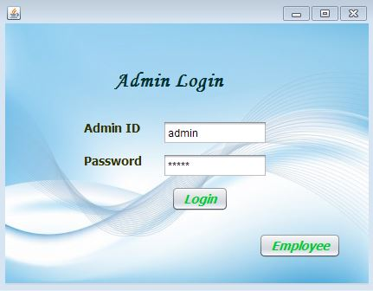
Admin Login


Welcome Page
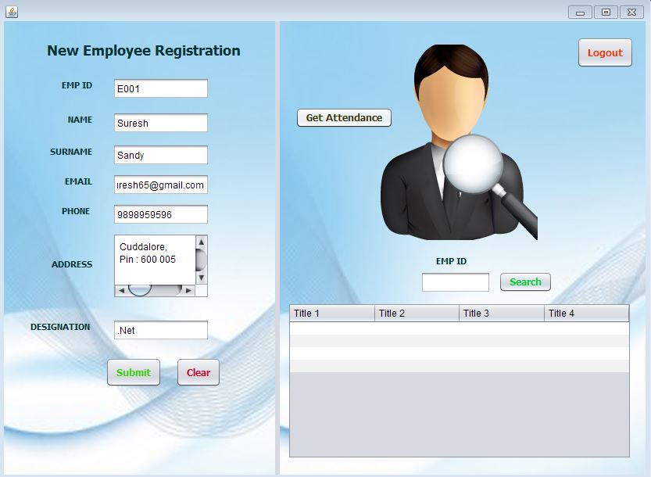

Register Employee

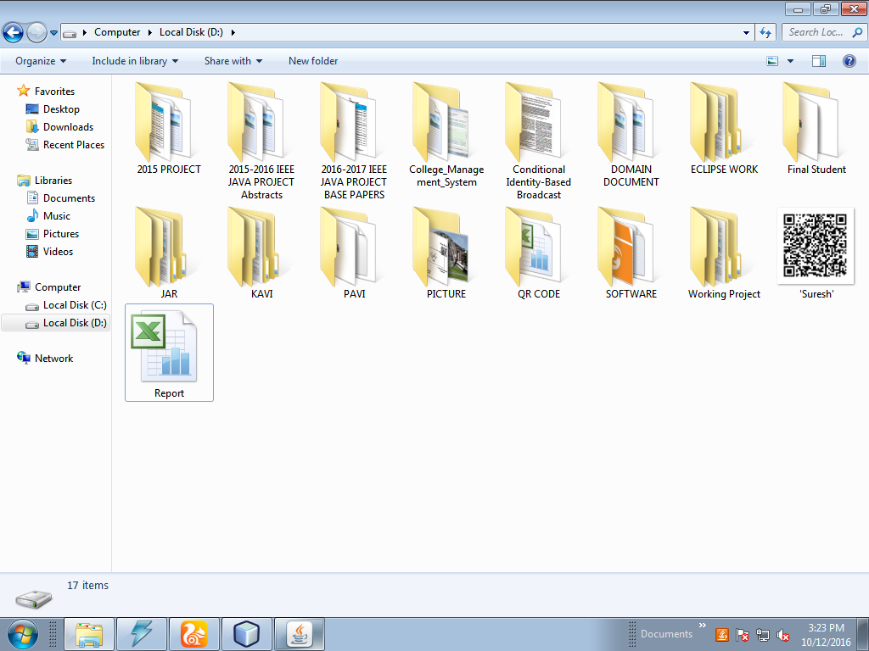

QR Code Generate

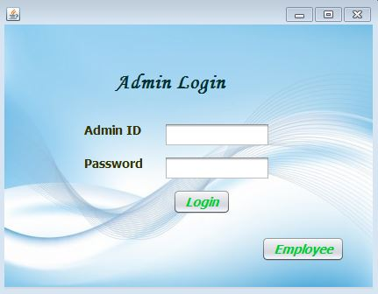

Employee Login

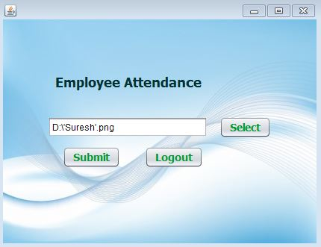

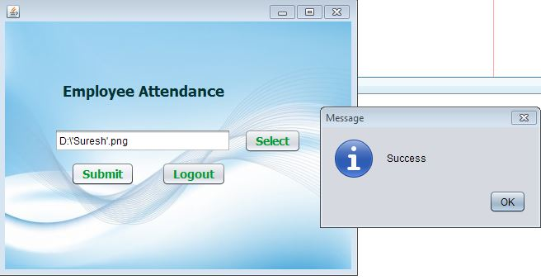

Employee Attendance Success

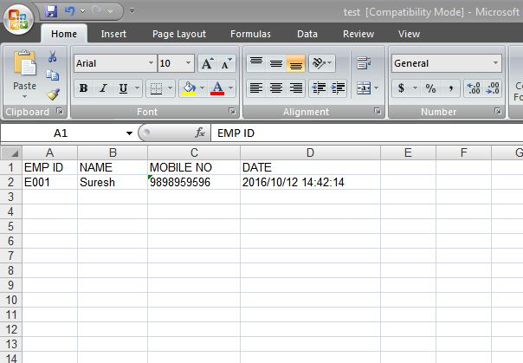

Database

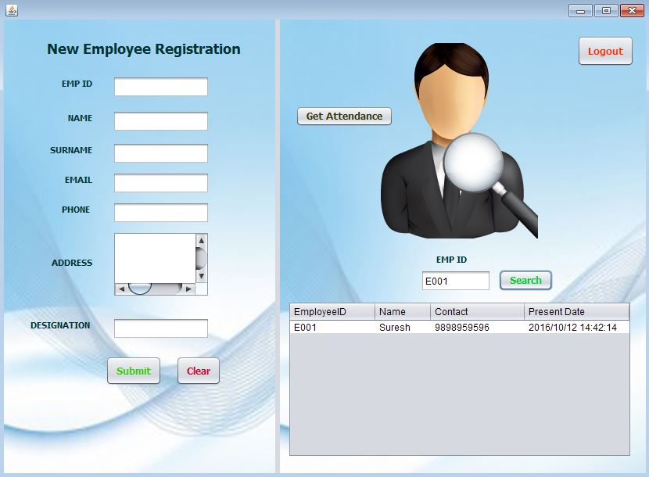

Employee Attendance Information

Chapter 8
CONCLUSION

This project is developed by creating a dynamic QR code which can be editable and is used for noting and store the employee attendance details by id cards and they need to scan the id card which has QR code and the attendance is taken and we can modify employee details in the same QR code and the admin maintains and analysis the employee attendance details.

REFRENCES

[1]” An RFID Attendance and Monitoring System for University Applications”, an IEEE paper by A.Kassem, M.Hamad, Z.Chalhoub and S. El Dahdaah, Department of Electrical and computer and communication engineering, Notre Dame University, Louaize.

[2]” Portable Lab: Implementation of Mobile remote laboratory for Android platform”, an IEEE paper by Macro Andre Guerra, Claudia Mariline Francisco, RuiNeves Madeira, Portugal.

[3]” Ear based Attendance Monitoring System”- an IEEE paper by Mr. Jitendra B. Jawale and Dr. Smt. Anjali S. Bhalchandra at the Army Institute of Technology, Pune and Government college of Engineering, Aurangabad respectively.

[4]” Remote Access of Building Management System on Windows Mobile Devices”- an IEEE paper by OndrejKrejcar, Department of measurement and control, VSB Technical Institute of Ostrava, Czech Republic.
[5] Yue Liu, Ju Yang, Mingjun Liu, “Recognition of QR Code with mobile phones,” Control and Decision Conference, CCDC 2008. Chinese, pp. 203 - 206, 2-4 July 2008.
[6] Yu-Hsuan Chang, Chung-Hua Chu and Ming-Syan Chen, “A General Scheme for Extracting QR Code from a Non-uniform Background in Camera Phones and Applications,” Ninth IEEE International Symposium on Multimedia, ISM 2007. pp. 123-130, 10-12 Dec. 2007
[7] Aidong Sun, Yan Sun and Caixing Liu, “The QR-code reorganization in illegible snapshots taken by mobile phones,” International Conference on Computational Science and its Applications, 2007. ICCSA 2007, pp. 532-538, 26-29 Aug. 2007.
[8] Yuan-Cheng Lai, Frannie Han, Yi-Hsuan Yeh, Ching-Neng Lai and Yu-Chin Szu, “A GPS navigation system with QR code decoding and friend positioning in smart phones,” 2nd International Conference on Education Technology and Computer (ICETC), pp.V5-66-V5-70, 22-24 June 2010 [5] [online] http://goo.gl
[9] [online] http://bit.ly
[10] ISO/IEC 18004:2000. Information technology-Automatic identification and data capture techniques-Bar code Symbology-QR Code, 2000.
[11] QR Code standard, GB/T 18284-2000, National standard of the People’s Republic of China: Quick Response Code (in Chinese), Issued by China State Bureau of Quality and Technical Supervision, 2000.
[12] [online] QR Code.com, http://www.denso-wave.com/qrcode/aboutqr-e.html
[13] [online] Drupal, drupal.org
[14] John K. Vandyk, Pro Drupal Development Second Edition.
[15] [online] Kentaro Fukuchi, "libqrencode," http://fukuchi.org/works/qrencode/index.en.html
[16] [online] Ubuntu, http://www.ubuntu.com/

