SIMATS ENGINEERING
ASSESSMENT TOOL 2

COURSE NAME: Database Management Systems COURSE CODE: CSA0504

COURSE OUTCOME COVERED

CO2: Apply the relational model, relational algebra, SQL query structures, and views to solve database querying and data manipulation problems. (BL3, BL6)

Activity Tool : Scenario-Based Task (Medium) Assessment Tool Weightage: 20%

QUESTIONS
Q.N o | Question | Bloom's Level
1 | A university stores student and course data in a single table. Analyze the structure and identify normalization issues, then redesign it up to 3NF | . BL4 – Analyze
2 | A company database contains employee and department details. Design appropriate SQL queries to retrieve employees working in multiple departments and justify your approach | . BL6 – Create
3 | Given a relation with multiple functional dependencies, determine the candidate keys and check whether the relation satisfies BCNF. If not, decompose it. | BL5 – Evaluate
4 | A banking system requires secure data access. Design views and constraints to ensure data security and integrity for different types of users. | BL6 – Create
5 | A sales database contains redundant data leading to anomalies. Analyze the schema and apply normalization up to 3NF or BCNF to eliminate redundancy. | BL4 – Analyze
6 | Given a dataset of customers and orders, write SQL queries using joins and subqueries to retrieve meaningful information such as frequent customers. | BL3 – Apply
7 | A relation contains multi-valued dependencies. Analyze the structure and decompose it into 4NF, explaining the reasoning. | BL4 – Analyze
8 | A database designer used improper constraints, leading to inconsistent data. Evaluate the schema and suggest appropriate integrity constraints. | BL5 – Evaluate
9 | For a given relational schema, analyze the presence of join dependencies and decompose it into 5NF to remove redundancy. | BL6 – Create
10 | A system uses inefficient SQL queries for data retrieval. Analyze the queries and optimize them using joins, indexing concepts, or query restructuring. | BL5 – Evaluate

Code of Conduct:

I M.keethi(192525243)(Name / Reg No) certify that this submission is my original work and that I have adhered to the guidelines specified for this assessment. I understand that any violation of academic integrity rules will result in disciplinary action.
R. Indhu
Signature of the student:

RUBRICS FOR CALCULATION:

Criteria | Level 4 (Exemplary) | Level 3 (Proficient) | Level 2 (Developing) | Level 1 (Beginning)
Understandin g of Scenario | Demonstrates clear and  complete  understanding  of the scenario and context | Shows good understanding with minor gaps | Partial understanding  ; misses key aspects | Misinterprets or fails to  understand the scenario
Identification  of Key Issues | Accurately identifies all  relevant issues and factors involved | Identifies most key issues with minor omissions | Identifies limited issues; some  irrelevant  points | Unable to identify key issues
Application of Concepts | Applies appropriate concepts  effectively to  address the  scenario | Applies concepts with minor errors | Limited or partially correct application | Unable to apply  relevant concepts
Decision  Making | Makes well-reasoned,  logical decisions with strong rationale | Makes reasonable  decisions with some  justification | Makes weak  decisions with limited justification | No clear decisions made or  rationale provided
Clarity of  Response | Response is  clear,  structured, and logically presented | Generally clear with minor issues | Somewhat unclear or poorly structured | Disorganized  and difficult to understand

Q1. Normalization up to 3NF
Scenario: University stores student and course details in one table.
Problems:
- Data redundancy
- Update, Insert & Delete anomalies
3NF Tables:
- Student(StudentID, StudentName, Department)
- Course(CourseID, CourseName, FacultyID)
- Faculty(FacultyID, FacultyName, Phone)
- Enrollment(StudentID, CourseID) Flow:
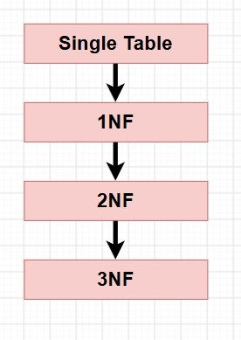
Conclusion: 3NF removes redundancy and improves consistency.
Q2. Employees in Multiple Departments
SQL Query
SELECT e.EmpID,e.EmpName
FROM Employee e
JOIN EmployeeDepartment ed
ON e.EmpID=ed.EmpID
GROUP BY e.EmpID,e.EmpName
HAVING COUNT(ed.DeptID)>1;
Diagram
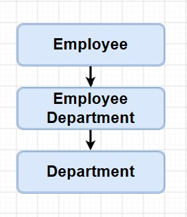
Conclusion: JOIN and GROUP BY identify employees working in multiple departments.
Q3. BCNF Decomposition
Candidate Key:
(StudentID, CourseID)
BCNF Tables
- Student(StudentID, Department)
- Course(CourseID, Faculty)
- Enrollment(StudentID, CourseID)
Diagram
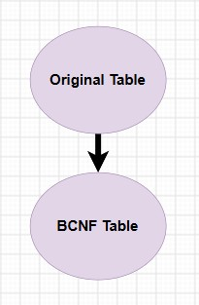
Conclusion: BCNF removes dependency violations.
Q4. Banking Views and Constraints
Views
- Manager_View
- Cashier_View
- Auditor_View
Constraints
- PRIMARY KEY
- FOREIGN KEY
- UNIQUE
- CHECK
- NOT NULL
Diagram
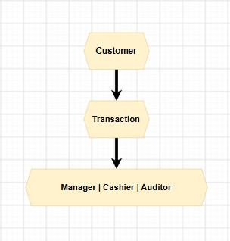
Conclusion: Views secure data and constraints maintain integrity.
Q5. Sales Database (3NF)
Problems
- Redundancy
- Update anomaly
Tables
- Customer
- Salesperson
- Orders
Flow
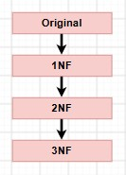
Conclusion: 3NF eliminates redundancy.
Q6. Customers and Orders
JOIN
SELECT C.CustomerName,
COUNT(O.OrderID)
FROM Customer C
JOIN Orders O
ON C.CustomerID=O.CustomerID
GROUP BY C.CustomerName;
Subquery
SELECT CustomerName
FROM Customer
WHERE CustomerID IN
(SELECT CustomerID
FROM Orders
GROUP BY CustomerID
HAVING COUNT(*)>2);
Conclusion: Identifies frequent customers.
Q7. 4NF Decomposition
Relation
Student(StudentID,Hobby,Language)
Tables
- Student_Hobby
- Student_Language
Diagram
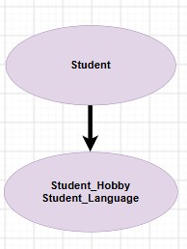
Conclusion: 4NF removes multivalued dependencies.
Q8. Integrity Constraints
Constraints
- PRIMARY KEY
- UNIQUE
- NOT NULL
- CHECK
Diagram
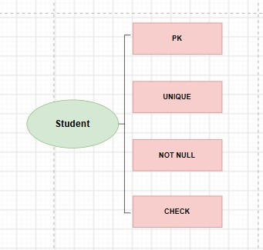
Conclusion: Prevents duplicate and invalid data.
Q9. 5NF Decomposition
Relation
Supply(Supplier, Part, Project)
Tables
- Supplier_Part
- Supplier_Project
- Part_Project
Diagram
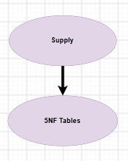
Conclusion: 5NF removes join redundancy.
Q10. SQL Query Optimization
Optimized Query
SELECT DISTINCT C.CustomerID,C.CustomerName
FROM Customer C
JOIN Orders O
ON C.CustomerID=O.CustomerID;
Index
CREATE INDEX idx_customer
ON Orders(CustomerID);
Diagram
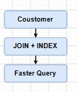
Conclusion: JOIN and INDEX improve query performance and reduce execution time.

