SIMATS ENGINEERING
ASSESSMENT TOOL 3

COURSE NAME: Database Management Systems COURSE CODE: CSA0504

COURSE OUTCOME COVERED

CO2: Apply the relational model, relational algebra, SQL query structures, and views to solve database querying and data manipulation problems. (BL3, BL6)

Activity Tool : Debugging & Optimisation Task (Low) Assessment Tool Weightage: 10%

QUESTIONS
Q.N o | Question | Bloom's Level
1 | Identify and correct errors in a given SQL CREATE TABLE statement with incorrect syntax and missing constraints. | BL2 –  Understand
2 | Debug an SQL query that incorrectly uses aggregate functions without GROUP BY and fix the issue. Bloom’s Level: | BL2 –  Understand
3 | Correct a faulty SELECT query where column names are misspelled or improperly referenced. | BL1 –  Remember
4 | Fix errors in an SQL query using JOIN, where the join condition is missing or incorrect. | BL3 – Apply
5 | Identify and correct a subquery error where multiple values are returned instead of a single value. | BL2 –  Understand
6 | Debug a VIEW creation statement that contains invalid column references or syntax errors. | BL1 –  Remember
7 | Examine an SQL query with unnecessary conditions and optimize it by simplifying the WHERE clause. | BL3 – Apply
8 | Identify violations of integrity constraints in a given table and correct them. | BL2 –  Understand
9 | Fix a relation that violates 1NF or 2NF by removing repeating groups or partial dependencies. | BL3 – Apply
10 | Identify redundant attributes in a relation and apply basic normalization (up to 3NF) to improve design. | BL3 – Apply

Code of Conduct:

Criteria | Level 4 (Exemplary) | Level 3 (Proficient) | Level 2 (Developing) | Level 1 (Beginning)
Problem  Identification | Accurately identifies all errors and  root causes with clear understanding | Identifies most errors with minor gaps | Identifies some errors  but misses key issues | Unable to identify errors correctly
Debugging | Applies systematic debugging  techniques  effectively to resolve issues | Uses appropriate debugging  methods with minor errors | Limited debugging approach; requires guidance | Unable to debug or resolve issues
I M.keerthi( 192525243 ) (Name / Reg No) certify that this submission is my original work and that I have adhered to the guidelines specified for this assessment. I understand that any violation of academic integrity rules will result in disciplinary action.
M.keerthi
Signature of the student:

RUBRICS FOR CALCULATION:

Optimization | Optimizes code by  significantly  improving time  complexity  using efficient algorithms | Improves time complexity with  minor gaps in efficiency | Limited improvement in time complexity | No improvement; inefficient approach retained
Analysis | Demonstrates strong logical  reasoning and clear  justification of solutions | Shows reasonable  analysis with some  justification | Limited analysis; weak reasoning | No analytical reasoning demonstrated
Code Quality | Produces clean,  well-structure  d code with proper  comments and | Code is mostly clear with minor  documentation gaps | Code lacks structure and proper  documentation | Poorly written code with no documentation

Q1. Debug CREATE TABLE Statement
Example Incorrect SQL
CREATE TABLE Student
(
StudentID INT,
StudentName VARCHAR(50)
Age INT,
PRIMARY KEY StudentID
);
Errors
- Missing comma after StudentName.
- PRIMARY KEY syntax is incorrect.
- StudentID should be NOT NULL.
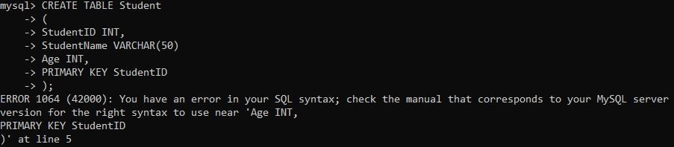
Correct SQL
CREATE TABLE Student
(
StudentID INT NOT NULL,
StudentName VARCHAR(50),
Age INT,
PRIMARY KEY (StudentID));
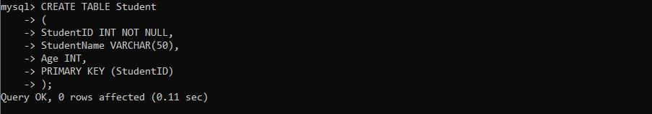
Explanation
Added the missing comma, corrected the PRIMARY KEY syntax, and made the primary key non-null.
Q2. Aggregate Function Without GROUP BY
Incorrect SQL
SELECT DeptID, AVG(Salary)
FROM Employee;
Error
Aggregate function is used with a normal column but no GROUP BY.
Correct SQL
SELECT DeptID, AVG(Salary)
FROM Employee
GROUP BY DeptID;
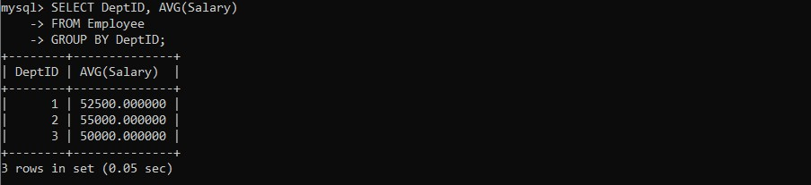
Explanation
GROUP BY groups employees according to department before calculating the average salary.
Q3. Incorrect SELECT Statement
Incorrect SQL
SELECT StudntName, Ag
FROM Student;
Errors
- StudntName is misspelled.
- Ag is misspelled.
Correct SQL
SELECT StudentName, Age
FROM Student;
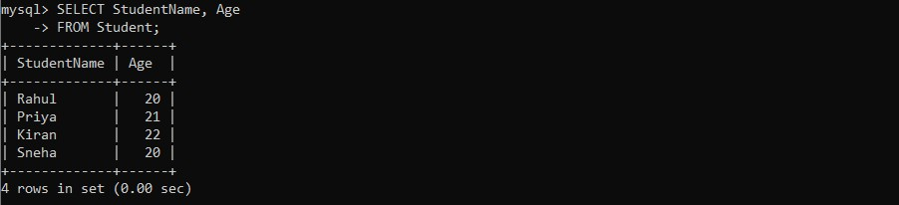
Explanation
Corrected the column names.
Q4. Incorrect JOIN
Incorrect SQL
SELECT Student.StudentName, Department.DeptName
FROM Student
JOIN Department;
Error
Missing JOIN condition.
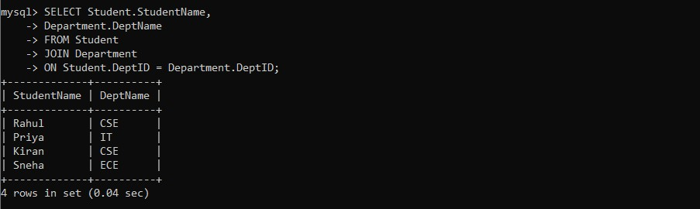
Correct SQL
SELECT Student.StudentName,
Department.DeptName
FROM Student
JOIN Department
ON Student.DeptID = Department.DeptID;
Explanation
Added the proper join condition.
Q5. Subquery Returns Multiple Values
Incorrect SQL
SELECT StudentName
FROM Student
WHERE DeptID =
(
SELECT DeptID
FROM Department);
Error
Subquery returns multiple rows.
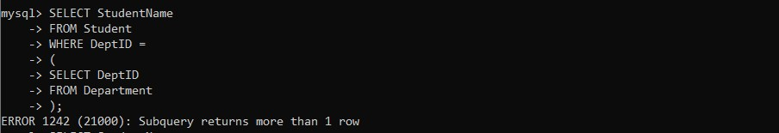
Correct SQL
SELECT StudentName
FROM Student
WHERE DeptID IN
(
SELECT DeptID
FROM Department);
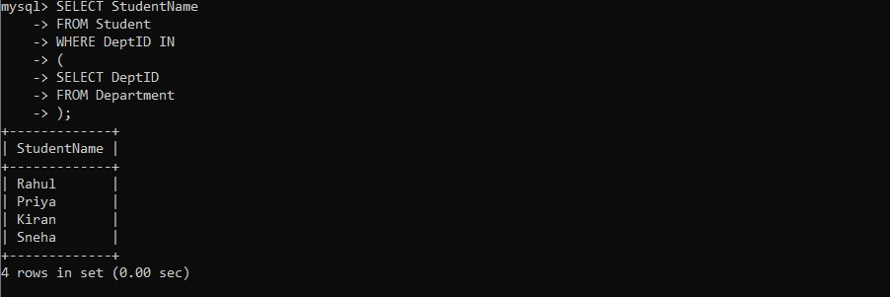
Explanation
IN is used because multiple department IDs are returned.
Q6. Debug VIEW Creation
Incorrect SQL
CREATE VIEW StudentView AS
SELECT StudentID, Name
FROM Student;
Error
Column Name does not exist.
Correct SQL
CREATE VIEW StudentView AS
SELECT StudentID, StudentName
FROM Student;
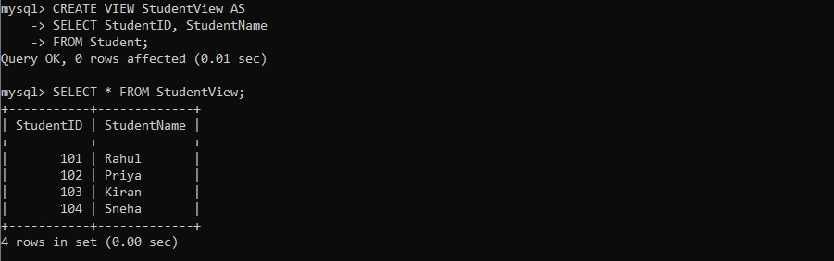
Explanation
Used the correct column name.
Q7. Optimize WHERE Clause
Incorrect SQL
SELECT *
FROM Employee
WHERE Salary > 5000
AND Salary > 3000;
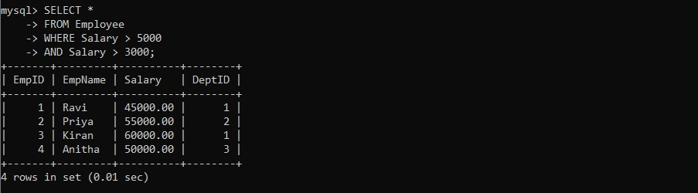
Error
Second condition is unnecessary.
Correct SQL
SELECT *
FROM Employee
WHERE Salary > 5000;
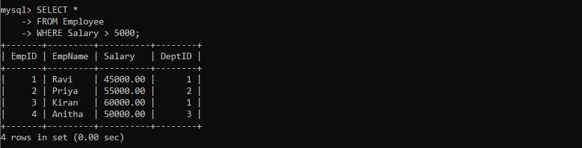
Explanation
If salary is greater than 5000, it is automatically greater than 3000.
Q8. Integrity Constraint Violation
Incorrect SQL
INSERT INTO Student
VALUES
(NULL,'Rahul',20);
Error
Primary key cannot be NULL.
Correct SQL
INSERT INTO Student
VALUES
(101,'Rahul',20);
Explanation
Provided a valid primary key.
Q9. Fix 1NF / 2NF Violation
Incorrect Table
StudentID | StudentName | Subjects
101 | Ravi | DBMS, Java
Error
Multiple values are stored in one column (violates 1NF).
Correct Design
Student
StudentID | StudentName
101 | Ravi
StudentSubject
StudentID | Subject
101 | DBMS
101 | Java
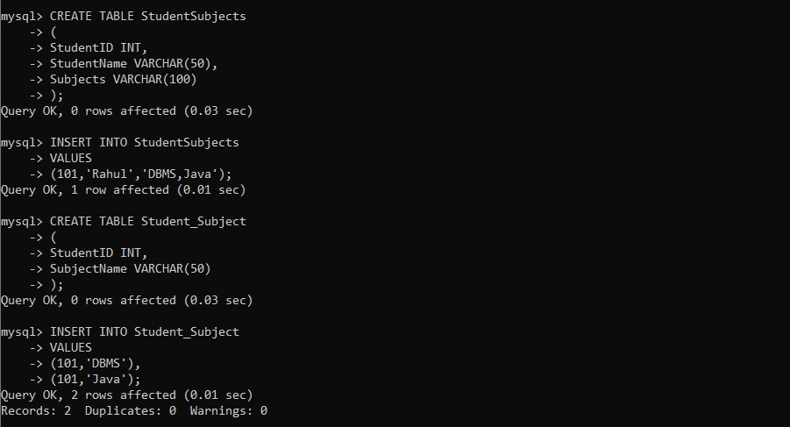
Explanation
Each cell now contains only one value.
Q10. Normalize to 3NF
Incorrect Relation
StudentID | StudentName | DeptID | DeptName
Error
DeptName depends on DeptID, causing redundancy.
Correct Design
Student
StudentID StudentName DeptID
Department
DeptID | DeptName
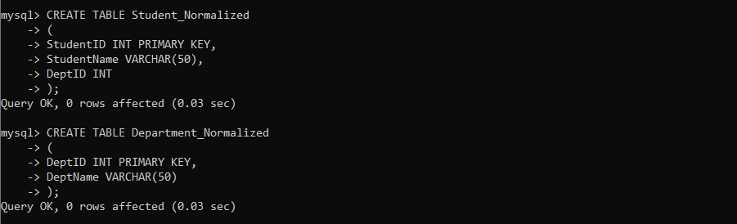
Explanation
Department information is stored separately, eliminating redundancy and satisfying 3NF.

