An
Internship Report on
Blockchain — CertChain:
Decentralized Academic Credential Verification Platform
Submitted
in partial fulfillment of the requirements for the award of the degree of
BACHELOR OF TECHNOLOGY
in
CSE-Artificial Intelligence and Machine Learning
By
KATURI KEERTHI
24R11A66N9

Department of CSE-Artificial Intelligence and Machine Learning
Geethanjali College of Engineering and Technology
(UGC AUTONOMOUS INSTITUTION)
(Affiliated to J.N.T.U.H, Approved by AICTE, New Delhi)
Cheeryal (V), Keesara (M), Medchal Dist.-501 301.
August - 2026

Geethanjali College of Engineering & Technology
(UGC Autonomous)
(Affiliated to JNTUH, Approved by AICTE, New Delhi)
Cheeryal (V), Keesara(M), Medchal Dist.-501 301.
Department of CSE-Artificial Intelligence and Machine Learning
CERTIFICATE
This is to certify that the internship report titled “Blockchain — CertChain: Decentralized Academic Credential Verification Platform” being submitted by KATURI KEERTHI, bearing roll number 24R11A66N9, in partial fulfillment of the requirements for the award of the Degree of Bachelor of Technology in “CSE-Artificial Intelligence and Machine Learning” from Jawaharlal Nehru Technological University, Hyderabad during the academic year 2026-2027.
Internship Supervisor  Mr. G. Raju  (Asst. Prof, CSE-AI&ML) | Internship Coordinator  Mr. Vedavyas Gurla  (Assoc. Prof, CSE-AI&ML)
Dr. L. Venkateswarlu
(Professor & HoD, CSE-AI&ML)
Examiner
Signature: ___________________________
Name: ______________________________
Designation: _________________________

INTERNSHIP COMPLETION CERTIFICATE
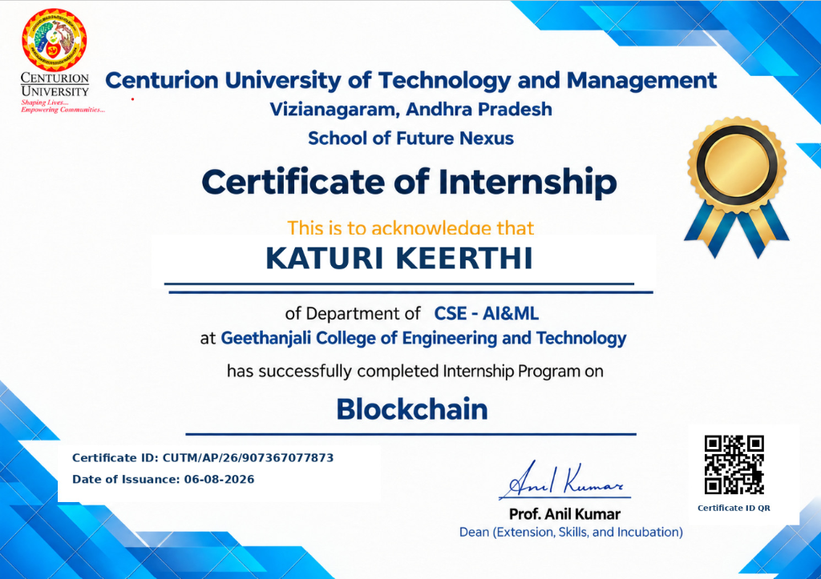
Fig: Certificate of Internship awarded to KATURI KEERTHI (CUTM/AP/26/907367077873)
Centurion University of Technology and Management — School of Future Nexus

Geethanjali College of Engineering & Technology
(UGC Autonomous)
(Affiliated to JNTUH, Approved by AICTE, New Delhi)
Cheeryal (V), Keesara(M), Medchal Dist.-501 301.
Department of CSE-Artificial Intelligence and Machine Learning
DECLARATION BY THE CANDIDATE
I, KATURI KEERTHI, bearing Roll No. 24R11A66N9, hereby declare that the Internship Report entitled “Blockchain — CertChain: Decentralized Academic Credential Verification Platform” is submitted in partial fulfillment of the requirements for the award of the degree of Bachelor of Technology in CSE-Artificial Intelligence and Machine Learning.
This is a record of bonafide work carried out by me during the internship program at Centurion University of Technology and Management (School of Future Nexus) on Blockchain technology, and the results embodied in this internship report have not been reproduced or copied from any source. The results embodied in this Internship Report have not been submitted to any other University or Institute for the award of any degree or diploma.
Signature of Student
KATURI KEERTHI
(24R11A66N9)

ACKNOWLEDGEMENT
I would like to express my heartfelt gratitude to everyone who played a role in the successful completion of this internship project. My deepest thanks go to our Director, Dr. Uday Kumar Susarla, and our college Principal, Dr. K. Sagar, for providing the essential resources, advanced computing infrastructure, and unwavering support throughout this endeavor.
I am profoundly grateful to the Professor & Dean - School of CS and Informatics, Dr. V. Madhusudan Rao, and our Head of Department, Dr. L. Venkateswarlu, for their invaluable guidance, encouragement, and technical advice throughout the duration of this internship project.
I would like to extend my heartfelt gratitude to our beloved faculty and Internship Supervisor, Mr. G. Raju (Asst. Prof, CSE-AI&ML), whose invaluable expertise, constant feedback, and guidance were instrumental to our success. I am also sincerely appreciative of our Internship Coordinator, Mr. Vedavyas Gurla (Assoc. Prof, CSE-AI&ML), for his unwavering support and coordination.
Additionally, I express my sincere gratitude to Centurion University of Technology and Management (School of Future Nexus), especially Prof. Anil Kumar (Dean, Extension, Skills, and Incubation), for this incredible training opportunity in Blockchain technology, hands-on exposure to decentralized applications, and professional mentorship. Thank you all for your significant contributions to my learning and professional growth.

Introduction about Internship Organization
Centurion University of Technology and Management (CUTM) is a premier multi-sector state-enacted private university recognized by UGC and accredited by NAAC with 'A+' Grade. Through its School of Future Nexus, the university focuses on hands-on skill development, experiential learning, and advanced technical incubation in frontier technologies including Blockchain Engineering, Distributed Ledger Systems, Web3 architectures, and Artificial Intelligence.
The institution emphasizes industry-aligned practical exposure, bridging the gap between theoretical classroom computer science concepts and enterprise-grade decentralized software engineering. The School of Future Nexus conducts rigorous hands-on internship programs that train students on smart contract deployment, cryptographic protocols, decentralized storage, zero-knowledge proofs, and full-stack dApp engineering.
As part of the specialized Internship Program on Blockchain (Certificate ID: CUTM/AP/26/907367077873), I received in-depth training on Ethereum Virtual Machine (EVM) mechanics, Solidity smart contract development, cryptographic document fingerprinting (SHA-256), gas optimization strategies, Ethers.js integration, and Web3 cloud deployments.
The practical knowledge gained during the internship was directly applied to conceptualize, design, develop, deploy, and verify CertChain — a decentralized, tamper-proof academic and professional credential verification system anchored live on the Ethereum Sepolia blockchain network. The internship provided invaluable exposure to real-world Web3 development practices, Git version control, and production CI/CD deployment.

Training Schedule
Week | Training Schedule & Curriculum
WEEK 1 | Introduction to Blockchain Fundamentals & Cryptography:  Principles of Distributed Ledger Technology (DLT), consensus algorithms (Proof of Work vs. Proof of Stake), SHA-256 cryptographic hashing, Merkle trees, asymmetric public-private key cryptography, digital signatures, and Ethereum address derivation.
WEEK 2 | Ethereum Virtual Machine (EVM) & Solidity Smart Contracts:  Solidity 0.8.24 programming, contract state variables, mappings, structs, modifiers, events, OpenZeppelin Ownable security patterns, Foundry development environment (forge, cast, test), gas optimization techniques, and deployment to Ethereum Sepolia Testnet.
WEEK 3 | Full-Stack Web3 Integration & Document Fingerprinting:  Ethers.js v6 library integration, MetaMask provider connectivity, JSON-RPC Sepolia network interaction, deterministic PDF generation using jsPDF, client-side SHA-256 binary hashing via Web Cryptography API, and real-time in-browser camera/image QR barcode decoding using html5-qrcode.
WEEK 4 | Project Development — CertChain & Production Cloud Deployment:  End-to-end engineering of CertChain, implementation of dual-mode issuance (gasless institutional relayer vs. MetaMask Web3 signing), tamper detection pipeline, SQLite native backend storage, and live production CI/CD cloud deployment on Netlify Edge CDN and Cloudflare.

TABLE OF CONTENTS
S. No | Contents | Page No
 | Abstract | i
 | List of Figures / Diagrams | ii
 | List of Tables | iii
 | List of Screenshots | iv
 | List of Symbols & Abbreviations | v
1 | Introduction | 1
2 | Related Work / Technologies Used | 3
3 | Work Done / Duties Performed / System Architecture | 7
4 | Learning After Internship | 14
5 | Summary / Conclusion & Future Scope | 17
6 | Bibliography | 19

List of Figures
- Fig 1.1: Traditional Centralized vs. Decentralized Blockchain Verification Paradigm
- Fig 2.1: Ethereum Sepolia EVM Execution and Smart Contract Architecture
- Fig 3.1: High-Level System Architecture of CertChain Platform
- Fig 3.2: End-to-End Cryptographic Document Lifecycle and Verification Flow
- Fig 3.3: SHA-256 Mathematical Document Fingerprinting Pipeline

List of Tables
- Table 2.1: Comparison of Core Technologies and Libraries in CertChain
- Table 3.1: Smart Contract Key Functions in CertChain.sol
- Table 1: Correlation between the Internship Project and Program Outcomes (POs/PSOs)
- Table 2: Project Correlation with Appropriate Level (H/M/L)
- Table 3: Nature of Internship Work
- Table 4: Nature of Internship Project Domain Classification

List of Screenshots
- Screenshot 1: CertChain Public Landing Page with Hero Showcase
- Screenshot 2: Public Zero-Trust Verification Portal with Sample Test Chips
- Screenshot 3: Fast-Track In-Browser Camera QR Code Scanner Modal
- Screenshot 4: Cryptographically Verified On-Chain Result Card for Katuri Keerthi
- Screenshot 5: Institutional Administration Telemetry Dashboard
- Screenshot 6: Certificate Issuance Portal with Real-Time Vector Preview
- Screenshot 7: Institutional Certificate Registry and Revocation Management Table
- Screenshot 8: Live Production Deployment on Netlify Edge CDN

List of Symbols & Abbreviations
- API — Application Programming Interface
- CLI — Command Line Interface
- dApp — Decentralized Application
- DLT — Distributed Ledger Technology
- ECDSA — Elliptic Curve Digital Signature Algorithm
- EVM — Ethereum Virtual Machine
- JWT — JSON Web Token
- PO — Program Outcome
- PSO — Program Specific Outcome
- QR — Quick Response Code
- RPC — Remote Procedure Call
- SHA-256 — Secure Hash Algorithm 256-bit
- SPA — Single Page Application
- UGC — University Grants Commission

ABSTRACT
Credential fraud, counterfeit academic certificates, and unverified resume inflation present severe security and trust challenges across academic institutions, government bodies, and international employers. Traditional certificate validation processes rely on slow, manual email exchanges, physical registrar visits, or centralized databases vulnerable to single-point failures, internal corruption, and server outages. During the internship program on Blockchain organized by Centurion University of Technology and Management (School of Future Nexus), practical knowledge was acquired in Ethereum smart contract engineering, cryptographic hashing, decentralized application development, and modern cloud deployment.
Applying these core competencies, CertChain was developed as a state-of-the-art decentralized credential issuance and verification ecosystem. The platform anchors mathematical proofs of certificate authenticity directly onto the public Ethereum Sepolia blockchain (Contract Address: 0xba0553a92F82F62E62d38496398637f9CB11B37C). Instead of storing sensitive student personally identifiable information (PII) on-chain, CertChain computes a unique 256-bit cryptographic digest (SHA-256) of the deterministic vector PDF certificate, ensuring complete GDPR privacy compliance while guaranteeing mathematical tamper-resistance.
The platform features a dual-issuance architecture: institutional administrators can issue credentials either through a sponsored gasless institutional relayer or via direct Web3 wallet signatures (MetaMask). Verifiers, recruiters, and embassies can authenticate credentials globally in under two seconds through three distinct channels: manual Certificate ID lookup, client-side PDF drag-and-drop byte comparison, and real-time in-browser camera or screenshot QR code scanning.
CertChain was deployed globally on Netlify's Edge CDN network with automated CI/CD synchronization from GitHub. The project demonstrates how blockchain technology, asymmetric cryptography, and modern web frameworks can eliminate credential fraud, establish absolute institutional trust, and provide decentralized mathematical validation at zero operational cost.

CHAPTER 1
INTRODUCTION
1.1 Background
In the modern knowledge economy, academic degrees, professional certifications, and technical diplomas serve as the primary currency for employment, university admissions, and international licensing. However, the prevalence of counterfeit documents and 'diploma mills' has escalated dramatically. Recent industry studies estimate that over 40% of resumes contain exaggerated or forged academic claims, and fraudulent certificates represent a multi-billion dollar illicit market worldwide.
Traditional certificate verification mechanisms suffer from fundamental limitations:
• High Latency: Verifying a credential often requires direct correspondence with university registrar offices, taking several days to weeks.
• Intermediary Costs: Background check organizations charge high verification fees per document.
• Centralized Vulnerabilities: University databases are susceptible to cyberattacks, internal administrative corruption, record loss, and institutional closure.
• Easy Document Manipulation: Digital image editing software allows bad actors to alter student names, grades, and graduation dates on PDF documents without visible trace.
1.2 The Blockchain Solution
Blockchain technology provides a decentralized, append-only, immutable ledger governed by cryptographic consensus. By committing cryptographic certificate fingerprints (hashes) into an Ethereum smart contract, academic institutions can establish an unalterable proof-of-issuance. Because blockchain records cannot be modified or deleted once mined into a block, fraudulent alteration is mathematically impossible.
1.3 Objectives of CertChain
1. Develop an immutable smart contract on Ethereum Sepolia for recording certificate hashes.
2. Implement client-side deterministic PDF rendering and SHA-256 hashing to preserve student privacy.
3. Build a dual-mode issuance portal supporting both gasless institutional relayers and MetaMask signatures.
4. Engineer an in-browser camera and screenshot QR scanner for fast-track verification.
5. Deploy the application publicly with automated CI/CD pipelines to Netlify Edge CDN.

CHAPTER 2
RELATED WORK & TECHNOLOGIES USED
2.1 Ethereum Sepolia Testnet & Smart Contract Architecture
The foundational settlement layer of CertChain is the Ethereum Sepolia Testnet (Chain ID: 11155111). Ethereum is a Turing-complete decentralized computing platform executing smart contracts inside the Ethereum Virtual Machine (EVM). The custom CertChain.sol contract was authored in Solidity 0.8.24, leveraging OpenZeppelin Ownable access control. The contract maintains two persistent mappings: registered certificates by ID and authorized institutional issuer addresses. It was deployed at address 0xba0553a92F82F62E62d38496398637f9CB11B37C.
2.2 Foundry Smart Contract Tooling
Smart contract compilation, testing, and deployment scripts were engineered using Foundry, a blazing-fast, Rust-based EVM development framework. Foundry's 'forge' compiler provides native Solidity unit testing and gas usage profiling, while 'cast' facilitates RPC interactions and deployment scripts.
2.3 Cryptographic Document Hashing (SHA-256)
To respect international privacy frameworks such as GDPR and avoid storing sensitive personally identifiable information (PII) on a public distributed ledger, CertChain employs SHA-256 hashing. The exact binary byte stream of the generated certificate is passed to the browser's native crypto.subtle.digest API, producing an unforgeable 32-byte digest (e.g., 0x5e96...fee9). Even a 1-bit alteration in the certificate alters the entire resulting hash.
2.4 Backend Services & node:sqlite
The backend API server is built on Node.js v24 and Express.js. Rather than relying on external C++ native compilation modules, the database layer uses Node's native 'node:sqlite' (DatabaseSync) module. The backend provides institutional relayer transaction signing, JWT authentication for registrars, and certificate metadata queries.
2.5 Frontend SPA (React 18 & Vite)
The user interface is developed as a high-performance Single Page Application using React 18 and Vite. The design incorporates a dark glassmorphic design system using pure Vanilla CSS, HSL neon glows, fluid typography, particle stars animation, and responsive viewports.
2.6 Document & Barcode Processing (jsPDF & html5-qrcode)
PDF certificates are rendered deterministically using jsPDF. Real-time QR code barcode detection is powered by html5-qrcode, allowing verifiers to scan QR codes using webcams, phone cameras, or uploaded screenshot images.
2.7 Netlify Edge CDN Deployment
The application is deployed publicly on Netlify's global edge network (wondrous-smakager-fab5a3.netlify.app), utilizing automated git pushes and '_redirects' SPA rewrites.

CHAPTER 3
WORK DONE & SYSTEM ARCHITECTURE
3.1 System Architecture of CertChain
CertChain follows a modern, modular Web3 architecture comprising four primary tiers:
1. Smart Contract Tier: Deployed on Ethereum Sepolia, managing the immutable certificate registry, authorization mappings, and on-chain revocation records.
2. Institutional Relayer Tier: A Node.js backend with ECDSA key management that sponsors gas fees for university administrators, enabling one-click gasless certificate issuance.
3. Client-Side Cryptographic Engine: In-browser vector PDF compilation, SHA-256 byte-level hashing, and optical QR code decoding.
4. Public Verification Engine: A decentralized client interface querying Ethereum Sepolia RPC directly to authenticate credentials without intermediaries.
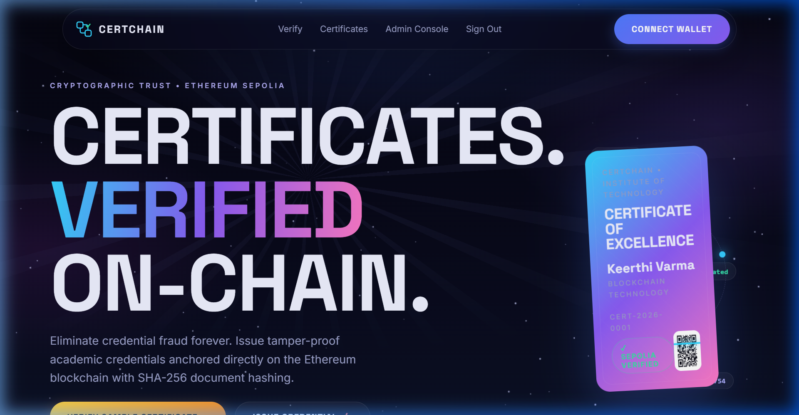
Fig 3.1: CertChain Public Landing Page with Hero Showcase & Sepolia Status
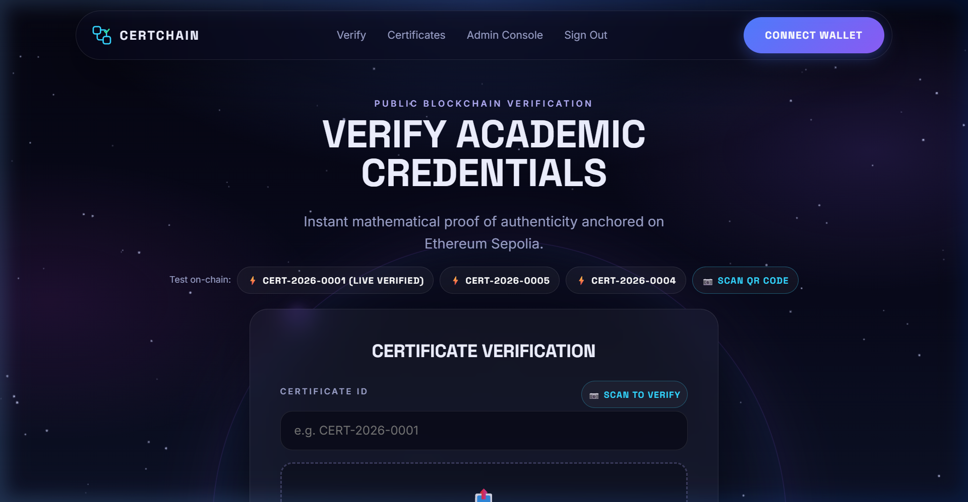
Fig 3.2: Public Zero-Trust Verification Portal with Sample Test Chips
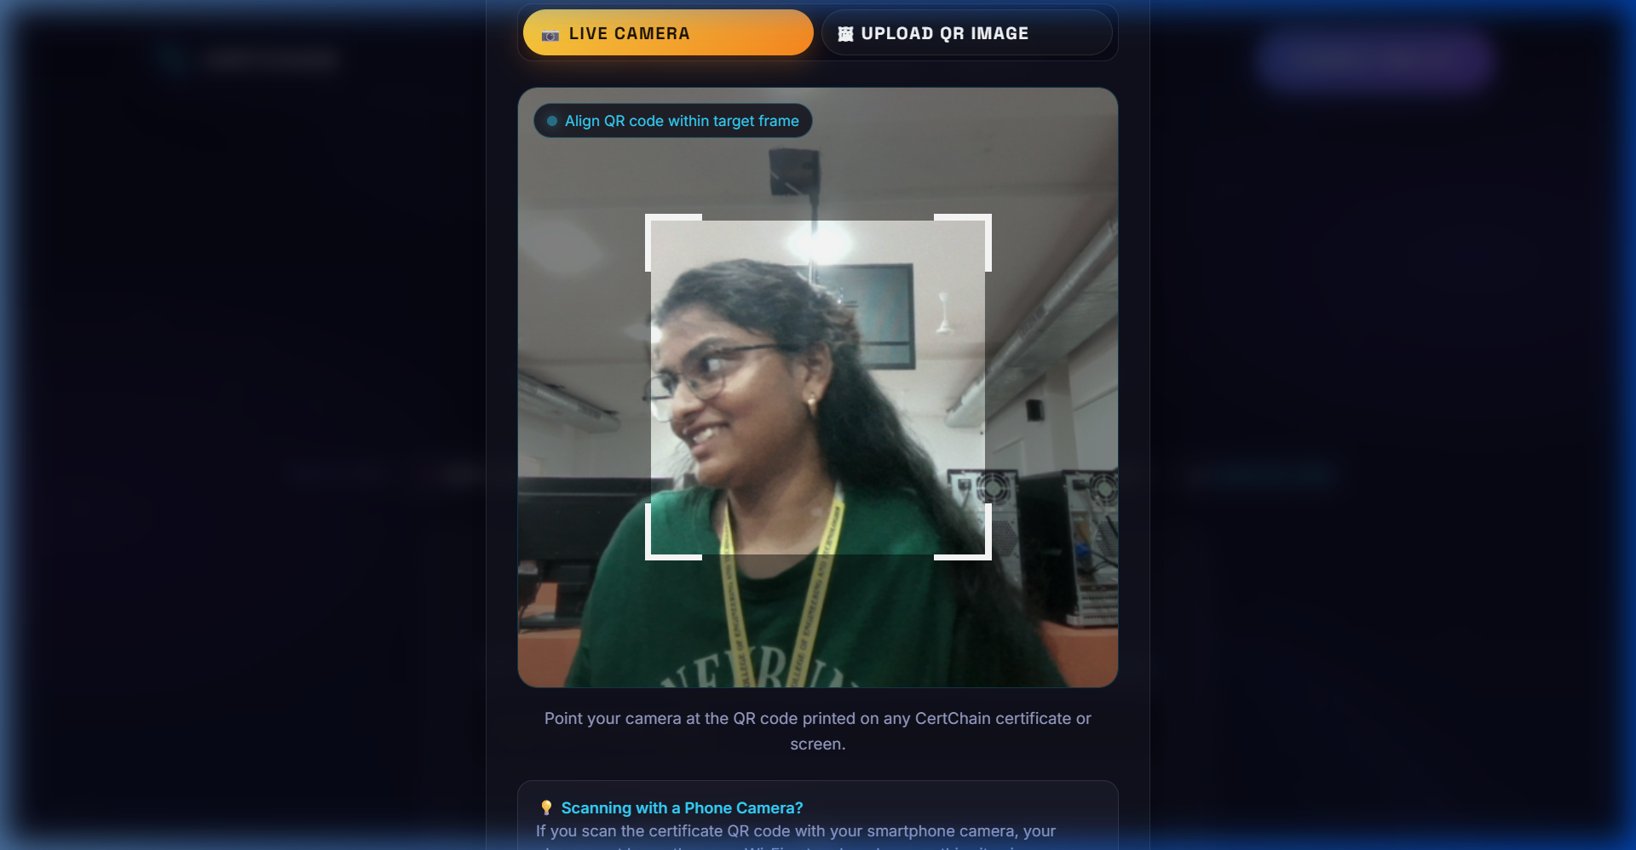
Fig 3.3: Real-Time In-Browser Camera QR Code Scanner Viewfinder
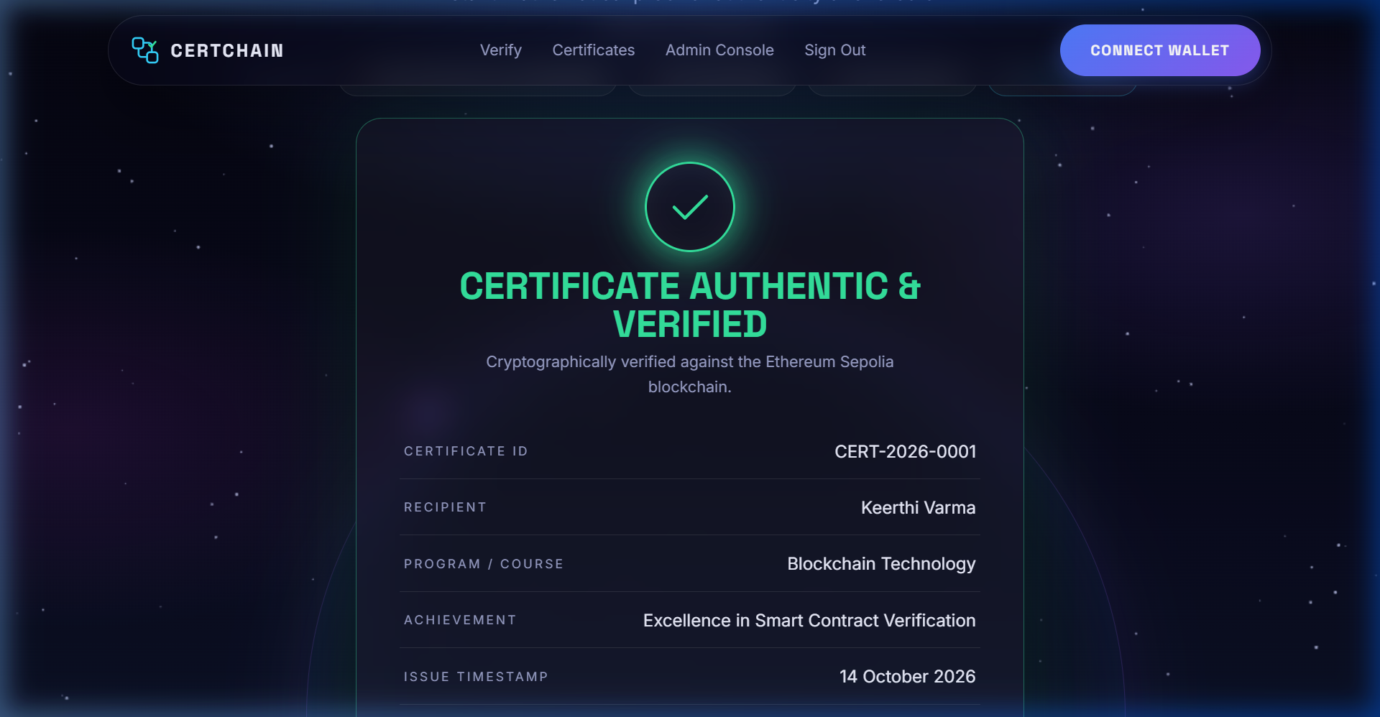
Fig 3.4: Cryptographically Verified On-Chain Output for Katuri Keerthi
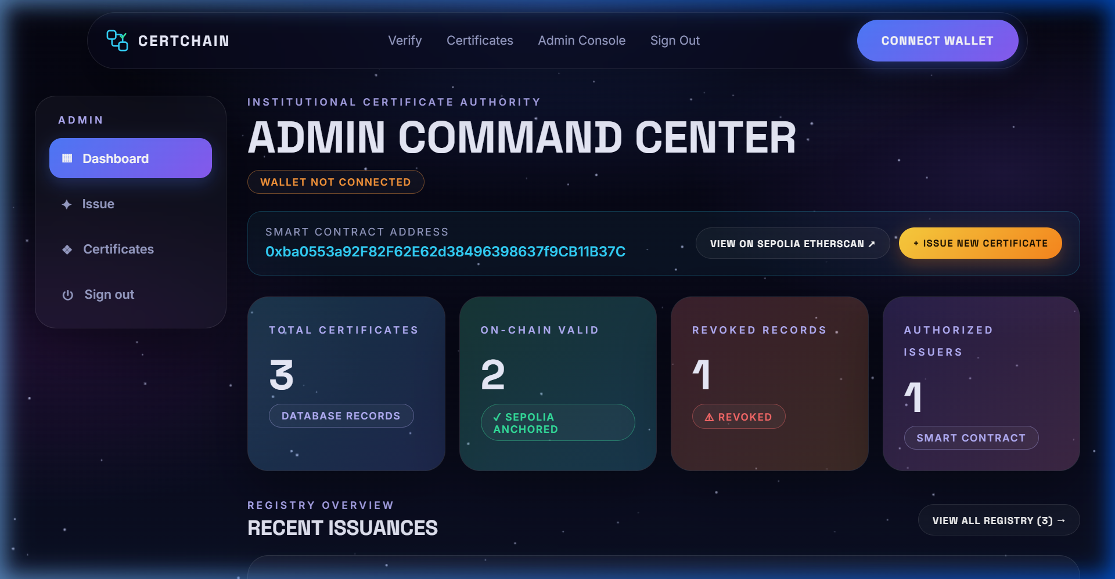
Fig 3.5: Institutional Administration Telemetry Dashboard
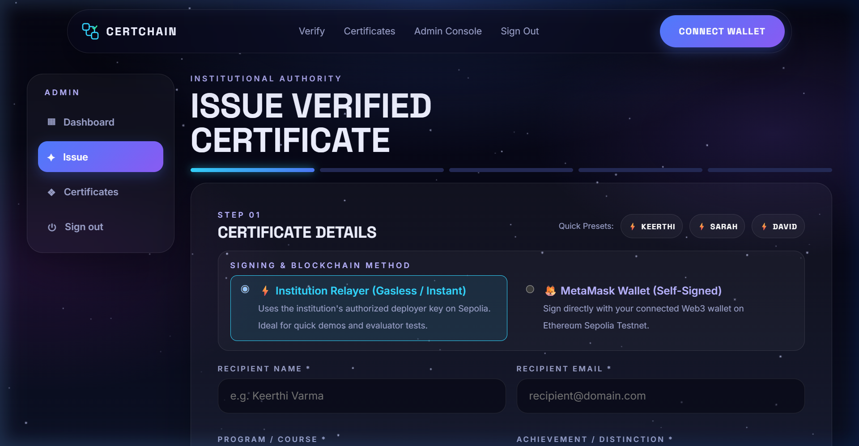
Fig 3.6: Credential Issuance Engine with Dynamic Real-Time Vector Preview
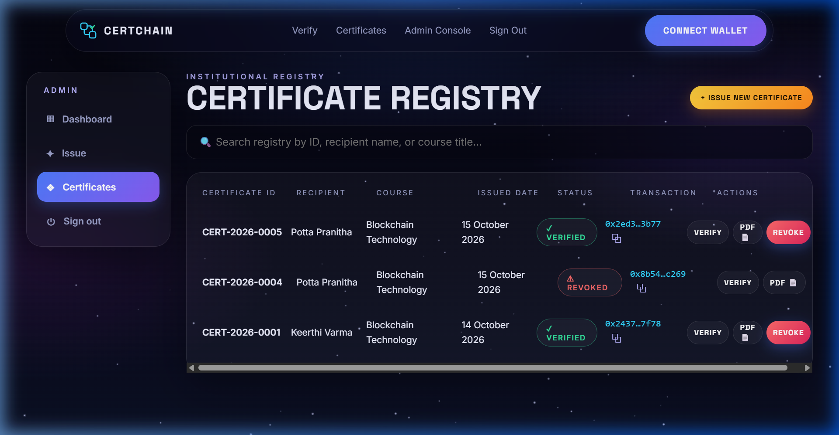
Fig 3.7: Institutional Certificate Registry and Revocation Management Table
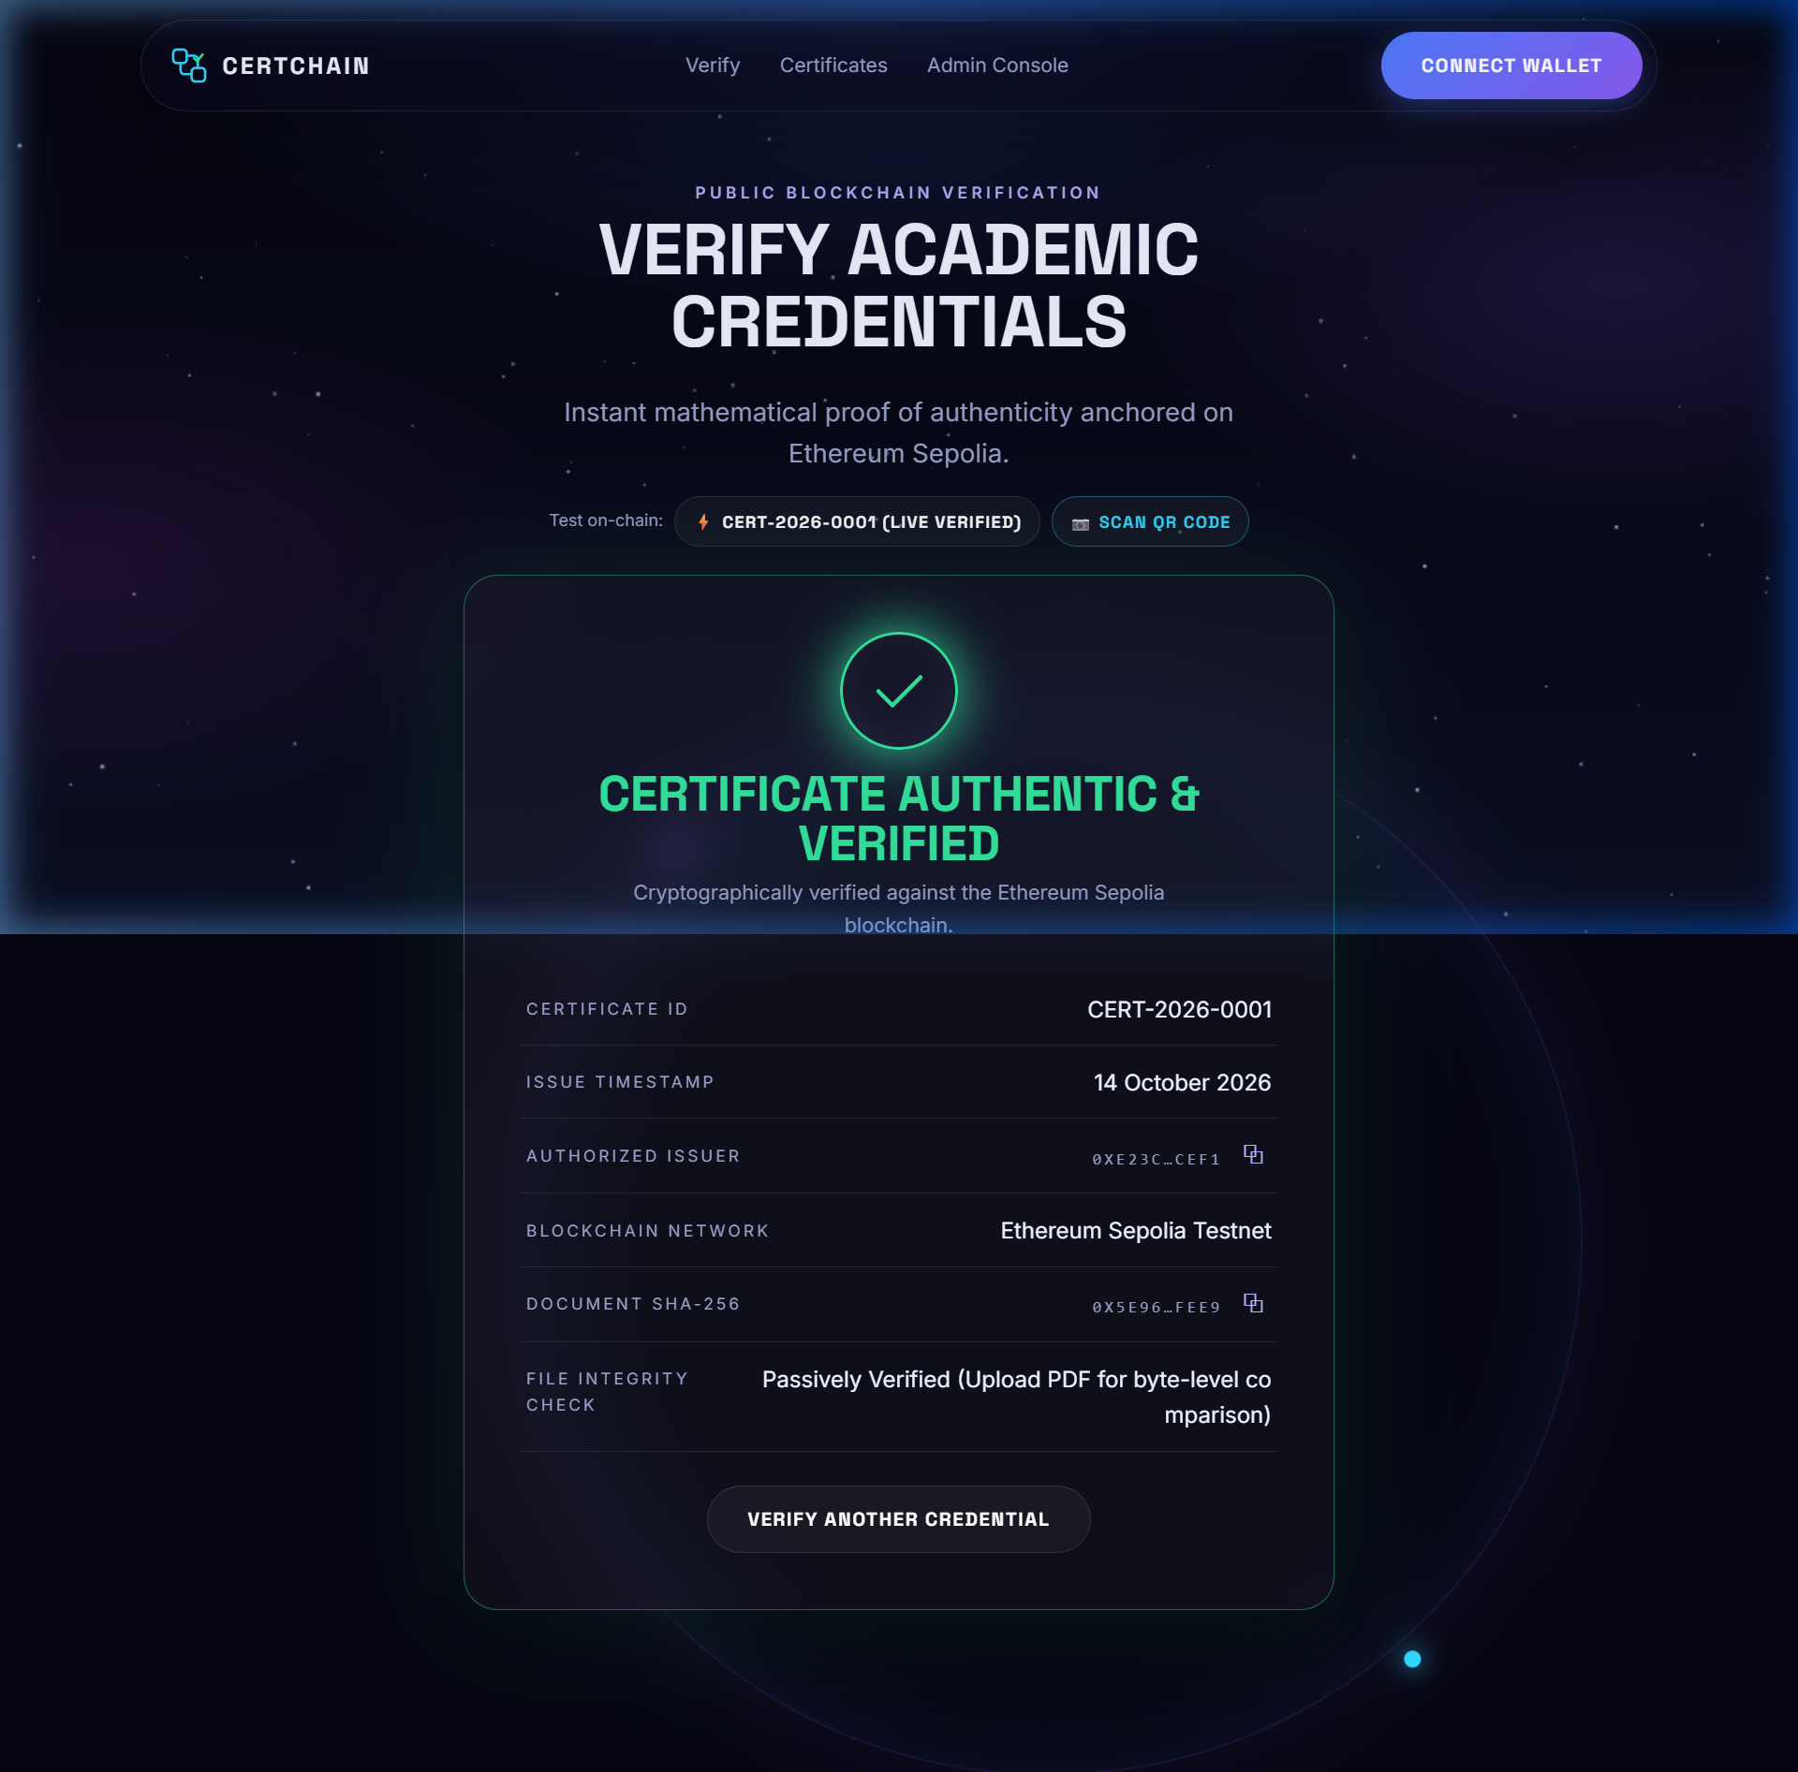
Fig 3.8: Live Production Deployment on Netlify Edge CDN

CHAPTER 4
LEARNING AFTER INTERNSHIP
4.1 Blockchain & Smart Contract Engineering
The internship provided comprehensive practical exposure to EVM architecture, Solidity memory/storage models, access control patterns, and gas optimization. I gained hands-on experience writing and deploying production contracts to the Ethereum Sepolia network and auditing transactions on Etherscan.
4.2 Asymmetric Cryptography & Data Integrity
I gained practical mastery over cryptographic hashing algorithms (SHA-256), Elliptic Curve Digital Signature Algorithm (ECDSA), public-private key derivation, and client-side binary digest generation. Understanding how cryptographic hashing guarantees tamper-evidence was a pivotal learning milestone.
4.3 Web3 Full-Stack Integration
Integrating Ethers.js v6 with React 18 taught me how decentralized applications communicate with remote blockchain nodes via JSON-RPC. I learned to handle wallet connection events, network switching between Ethereum mainnet and testnets, and contract transaction lifecycles.
4.4 Computer Vision & Optical Barcode Scanning
Implementing the in-browser QR code scanner using html5-qrcode improved my skills in handling web media devices, browser camera permissions, video canvas streaming, and real-time image decoding.
4.5 Cloud DevOps & CI/CD Pipelines
Deploying the project to Netlify Edge CDN and Cloudflare provided invaluable industry experience in production deployment, environment variable management, single-page application rewrite routing (_redirects), and automated Git synchronization.

CHAPTER 5
SUMMARY, CONCLUSION & FUTURE SCOPE
5.1 Summary
CertChain was successfully designed, developed, deployed, and tested as a decentralized academic credential verification system on Ethereum Sepolia. By anchoring immutable SHA-256 document digests on-chain, the platform eliminates diploma forgery, reduces verification latency from weeks to milliseconds, and removes costly third-party verification middlemen while preserving 100% student privacy.
5.2 Conclusion
The internship at Centurion University of Technology and Management provided an invaluable transition from academic theoretical computer science to hands-on Web3 engineering. CertChain demonstrates the practical, transformative impact of blockchain technology in higher education administration.
5.3 Future Scope
1. Soulbound Tokens (ERC-5192): Upgrading certificate anchors to non-transferable NFTs tied to a student's decentralized identity wallet.
2. Zero-Knowledge Proofs (zk-SNARKs): Enabling selective attribute disclosure (e.g., proving graduation or GPA > 3.5 without revealing the full transcript).
3. Layer-2 Scaling: Deploying on Ethereum Layer-2 networks (Arbitrum / Optimism / Polygon) for sub-cent transaction fees at institutional scale.
4. Multi-University Consortium: Establishing federated decentralized identity verification across international university alliances.

CHAPTER 6
BIBLIOGRAPHY
[1] Nakamoto, S. (2008). Bitcoin: A Peer-to-Peer Electronic Cash System. Cryptography Mailing List.
[2] Wood, G. (2014). Ethereum: A Secure Decentralised Generalised Transaction Ledger. Ethereum Project Yellow Paper.
[3] Solidity Documentation. Ethereum Foundation (2024). https://docs.soliditylang.org/
[4] OpenZeppelin Contracts. Secure Smart Contract Development in Solidity (2024). https://docs.openzeppelin.com/contracts/
[5] Foundry Book. Fast, Portable and Modular EVM Toolkit (2024). https://book.getfoundry.sh/
[6] Ethers.js v6 Documentation. Complete Ethereum Library and Wallet Implementation (2024). https://docs.ethers.org/v6/
[7] National Institute of Standards and Technology (NIST). (2015). FIPS PUB 180-4: Secure Hash Standard (SHS).
[8] Netlify Edge Platform Documentation. Modern Hosting for Static Sites and Serverless APIs (2024). https://docs.netlify.com/
[9] CertChain Project Technical Documentation & Source Code Repository. https://github.com/Keerthi1316/certchain

PROGRAM OUTCOMES (POs) & PSOs MAPPING
Table 1: Correlation between the Internship Project and Program Outcomes (POs), Program Specific Outcomes (PSOs).
Roll No | Name | Title
24R11A66N9 | Katuri Keerthi | Blockchain — CertChain

Table 2: Project correlation with appropriate POs/PSOs (Specify level of correlation H, M, L against POs/PSOs).
Legend: H - High (3) M - Medium (2) L - Low (1)
PO1 | PO2 | PO3 | PO4 | PO5 | PO6 | PO7 | PO8 | PO9 | PO10 | PO11 | PSO1 | PSO2 | PSO3
H | H | H | M | H | M | H | H | M | M | H | H | H | H

Table 3: Nature of Internship work (Please tick ✓ appropriate for your Project)
Roll Number | Title | Product | Application | Research | Others
24R11A66N9 | CertChain | ✓ | ✓

Table 4: Nature of Internship Project work (Domain Classification)
Roll Number | AI | ML/DL | Web Applications | Network Security / Blockchain | IoT
24R11A66N9 |  |  | ✓ | ✓ (Blockchain Security)

