**Automobile Data Project: Developing an App to understand Automobile Models, compare performance and Evaluate brands.**

**Table Of Contents**

1. **Executive Summary**
2. **Introduction to the Project**
3. **Vision and Goals**
4. **Product Roadmap**
5. **Daily Scrum**
6. **Sprint Retrospective**
7. **Artifacts**
   1. **Product Backlog**
   2. **Sprint 0 Backlog**
   3. **Increment - Screenshot**
8. **Appendix**
   1. **Reference Page**
   2. **Meeting Notes**
   3. **Task Board**
   4. **Other Documents**

# **Executive Summary**

The automobile business is facing major challenges as a result of rapid technological improvements and changes in customer behavior. We are very pleased to introduce a mobile application that simplifies and enhances the car-buying experience for consumers by giving deep, actionable insights into automobile data. Using extensive data analytics and a user-friendly interface, our application gives detailed and individualized information about future and existing automotive models. The technology enables users to access more specific information, performance statistics, and direct comparisons of products from different brands on the site, allowing them to make more informed and personalized purchasing decisions based on their preferences.

**Distinctive Features of Our Application:**

* **Model Information:** Detailed info on model specifications, including features and pricing.
* **Performance Evaluation:** Implement car performance software that targets fuel consumption, safety ratings, ease of use, and other user-focused measures.

* **Comparative Analysis Tool:** Specifying system concepts such as brand dependability, cost-effectiveness, and customer rating measures.

We want to provide people with all this useful information in an easy-to-use style, allowing them to confidently choose the right car. Our flexible development strategy, based on the Scrum framework, allows us to swiftly make adjustments based on what customers tell us, making our app even better. With this project, we hope to establish a new standard for assisting people in purchasing vehicles, one based on trust, transparency, and customer satisfaction. As the car market evolves, our app will make it easier for customers to stay current and select the ideal vehicle for them.

# **Introduction of the Project**

* The automobile sector is currently experiencing an unimaginable phase of transformation, driven by advances in technology, evolving consumer demands, and a growing tendency towards openness. The traditional car-buying procedure is ready for disruption in this situation. Customers are looking for tools that will enable them to sort through the stuff, weigh their options, and decide on a purchase with confidence.
* Our vehicle data project appears to be an appropriate approach to these changing demands from customers. Through the utilization of data analytics, creative UX design, and strong technology, our goal is to develop an application that overcomes simple automobile classifieds.
* Our project's main goal is to distribute access to automobile information in order to empower customers. We understand that purchasing a car can be a complicated procedure, which affects buyers. We want to level competition by offering users with extensive, verifiable automobile data as well as accessible comparison tools.

The project's significance originates from its ability to completely transform the automobile research and purchasing process. Key implications include:

1. Streamlining research by consolidating vehicle information in a single platform.   
2. Enabling data-driven decision-making through easy side-by-side vehicle comparisons.   
3. Personalize the experience with intelligent vehicle recommendations based on customer input.   
4. Integrating expert and customer reviews increases confidence and transparency.   
5. Providing comprehensive guidelines and tools to help with vehicle ownership.

# **Visions and Goals**

**Vision:**

Our vision is to create a mobile application that will improve the way people research and buy cars. With the use of this application, customers will have exclusive access to thorough car data and insights, enabling them to make smart decisions. Our goal is to create a new benchmark for the industry that is transparent, easy to use, and customized. The objective is to change the way people look for, evaluate, and buy cars by guiding them through every stage of the ownership process with ease. We want to transform the automobile industry and give customers confidence in every purchase by giving them the power and resources they need.

**Project Goals and Strategies:**

1. **User-friendly Interface**:

* **Goal**: Adopt a user-friendly interface that completely enwraps customers with their designer and helps them easily understand all the models of cars.
* **Strategy**: Factor in user experience design (UX) principles and identify users that can test the app in real life situations. Along the way, you’ll make the app visually appealing and easy to navigate.
* **Outcome**: Users will be able to receive a seamless online browsing experience with no difficulties whatsoever in searching for key information about various car models.

1. **In-depth performance analysis:**

* **Purpose**: The second point of our platform is to offer a complete bunch of performance rating tools to aid consumers analogize each car proficiency against another and make the most informed purchasing decision they can.
* **Strategy**: The user will have multiple parameters that cover the fuel efficiency, safety ratings, and user-feedback. This analytics process is propounded by advanced data-science approaches.
* **Outcome**: People will clearly know what type of vehicle they need and be capable of choosing the option that fits with their needs and lifestyle by the end of this training.

1. **Facilitate Brand Comparisons:**

* **Goal**: The third purpose in our mind is making the brands contrast more efficient and to let the customers to compare the brands according to the trustworthiness, cost, and satisfaction.
* **Strategy**: We will cover the ability to get extensive and holistic comparative knowledge to customers, where they can see the rivals on the same page by the side-by-side comparisons of what they offer in terms of the mailings.
* **Outcome**: Consumers are provided here with the opportunity to test from various brands, eventually making their minds up on which one of the brands matches their interests and ideals.

1. **Enhance the Overall Car-Buying Experience:**

* **Goal**: The objective is to have a redefined car-buying experience in which the consumer will have a higher level of transparency and will no longer have to rely on their instinct when making a purchase decision as they will be provided with the necessary knowledge to make an informed decision.
* **Strategy**: The transparent assessment format with customized guidance for each customer will be provided to explore the automobile purchasing process and allow people to take full advantage of the available information.
* **Outcome**: Through the provision of those services, users will feel inspired, assured, and best of all will like their car consulting application, thus building up the clients’ trust and loyalty to the app.

# **Product Roadmap**

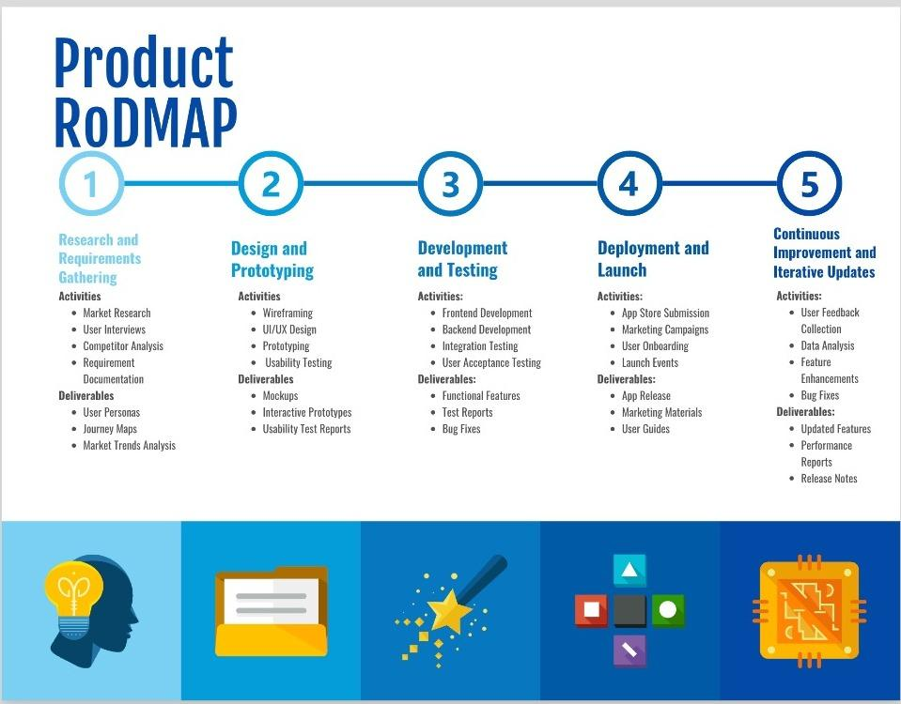

**Roadmap Timeline**

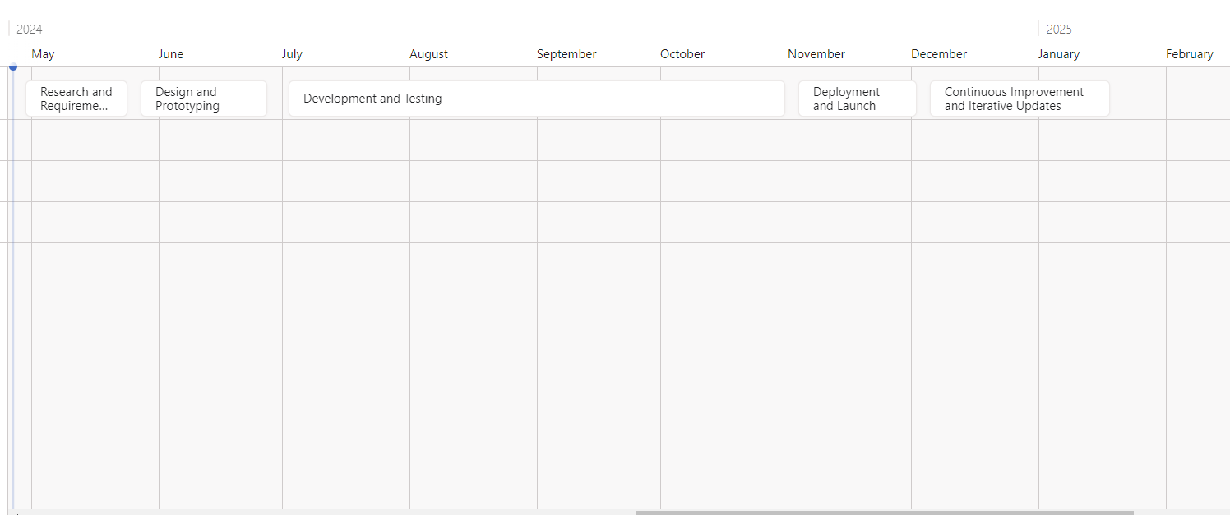

**Phase 1: Research and Requirements Gathering**

**Duration:** 4 weeks

1. **Activities:**

* Market Research
* User Interviews
* Competitor Analysis
* Requirement Documentation

1. **Deliverables:**

* User Personas
* Journey Maps
* Market Trends Analysis

**Phase 2: Design and Prototyping**

**Duration:** 6 weeks

1. **Activities:**

* Wireframing
* UI/UX Design
* Prototyping
* Usability Testing

1. **Deliverables:**

* Mockups
* Interactive Prototypes
* Usability Test Reports

**Phase 3: Development and Testing**

**Duration:** 12 weeks

1. **Activities:**

* Frontend Development
* Backend Development
* Integration Testing
* User Acceptance Testing

1. **Deliverables:**

* Functional Features
* Test Reports
* Bug Fixes

**Phase 4: Deployment and Launch**

**Duration:** 4 weeks

1. **Activities:**

* App Store Submission
* Marketing Campaigns
* User Onboarding
* Launch Events

1. **Deliverables:**

* App Release
* Marketing Materials
* User Guides

**Phase 5: Continuous Improvement and Iterative Updates**

**Duration:** Ongoing

1. **Activities:**

* User Feedback Collection
* Data Analysis
* Feature Enhancements
* Bug Fixes

1. **Deliverables:**

* Updated Features
* Performance Reports
* Release Notes

**Automobile Data Project Development Timeline**

# **Daily Scrum**

The Daily Scrum forms a basic part of the Agile model. It is a quick summary meeting that assists in aligning the team and provides updated information on tasks progress. It is the key component that enables quality communication and participation across the whole team and through its impediments can be identified and addressed at the speed of light.

**Scrum master’s Facilitation:**

**Meeting Leadership**: It is in the Scrum master’s responsibility to conduct each Daily Scrum meeting, while being concerned about its purpose and length which should be no longer than 15 minutes to demonstrate respect for each one of the team’s members and to create a productive work environment and culture.

**Guidance on Best Practices:** What is done in the past meeting is explained as well as the problems, if any, which the team members are faced with. It is done this way to ensure effective communication within the team.

**Obstacle Management:** The Scrum Master provides open ears during the Daily Scrum where impediments, mentioned by team members, are identified, the Scrum Master takes ownership of such challenges and works on finding a solution fast. This could mean either liaising with other parts of the organization to remove the impediments or contributing the extra resources or assistance already in existence.

**Role in Enhancing Communication:**

**Stakeholder Updates**: The stakeholders may not be a part of Daily Scrum, which is clarified and repeated every day to make sure the progress and any big impediments and decisions are conveyed clearly from the Scrum Master. It does this by assuring that the project goals are clear, and by communicating the status of the project to the relevant stakeholders.

**Encouraging Engagement:** As the Scrum Master, you should facilitate the Daily Scrum and consequently make sure that the whole team provides their input. Every voice is going to be considered, which means that the whole team is involved in making decisions and taking an active position.

# **Sprint Retrospective**

**What went well**:

* **Full function:**  Full group of vehicle comparison where the users can switch for the different models the cars, they would want to have one by one.
* **Effective Collaboration:** Cooperation among the team members take place through collaboration, information sharing and each other's support to fulfill the Sprint Goal.
* **On-time delivery:** The team fulfilled deliverables within deadlines, completed all required user stories, achieved the Sprint Goal, and attained a synchronization with the project's calendar.
* **Quality Assurance:** Assessment is done on a per sprint basis and very few issues are reported after testing.
* **Good User Feedback:** The initial users' reactions towards the new features are quite positive, which, in my opinion, implies that integration of these features has enhances the functional capabilities of the app to the extent that the user experience becomes much better.

**What Didn't Go Well**:

* **Technical Challenges:** The obstacle that the team had was the syncing of data and, as a result, the solution was not completed on time for the main features.
* **Scope Creep:** Out of scope creep, the user story derived smack dab in Sprint gets added without doing an impact assessment in Sprint Backlog.
* **Communication problems:** There is a communication hole in the middle team which halts the completion of tasks and prioritizing between the team members.
* **Dependency bottleneck:** The APIs run on outside applications, causing a certain period of the task to be delayed. This shows how coordination with external stakeholders will help the situation.
* **Resource Constraints:** There are resources, mainly skilled developers who duper the ability of the team to perform all tasks planned for the Sprint period.

**Improvements Required:**

* **Advanced Data Integration**: In such a way, investing into a true integration process allowing the user to interact without obstacles.
* **Improved Scope Management:** Adopt a concise method of ranking any new needs to ensure that they do not cause any delay in identifying the sprint goals.
* **Improve pipeline:** Use checklists and status updates to improve communication amongst all parties to guarantee that everyone is in the loop with the latest update and is well-aligned.
* **Resolve external dependencies:** Find the ways to avoid dependencies to external APIs or the third-party services to minimize the impedance factor in progress realization in sprint.
* **Resource Planning:** Point out the accessibilities and skillets gaps prevalent in sprint planning process to facilitate the team with the required knowledge and expertise to complete the task as planned earlier.

# **Artifacts**

## **Product Backlog - Automobile Data Project:**

1. **User story**: Explore Automobile Models

As a user, I want to browse different car models and understand their specifications and features.

**Acceptance Criteria**:

* Lists the car models by name, type, and year.
* Describes in detail each model, supplying the technical parameters, e.g., engine size, transmission type and fuel efficiency.
* Users can narrow down the vehicle models available based on criteria such as vehicle type (car, SUV, truck) and price range.
* Uses a search function which lets users find models by name or content.

1. **User story**: Compare vehicle performance.

As a customer, I wish to see a comparison between the models to better make a decision.

**Acceptance Criteria**:

* People can choose several vehicle models or compare them within one page.
* Displays comparison data such as horsepower, torque, acceleration, and fuel economy for each of the models chosen by the user.
* Use visual aids like tables or graphs to make it clear that there’s model discrepancy.
* Gives users the option of setting the comparison model and tweaking the scale to the extent that they want it to.

1. **User Story**: View Brand Information

As a user, I am going to seek for information about variety of cars including their customer service and products.

**Acceptance Criteria**:

* Shows the list of car names with a short overview and own appearance arrangement.
* Has links and buttons that redirect to pages such as the history, importance and outstanding models of that theme.
* Aggregates user reviews and opinion ratings to bring forth the brand reputation and customer satisfaction.
* Socialization functionality that lets users to share businesses information among their connections.

1. **User story**: Provide bookmarks.

As a user, I would like to save my best car models choice for future use and make reference to them in comparison.

**Acceptance Criteria**:

* Users can also compile and track their collected models from a favorable list into their user profile account.
* The template site was enhanced with a "Save" button or icon in the page in case of quick saving.
* Enable users to view and edit stock lists, which comprise of both possibilities to delete/add new items to an existing list.
* Protect saved preferences and make sure they are handy and available in various devices for stable usage.

1. **User Stories**: Get updates and alerts.

As a user, I would like to receive updates and notifications about new models, changes and supports.

**Acceptance Criteria**:

* Provide an email subscription option and users will be able to receive newsletters and other newsmakers updates by e-mail.
* It also lets customers to establish alerts limited to specific cases, i.e., price drops or new models being introduced.
* Empower users to choose the most suitable notify needs, and the frequency of updated.
* Provides a framework to meet different data privacy laws of varying country jurisdictions and offers clear opt-in/ opt-out procedures for communication.

## **Sprint 0 Backlog - Automobile Data Project:**

**1. Creation of Development Environment:**

**Task**: Create and configure a state-of-the-art development environment that is suitable to the project's technical demands.

**Details:**

* Implement software tools and standards for front-end and back-end parts of the website.
* Set up a version control system (e.g., Git) and create a directory structure.
* Create project management tools (like Jira and Trello) for tracking the progress and managing user stories.

**2. Business Studies and Market Analysis**

**Task**: Conduct in-depth market research as well as business studies to understand the current market demands and preferred user needs.

**Details:**

* Perform in-depth market research to identify the niches of car markets as well as the tastes and preferences of consumers.
* Study competitors’ applications and websites to determine general features and functionalities.
* Engage users through surveys or direct conversations to get their critical insights on pain points and expectations.

**3. Define the Project Vision and Objectives:**

**Task:** Partner with stakeholders to build a project’s vision and to set specific, measurable, and attainable goals.

**Details:**

* Partner with stakeholders to outline the scope, goal, and criteria for success.
* Capture the project’s vision and goals in the project charter or the vision statement.
* Develop SMART (Specific, Measurable, Achievable, Relevant, Time-bound) sustainable development goals.

**4. Creation of Preliminary Wireframes and Prototypes:**

**Task:** Develop preliminary wireframes and UI prototypes to provide user interface and experience idea.  
**Details:**

* Develop interface wireframes mapping all key screens and user interactions.
* Simulate actions and user flows by creating interactive mockups using tools like Sketch or Adobe XD.
* Collect feedback on wireframes and prototypes from stakeholders and potential users to fine tune designs.

## **Increment:**

**Increment 1:**

**Features Implemented:**

* Basic user authentication: Members are upon registration, login and manage their own data.
* Model List: Brand, model, year, etc. Shown to the user by the models list with the brief information like the model’s name.
* Model Details Page: Enlarged view of any car model and information on this, spec. and features of it.
* Search function: The avenue arises for product search with terms or conditions (such as brand, model or year specifications) utilized as search parameters.

**Increment 2:**

**Features Implemented:**

* Customer collection: Users can thus add the brand of cars they love to a list of favourites and view all of them in a separate place.
* Comparison Tool: Single out the device and get the models you are looking for compared to using other ones.
* Brand information pages: Car brand pages, with detailed information about brands, including company history, the most popular models and the price intervals.
* Responsive Design: Guarantee that the application is fast and shows a specific content adjusted to various devices and display sizes.

# **Appendix**

## **Reference pages:**

* Has compiled a list of guidelines used throughout the project:
* Jobs reports come from reputable sources like JD Power and Associates and Statista.
* Tips on car use and consumer behavior.
* Legal information from API providers like Edmunds and Kelley Blue Book.
* References to sources and statistics used in the study.

## **Meeting minutes:**

* **Sprint Planning Meeting:** Share user stories, acceptance criteria, and work activities for future Sprints.
* **Daily Scrum Meetings:** Complete daily updates, identify roadblocks, and plan next steps.
* **Sprint Review Meeting:** Gather feedback from stakeholders, present the presentation, and identify actions for improvement.
* **Sprint Retrospectives:** Documented retrospectives discuss achievements, areas for improvement, and recommendations for future sprints.

## **Task board:**

* Provides a snapshot of the digital task board used by the development team throughout the project and references:
* User stories are divided into projects with detailed descriptions and approvals.
* Visual representation of tasks, including “To Do,” “In Progress,” and “Completed” fields.
* Description of blockers, dependencies, or obstacles encountered during sprint execution.
* Progress metrics such as velocity lines and burn lines are used to track team performance and sprint progress.



­

## **Other information:**

* Contains additional information and structures important for success, such as:
* Wireframes and design mockups created during the initial project phase to demonstrate the application's user interface and functionality.
* Technical documentation and architectural diagrams outlining the system design, database schema, and API integration.
* Test plan and QA report detailing the testing strategy, testing conditions, and recovery, integration, and user detection results.
* Publication of user manual, guidance and documentation for end users and stakeholders to promote implementation and use.