**Mini project on**

**Smart Prognosis of Human Health Condition**

**Table of contents**

|  |  |  |
| --- | --- | --- |
| **Sl. no** | **Contents** | **Page no** |
| 1 | Introduction | 3 |
| 2 | Scope of the project | 3 |
| 3 | Aim and objectives | 3-4 |
| 4 | Problem statement description | 4 |
| 5 | System requirements | 5 |
| 6 | design | 6 |
| 7 | Test plan and test cases | 7 |
| 8 | Expected results | 8 |
| 9 | conclusion | 8 |
| 10 | References | 8 |

**1.Introduction**

“Health is wealth”, Current situation of human life style makes it very important for us to take care of our health. But this busy life does not allow us to visit hospitals regularly as it kills lot of time in reaching the hospitals and getting the doctor appointment. It can either be a common cold or something very dangerous. Early prediction helps us to overcome our health conditions by taking proper measures.

**2. Scope of the project**

1.This project helps people to know about their health condition.

2.Helps in reducing the time consumed in travelling to the hospital to get the checkup.

**3. Aim and Objectives**

Aim of this project is to create a system which will interact with the users with series of queries to identify the symptoms of the users and thereby predicts the disease and recommends treatment.

Objective of the project is to:

1. Develop a system which can take user input.
2. To provide related output.
3. To reduce the time consumed in visiting the hospitals.

**4. Problem statement description**

Hospitals are most widely used means by which a sick person gets medical check-ups, disease diagnosis and treatment recommendation. The proposed mini project is used to create an alternative to the conventional method of visiting hospital as this will consume a lot of time in visiting hospital and getting a doctor appointment.

This mini project is implemented using C programming language which will interact with the users with series of queries or symptoms to identify the user's condition and thereby predicts the disease and recommends treatment. This system is capable of predicting 2-3 common diseases faced by the people of our country, which makes people aware of their health status and encourages people to make proper measures to remain healthy. This mini project will help people avoid the time-consuming method of visiting hospitals.

**5. System requirements**

Software and hardware requirements

1. OS: Windows 7,8 or 10
2. Memory: 250MB (minimum)
3. Processor: Intel core 3 or 5
4. IDE: Codeblocks Version 20.3
5. Compiler: GNU GCC Complier
6. Programming Language: C programming

**6. Design**

Architectual Design

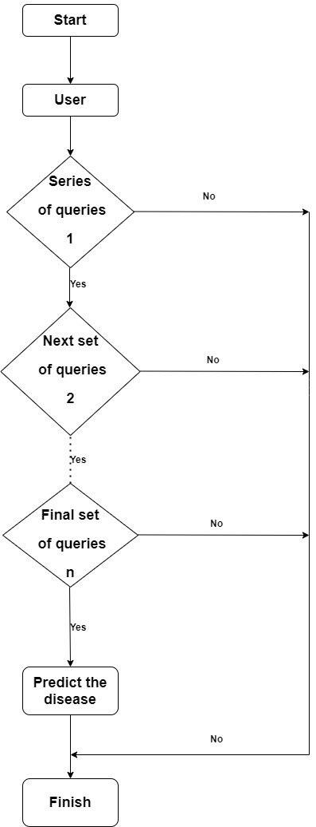

Fig: Architectural design description

**Description of the design**: User will be provided with series of queries which consist of symptoms of particular disease. If the user is suffering from the mentioned symptoms, then the system will suggest to consult doctor for the treatment of that particular disease.

**7. Test plan and Test cases**

Test plan is to check whether the system is able to predict the disease according to the user input given to the series if queries asked by the system.

|  |  |  |
| --- | --- | --- |
| **Sl. no** | **Test cases** | **Pass/Fail** |
| 1 | To check system behavior if user chooses the correct options displayed. | Pass |
| 2 | To check system behavior if user chooses the wrong options. | Pass |
| 3 | To check if user is able to navigate through the flow. | Pass |
| 4 | To check whether the system is able to provide output according to user input. | Pass |

**8. Expected output**

1. User will be successfully able to choose the options provided.
2. User will be able to navigate through the flow.
3. System will be able to provide output according to user input.

**9. Conclusion**

Developed system will be capable of predicting the disease according to the user's symptoms which are given as input.

**10. References**

1. Rohit Binu Mathew, Sandra Varghese, Sera Elsa Joy, [Swanthana Susan Alex](https://ieeexplore.ieee.org/author/37087041962), “Chatbot for Disease Prediction and Treatment Recommendation using Machine Learning”, 10 October 2019.
2. [www.guru99.com](http://www.guru99.com)
3. Draw.io