**BLOCKCHAIN-BASED CRYPTOCURRENCY USING IOT**

**INSTITUTE OF AERONAUTICAL ENGINEERING**

Department of computer science and engineering

**ABSTRACT**

Due to the boom in the cryptocurrency market in 2017, some governments around the world have begun to work towards regulating and regulating digital currencies. People gain trust in the use of cryptocurrencies due to the security of blockchain technology and its economic ecosystem. Blockchain provides an innovative way to store information, execute transactions, perform functions and build trust in an open environment. Blockchain technology is a recent breakthrough in secure computing without centralized authority in open networked systems. In the context of the Bitcoin system, the blockchain is used as its secure, private and trusted public archive for all Bitcoin transactions on the Bitcoin network. This ensures that all Bitcoin transactions are recorded, organized and stored in cryptographically secure blocks that are linked in a verifiable and durable way. There are multiple factors that have contributed to Bitcoin’s success, although there is still some doubt that the decentralized design of blockchain technology and its perceived resilience to government or third-party intervention have played an extremely critical role in its adoption. Distributed encrypted cash, and more specifically blockchain technology, has been hailed as one of Bitcoin's key, most prominent and widely accepted innovations. In this article, we focus on implementing cryptocurrency for the Internet of Things using blockchain technology.

• Keywords: Blockchain technology, cryptographic, Decentralized - ledger, SHA256

**INTRODUCTION:**

Blockchain technology and cryptocurrency is one of the coolest and widespread technologies these days. Blockchain technology is a system of recording information. Blockchain makes difficult or impossible to change or hack the data stored which means the data once entered will never get eradicated. Blockchain is a distributed ledger of transactions where the transactions are duplicated and distributed across the entire network in the blockchain. Bitcoin is the application of cryptocurrency that completely forms a peer-to-peer, decentralized and worldwide transaction system, without concentrating control or power in the hands of single authority. The blockchain application is installed on thousands of computers throughout the world and is maintained and cared for by a group of ordinary people and experts called as miners. Bitcoin transactions are carried out via peer-to-peer network between interested parties, with no intermediary bank or individual taking a cut, obviating the need for middleman. In 2008, a person known as Satoshi Nakamoto promoted the blockchain. The blockchain is a secure technology that is powered by a variety of cryptographic algorithms. It is a comprehensive, open-source system that includes decentralized ledgers for keeping track of transactions. This means it is independent of any particular bank, government or organization and anyone with the active internet connection can access it. The advantages and benefits of a decentralized blockchain are numerous: Fraudulent activity should be avoided at all costs. Blockchain is made up of open-source ledgers that record every single transaction, making a fraud detection easy process. The incorruptibility of blockchain system is monitored and maintained by miners, who are responsible for frequently confirming transactions. Faster transaction times are provided by blockchain based cryptocurrency. Transfers of cryptocurrency are instantaneous, fee-free, easily traceable and securely kept in the blockchain. All of the blockchain technology’s provisions on cryptocurrency transfers are globally applicable. Data can be inserted but never be withdrawn from the blockchain database. With the adoption of blockchain technology, individuals all over the world will no longer be reliant on banks and other middlemen, and they will no longer be at the whim of businessmen who acquire and store their personal information. While still in its enlarging stage, blockchain has potential to breakthrough and disrupt various industries in the next months and years.

**EXISTING SYSTEM:**

Blockchain creation primarily comprises of the accompanying parts:

**A. proof of-Work**

Proof of work framework is one that expects excavators to spend

sometime accomplishing computational work to add squares to the

chain. This has the advantage of deciding untrustworthy companions from

supplanting the square chain with bad and invalid information. In

blockchain, any friend has the capacity of presenting a new

chain to the framework. However long that chain is long sufficient it

contains substantial hash information. Beginning from the Genesis block that

change will be acknowledged by every one of the companions in the blockchain

network. To beat these genuine people in the organization down

from assuming control over the whole square chain with a bad chain

in support of themselves that really has substantial hashes. The verification of

work framework makes it computationally costly to do as such.

The evidence of work framework makes it, so individual hubs

in the square chain can place in an unmanageable measure of

computational work to add a square. Notwithstanding, for a

untrustworthy hub, the evidence of work makes it immeasurably inefficient

to attempt to take over with a completely newly created chain.

Numerous digital currency blockchains, for example, Bitcoin utilize a proof

of work motivated by a framework called hash cash made in 1997

that was utilized to forestall email spamming just like a

forswearing of administration assaults that would over-burden web servers. At

some random point there is a degree of trouble in the square chain

framework. Contingent upon this trouble one may very well attempt to add

another square. They should observe a hash an incentive for this

block that matches this trouble for this coordinating. Diggers

need to track down similar number of driving zeros as the current

trouble for the created hash of the new square. To add to

the chain tracking down the specific number of driving zeros arbitrarily

turns out to be dramatically more earnestly as the actual trouble rises. In

request to address the verification of work an excavator should create

a huge load of hashes to ultimately track down one that fulfills the trouble. Nonce is a term to allude to a worth that can

be utilized once since each remarkable hub worth will produce a

extraordinary hash. The nonce is utilized to produce new hash for the

block. The hub esteem begins at nothing and additions until a

hub is utilized that has a matching number of driving zeroes

as indicated by the set trouble which produces the hash. This

nonce esteem is then put away as a feature of the Block. Also this demonstration of creating new hashes with changing qualities takes a lot

of computational work. The demonstration of expenditure this computational

work is important for the justification for why adding a square to the blockchain

is called mining and when an excavator has effectively mined a

block they will present their square with the observed nonce esteem

to different diggers.

**B. SHA256**

Secure Hash Algorithm 256 addresses the quantity of pieces

of which the extraordinary hash code will be produced. It is a

cryptographic hash work with digest length of 256 pieces.

It is a keyless hash function. The hash starts with the number

of 0 pieces.

**C. SECP 256 K1**

Principles of productive cryptography. P represents prime. 256

addresses the key part which is an indivisible number to

create the bend. It is an unadulterated SECG bend. It is built

in an exceptional non-arbitrary manner which takes into consideration particularly proficient calculation. It permits quick calculation and complex

duplication using-adic development and highlights

numerous beneficial attributes when utilized in elliptic bend

cryptosystems.

**D. 51% Attack**

A deceitful and a bad digger would require more

network power than the remainder of the organization joined (subsequently

51% of the organization power) to add squares to his

rendition of the blockchain quicker, subsequently allowing him to construct

a more drawn out chain. A 51% assault for bitcoin would be more than

$6 billion according to the beginning of 2018. Aggressors utilize 51% assaults

to topple previously existing exchanges in a blockchain.

**E. Merkle Tree**

Merkle trees (Bitcoin) store, and eventually prune transactions in every block. The cryptographic hash function used by bitcoin algorithm which stands for secure and efficiency.it is used for mathematical of data structures which served as summary for transactions.

**DRAWBACKS:**

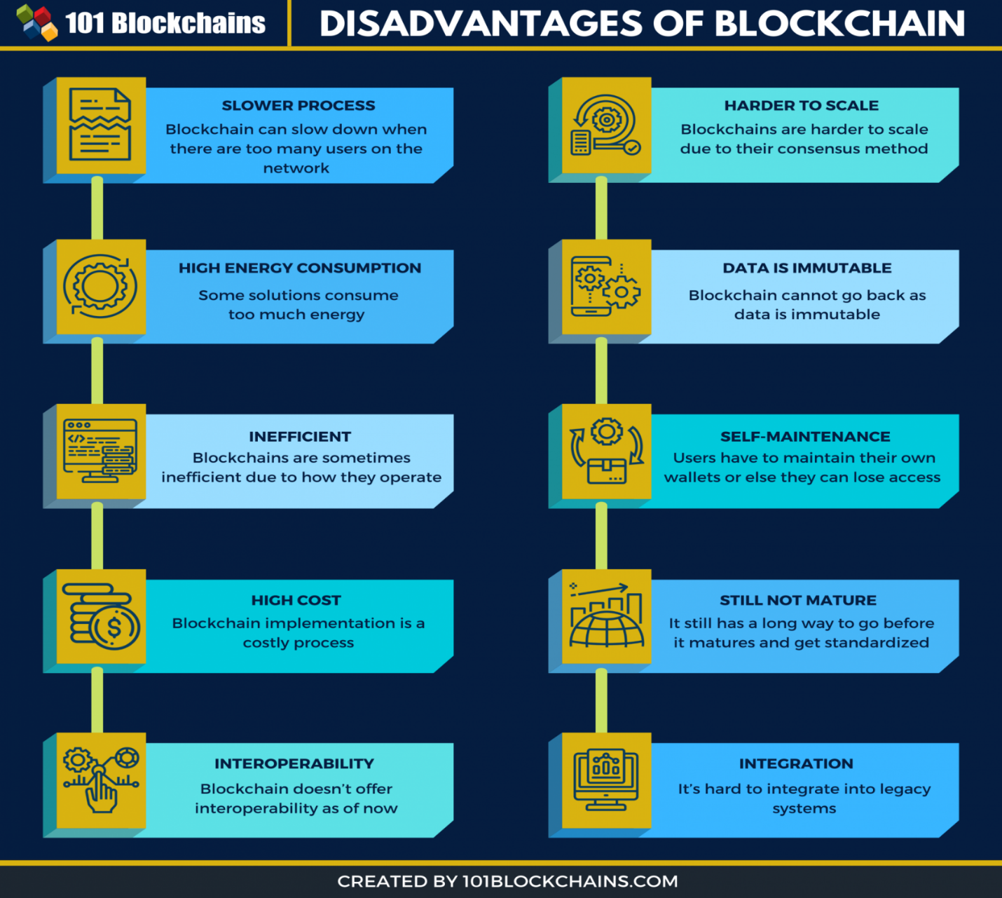

**PROPOSED SYTEM:**

IoT enables devices across the Internet to send data to private blockchain networks to create tamper-resistant records of shared transactions. IBM Blockchain enables your business partners to share and access IoT data with you — but without the need for central control and management. Each transaction can be verified to prevent disputes and build trust among all permissioned network members. we can combine blockchain with iot to make crypto transactions easy and more secured with proper authorization and it helps in storing all the private keys and essential data and helps in computing and communicating with different servers and iot devices.by using the below methods we can achieve that combination of blockchain and IOT for our crypto currency transactions.

**WORKING:**

Why does IoT need a blockchain? The idea of Internet of Effects is a smart bias, similar as detectors, wearables, complicated mechanisms ( selectors), collect data, connect to the internet and other bias through routers and gates via Bluetooth or Wi-Fi. They partake and collect data and/ or commands. Also, in the IoT networks bias with stoner interfaces can be applied, like particular computers, laptops, tablets,etc. This technology is used for communication purposes — starting at data transfer between meteorological and hydro-meteorological stations or launching the structure for smart houses and municipalities. The issues, styles, and ways to apply IoT constantly appear. So do the conditions for their security and scaling. According to the Gartner cast, these two effects will be the main difficulties for IoT development in the coming many times, and the veritably stylish result is blockchain technology. These are the major debit, that blockchain technology can fix . * Out of date firmware. Not numerous suppliers offer regular updates for their IoT results, and not numerous druggies will modernize the firmware, when a new interpretation is available. In the outdated firmware, security gaps and weak points might appear, so the systems can be unproductive and fluently addressed. * Weak authentication. Numerous IoT results use simple authentication for operations with strong programmed watchwords. This type of security is fluently addressed, just by chancing the proper word. * Unsecure connection. Numerous data leaks in IoT are the consequence of poor security measures during the data transfer between IoT bias or IoT and the pall, or during the data storehouse on a device or in the pall. * Physical intrusion. There's a chance that the hackers will change the configuration of the IoT device, for illustration, when they need to eavesdrop commodity, record videotape or launch DDoS attacks. The advantages of IoT enforcing Data decentralization. The information collected by IoT is hourly stored and managed by centralized waiters, which is a possibility for playing the nonpublic data by third- party people. Also, the network might fall incontinently. The decentralized structure of the blockchain considers that there's no centralized control point and data storehouse, so there are no single attack points. Despite shadows, the blockchain network is managed by different independent points, so there's no association to control a major quantum of data generated by the bias of IoT. Secure dives Streamlining. The increased safety and secure measures of blockchains allows the inventors to break the outdated IoT software issues, since they can safely transfer the law on the IoT bias. This was successfully tested by the University of Tulsa workers, who used the open- source blockchain to modernize the ESP8266 firmware via Wi-Fi connection. Enhanced sequestration. The blockchain can indeed hide the connection between the bias, offering sale confirmation without third- party perpetration. Also, the blockchain can optimize the IoT protocols, and supply the encryption. This lowers the pitfalls of data oohing and IoT network hacking. Enhanced data operation. IoT networks should transfer huge quantities of data in real- time through bias, systems and platforms, which raises new challenges for data operation. The blockchain allows the bias to transfer data directly, without garçon’s, cloud’s, or original database’shelp., This shortens the number of deals at least for one third ( device — other device — garçon/ pall/ original network — device). Also, smart contracts can make utmost of the processes between IoT bias automatic. Enhanced scaling. Decentralized blockchain networks partake the workload, which provides an advanced sale processing and increases the collaboration between billions of IoT bias that are connected to it. The capability to partake the data also helps to gauge. Stricter authentication. To identify the druggies, numerous blockchain platforms use the decentralized PKI approach that generates retired and open keys. This approach is different from centralized PKIs, its security measures are much more advanced since only the stoner has the retired key for their personality identification, while the network provider gets the open key. Since both keys are cryptographically generated, it's virtually insolvable to hack them. Automatic connection. Blockchain technology helps to make the commands and dispatches in IoT automatic by the means of smart contracts. These computer algorithms are used within IoT bias for data analysis, IoT bias temperature measuring, and diurnal temperatures measuring. The other illustration is an automatic stuffing of custom documents or automatic duty checkout after passing the border. 3 ways to integrate blockchain technology in an IoT network Before developing an IoT armature grounded on blockchain, you'll need to consider the way it'll interact. Then you'll have 3 results. IoT — IoT. This is actually the easiest way of blockchain integration into the IoT network, since it requires using only a sharing register for IoT data storehouse. The data transferring will take place out of the blockchain using colorful mechanisms of routing. This will help to achieve fast sale speed and smaller detainments. Likewise, this approach offers the capability to offline work for the bias. This is an easy result to apply, since it isn't considering major changes to the workflow of the IoT bias, all you need to do is to set up the transferring, storing, and rooting data from blockchain rather of a pall or a garçon. IoT — blockchain. For this approach, the IoT bias commerce will take place through the blockchain, which actually works as a pall for traditional IoT networks. From one point of view, this will enhance the dogging, security of communication, workflow automatization, and it'll increase the capacity. From the other point of view, it'll make the system much more complicated, which will beget detainments, if the blockchain isn't presto enough. The perpetration of this blockchain in IoT networks is complicated, since it requires numerous changes in the work of IoT bias and the blockchain development. Likewise, a proper blockchain with increased working speed, capacity and zero freights should be used. This can be an IOTA,Modum.io, or Riddle & Code- grounded blockchain. Page 1 of 3 Mongrel approach. In this case, a major part of data and relations are participated between the IoT bias, while the blockchain stores only some types of data. This brings a lot of advantages, but the low detainments and high working speed for IoT bias in real- time are hardly possible. Also, this approach helps to introduce fog computing to compensate for the limits of blockchains and IoT bias. For illustration, you can use this computing system to prize, store, and use the analysis of private data by the means of supplemental bias rather of pall computing which will help to save operating charges. The difficulties of blockchain in IoT integration Delicate choice of a agreement protocol. To choose the stylish blockchain option for the IoT you'll need to take into account that numerous mechanisms can't be used in the ultramodern IoT terrain due to high conditions to the computing power, spanning difficulties, high freightsetc. For case, if you choose the Bitcoin or Ethereum Blockchain, also each sale between the bias will bring 2-20 bones. Since the IoT deals with thousands or indeed millions of deals every day, a vast quantum of plutocrat is necessary, which is a huge debit. Likewise, the blockchains are veritably picky in terms of validators, which isn't applicable for IoT, since IoT bias are bitsy detectors with little computing power and limited functionality. it should fit the following criteria * High sale speed. * Low computing costs. * Low sale freights. * Low communication complexity. * IoT- concentrated confirmation styles. * High position of fault forbearance * Sybil attacks resistance. * DoS attacks resistance. Limited Coffers of the Internet of Effects structure. The coming problem is in the limited computing capacities and little memory available of the IoT bias. The blockchain technology requires a lot of memory to store the record and power to mine. As for now, no bone has plant a result for this issue, but it seems that IBM is really close. They've constructed the conception of protean and indigenous blockchains. The idea is that the network bumps are divided on * Simple p2p bumps — store their blockchain address and balance; * Standard p2p bumps — store recent sale and simple bumps; * p2p exchangers — replicate the complete blockchain and perform the data analysis. Weak data encryption. Encryption — is a pivotal part of numerous ultramodern operations, programs, and systems. Unfortunately, IoT bias can't interact with systems and druggies and cipher the data as blockchain does. One of the possible results to increase the cracking security in IoT is furnishing the entropy encryption, grounded on amount arbitrary number generation. This approach uses amount drugs- grounded data that's different from classical drugs, because it's arbitrary. You can apply the medium of amount arbitrary number generation to ameliorate IoT network encryption. EaaS providers offer high- quality sources of entropy on the physical processes of amount bias ground. These bias guarantee real randomness, which can be used by the inventors to make their IoT operations, systems, and bias safer and secure from cyberattacks. Spanning difficulties. The problem is that IoT networks continue their rapid-fire growth, which means that further smart bias, further deals, and further data should be reused. The connection between the IoT rudiments typically requires immediate data transferring. All this causes difficulties with scaling, especially for blockchains with poor working speed. The perfect armature of a blockchain for the Internet of Effects should reuse thousands of deals per second and give security for simple network bumps. This can be achieved in a many ways. * Resemblant computing. This processes a many deals at a time and increases the sale effectiveness. Also, when one chain gets too complicated, it can be divided on resemblant chains to help the business. This computing system can be used for data collecting and analysis in the IoT, for vast quantities of data analysis, and side systems recycling that bear a lot of computing. * Other results that increase the work speed of a blockchain. Protocols like Tube and Tube Cash, have the eventuality of adding the work speed by using chapter chains, maternal chains, and root chains by also adding smart contracts that can interact with the main blockchain .No standard communication protocols. The traditional IoT network bias generally connect to the internet via secure and fast connection styles (wireless or wired), like DSL/ ADSL, Wi-Fi, 4G and LTE. Smart bias for blockchain and IoT integration are generally connected to the internet via protocols with low bandwidth and energy consumption802.15.4,802.11 a/ b/ g/ n/ p, LoRa, Zigbee, NB-IoT, and Sigfox. Still, these protocols aren't designed to work with blockchains. To break this issue, the inventors need to produce special protocols that will be designed to work with blockchains and IoT networks. For this, they need a lot of time and plutocrat. The threat of overfilling smart contracts with IoT bias. We've bandied the advantages that the Internet of Effects gets for smart contracts integration. But, it still brings some difficulties. * Smart contracts bear third- party data sources to complete the contract. The problem is that the work of smart contracts can be addressed this way, so it needs a strong authentication, security and trust on the Internet of Effects terrain. * Smart contracts can be overfilled since they might bear access to a couple of data sources. While smart contracts are decentralized, they still bear a lot of calculating power, and this is a critical issue for IoT. The way this issue can be answered isn't known yet. As for now, the inventors use independent control, but this is complicated, precious, and not always secure. The overfilling issue can be answered by adding the productivity of the bias, deals, and bandwidth.

**ALGORITHM:**

Algorithm 1

mine block functionality

return timestamp,lastHash,hash,data,nonce,difficulty

while hash.substring(0,difficulty) !== ’0’.repeat(difficulty) do nonce++

set timestamp = Date.now()

set difficulty = Block.adjustDifficulty(lastblock,timestamp)

set hash = Block.hash(timestamp,lastHash,data,nonce,difficulty)

Algorithm 2

adjustDifficulty functionality:

return difficulty

set difficulty = lastBlockDifficulty

check whether lastblock.timestamp + mine rate is greater than currentTime

if yes then set difficulty = difficulty + 1

otherwise set difficulty = difficulty - 1

**RESULT:**

Bitcoin, Ethereum, Ripples, Litecoin, and a few other

digital forms of money appear to encounter a huge scope development in cost, market capitalization and far and wide open acknowledgment.

The digital currencies will more often than not offer a great deal of elements and capacities that are changing the manner in which we do and execute things.

Cryptographic forms of money are without a doubt incredibly interceding the worldwide economy. The reality of the situation will become obvious eventually how far this unrest will go.

This digital money network executed with the assistance of blockchain innovation essentially and eventually makes a work area wallet empowering the clients to execute real cash. It has been shown the way that this working really takes place utilizing postman programming has been utilized to access get and present solicitations and on likewise grandstand the result.

Most importantly to make and to start the blockchain, a square comprising of all expected subtleties that are timestamp, hash, information, nonce and trouble is made. Utilizing POST man post demand is gotten to and production of first square of the blockchain gets achieved. To exhibit how exchanges are really mined, another square instilling information and result subtleties also is made. Information of this square being made comprises of data regarding the beneficiary to which the cash must be executed. This data incorporates the timestamp, sum to be executed as well as the location to which the predefined cash should be executed. This location is essentially the public key of that particular square. Through execute work, public key of a particular square is acquired that functions as the location while executing cash from one port to another.

**CONCLUSION:**

Blockchain Technology may not supplant inheritance frameworks or old

applications soon. Be that as it may, Blockchain can surely be a corresponding application to inheritance frameworks and may even prompt the improvement of new frameworks soon.

Taking everything into account, more escalated research around here of Blockchain Technology is important to propel the development of this field, since it is as yet in the exploratory stage and there are numerous legitimate and specialized issues to be settled. In this way,

this survey offers a helpful beginning stage for future exploration subjects for the advancement of Blockchain application, and help specialists and scientists. Inside only 10 years, digital currencies along with their standard blockchain innovation have made a critical imprint in the time of business which is without a doubt becoming strong as the time elapses. With the approaching digital currency teaching blockchain innovation making it considerably more secure, a many individuals involved in mechanical work bought bitcoins as well as continue to achieve something with the blockchain convention itself. Blockchain innovation is expected to have a seriously well-off future. It's significance and applications goes a long ways past bitcoin and installment exchanges as this is only one - and generally utilized of its

numerous applications. This is definitely a progressive innovation that takes into account the safe, appropriated and above all decentralized capacity of touchy data. It has taken the designing scene by storm. Evidently, it additionally appears to be that it's anything but an impartial innovation. This innovation rather supports the reallocation and decentralization of force across wide networks of communicating peers with each other. Also in this way, disposes of fraudlance or any possibilities of debasement engaged by arbiters, thusly substantiating itself to be an altruist innovation every now and then. Additionally, most significant and progressive parts of blockchain improvement

appears to guarantee and advance reallocation and straightforwardness

every way under the sun even in the moderate execution of itself. It certainly appears to have a dream of making each conceivable precautionary measure necessary and essential to individuals' data security and straightforwardness. With the acknowledgment of blockchain innovation, individuals all over the planet can be liberated from steady reliance on banks and different brokers, and furthermore not to be helpless before financial specialists who might clutch their vital also private data.

**REFERENCES**

1.<https://merehead.com/blog/implement-blockchain-in-iot/>

2.<https://www.ibm.com/topics/blockchain-iot#:~:text=Next%20Steps-,How%20does%20IoT%20work%20with%20blockchain%3F,for%20central%20control%20and%20management>.

3.Blockchain based Cryptocurrency for IOT Samyak Jain1 Umang Rastogi1 Nikita Bansal1 Gagandeep Kaur1 1Department of Computer Science and Engineering Jaypee Institute of Information Technology Noida, India

4. A Review of Blockchain Technology and Its Applications in the Business Environment Thomas kitsantas1 , Athanasios Vazakidis2 and Evangelos Chytis3