**PartA Code Output:**

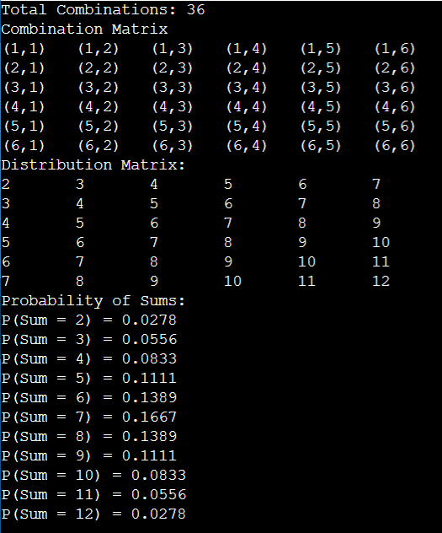

**PartB Code Output:**

