**Term Work: 2**

**Name: USN:**

**Linear Regression Using Gradient Descent**

Theta found by gradient descent:

Intercept: **98.1831**

Slope: **79.7154**

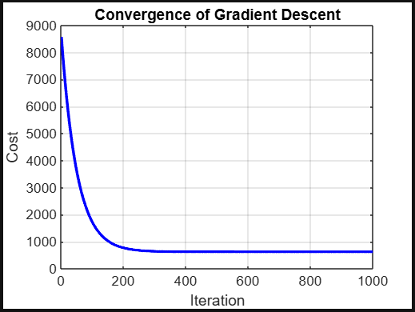

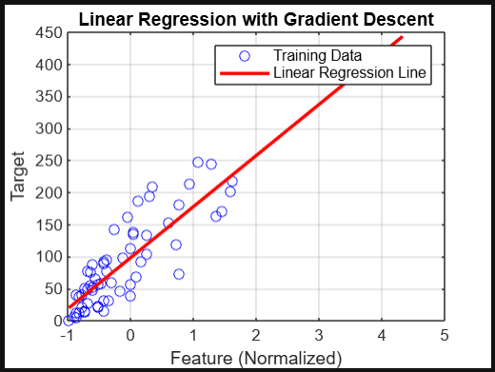

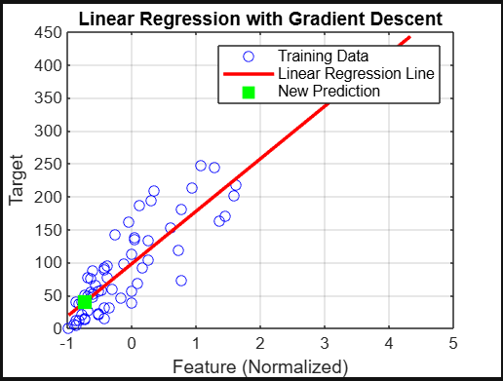For a new input x = **6.00**, the predicted y = **40.48**

**Term Work: 3**

**Name: USN:**

**Simple Linear Regression Analysis**

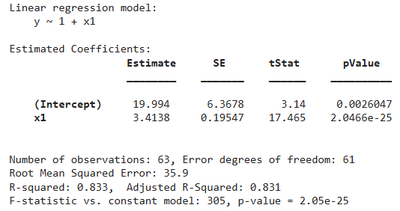

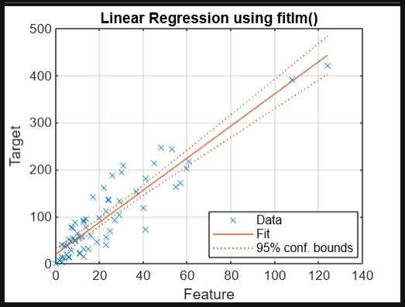

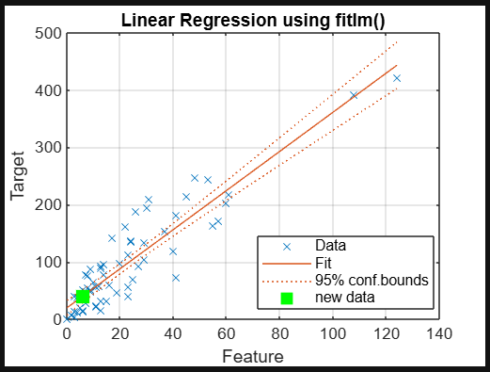Prediction for x = 6.00: y = 40.48

**Term Work: 4**

**Name: USN:**

**Naive Bayes Classifier**

Prediction: Run = Yes

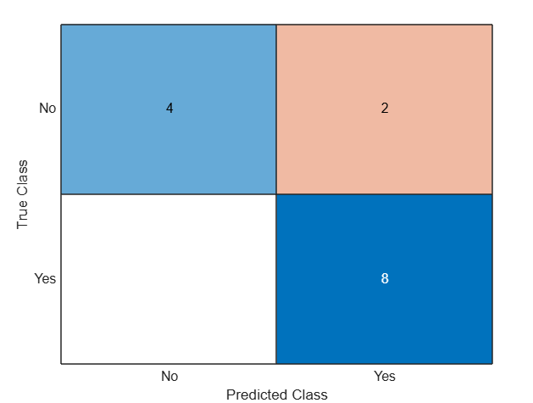

Training Accuracy: 85.71%

**Term Work: 5.1**

**Name: USN:**

**K Mean Clustering**

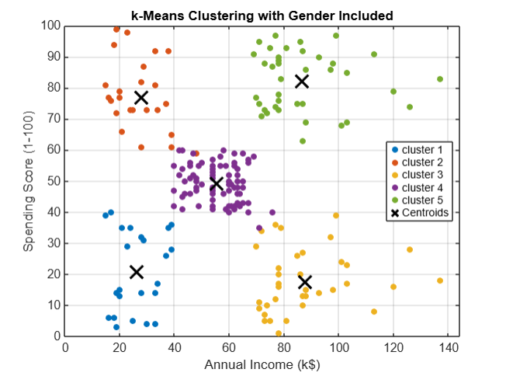

Gender = Female(0), Age = 27, Annual Income = 55k. Spending Score = 60

new_customer = [0, 27, 55, 60];

The new customer is assigned to Cluster : 4.

**Term Work: 5.2**

**Name: USN:**

**Agglomerative Hierarchical Clustering**

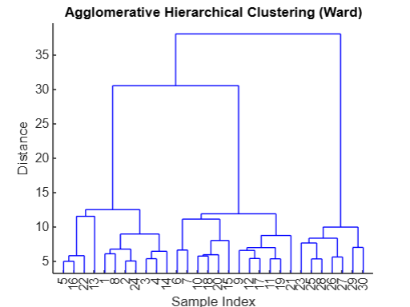

Cophenetic Correlation Coefficient: 0.7089

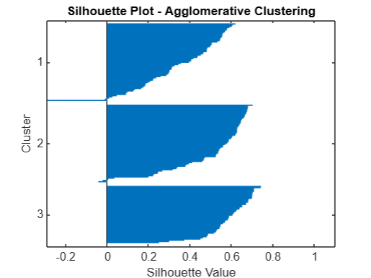

Average Silhouette Score: 0.4725

**Term Work: 5.3**

**Name: USN:**

**Divisive Hierarchical Clustering**

**Term Work: 6**

**Name: USN:**

**Shallow Neural Network**

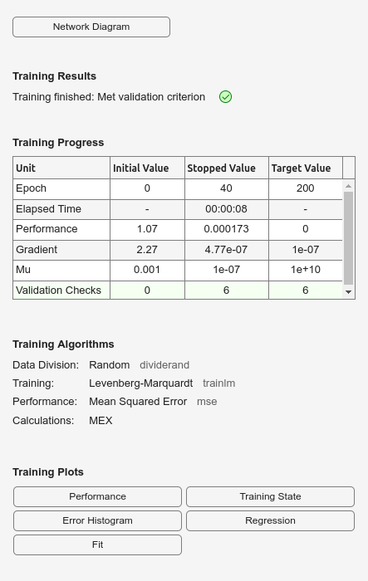

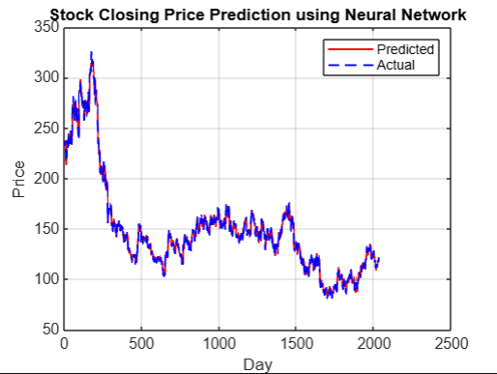

Mean Squared Error (MSE): 0.0002

Root Mean Squared Error (RMSE): 0.0131

RMSE (actual prices): 3.2041

Mean Absolute Error (MAE): 2.2415

R-squared: 0.9957

**Term Work: 7**

**Name: USN:**

**Convolutional Neural Network**

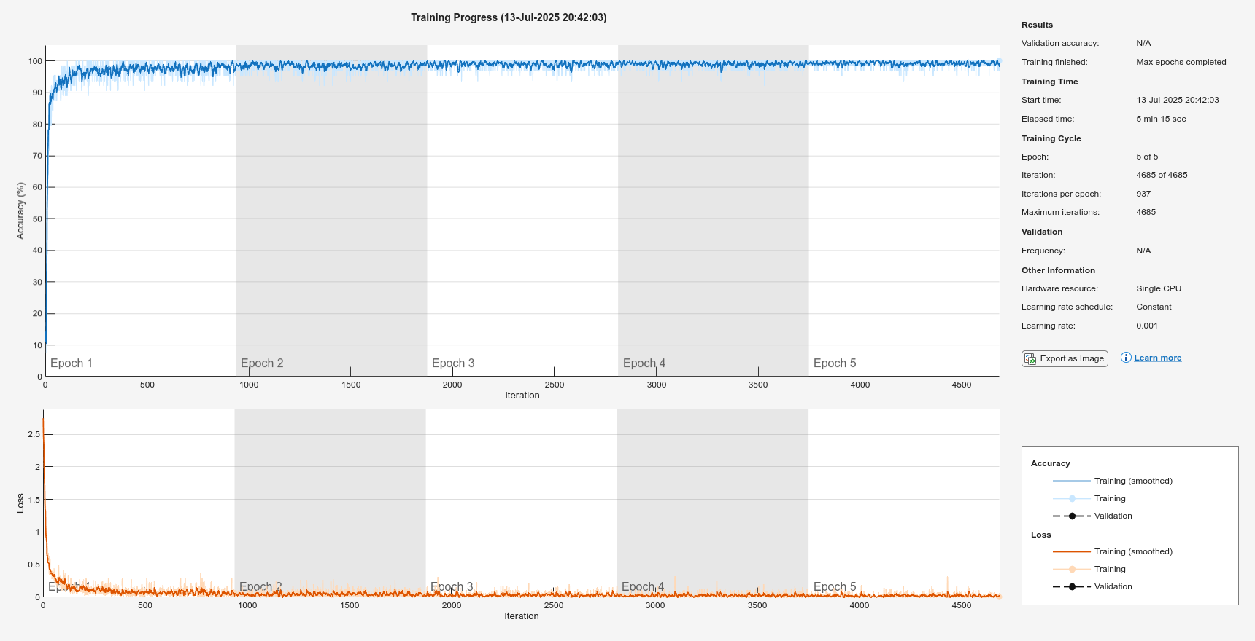

Test Accuracy: 99.00%

