**Termwork: 1**

**Name:** Jeeshan Inamdar **USN:** 2GI22IS018

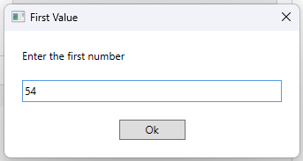

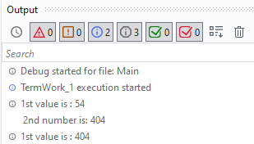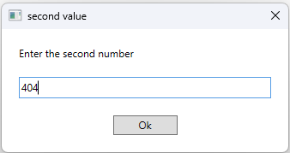

**Termwork: 2**

**Name:** Jeeshan Inamdar **USN:** 2GI22IS018

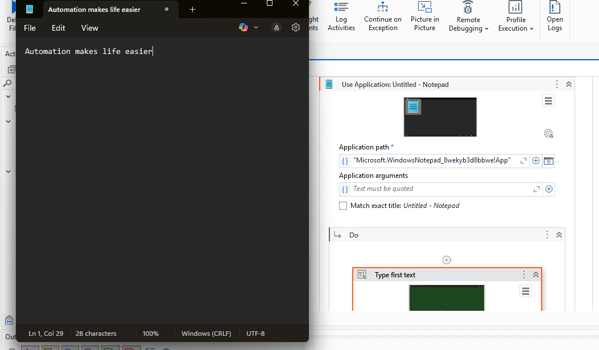

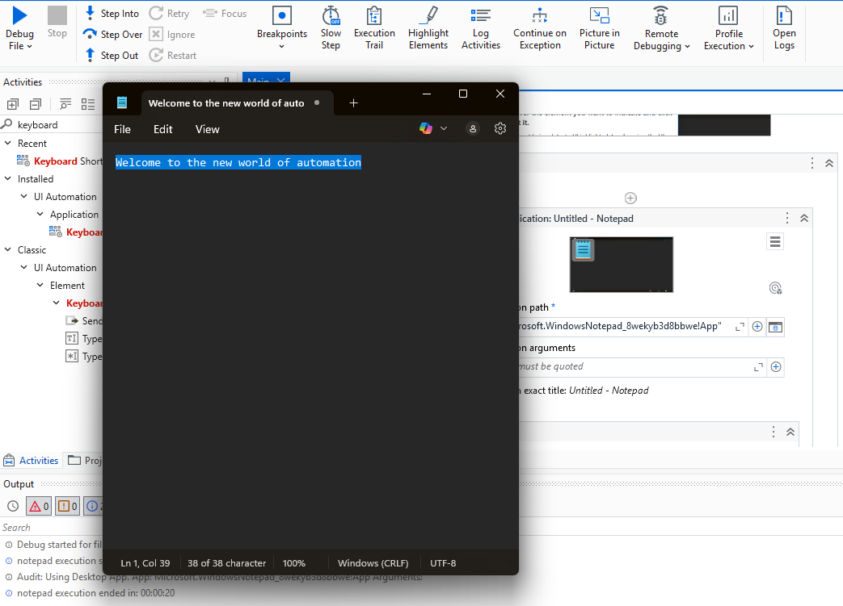

**Termwork: 3.1**

**Name:** Jeeshan Inamdar **USN:** 2GI22IS018

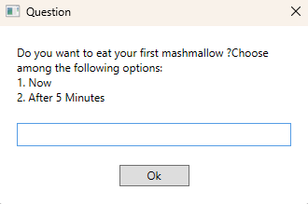

If now :

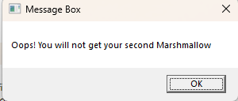

If After 5 minutes :

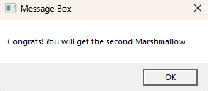

If invalid input :

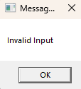

**Termwork: 3.2**

**Name:** Jeeshan Inamdar **USN:** 2GI22IS018

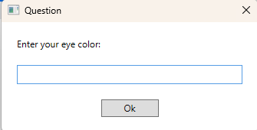

**Case : Blue Case : Green**

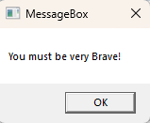 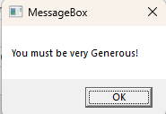

**Case : Gray**  **Case : Black**

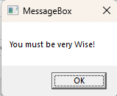 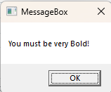

**Case : Invalid Color**

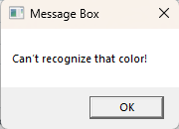

**Termwork: 4.1**

**Name:** Jeeshan Inamdar **USN:** 2GI22IS018

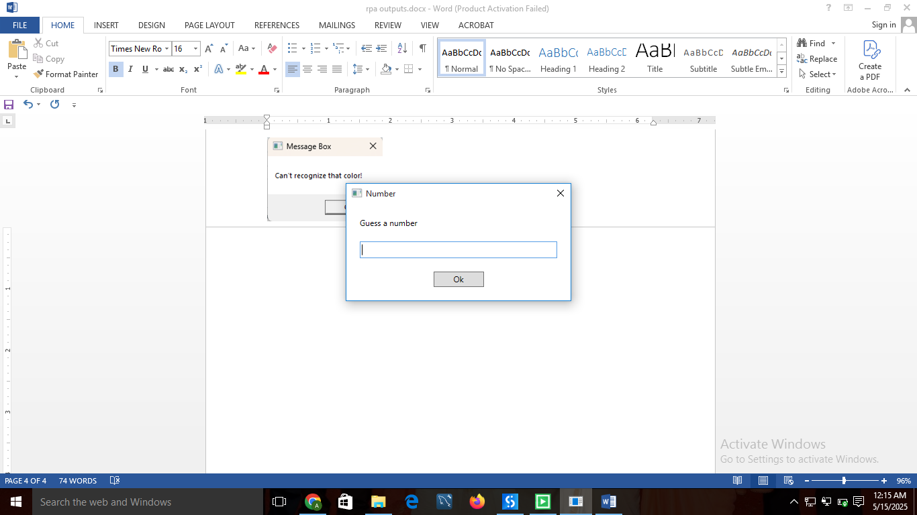

If guessed number < random number

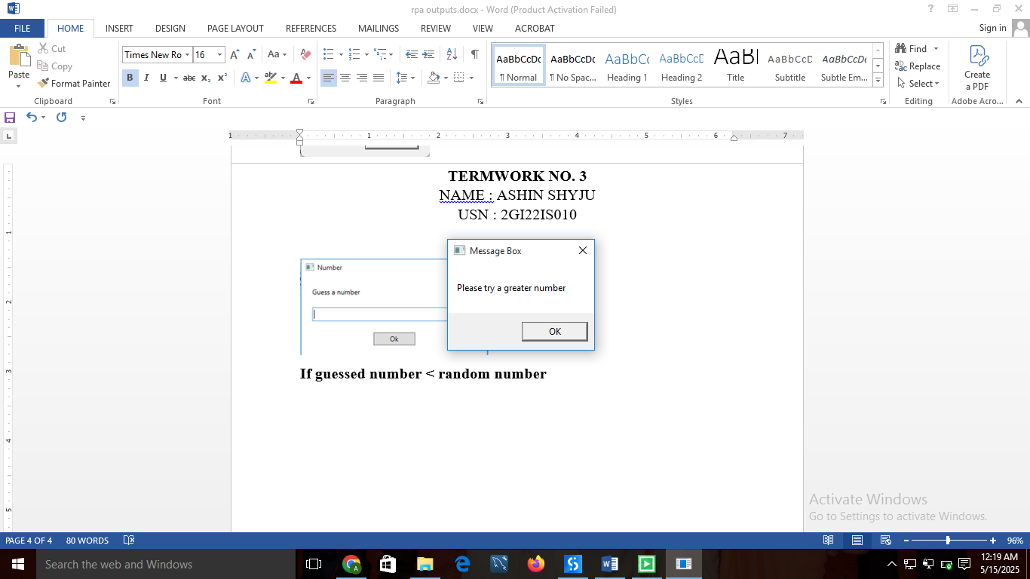

If guessed number > random number

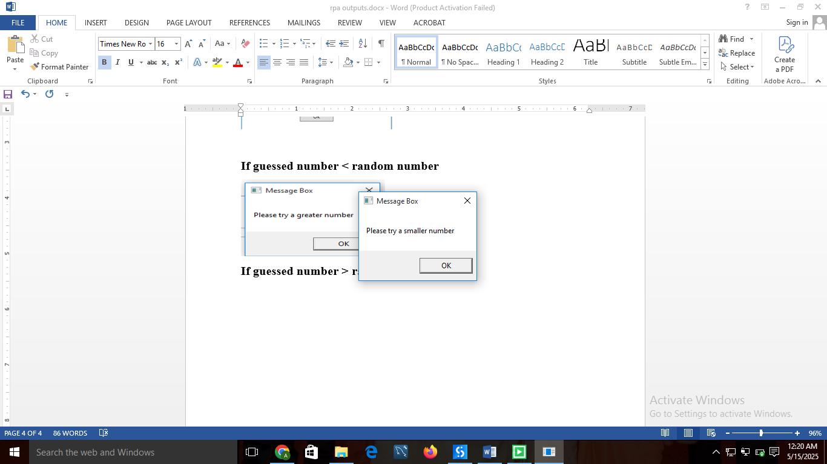

If guessed number = random number

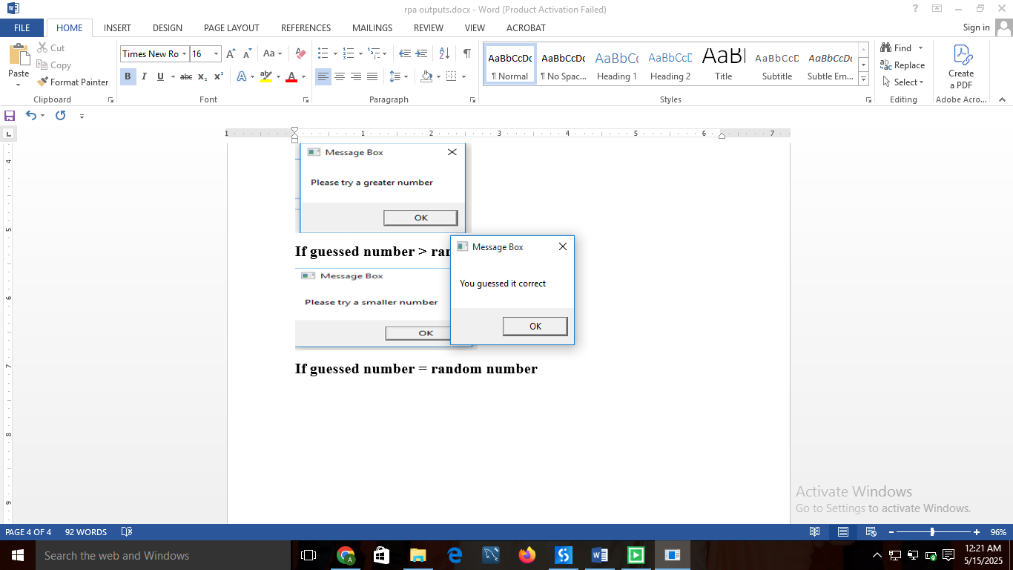

**Termwork: 4.2**

**Name:** Jeeshan Inamdar **USN:** 2GI22IS018

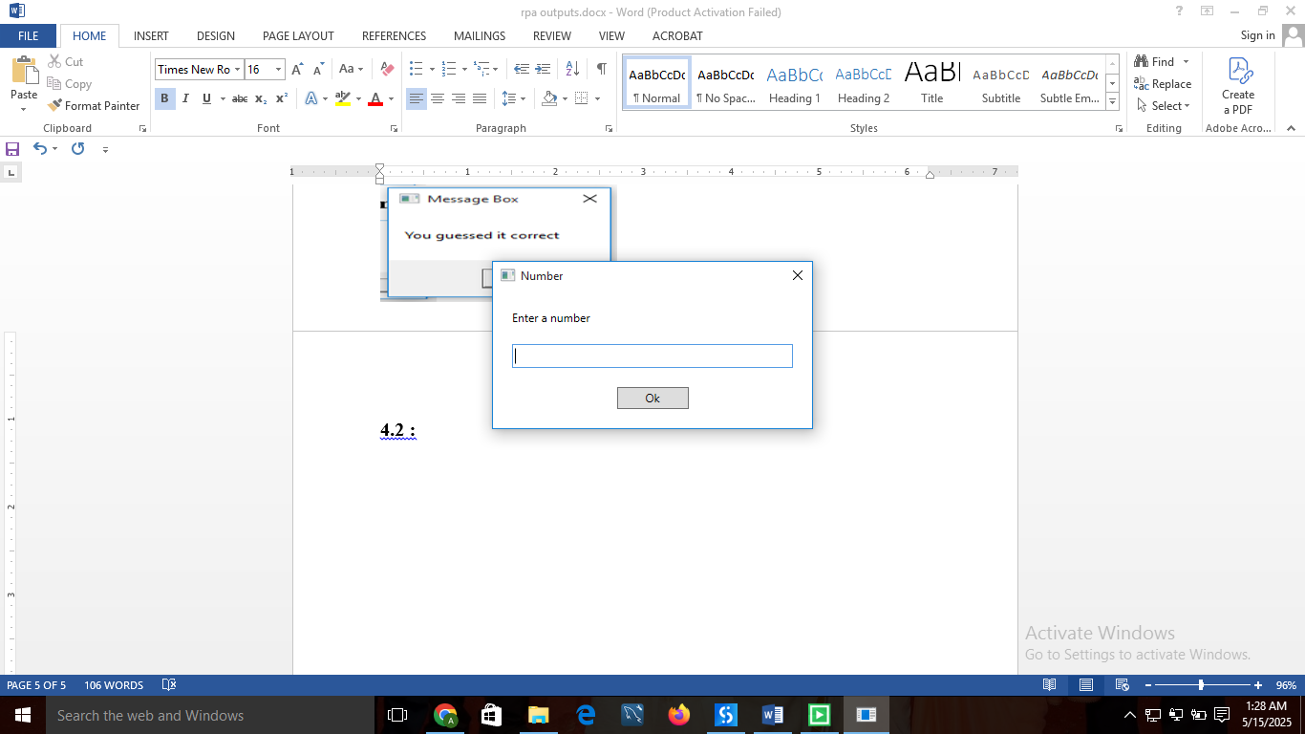

If Prime number entered :

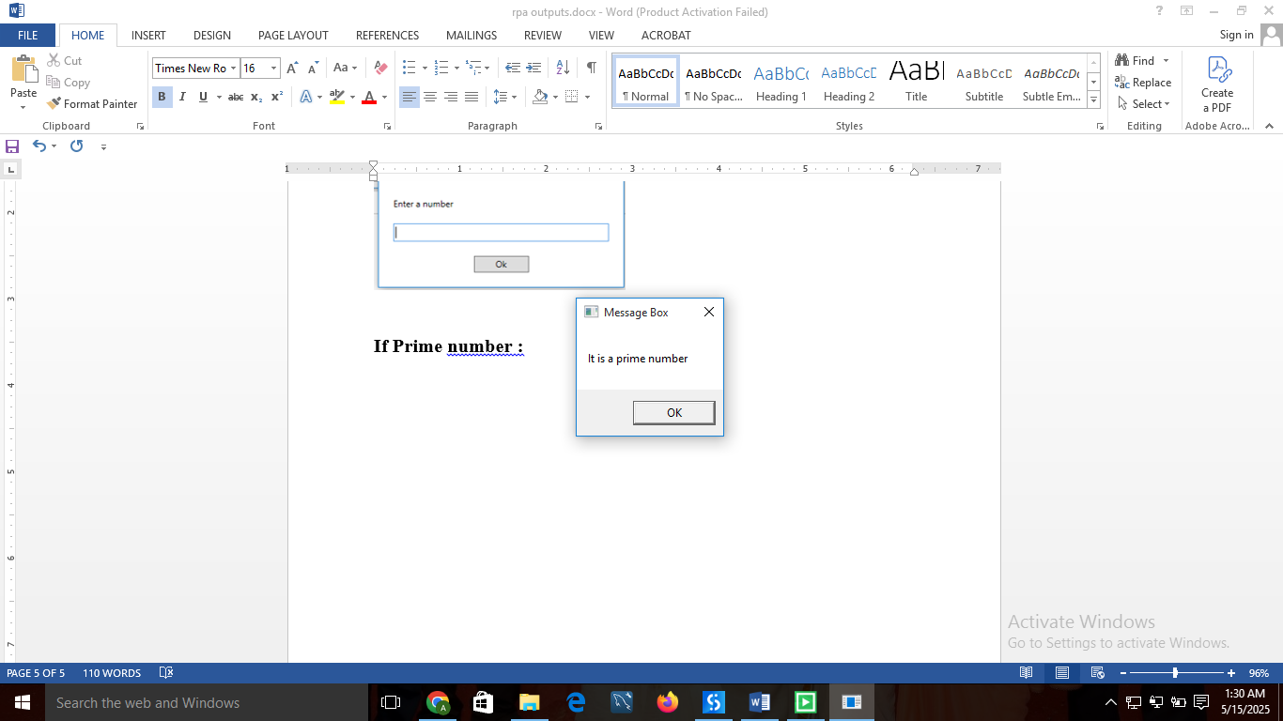

If a prime number is not entered:

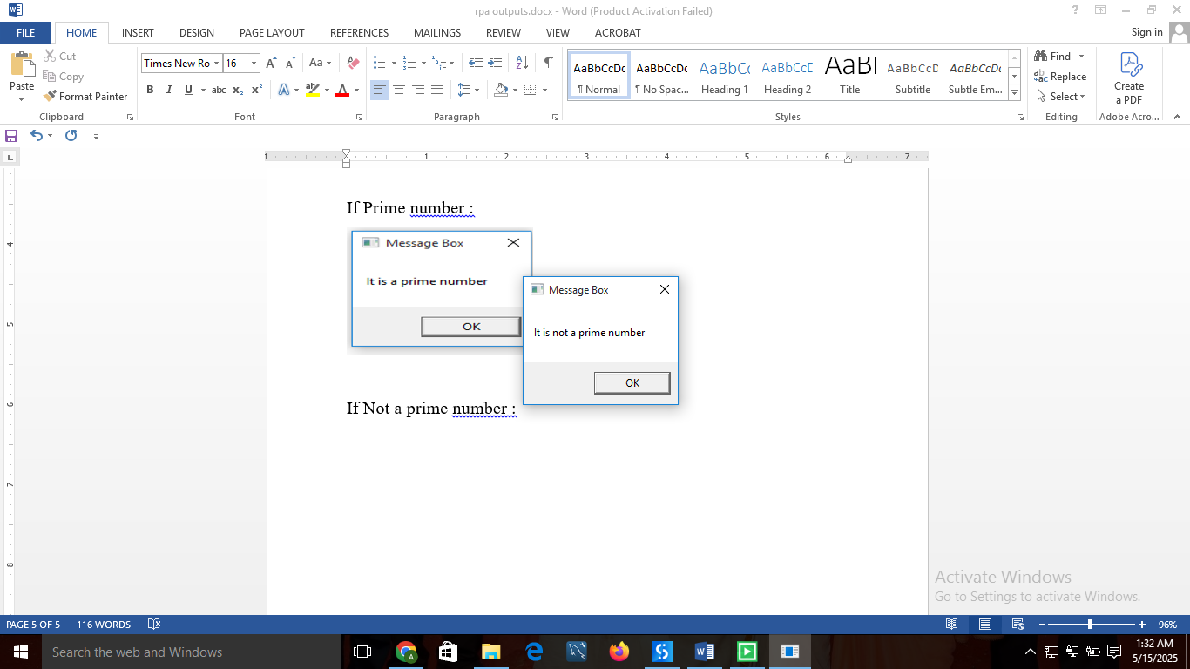

**Termwork: 5**

**Name:** Jeeshan Inamdar **USN:** 2GI22IS018

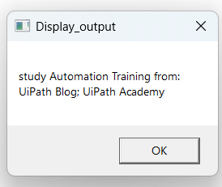

**Termwork: 6**

**Name:** Jeeshan Inamdar **USN:** 2GI22IS018

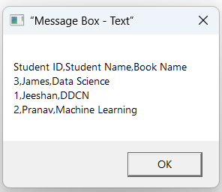

**Termwork: 7**

**Name:** Jeeshan Inamdar **USN:** 2GI22IS018

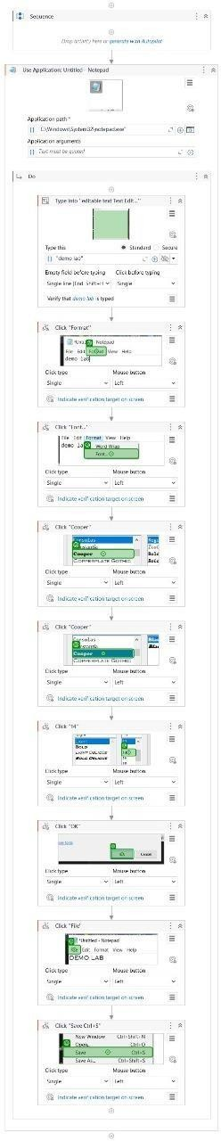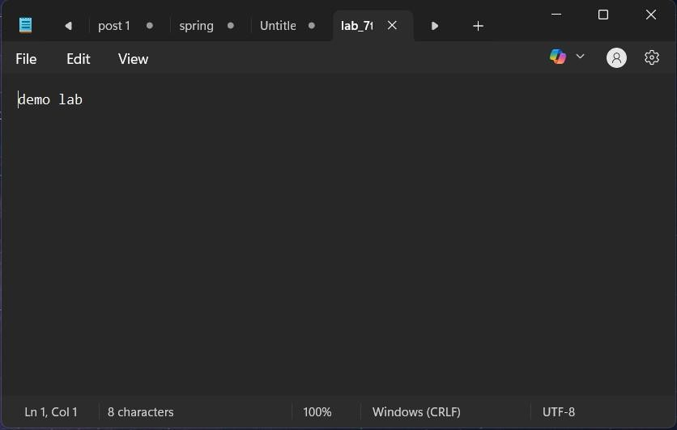

**Term Work 8.1**

**Name:** Jeeshan Inamdar **USN:** 2GI22IS018

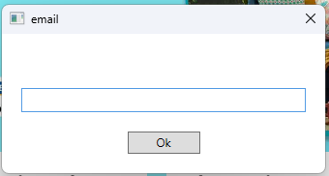

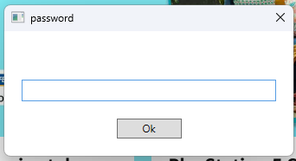

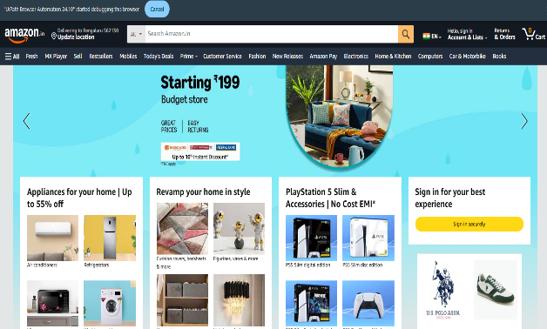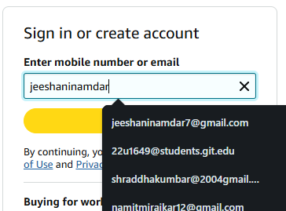

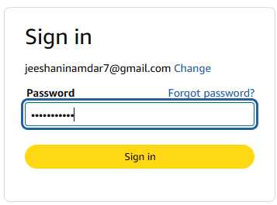

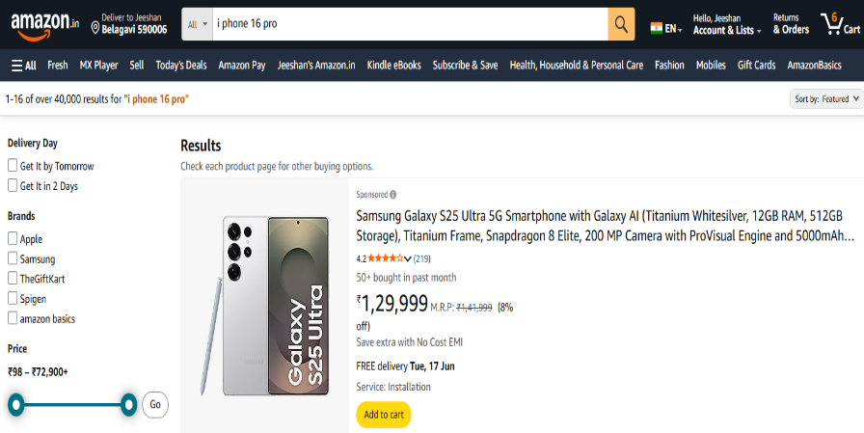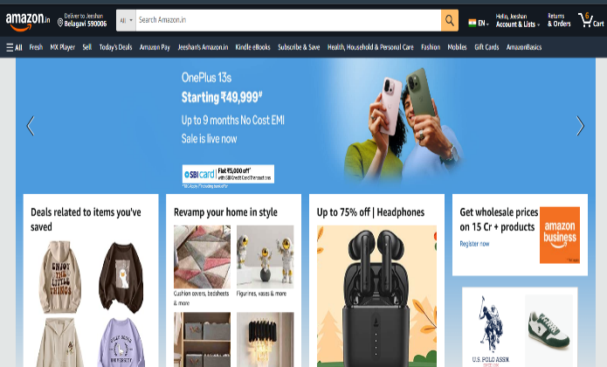

**Term Work 8.2**

**Name:** Jeeshan Inamdar **USN:** 2GI22IS018