CHAPTER 5
SYSTEM DESIGN
The System design is the phase where the system functionality is outlined using the specifications provided in the previous chapters. This system design elaborates the proposed system with the flow diagrams and the block diagrams of the technique used. By using the system design the quality of the software can be predicted. Thus it is one among the critical phases to be carried during the implementation of any project.
The modules and their specifications are also discussed in this chapter. This phase builds the communication between the requirement and the implementation phase.
5.1 DESIGN REQUIREMENTS
The Requirements are determined in light of the craved objectives, the outline objectives are utilized to distinguish the nature of the framework created or executed. The majority of the objectives that are really planned falls under non-functional prerequisites and even the application area take after the same arrangement of criteria. The System outline is the most basic component influencing the nature of the product and has real effect on the later stage, particularly on the testing and upkeep. This is used to identify the modules of the system, specifications and detailed development of these modules that specifies the interaction with each other to produce the desired output. Once the system has been designed all major types, modules and expected output, the specifications for implementing are decided.
This deals with data flow diagram, detailed flow graph, requirement analysis, and the design process of the front end and back end design of the student information management system.

5.1.1 Dataflow Diagram

A Data Flow Diagram (DFD) is a graphical representation of the flow of “Online College Portal”. A data Flow diagram can also be used for the visualization of Data Processing.DFD shows the interaction between the system and outside entities. This context-level DFD is then “exploded” to show more detail of the system being modelled. A DFD represents flow of data through a system. Data flow diagrams are commonly used during problem analysis. It views a system as function that transforms the given input into required output. Movement of data through the different transformations or processes in the system is shown in Data Flow Diagram.
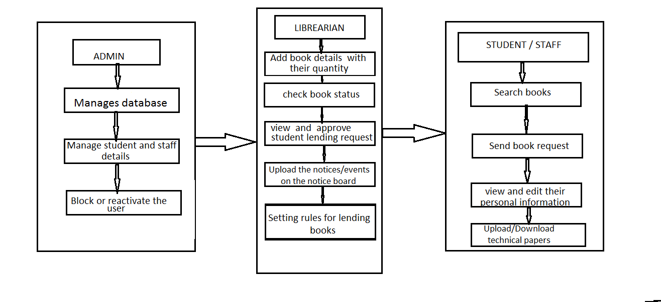
Figure 5.1: Illustrating Data Flow Overview.

5.1.2 Use Case Diagram
The use case diagram depicts the essential functionality and actors of the application namely admin, student and staff .
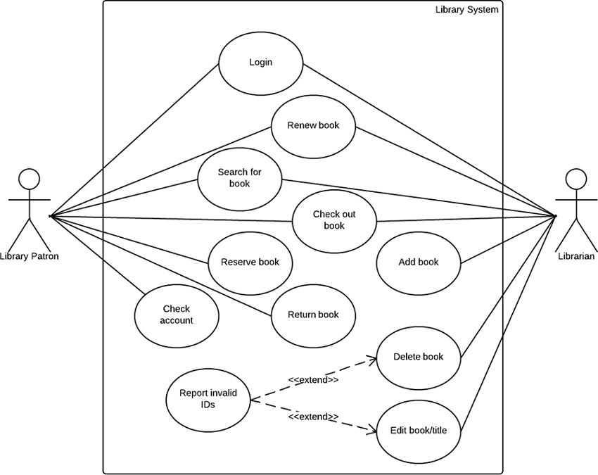
Figure 5.4 Use Case Diagram

5.2 ARCHITECTURAL DESIGN
The Architecture Design describing the different modules in the project is as shown below. There can be four kinds of users student, staff, library staff and admin. Each one can login either through mobile or desktop application. Once the login credentials are done, one can find the different modules as shown in the figure.

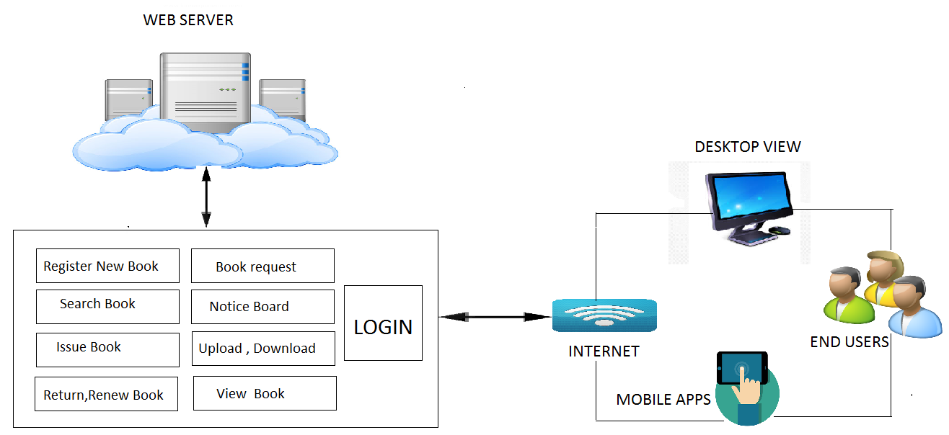
Figure 5.2 Illustrating Architectural Design

