**TDD USING Junit5 AND MOCKITO**

**Exercise 1: Mocking and Stubbing**

**Scenario:**

You need to test a service that depends on an external API. Use Mockito to mock the

external API and stub its methods.

**Steps:**

1. Create a mock object for the external API.

2. Stub the methods to return predefined values.

3. Write a test case that uses the mock object.

**Solution Code:**

import static org.mockito.Mockito.*;

import org.junit.jupiter.api.Test;

import org.mockito.Mockito;

public class MyServiceTest {

@Test

public void testExternalApi() {

ExternalApi mockApi = Mockito.mock(ExternalApi.class);

when(mockApi.getData()).thenReturn("Mock Data");

MyService service = new MyService(mockApi);

String result = service.fetchData();

assertEquals("Mock Data", result);

}

}

**FOLDER STRUCTURE**

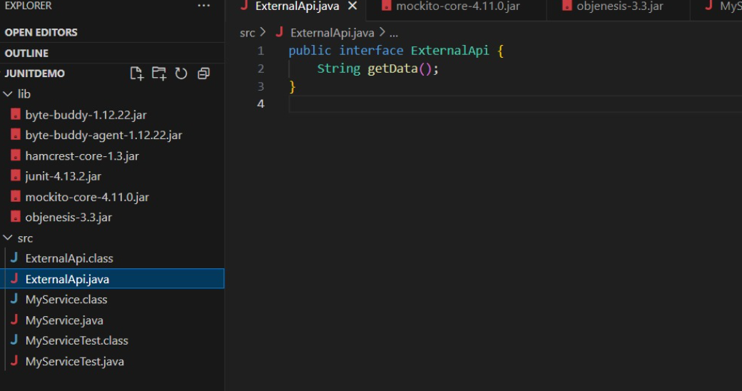 **PROGRAM**

**ExternalAPI.java**

public interface ExternalApi {

String getData();

}

**MyService.java**

public class MyService {

private ExternalApi api;

public MyService(ExternalApi api) {

this.api = api;

}

public String fetchData() {

return api.getData();

}

}

**MyServiceTest.java**

import static org.mockito.Mockito.*;

import static org.junit.jupiter.api.Assertions.*;

import org.junit.jupiter.api.Test;

import org.mockito.Mockito;

public class MyServiceTest {

@Test

public void testExternalApi() {

// Step 1: Create mock object

ExternalApi mockApi = Mockito.mock(ExternalApi.class);

// Step 2: Stub the getData() method

when(mockApi.getData()).thenReturn("Mock Data");

// Step 3: Inject mock into service and test

MyService service = new MyService(mockApi);

String result = service.fetchData();

// Step 4: Assert the result

assertEquals("Mock Data", result);

}

}

**OUTPUT**

