**TDD USING Junit5 AND MOCKITO**

**Exercise 2: Verifying Interactions**

**Scenario:**

You need to ensure that a method is called with specific arguments.

**Steps:**

1. Create a mock object.

2. Call the method with specific arguments.

3. Verify the interaction.

**Solution Code:**

import static org.mockito.Mockito.*; import org.junit.jupiter.api.Test;

import org.mockito.Mockito;

public class MyServiceTest {

@Test

public void testVerifyInteraction() {

ExternalApi mockApi = Mockito.mock(ExternalApi.class);

MyService service = new MyService(mockApi);

service.fetchData();

verify(mockApi).getData();

}

}

**FOLDER STRUCTURE**

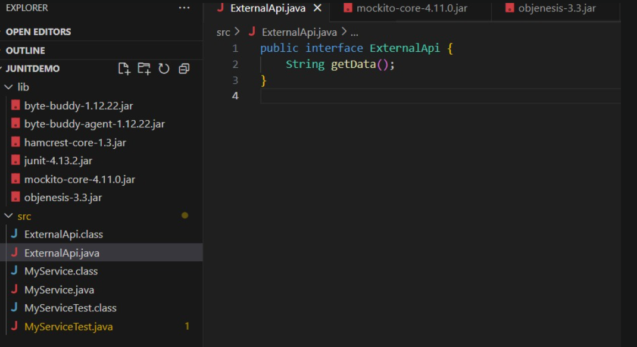 **PROGRAM**

**ExternalApi.java**

public interface ExternalApi {

String getData();

}

**MyService.java**

public class MyService {

private ExternalApi api;

public MyService(ExternalApi api) {

this.api = api;

}

public String fetchData() {

// Calling the external API

return api.getData();

}

}

**MyServiceTest.java**

import static org.mockito.Mockito.*;

import static org.junit.Assert.*;

import org.junit.Test;

import org.mockito.Mockito;

public class MyServiceTest {

@Test

public void testVerifyInteraction() {

// Step 1: Create mock object

ExternalApi mockApi = Mockito.mock(ExternalApi.class);

// Step 2: Pass mock to service

MyService service = new MyService(mockApi);

// Step 3: Call method

service.fetchData();

// Step 4: Verify interaction

verify(mockApi).getData();

}

}

**OUTPUT**

