**PL SQL PROGRAMMING**

**Exercise 1: Control Structures**

**Scenario 1: The bank wants to apply a discount to loan interest rates for customers above 60 years old.**

* + **Question: Write a PL/SQL block that loops through all customers, checks their age, and if they are above 60, apply a 1% discount to their current loan interest rates.**

**QUERY**BEGIN

FOR rec IN (

SELECT c.CustomerID, c.Name, c.DOB, l.LoanID, l.InterestRate

FROM Customers c

JOIN Loans l ON c.CustomerID = l.CustomerID

WHERE MONTHS_BETWEEN(SYSDATE, c.DOB)/12 > 60

) LOOP

UPDATE Loans

SET InterestRate = InterestRate - 1

WHERE LoanID = rec.LoanID;

DBMS_OUTPUT.PUT_LINE('Discount aaplied to Loan ID: ' || rec.LoanID || ' of Customer: '

|| rec.Name);

END LOOP;

END;

/

**OUTPUT:**

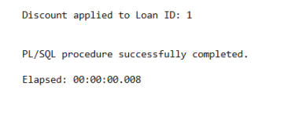

**Scenario 2: A customer can be promoted to VIP status based on their balance.**

* + **Question: Write a PL/SQL block that iterates through all customers and sets a flag IsVIP to TRUE for those with a balance over $10,000.**

**QUERY**

BEGIN

FOR rec IN (

SELECT CustomerID, Balance

FROM Customers

WHERE Balance > 10000

) LOOP

UPDATE Customers

SET IsVIP = 'TRUE'

WHERE CustomerID = rec.CustomerID;

DBMS_OUTPUT.PUT_LINE('Customer ID ' || rec.CustomerID || ' promoted to VIP.');

END LOOP;

END;

**OUTPUT**

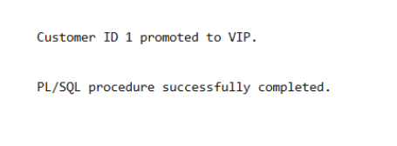

**Scenario 3: The bank wants to send reminders to customers whose loans are due within the next 30 days.**

* + **Question: Write a PL/SQL block that fetches all loans due in the next 30 days and prints a reminder message for each customer.**

**QUERY**

BEGIN

FOR rec IN (

SELECT l.LoanID, l.CustomerID, c.Name, l.EndDate

FROM Loans l

JOIN Customers c ON l.CustomerID = c.CustomerID

WHERE l.EndDate <= SYSDATE + 30

) LOOP

DBMS_OUTPUT.PUT_LINE('Reminder: Dear ' || rec.Name ||

', your Loan ID ' || rec.LoanID ||

' is due on ' || TO_CHAR(rec.EndDate, 'DD-MON-YYYY') ||

'. Please make the necessary arrangements.');

END LOOP;

END;

/

**OUTPUT**

