**TDD USING Junit5 AND MOCKITO**

**Exercise 1: Setting Up JUnit**

**Scenario:**

You need to set up JUnit in your Java project to start writing unit tests.

Steps:

1. Create a new Java project in your IDE (e.g., IntelliJ IDEA, Eclipse).

2. Add JUnit dependency to your project. If you are using Maven, add the following to your

pom.xml:

<dependency>

<groupId>junit</groupId>

<artifactId>junit</artifactId>

<version>4.13.2</version>

<scope>test</scope>

</dependency>

**3. Create a new test class in your project**

**FOLDER STRUCTURE**

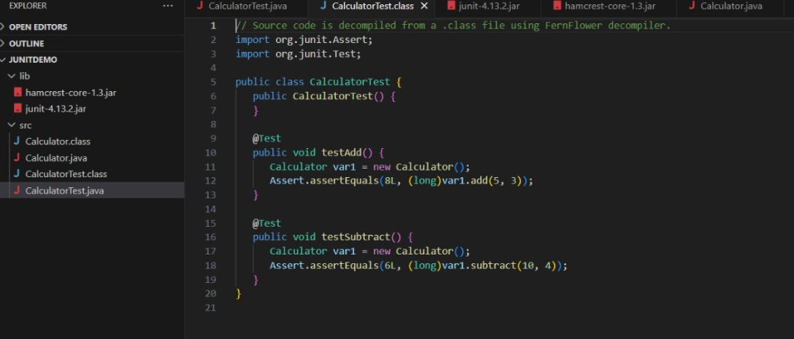

**PROGRAM**

**Calculator.java**

public class Calculator {

public int add(int a, int b) {

return a + b;

}

public int subtract(int a, int b) {

return a - b;

}

}

**CalculatorTest.java**

import org.junit.Test;

import static org.junit.Assert.assertEquals;

public class CalculatorTest {

@Test

public void testAdd() {

Calculator calc = new Calculator();

assertEquals(8, calc.add(5, 3));

}

@Test

public void testSubtract() {

Calculator calc = new Calculator();

assertEquals(6, calc.subtract(10, 4));

}

}

**OUTPUT**

