**TDD USING Junit5 AND MOCKITO**

**Exercise 3: Assertions in JUnit**

**Scenario:**

You need to use different assertions in JUnit to validate your test results.

**Steps: 1.** Write tests using various JUnit assertions.

Solution Code:

public class AssertionsTest {

@Test

public void testAssertions() {

// Assert equals

assertEquals(5, 2 + 3);

// Assert true

assertTrue(5 > 3);

// Assert false

assertFalse(5 < 3);

// Assert null

assertNull(null);

// Assert not null

assertNotNull(new Object());

}

}

**FOLDER STRUCTURE**

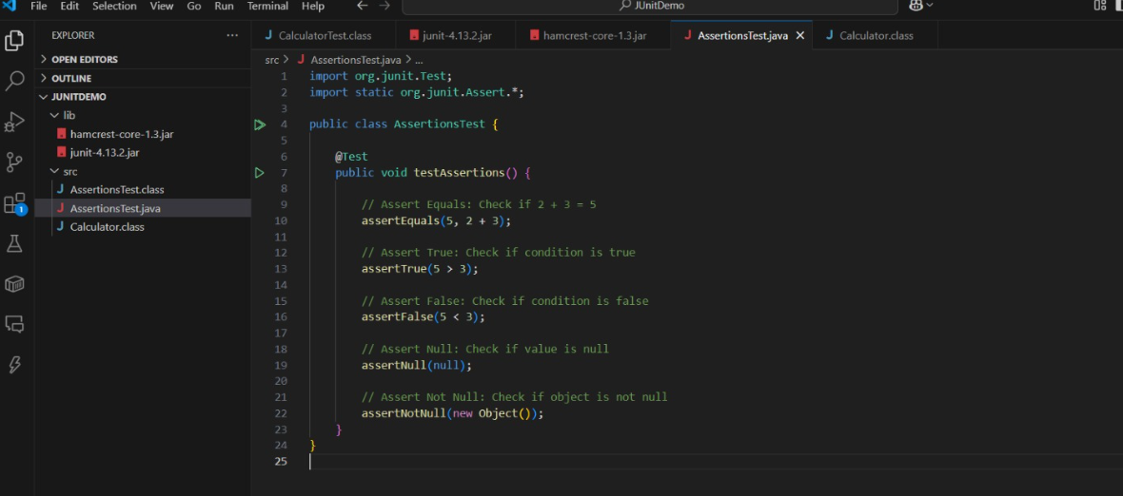

**PROGRAM**

**AssertionsTest.java**

import org.junit.Test;

import static org.junit.Assert.*;

public class AssertionsTest {

@Test

public void testAssertions() {

// Assert Equals: Check if 2 + 3 = 5

assertEquals(5, 2 + 3);

// Assert True: Check if condition is true

assertTrue(5 > 3);

// Assert False: Check if condition is false

assertFalse(5 < 3);

// Assert Null: Check if value is null

assertNull(null);

// Assert Not Null: Check if object is not null

assertNotNull(new Object());

}

}

**OUTPUT**

