**SPRING CORE MAVEN**

**Exercise 2: Implementing Dependency Injection**

**Scenario:**

In the library management application, you need to manage the dependencies between the BookService and BookRepository classes using Spring's IoC and DI.

**Steps:**

1. **Modify the XML Configuration:**
   * Update applicationContext.xml to wire BookRepository into BookService.
2. **Update the BookService Class:**
   * Ensure that BookService class has a setter method for BookRepository.
3. **Test the Configuration:**
   * Run the LibraryManagementApplication main class to verify the dependency injection.

**FOLDER STRUCTURE:**

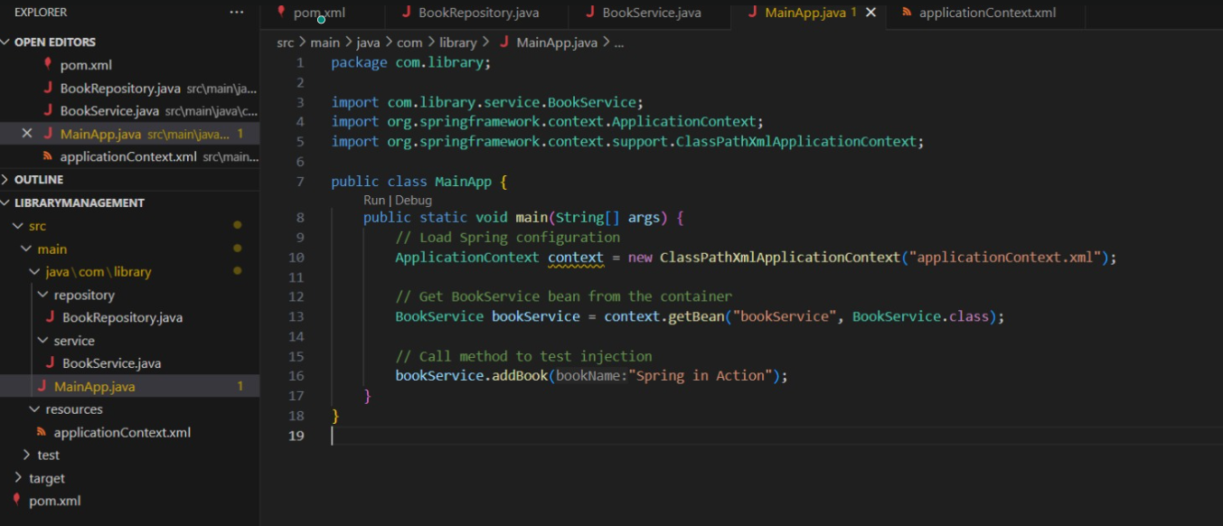

**PROGRAM:**

**applicationContext.xml**

<?xml version="1.0" encoding="UTF-8"?>

<beans xmlns="http://www.springframework.org/schema/beans"

xmlns:xsi="http://www.w3.org/2001/XMLSchema-instance"

xsi:schemaLocation="

http://www.springframework.org/schema/beans

http://www.springframework.org/schema/beans/spring-beans.xsd">

<!-- Define BookRepository bean -->

<bean id="bookRepository" class="com.library.repository.BookRepository" />

<!-- Define BookService bean and inject BookRepository -->

<bean id="bookService" class="com.library.service.BookService">

<property name="bookRepository" ref="bookRepository" />

</bean>

</beans>

**BookService.java**

package com.library.service;

import com.library.repository.BookRepository;

public class BookService {

private BookRepository bookRepository;

//Setter-based Dependency Injection

public void setBookRepository(BookRepository bookRepository) {

this.bookRepository = bookRepository;

}

public void addBook(String bookName) {

bookRepository.save(bookName);

System.out.println("BookService: Book '" + bookName + "' added.");

}

}

**MainApp.java**

package com.library;

import com.library.service.BookService;

import org.springframework.context.ApplicationContext;

import org.springframework.context.support.ClassPathXmlApplicationContext;

public class MainApp {

public static void main(String[] args) {

// Load Spring configuration

ApplicationContext context = new ClassPathXmlApplicationContext("applicationContext.xml");

// Get BookService bean from the container

BookService bookService = context.getBean("bookService", BookService.class);

// Call method to test injection

bookService.addBook("Spring in Action");

}

}

**BookRepository.java**

package com.library.repository;

public class BookRepository {

public void save(String bookName) {

System.out.println("Book '" + bookName + "' has been saved to the database.");

}

}

**pom.xml**

<project xmlns="http://maven.apache.org/POM/4.0.0"

xmlns:xsi="http://www.w3.org/2001/XMLSchema-instance"

xsi:schemaLocation="http://maven.apache.org/POM/4.0.0

http://maven.apache.org/xsd/maven-4.0.0.xsd">

<modelVersion>4.0.0</modelVersion>

<groupId>com.library</groupId>

<artifactId>LibraryManagement</artifactId>

<version>1.0-SNAPSHOT</version>

<dependencies>

<!-- Spring Core -->

<dependency>

<groupId>org.springframework</groupId>

<artifactId>spring-context</artifactId>

<version>5.3.31</version>

</dependency>

</dependencies>

</project>

**OUTPUT:**

