**SPRING CORE MAVEN**

**Exercise 4: Creating and Configuring a Maven Project**

**Scenario:**

You need to set up a new Maven project for the library management application and add Spring dependencies.

**Steps:**

1. **Create a New Maven Project:**
   * Create a new Maven project named LibraryManagement.
2. **Add Spring Dependencies in pom.xml:**
   * Include dependencies for Spring Context, Spring AOP, and Spring WebMVC.
3. **Configure Maven Plugins:**
   * Configure the Maven Compiler Plugin for Java version 1.8 in the pom.xml file.

**FOLDER STRUCTURE:**

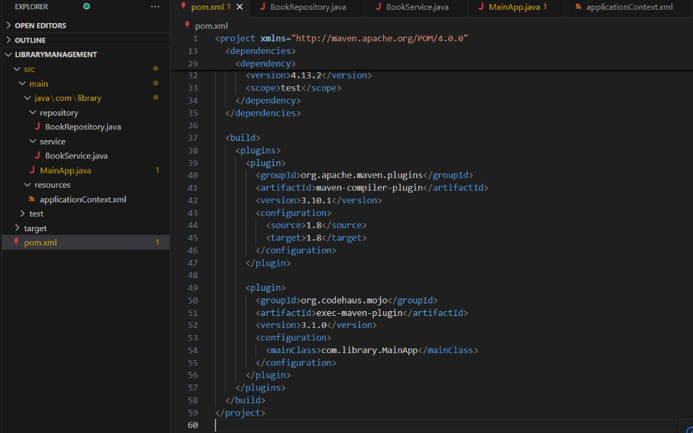

**PROGRAM:**

**pom.xml**

<project xmlns="http://maven.apache.org/POM/4.0.0"

xmlns:xsi="http://www.w3.org/2001/XMLSchema-instance"

xsi:schemaLocation="http://maven.apache.org/POM/4.0.0

http://maven.apache.org/xsd/maven-4.0.0.xsd">

<modelVersion>4.0.0</modelVersion>

<groupId>com.library</groupId>

<artifactId>LibraryManagement</artifactId>

<version>1.0-SNAPSHOT</version>

<packaging>jar</packaging>

<name>LibraryManagement</name>

<dependencies>

<dependency>

<groupId>org.springframework</groupId>

<artifactId>spring-context</artifactId>

<version>5.3.31</version>

</dependency>

<dependency>

<groupId>org.springframework</groupId>

<artifactId>spring-aop</artifactId>

<version>5.3.31</version>

</dependency>

<dependency>

<groupId>org.springframework</groupId>

<artifactId>spring-webmvc</artifactId>

<version>5.3.31</version>

</dependency>

<dependency>

<groupId>junit</groupId>

<artifactId>junit</artifactId>

<version>4.13.2</version>

<scope>test</scope>

</dependency>

</dependencies>

<build>

<plugins>

<plugin>

<groupId>org.apache.maven.plugins</groupId>

<artifactId>maven-compiler-plugin</artifactId>

<version>3.10.1</version>

<configuration>

<source>1.8</source>

<target>1.8</target>

</configuration>

</plugin>

<plugin>

<groupId>org.codehaus.mojo</groupId>

<artifactId>exec-maven-plugin</artifactId>

<version>3.1.0</version>

<configuration>

<mainClass>com.library.MainApp</mainClass>

</configuration>

</plugin>

</plugins>

</build>

</project>

**applicationContext.xml**

<?xml version="1.0" encoding="UTF-8"?>

<beans xmlns="http://www.springframework.org/schema/beans"

xmlns:xsi="http://www.w3.org/2001/XMLSchema-instance"

xsi:schemaLocation="

http://www.springframework.org/schema/beans

http://www.springframework.org/schema/beans/spring-beans.xsd">

<!-- Define BookRepository bean -->

<bean id="bookRepository" class="com.library.repository.BookRepository" />

<!-- Define BookService bean and inject BookRepository -->

<bean id="bookService" class="com.library.service.BookService">

<property name="bookRepository" ref="bookRepository" />

</bean>

</beans>

**BookService.java**

package com.library.service;

import com.library.repository.BookRepository;

public class BookService {

private BookRepository bookRepository;

//Setter-based Dependency Injection

public void setBookRepository(BookRepository bookRepository) {

this.bookRepository = bookRepository;

}

public void addBook(String bookName) {

bookRepository.save(bookName);

System.out.println("BookService: Book '" + bookName + "' added.");

}

}

**MainApp.java**

package com.library;

import com.library.service.BookService;

import org.springframework.context.ApplicationContext;

import org.springframework.context.support.ClassPathXmlApplicationContext;

public class MainApp {

public static void main(String[] args) {

// Load Spring configuration

ApplicationContext context = new ClassPathXmlApplicationContext("applicationContext.xml");

// Get BookService bean from the container

BookService bookService = context.getBean("bookService", BookService.class);

// Call method to test injection

bookService.addBook("Spring in Action");

}

}

**BookRepository.java**

package com.library.repository;

public class BookRepository {

public void save(String bookName) {

System.out.println("Book '" + bookName + "' has been saved to the database.");

}

}

**OUTPUT:**

