**SPRING REST USING SPRING BOOT 3**

**Create a Spring Web Project using Maven**

**FOLDER STRUCTURE:**

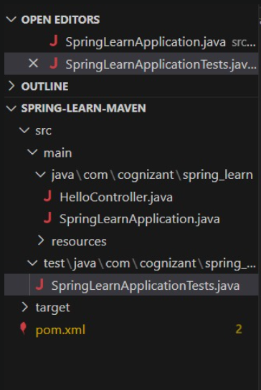

**PROGRAM:**

**src/main/java/com/cognizant/spring_learn/SpringLearnApplication.java**

package com.cognizant.spring_learn;

import org.springframework.boot.SpringApplication;

import org.springframework.boot.autoconfigure.SpringBootApplication;

@SpringBootApplication

public class SpringLearnApplication {

public static void main(String[] args) {

SpringApplication.run(SpringLearnApplication.class, args);

}

}

**src/test/java/com/cognizant/spring_learn/SpringLearnApplicationTests.java**

package com.cognizant.spring_learn;

import org.junit.jupiter.api.Test;

import org.springframework.boot.test.context.SpringBootTest;

@SpringBootTest(classes = SpringLearnApplication.class)

class SpringLearnApplicationTests {

@Test

void contextLoads() {

}

**pom.xml**

<?xml version="1.0" encoding="UTF-8"?>

<project xmlns="http://maven.apache.org/POM/4.0.0" xmlns:xsi="http://www.w3.org/2001/XMLSchema-instance"

         xsi:schemaLocation="http://maven.apache.org/POM/4.0.0 https://maven.apache.org/xsd/maven-4.0.0.xsd">

    <modelVersion>4.0.0</modelVersion>

    <parent>

        <groupId>org.springframework.boot</groupId>

        <artifactId>spring-boot-starter-parent</artifactId>

        <version>3.2.0</version>

        <relativePath/>

    </parent>

    <groupId>com.cognizant</groupId>

    <artifactId>spring-learn</artifactId>

    <version>0.0.1-SNAPSHOT</version>

    <name>spring-learn</name>

    <description>Spring Learn Hands-on</description>

    <properties>

        <java.version>17</java.version>

    </properties>

    <dependencies>

        <dependency>

            <groupId>org.springframework.boot</groupId>

            <artifactId>spring-boot-starter-web</artifactId>

        </dependency>

        <dependency>

            <groupId>org.springframework.boot</groupId>

            <artifactId>spring-boot-devtools</artifactId>

            <scope>runtime</scope>

            <optional>true</optional>

        </dependency>

        <dependency>

            <groupId>org.springframework.boot</groupId>

            <artifactId>spring-boot-starter-test</artifactId>

            <scope>test</scope>

        </dependency>

    </dependencies>

    <build>

        <plugins>

    <plugin>

        <groupId>org.codehaus.mojo</groupId>

        <artifactId>exec-maven-plugin</artifactId>

        <version>3.1.0</version>

        <configuration>

            <mainClass>com.cognizant.springlearn.SpringLearnApplication</mainClass>

        </configuration>

    </plugin>

</plugins>

    </build>

</project>

**OUTPUT:**

