**SPRING REST USING SPRING BOOT 3**

**Hello World RESTful Web Service**Write a REST service in the spring learn application created earlier, that returns the text "Hello World!!" using Spring Web Framework. Refer details below:  
  
Method: GET  
URL: /hello  
Controller: com.cognizant.spring-learn.controller.HelloController  
Method Signature: public String sayHello()  
Method Implementation: return hard coded string "Hello World!!"  
Sample Request: http://localhost:8083/hello  
Sample Response: Hello World!!   
  
IMPORTANT NOTE: Don't forget to include start and end log in the sayHello() method.  
  
Try the URL http://localhost:8083/hello in both chrome browser and postman.  
  
SME to explain the following aspects:

* In network tab of developer tools show the HTTP header details received
* In postman click on "Headers" tab to view the HTTP header details received

**FOLDER STRUCTURE:**

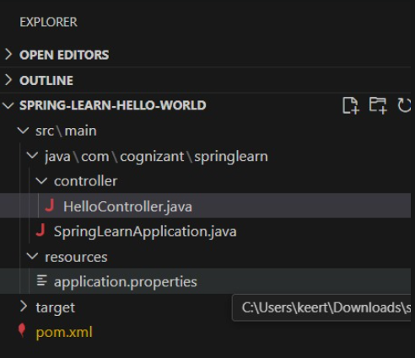

**PROGRAM:**

**HelloController.java**

package com.cognizant.springlearn.controller;

import org.slf4j.Logger;

import org.slf4j.LoggerFactory;

import org.springframework.web.bind.annotation.GetMapping;

import org.springframework.web.bind.annotation.RestController;

@RestController

public class HelloController {

private static final Logger LOGGER = LoggerFactory.getLogger(HelloController.class);

@GetMapping("/hello")

public String sayHello() {

LOGGER.debug("START");

String response = "Hello World!!";

LOGGER.debug("END");

return response;

}

}

**Web.xml**

<web-app xmlns="http://xmlns.jcp.org/xml/ns/javaee"

xmlns:xsi="http://www.w3.org/2001/XMLSchema-instance"

xsi:schemaLocation="http://xmlns.jcp.org/xml/ns/javaee

http://xmlns.jcp.org/xml/ns/javaee/web-app_3_1.xsd"

version="3.1">

<servlet>

<servlet-name>dispatcher</servlet-name>

<servlet-class>org.springframework.web.servlet.DispatcherServlet</servlet-class>

<init-param>

<param-name>contextConfigLocation</param-name>

<param-value>classpath:dispatcher-servlet.xml</param-value>

</init-param>

<load-on-startup>1</load-on-startup>

</servlet>

<servlet-mapping>

<servlet-name>dispatcher</servlet-name>

<url-pattern>/</url-pattern>

</servlet-mapping>

</web-app>

**Dispatcher-servlet.xml**

<?xml version="1.0" encoding="UTF-8"?>

<beans xmlns="http://www.springframework.org/schema/beans"

xmlns:context="http://www.springframework.org/schema/context"

xmlns:mvc="http://www.springframework.org/schema/mvc"

xmlns:xsi="http://www.w3.org/2001/XMLSchema-instance"

xsi:schemaLocation="

http://www.springframework.org/schema/beans

https://www.springframework.org/schema/beans/spring-beans.xsd

http://www.springframework.org/schema/context

https://www.springframework.org/schema/context/spring-context.xsd

http://www.springframework.org/schema/mvc

https://www.springframework.org/schema/mvc/spring-mvc.xsd">

<context:component-scan base-package="com.cognizant.springlearn.controller"/>

<mvc:annotation-driven/>

</beans>

**OUTPUT:**

