**SPRING REST USING SPRING BOOT 3**

**REST - Country Web Service**Write a REST service that returns India country details in the earlier created spring learn application.  
  
URL: /country  
Controller: com.cognizant.spring-learn.controller.CountryController  
Method Annotation: @RequestMapping  
Method Name: getCountryIndia()  
Method Implementation: Load India bean from spring xml configuration and return  
Sample Request: http://localhost:8083/country  
Sample Response:

{

"code": "IN",

"name": "India"

}

**FOLDER STRUCTURE:**

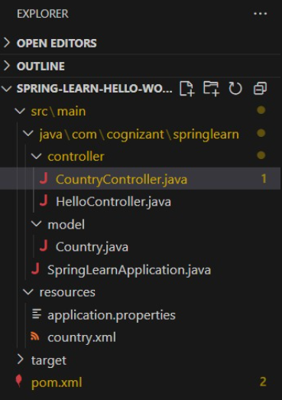

**PROGRAM:**

**Country.java**

package com.cognizant.springlearn.model;

import com.fasterxml.jackson.dataformat.xml.annotation.JacksonXmlProperty;

public class Country {

@JacksonXmlProperty(localName = "code")

private String code;

@JacksonXmlProperty(localName = "name")

private String name;

// getters and setters

}

**Countries.java**

package com.cognizant.springlearn.model;

import com.fasterxml.jackson.dataformat.xml.annotation.JacksonXmlElementWrapper;

import com.fasterxml.jackson.dataformat.xml.annotation.JacksonXmlProperty;

import java.util.List;

public class Countries {

@JacksonXmlElementWrapper(useWrapping = false)

@JacksonXmlProperty(localName = "country")

private List<Country> countries;

public List<Country> getCountries() {

return countries;

}

public void setCountries(List<Country> countries) {

this.countries = countries;

}

}

**CountryService.java**

package com.cognizant.springlearn.service;

import com.cognizant.springlearn.model.Countries;

import com.cognizant.springlearn.model.Country;

import com.fasterxml.jackson.dataformat.xml.XmlMapper;

import org.springframework.stereotype.Service;

import java.io.InputStream;

import java.util.List;

import java.util.Optional;

@Service

public class CountryService {

public Country getCountry(String code) throws Exception {

XmlMapper xmlMapper = new XmlMapper();

InputStream inputStream = getClass().getResourceAsStream("/country.xml");

Countries countries = xmlMapper.readValue(inputStream, Countries.class);

List<Country> countryList = countries.getCountries();

Optional<Country> country = countryList.stream()

.filter(c -> c.getCode().equalsIgnoreCase(code))

.findFirst();

return country.orElseThrow(() -> new Exception("Country Not Found"));

}

}

**OUTPUT:**

