**Microservices with Spring Boot 3 and Spring Cloud REST**

**Get country based on country code**

Write a REST service that returns a specific country based on country code. The country code should be case insensitive.  
  
Controller: com.cognizant.spring-learn.controller.CountryController  
Method Annotation: @GetMapping("/countries/{code}")  
Method Name: getCountry(String code)  
Method Implemetation: Invoke countryService.getCountry(code)   
Service Method: com.cognizant.spring-learn.service.CountryService.getCountry(String code)  
  
Service Method Implementation:

* Get the country code using @PathVariable
* Get country list from country.xml
* Iterate through the country list
* Make a case insensitive matching of country code and return the country.
* Lambda expression can also be used instead of iterating the country list

Sample Request: http://localhost:8083/country/in  
  
Sample Response:

{

"code": "IN",

"name": "India"

}

**FOLDER STRUCTURE:**  
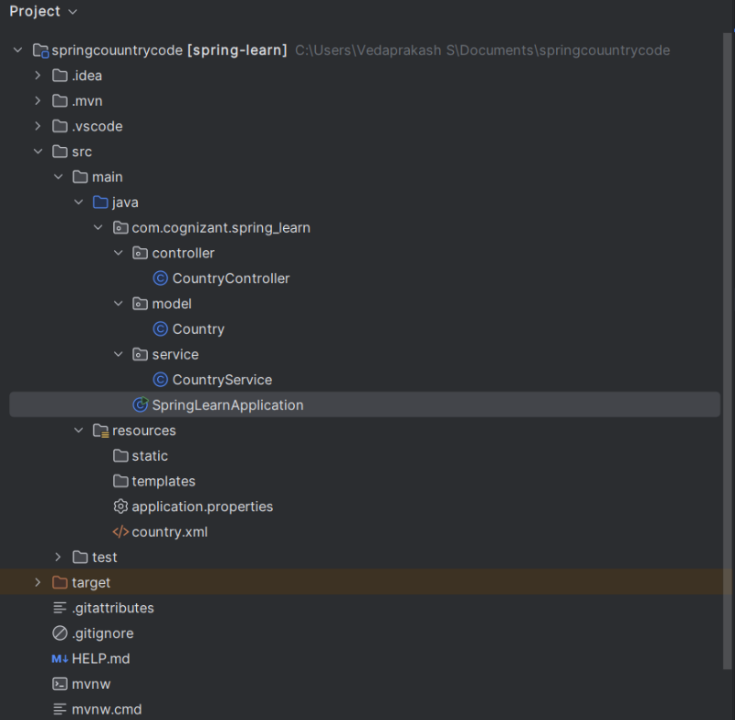

**PROGRAM:**

**CountryController.java:**

package com.cognizant.spring_learn.controller;  
  
import com.cognizant.spring_learn.model.Country;  
import com.cognizant.spring_learn.service.CountryService;  
import org.springframework.beans.factory.annotation.Autowired;  
import org.springframework.web.bind.annotation.*;  
  
@RestController  
public class CountryController {  
  
 @Autowired  
 private CountryService countryService;  
  
 @GetMapping("/country/{code}")  
 public Country getCountry(@PathVariable String code) {  
 return countryService.getCountry(code);  
 }  
}

**Country.java:**

package com.cognizant.spring_learn.model;  
  
public class Country {  
 private String code;  
 private String name;  
  
 public Country() {}  
  
 public Country(String code, String name) {  
 this.code = code;  
 this.name = name;  
 }  
  
 public String getCode() { return code; }  
 public void setCode(String code) { this.code = code; }  
  
 public String getName() { return name; }  
 public void setName(String name) { this.name = name; }  
}

**CountryService.java:**

package com.cognizant.spring_learn.service;  
  
import com.cognizant.spring_learn.model.Country;  
import org.springframework.stereotype.Service;  
import org.springframework.context.support.ClassPathXmlApplicationContext;  
  
import java.util.List;  
  
@Service  
public class CountryService {  
 public Country getCountry(String code) {  
 ClassPathXmlApplicationContext context = new ClassPathXmlApplicationContext("country.xml");  
 List<Country> countries = (List<Country>) context.getBean("countryList");  
  
 for (Country c : countries) {  
 if (c.getCode().equalsIgnoreCase(code)) {  
 context.close();  
 return c;  
 }  
 }  
 context.close();  
 return null;  
 }  
}

**SpringLearnApplication.java:**

package com.cognizant.spring_learn;  
  
import org.springframework.boot.SpringApplication;  
import org.springframework.boot.autoconfigure.SpringBootApplication;  
  
@SpringBootApplication  
public class SpringLearnApplication {  
 public static void main(String[] args) {  
 SpringApplication.*run*(SpringLearnApplication.class, args);  
 }  
}

**application.properties:**   
server.port=8085

**country.xml:**

<?xml version="1.0" encoding="UTF-8"?>  
<beans xmlns="http://www.springframework.org/schema/beans"  
 xmlns:xsi="http://www.w3.org/2001/XMLSchema-instance"  
 xsi:schemaLocation="  
 http://www.springframework.org/schema/beans  
 http://www.springframework.org/schema/beans/spring-beans.xsd">  
  
 <bean id="country" class="com.cognizant.spring_learn.model.Country">  
 <property name="code" value="IN"/>  
 <property name="name" value="India"/>  
 </bean>  
  
 <bean id="countryList" class="java.util.ArrayList">  
 <constructor-arg>  
 <list>  
 <ref bean="country"/>  
 <!-- Add more country beans here if needed -->  
 </list>  
 </constructor-arg>  
 </bean>  
</beans>

**OUTPUT:**

