**MICROSERVICES WITH API GATEWAY**

**Creating Microservices for account and loan**

In this hands on exercises, we will create two microservices for a bank. One microservice for handing accounts and one for handling loans.

Each microservice will be a specific independent Spring RESTful Webservice maven project having it's own pom.xml.

The only difference is that, instead of having both account and loan as a single application, it is split into two different applications.

These webservices will be a simple service without any backend connectivity.

**FOLDER STRUCTURE:**

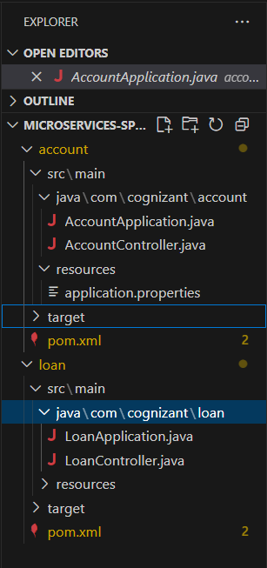

**PROGRAM:**

**AccountApplication.java**

package com.cognizant.account;

import org.springframework.boot.SpringApplication;

import org.springframework.boot.autoconfigure.SpringBootApplication;

@SpringBootApplication

public class AccountApplication {

    public static void main(String[] args) {

        SpringApplication.run(AccountApplication.class, args);

    }

}

**AccountController.java**

package com.cognizant.account;

import org.springframework.web.bind.annotation.GetMapping;

import org.springframework.web.bind.annotation.PathVariable;

import org.springframework.web.bind.annotation.RestController;

import java.util.Map;

@RestController

public class AccountController {

    @GetMapping("/accounts/{number}")

    public Map<String, Object> getAccount(@PathVariable String number) {

        return Map.of("number", number, "type", "savings", "balance", 234343);

    }

}

**LoanApplication.java**

package com.cognizant.loan;

import org.springframework.boot.SpringApplication;

import org.springframework.boot.autoconfigure.SpringBootApplication;

@SpringBootApplication

public class LoanApplication {

    public static void main(String[] args) {

        SpringApplication.run(LoanApplication.class, args);

    }

}

**LoanController.java**

package com.cognizant.loan;

import org.springframework.web.bind.annotation.GetMapping;

import org.springframework.web.bind.annotation.PathVariable;

import org.springframework.web.bind.annotation.RestController;

import java.util.Map;

@RestController

public class LoanController {

    @GetMapping("/loans/{number}")

    public Map<String, Object> getLoan(@PathVariable String number) {

        return Map.of("number", number, "type", "car", "loan", 400000, "emi", 3258, "tenure", 18);

    }

}

**OUTPUT:**

