**REACT**

**React JS-HOL (Handson 1)**

**Basic React Application**

**FOLDER STRUCTURE:**

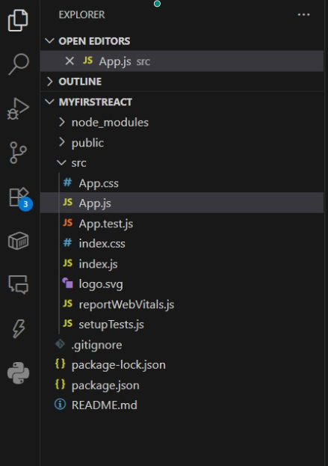

**PROGRAM:**

**App.js**

import React from 'react';

function App() {

return (

<div>

<h1>Welcome to the first session of React</h1>

</div>

);

}

**export default App;**

**OUTPUT:**

