**REACT**

**React JS HOL (Handson 3)**

**Score Calculator App**

**FOLDER STRUCTURE:**

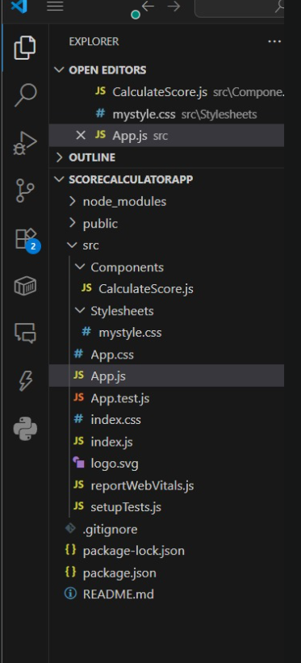

**PROGRAM:**

**CalculateScore.js**

import React from 'react';

import '../Stylesheets/mystyle.css';

function CalculateScore(props) {

const { name, school, total, goal } = props;

const average = total / goal;

return (

<div className="score-box">

<h2>Student Score Calculator</h2>

<p><strong>Name:</strong> {name}</p>

<p><strong>School:</strong> {school}</p>

<p><strong>Total Marks:</strong> {total}</p>

<p><strong>Subjects:</strong> {goal}</p>

<p><strong>Average Score:</strong> {average.toFixed(2)}</p>

</div>

);

}

export default CalculateScore;

**App.js**

import React from 'react';

import './App.css';

import CalculateScore from './Components/CalculateScore';

function App() {

return (

<div className="App">

<CalculateScore name="Keerthi" school="Sona College" total={450} goal={5} />

</div>

);

}

export default App;

**OUTPUT:**

