**REACT**

**React JS HOL (Handson 4)**

**Blog app**

**FOLDER STRUCTURE:**

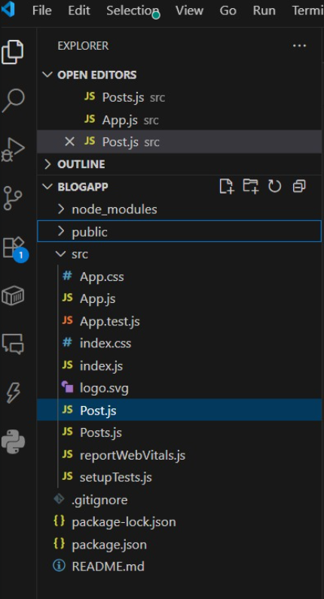

**PROGRAM:**

**Post.js**

import React from 'react';

function Post({ title, body }) {

return (

<div style={{ marginBottom: "20px", padding: "10px", border: "1px solid #ccc" }}>

<h3>{title}</h3>

<p>{body}</p>

</div>

);

}

export default Post;

**Posts.js**

import React, { Component } from 'react';

import Post from './Post';

class Posts extends Component {

constructor(props) {

super(props);

this.state = {

posts: [],

hasError: false

};

}

// Step 6: loadPosts method

loadPosts = () => {

fetch('https://jsonplaceholder.typicode.com/posts')

.then(response => {

if (!response.ok) {

throw new Error('Error fetching posts');

}

return response.json();

})

.then(data => this.setState({ posts: data }))

.catch(error => {

console.error('Fetch error:', error);

this.setState({ hasError: true });

});

};

// Step 7: componentDidMount

componentDidMount() {

this.loadPosts();

}

// Step 9: componentDidCatch

componentDidCatch(error, info) {

alert("Something went wrong: " + error);

}

// Step 8: render posts

render() {

if (this.state.hasError) {

return <h2 style={{ color: 'red' }}>Failed to load posts.</h2>;

}

return (

<div style={{ padding: "20px" }}>

<h1>Blog Posts</h1>

{this.state.posts.map(post => (

<Post key={post.id} title={post.title} body={post.body} />

))}

</div>

);

}

}

export default Posts;

**App.js**

import React from 'react';

import './App.css';

import Posts from './Posts';

function App() {

return (

<div className="App">

<Posts />

</div>

);

}

export default App;

**OUTPUT:**

