**REACT**

**React JS HOL (Handson 5)**

**CohortDetails Styling**

**FOLDER STRUCTURE:**

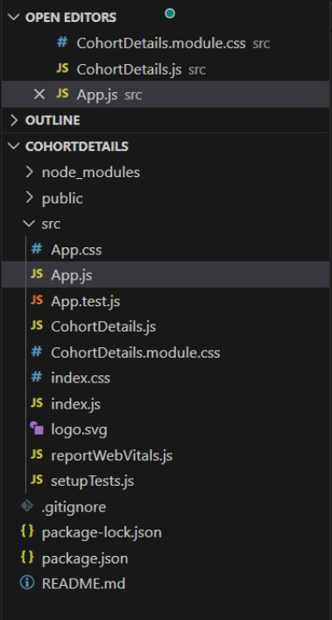

**PROGRAM:**

**CohortDetails.modules.css**

.box {

width: 300px;

display: inline-block;

margin: 10px;

padding: 10px 20px;

border: 1px solid black;

border-radius: 10px;

}

dt {

font-weight: 500;

}

**CohortDetails.js**

import React from 'react';

import styles from './CohortDetails.module.css';

function CohortDetails({ cohort }) {

const titleStyle = {

color: cohort.status === 'ongoing' ? 'green' : 'blue',

};

return (

<div className={styles.box}>

<h3 style={titleStyle}>{cohort.name}</h3>

<dl>

<dt>Start Date:</dt>

<dd>{cohort.startDate}</dd>

<dt>End Date:</dt>

<dd>{cohort.endDate}</dd>

<dt>Status:</dt>

<dd>{cohort.status}</dd>

</dl>

</div>

);

}

export default CohortDetails;

**App.js**

import React from 'react';

import CohortDetails from './CohortDetails';

function App() {

const cohorts = [

{

name: 'React Bootcamp',

startDate: '2025-06-01',

endDate: '2025-08-01',

status: 'ongoing',

},

{

name: 'Node.js Basics',

startDate: '2025-04-01',

endDate: '2025-06-01',

status: 'completed',

},

];

return (

<div style={{ padding: '20px' }}>

{cohorts.map((cohort, index) => (

<CohortDetails key={index} cohort={cohort} />

))}

</div>

);

}

export default App;

**OUTPUT:**

