**REACT**

**React JS HOL (Handson 10)**

**Office Space Rental App**

**FOLDER STRUCTURE:**

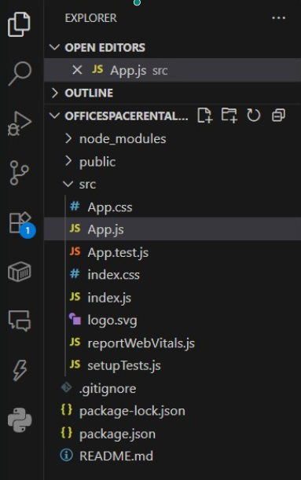

**PROGRAM:**

**App.js**

import React from 'react';

// Inline styling function based on rent

const getRentStyle = (rent) => {

return {

color: rent < 60000 ? 'red' : 'green',

fontWeight: 'bold',

};

};

function App() {

// Heading element

const heading = <h1>Office Space Rental</h1>;

// Office space image

const imageUrl = "https://via.placeholder.com/400x200.png?text=Office+Space";

// Object for a single office

const office = {

name: 'Workspace A',

rent: 50000,

address: '123, Business St, Chennai',

};

// List of office objects

const offices = [

{ name: 'Workspace A', rent: 50000, address: '123, Business St, Chennai' },

{ name: 'Workspace B', rent: 70000, address: '456, Tech Ave, Bangalore' },

{ name: 'Workspace C', rent: 55000, address: '789, Hub Rd, Hyderabad' },

];

return (

<div style={{ padding: '20px', fontFamily: 'Arial' }}>

{heading}

{/* Office Image */}

<img src={imageUrl} alt="Office" style={{ width: '400px', height: '200px', marginBottom: '20px' }} />

{/* Single office details */}

<div style={{ marginTop: '10px' }}>

<h2>Featured Office</h2>

<p><strong>Name:</strong> {office.name}</p>

<p><strong>Rent:</strong> <span style={getRentStyle(office.rent)}>{office.rent}</span></p>

<p><strong>Address:</strong> {office.address}</p>

</div>

{/* Office list */}

<div style={{ marginTop: '30px' }}>

<h2>Available Offices</h2>

{offices.map((item, index) => (

<div key={index} style={{ marginBottom: '15px' }}>

<p><strong>Name:</strong> {item.name}</p>

<p>

<strong>Rent:</strong>{' '}

<span style={getRentStyle(item.rent)}>{item.rent}</span>

</p>

<p><strong>Address:</strong> {item.address}</p>

<hr />

</div>

))}

</div>

</div>

);

}

export default App;

**OUTPUT:**

