**REACT**

**React JS HOL (Handson 12)**

**Ticket Booking App**

**FOLDER STRUCTURE:**

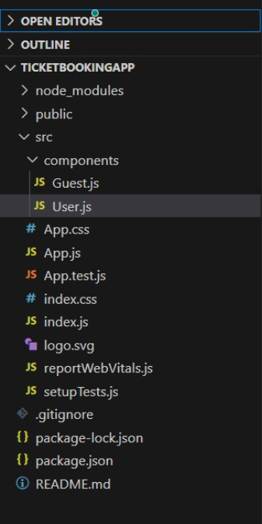

**PROGRAM:**

**App.js**

import React, { useState } from 'react';

import Guest from './components/Guest';

import User from './components/User';

function App() {

const [isLoggedIn, setIsLoggedIn] = useState(false);

const handleLogin = () => {

setIsLoggedIn(true);

}

const handleLogout = () => {

setIsLoggedIn(false);

}

return (

<div style={{ textAlign: 'center', padding: '20px' }}>

<h1>Flight Ticket Booking App ✈️</h1>

{isLoggedIn ? (

<>

<User />

<button onClick={handleLogout}>Logout</button>

</>

) : (

<>

<Guest />

<button onClick={handleLogin}>Login</button>

</>

)}

</div>

);

}

export default App;

**Guest.js**

import React from 'react';

const Guest = () => {

return (

<div>

<h2>Welcome Guest! </h2>

<p>You can view flight details, but you must log in to book tickets.</p>

</div>

);

};

export default Guest;

**User.js**

import React from 'react';

const User = () => {

return (

<div>

<h2>Welcome Back, User! </h2>

<p>You are now logged in. Book your flight tickets below:</p>

<ul>

<li>✈️ Chennai ➝ Delhi - ₹4500</li>

<li>✈️ Bangalore ➝ Mumbai - ₹5500</li>

<li>✈️ Hyderabad ➝ Kolkata - ₹4900</li>

</ul>

<button>Book Now</button>

</div>

);

};

export default User;

**OUTPUT:**

